RAG based pdf bot

The RAG based pdf bot is a query tool to search for information in the PDF files under the pdf folder.
The current query string is
"What is the formula used to calculate the OH processing stage index stgIx?"

The PDF file, Slides.pdf, is the document that contains the query result.

The steps to launch the pdf bot to make the query:

- GIT clone the repo
git clone https://github.com/haidong1965/pdf_bot_demo

- Enter the repo and initialize python environment
cd pdf_bot_demo
python -m venv my_rag_project_venv
my_rag_project_venv\Scripts\activate.bat
pip install chromadb google-genai langchain_community pypdf sentence-transformers

- Start the local LLM model from LM studio
- Load LLM module llama-3.2-3b-instruct
- Start local server
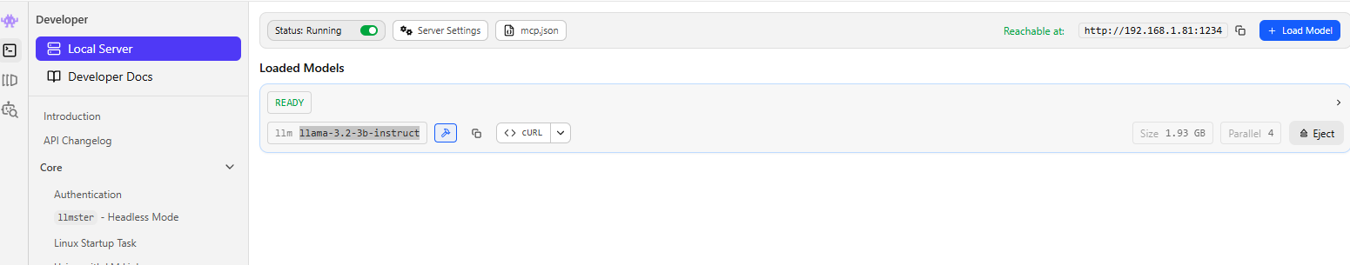

- Start the pdf bot to make the query
python concepture_openai.py
- The query result is shown in the prompt
