IoC / Dependency Injection

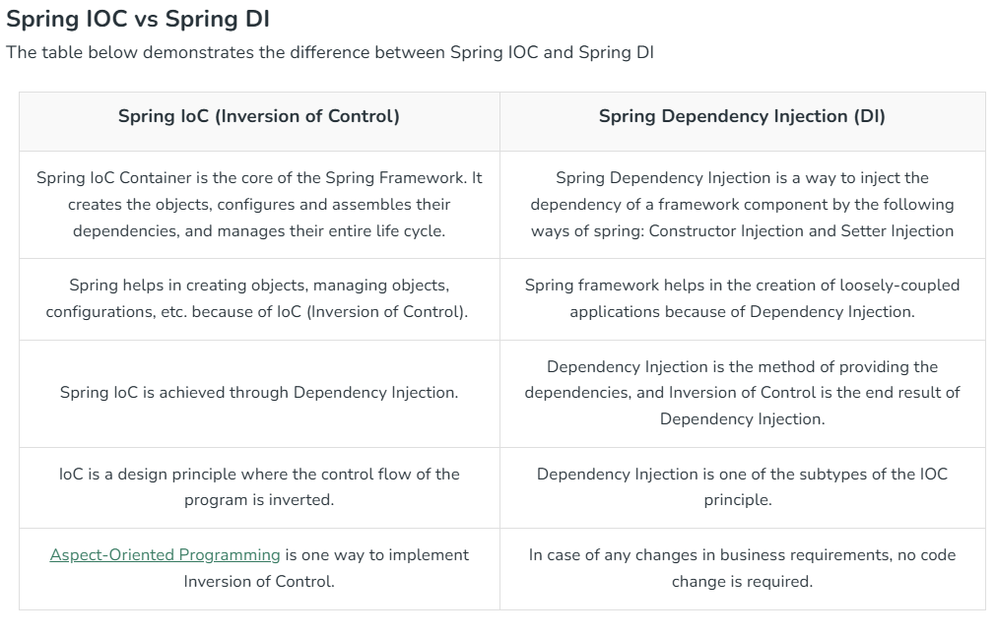
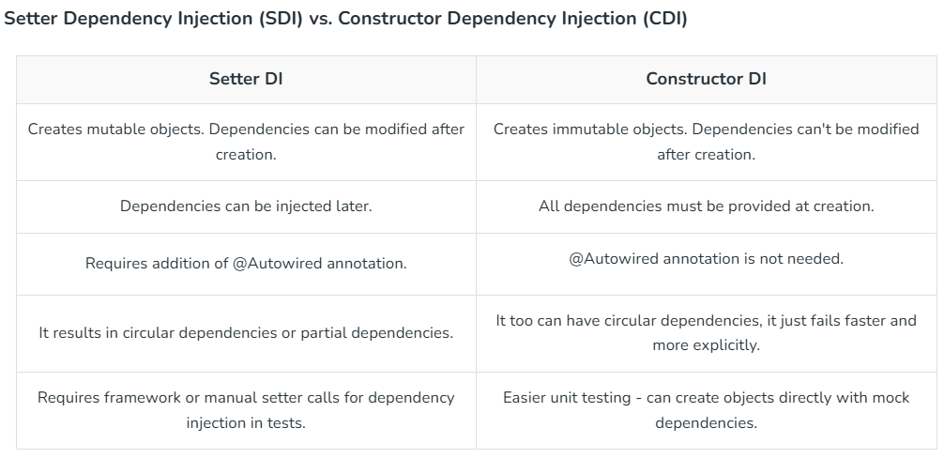

Spring-ApplicationContext
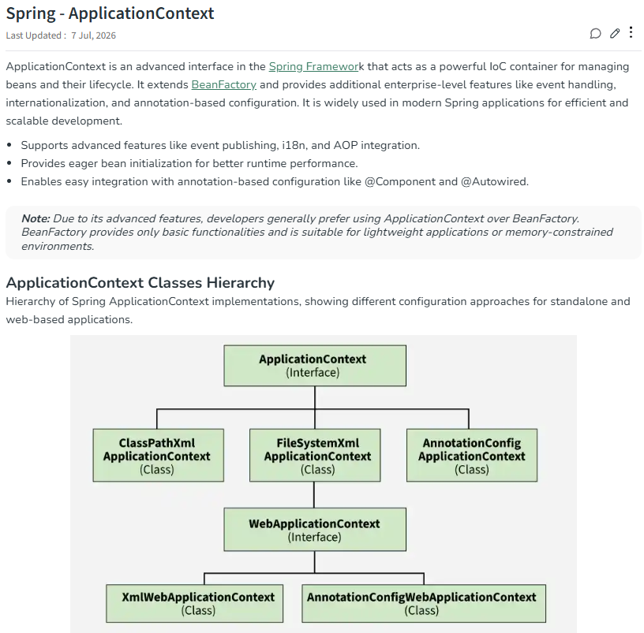
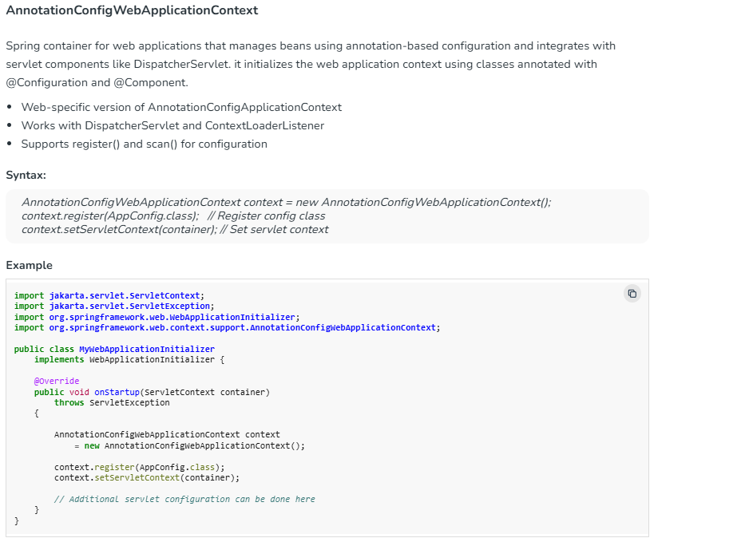
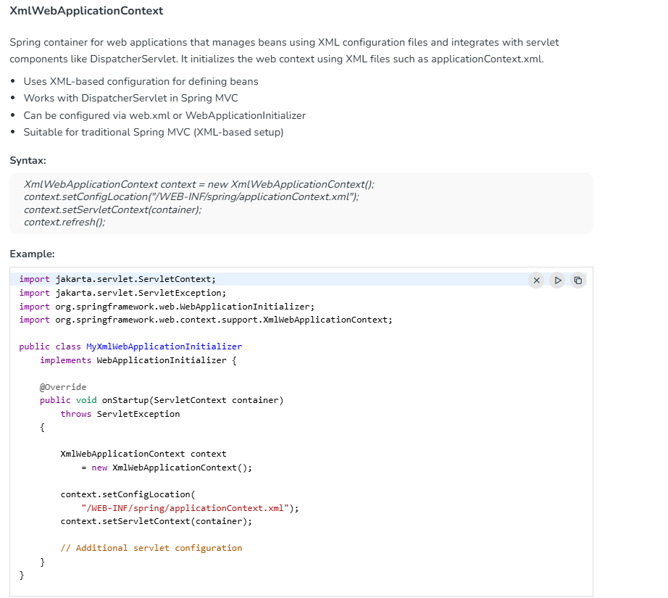
https://www.geeksforgeeks.org/java/spring-applicationcontext/

Spring – BeanFactory
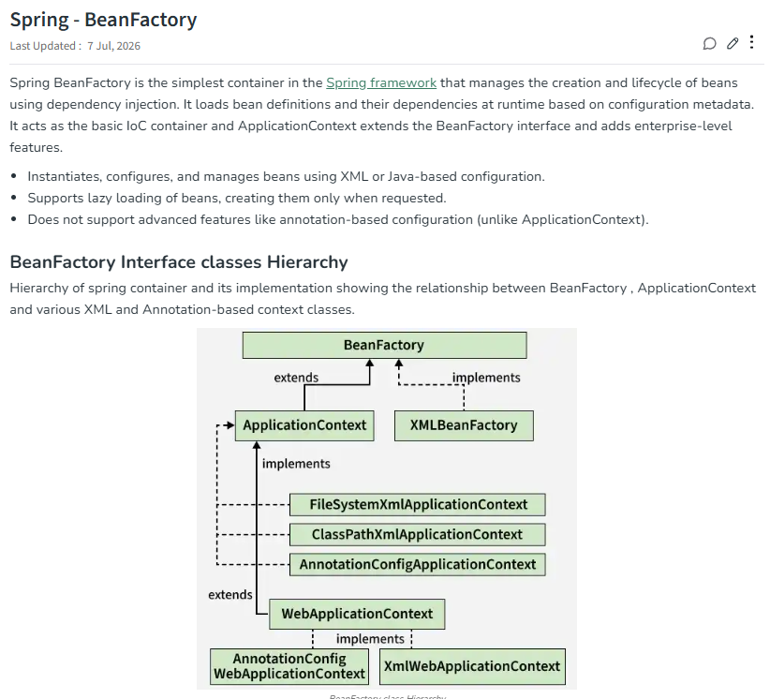
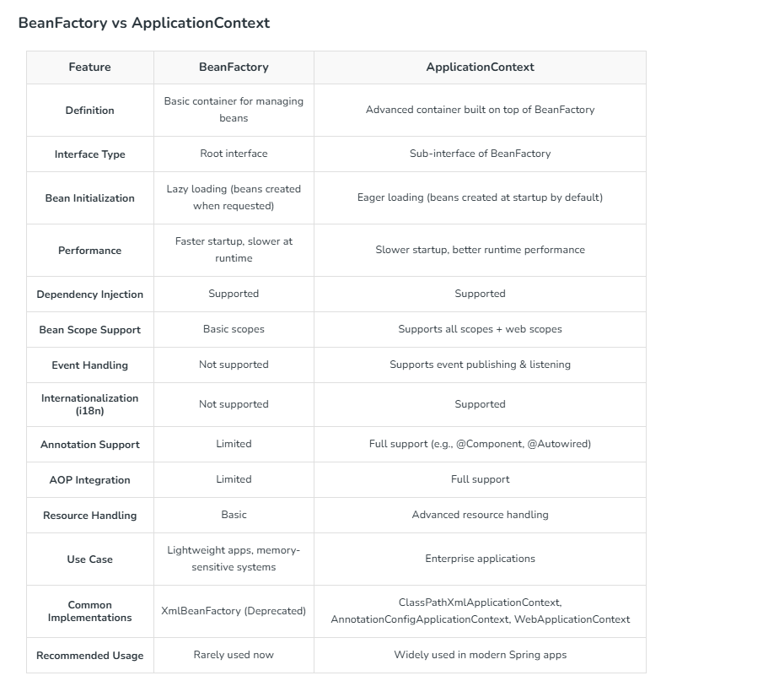
https://www.geeksforgeeks.org/springboot/spring-beanfactory/

@Component, @Service, @Repository, @Controller
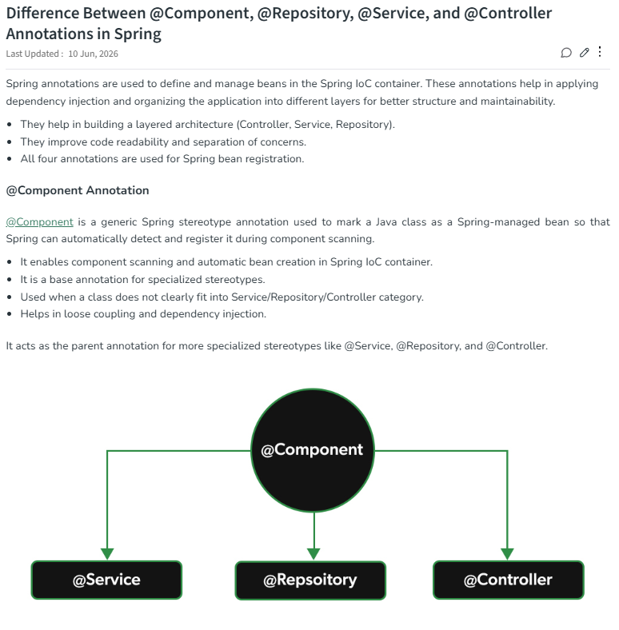
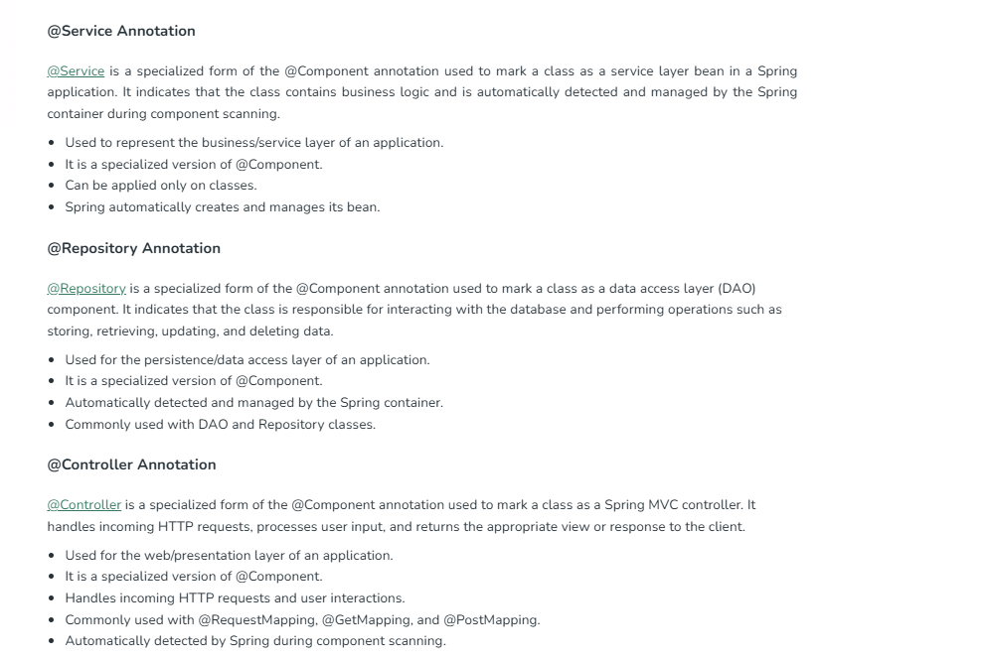
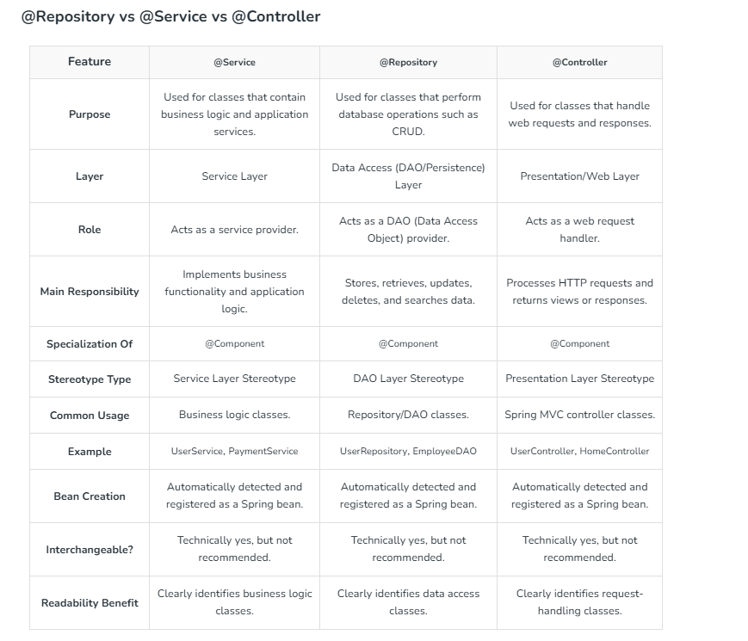
https://www.geeksforgeeks.org/java/difference-between-component-repository-service-and-controller-annotations-in-spring/

@Configuration and @Bean
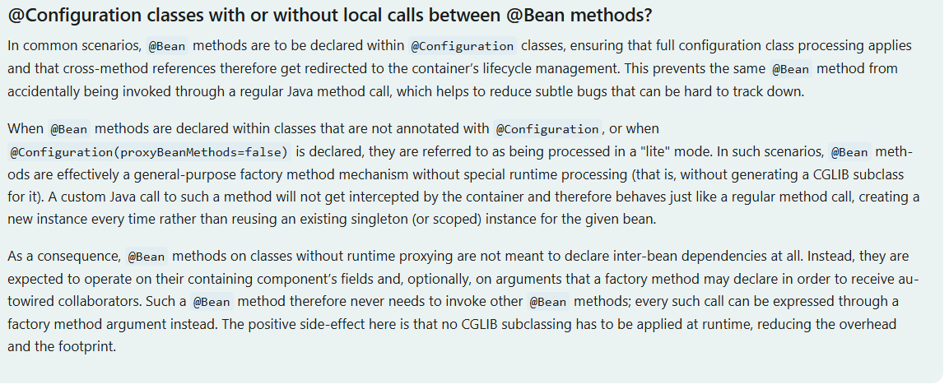
https://docs.spring.io/spring-framework/reference/core/beans/java/basic-concepts.html

Constructor, setter and field injection

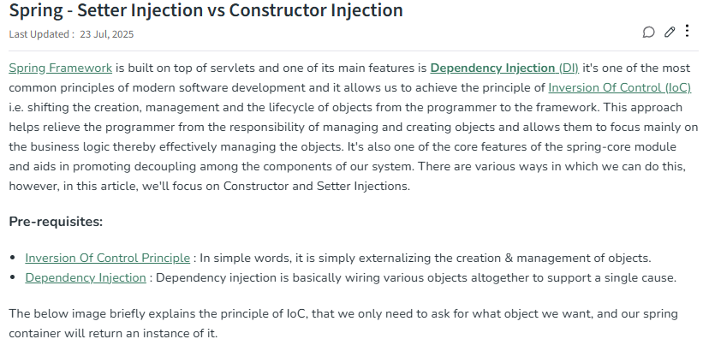
Why not Field injection?
the SOLID principles of object-oriented design
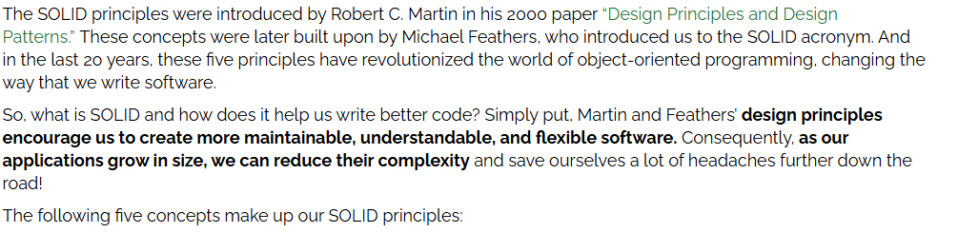
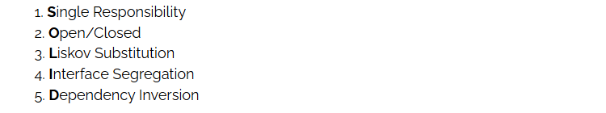
https://www.baeldung.com/solid-principles

Field injection creates a risk of NullPointerException if dependencies aren’t correctly initialized.
Using the field injection, we are unable to create immutable classes.
Single Responsibility Violation
Circular Dependencies
Test:
Unit testing reveals one of the major drawbacks of the field injection approach.
Suppose we’d like to write a unit test to check whether the process() method defined in the EmailService is working properly.
Firstly, we’d like to mock the EmailValidation object. However, since we inserted the EmailValidator using field injection, we can’t directly replace it with a mocked version
https://www.baeldung.com/java-spring-field-injection-cons

@Autowired
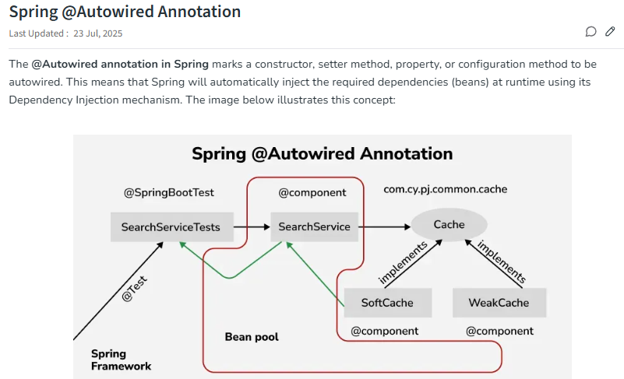

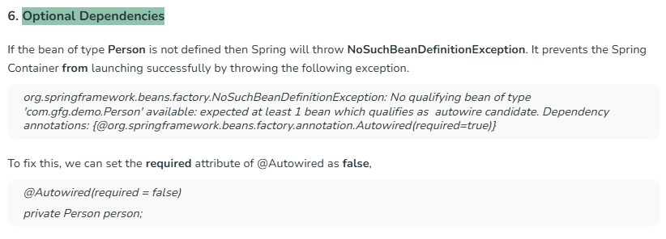

@Qualifier
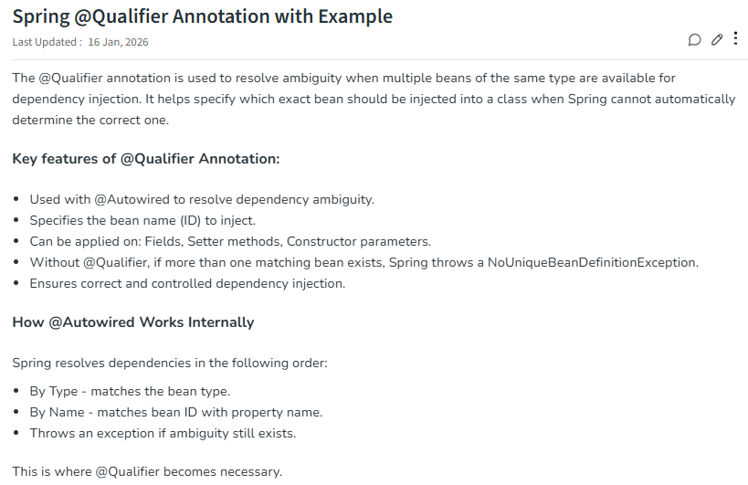
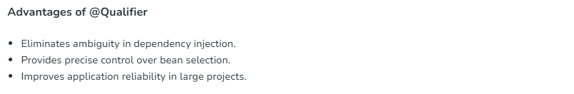
https://www.geeksforgeeks.org/springboot/spring-qualifier-annotation-with-example/

@Primary
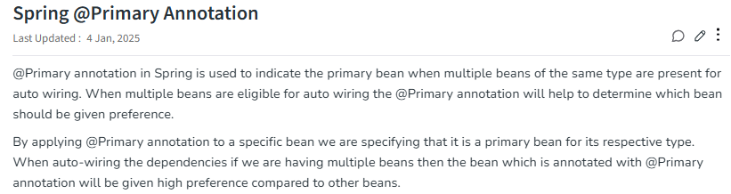

Multiple beans of the same type

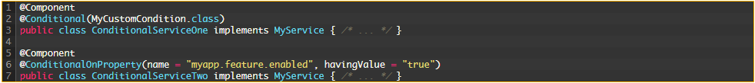
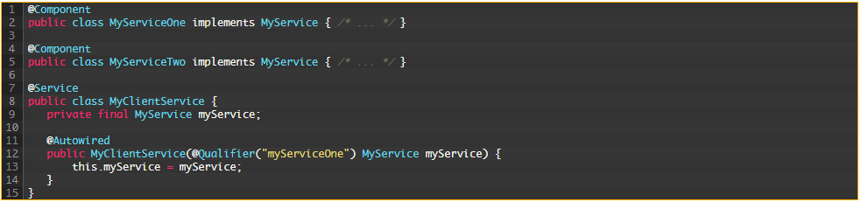
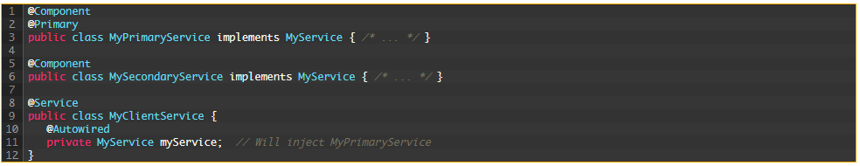
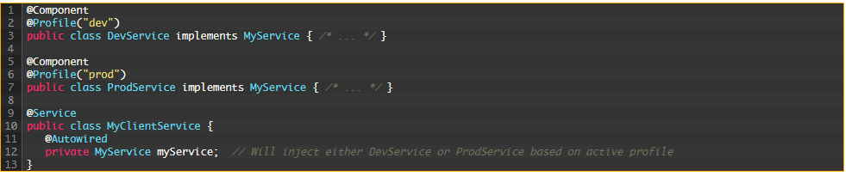
https://newdevpoint.in/how-to-handle-multiple-beans-of-same-type/

Dependency resolution
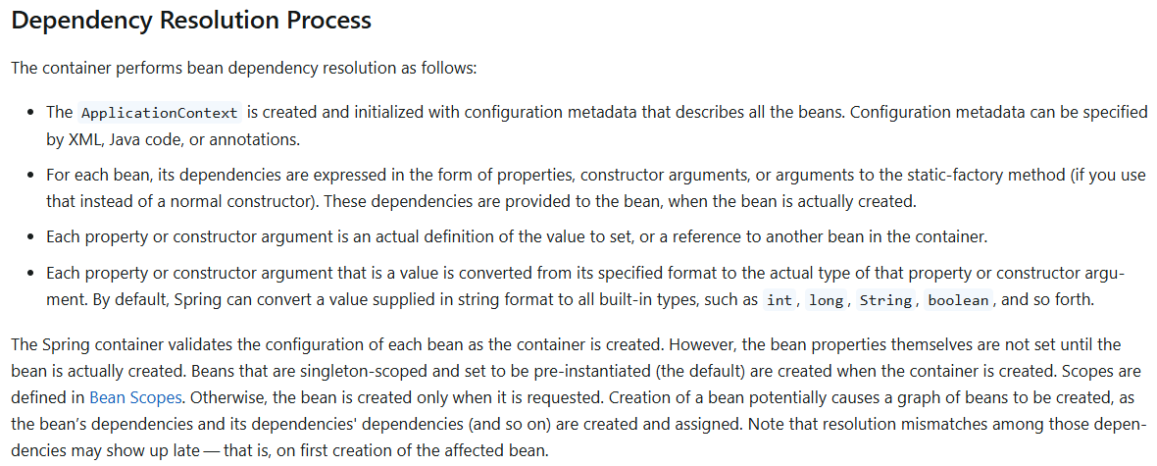

Circular dependencies
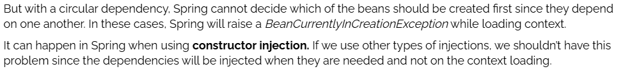
The Workarounds
Redesign
Use @Lazy
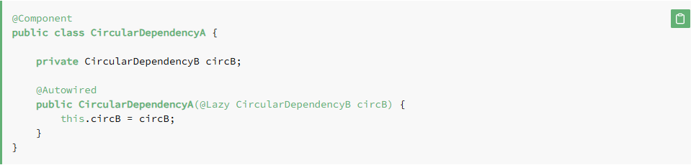
Use Setter/Field Injection
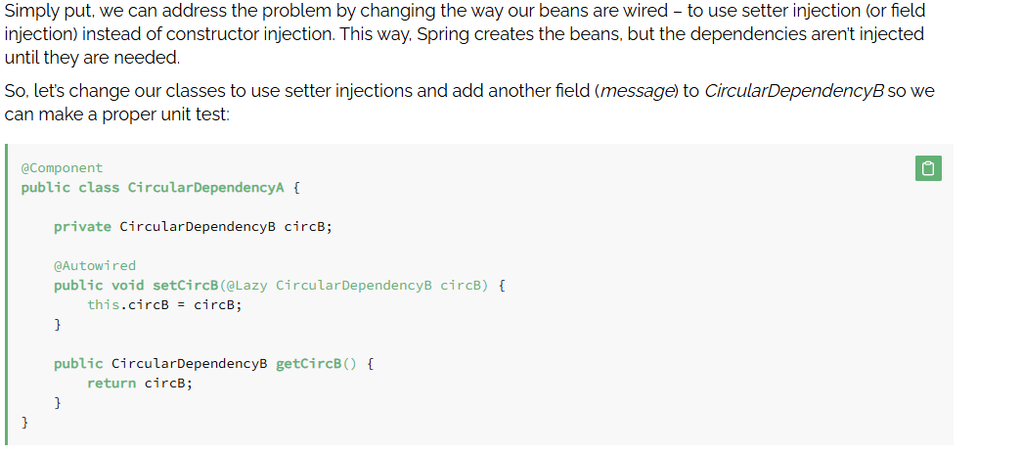
Use @PostConstruct
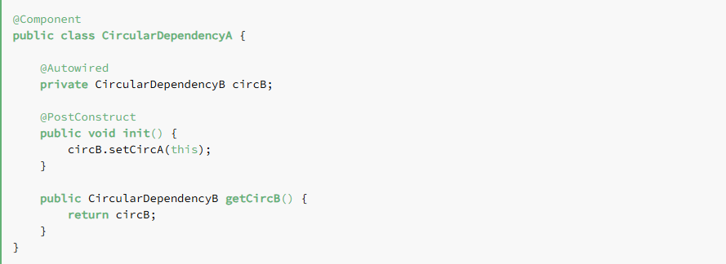
Implement ApplicationContextAware and InitializingBean

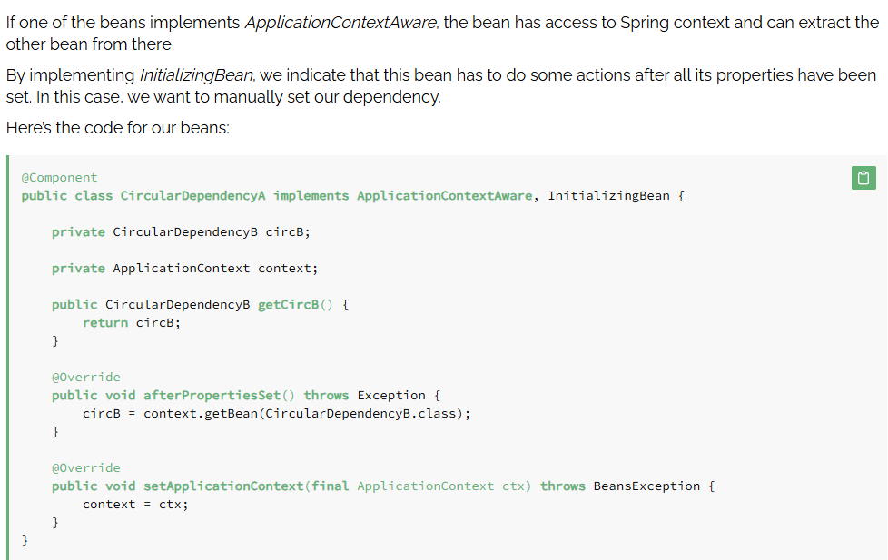
https://www.baeldung.com/circular-dependencies-in-spring

Bean definition vs bean instance
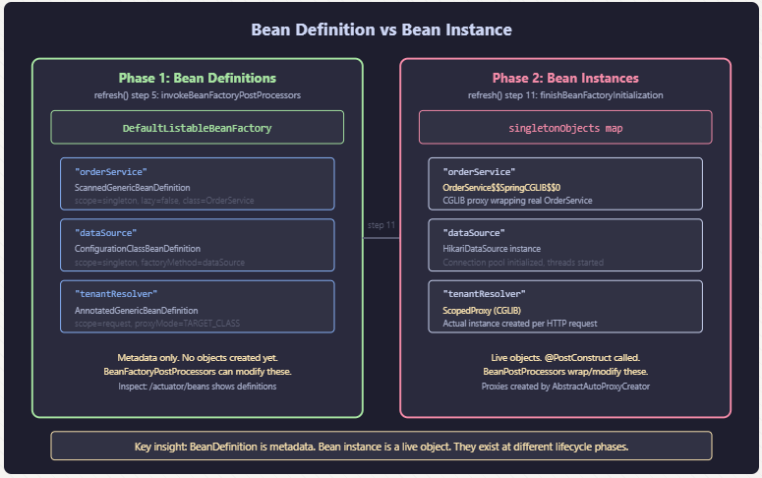
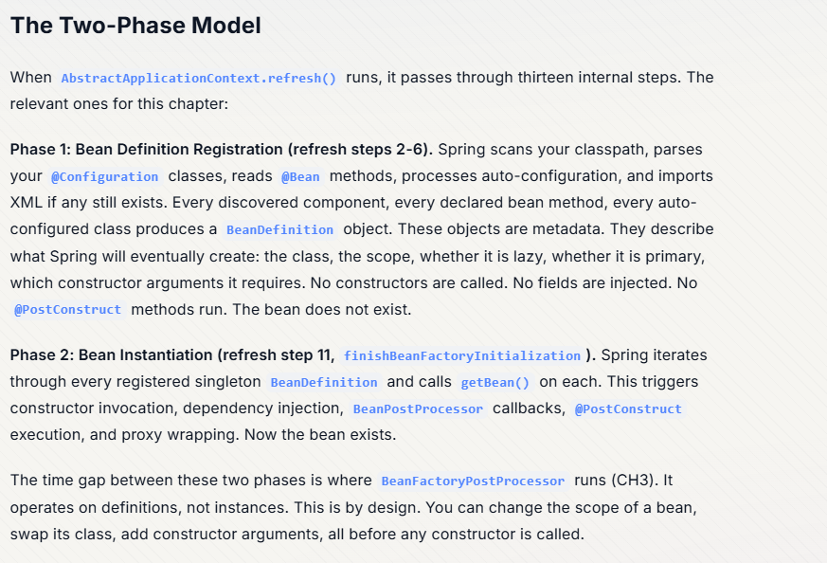
https://earezki.com/books/spring-internals/ch2/

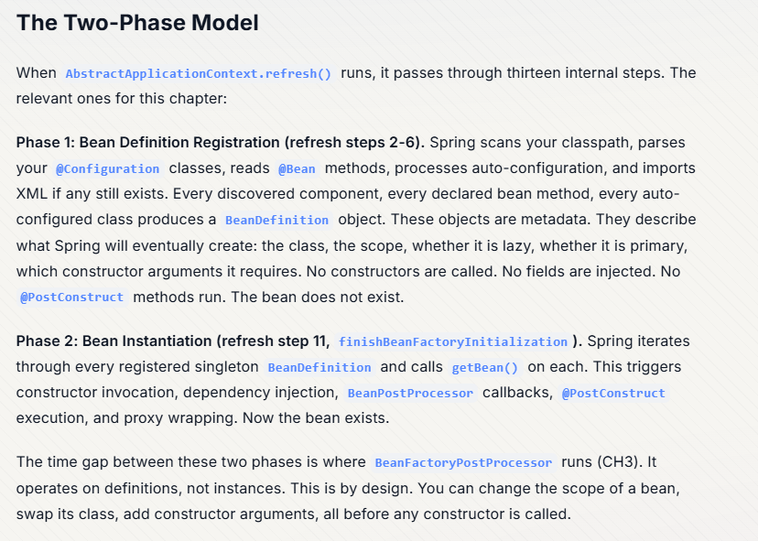
https://earezki.com/books/spring-internals/ch2/

Singleton scope

Prototype scope
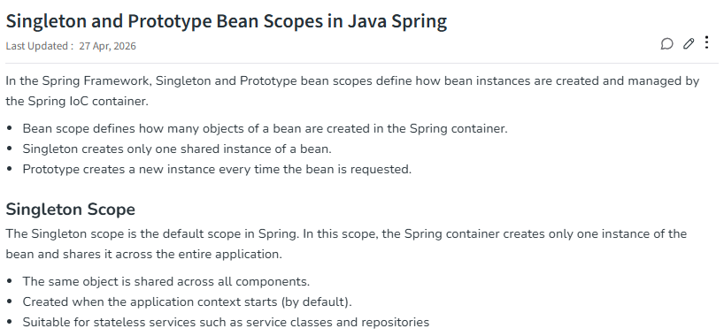
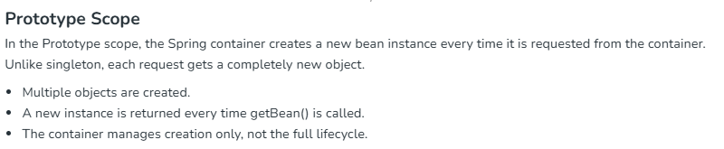
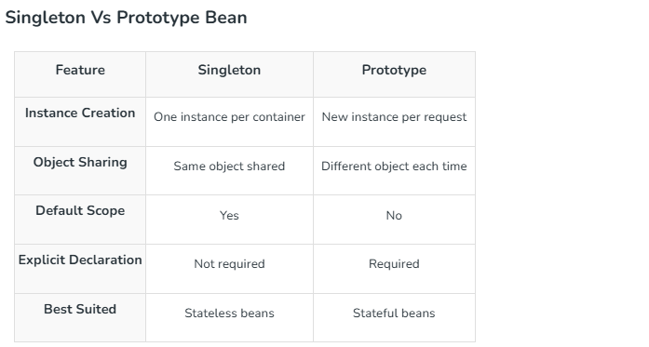
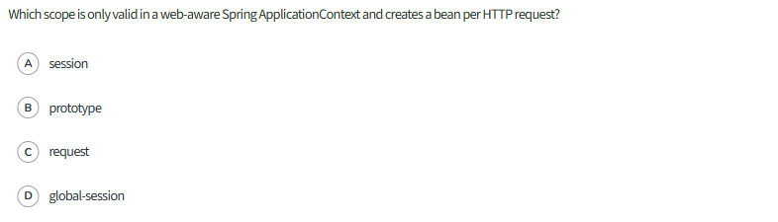
https://www.geeksforgeeks.org/java/singleton-and-prototype-bean-scopes-in-java-spring/

Request / session / application / WebSocket scopes

@Scope
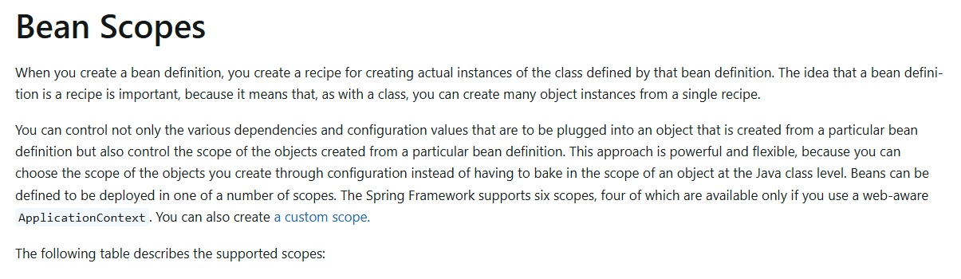
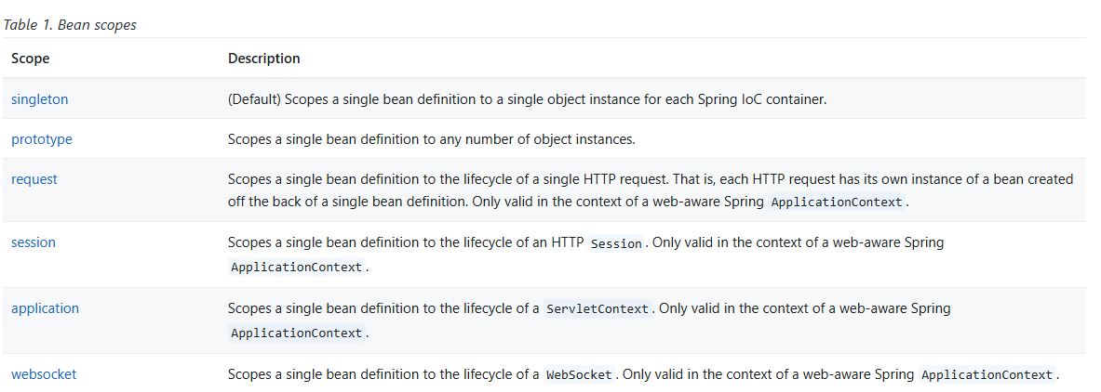
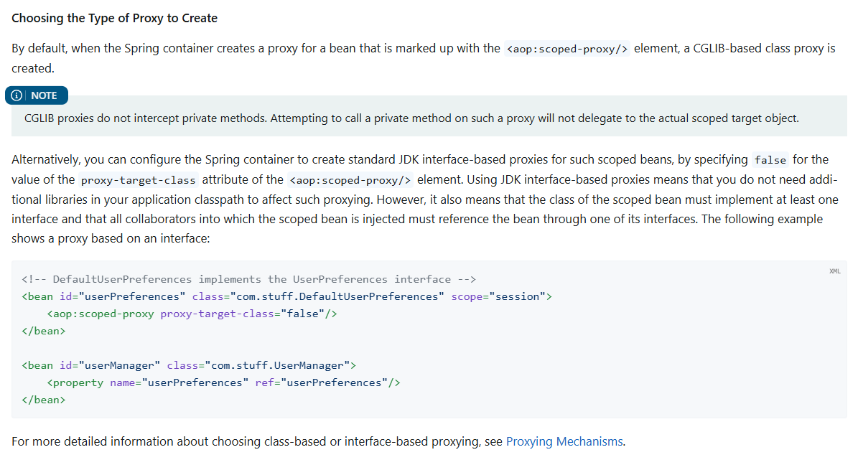
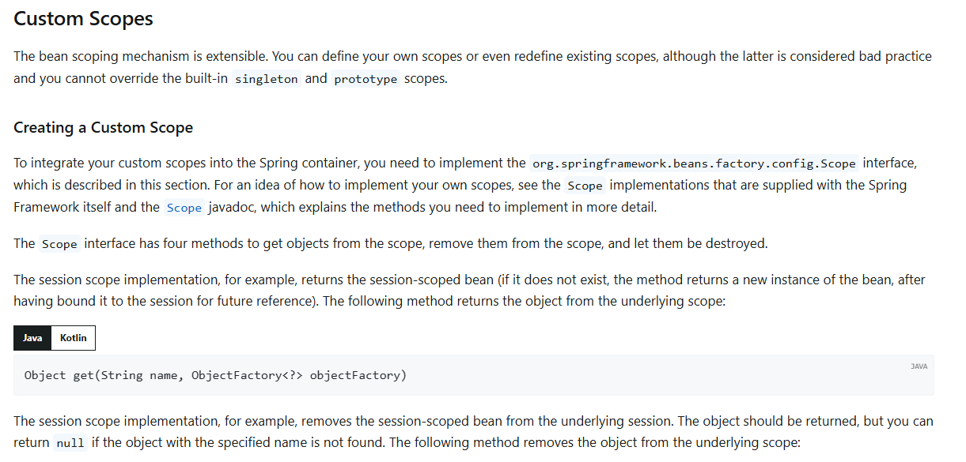
https://docs.spring.io/spring-framework/reference/core/beans/factory-scopes.html
https://github.com/javalearnerss/bean-scopes/tree/main/session-scope

@PostConstruct and @PreDestroy
