Elastic Search Investigation Task

What is Elastic Search
It is a distributed search and analytics engine, recently it has become the most popular search engine worldwide.
Commonly used for log analytics, full-text search, business analytics, and more.
It is a No SQL database that lets you create indices and perform API requests on it
It is scalable open source multitenant-capable, full-text, distributed search and analytics engine
Uses unstructured or semi-structured data Document Oriented Database

Main Components of Elastic Search

Index:
It is like a Table in Database
It stores complex data structure in the form of JSON Document,
Logical data organization mechanism where each document has a field with key and value pair
Created using PUT/<index>

Shard:
Pieces of data where each piece contains n number of entire document as per the configuration of shard in the index

Replica:
Copy of information of the shards

Node:

Some collection of shards and replicas, starting an instance of elastic search will initiate a node

Cluster:
Collection of nodes

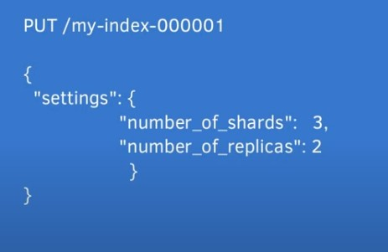
Example of creating an index with its configurations

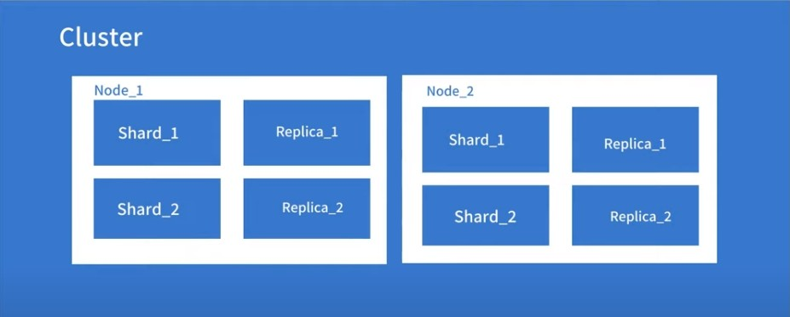

Primary Use Cases
Application Search Website Search Enterprise Search Logging and Log Analytics

Why Elastic Search?
Products with huge databases are facing issues as very long time in retrieving data because relational database work comparatively slow when it comes to huge data and fetching search results through database queries which leads to poor user experience

How it works
It can work in two ways:
Sending the data in the form of JSON document using API.

Using ingestion tools that visualize the data and build interactive dashboards such as Kibana, Logstash, and Amazon Kinesis Firehose.
Both ways enable elastic search to automatically stores the document, add a searchable reference to the document in the cluster’s index, and let you search or retrieve data and find the best matches
- First, install and configure ES on your system

- Create required indices using POST or PUT requests and specify their URLs and data using JSON format.
- Apply queries on your specified index using GET request.

Benefits
Simple REST API HTTP Interface
uses schema-free JSON document
Can process large data and process them in parallel

Instead of API, it can be used from a tool -Kibana- in order to: visualize data
Load data into elastic search’s cluster

Supports many languages such as Java, Ruby, JavaScript, PHP, and more

Elastic Search vs SQL
Elastic Search is way better in terms of a large amount of data being indexed and searched while SQL is better in terms of transactions and complex queries
ES supports unstructured or semi-structured data while SQL supports structured data

SQL | Elastic Search
Column | Field
Row | Document
Table | Index
Schema | Implicit
Database | Cluster

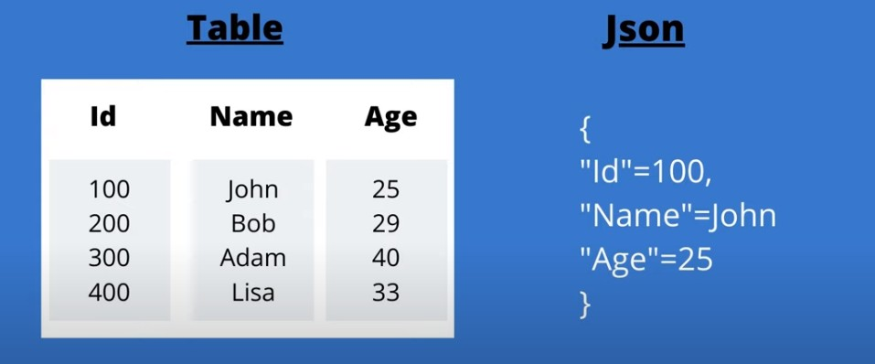
💡
How Data is stored in Table in SQL, and in JSON format in elastic
Search Document:

Important Links
- Amazon AWS
- ES Documentation
- Installing and how to use ES

- ES in spring-boot
- ES in angular

- Example of Elastic Search and Angular

