Overview
This is a custom-built Sense Chess Robot Clone! Inspired by the famous, high-end SenseRobot AI Chess Trainer. Replicate its physical piece-moving mechanics, AI vision tracking, and robotic arm precision using DIY components
Original |  | Cloned
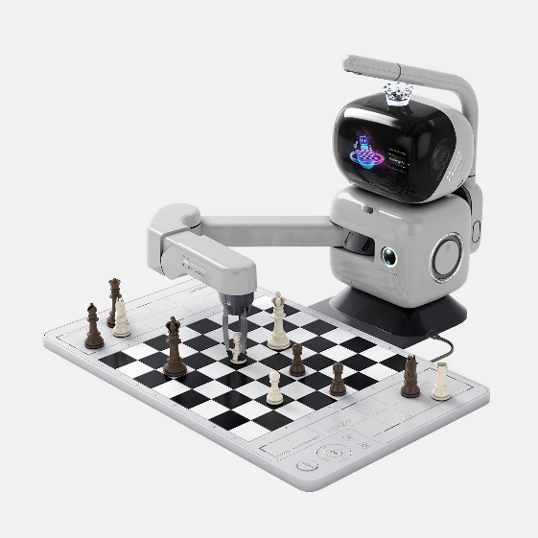 |  | 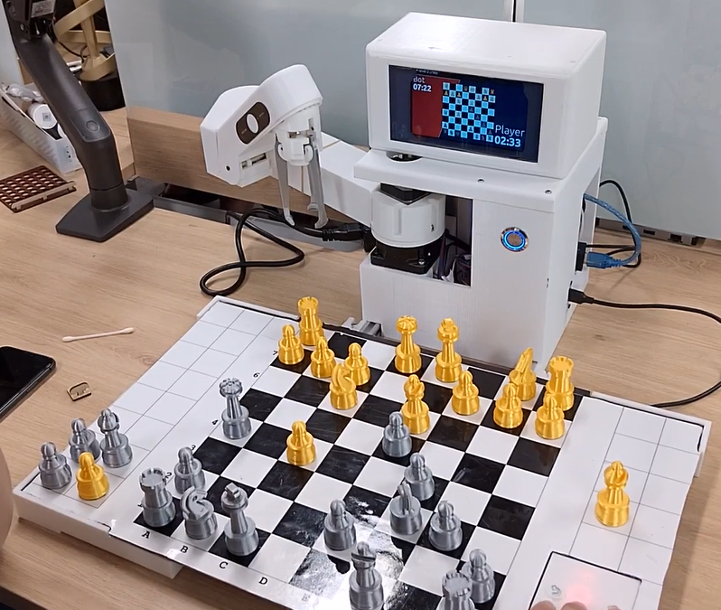

Design

Robot Arm
4 Degrees of Freedom SCARA robotic arm style, 3 Finger gripper utilizes a vertical descent mechanism to pick pieces straight up and place them down, avoiding collisions with adjacent pieces.

Main Shaft
The Hollow Rotary Table SHA 060 GEAR Ratio 1/18 Step Motor to create stable shaft, smooth motion, high torque when the arm moves fast to reach the farthest position on board.
https://www.famotor.co.kr/shop/item.php?it_id=1528953759&ca_id=104010&page=1
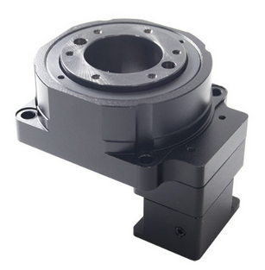

Second Arm

Third Arm

Third Arm up-down

Gripper

Robot Shell

Chess Player

1080P USB webcam
Low-cost Full HD usb webcam, include camera and microphone, enough to capture the whole chess board for image classification
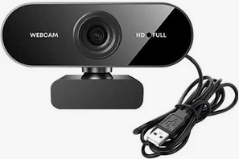

Intel NUC 7 Celeron J4025
Low-cost pc, enough to run simple image processing (Opencv C++), image classification (Openvino C++) and ai models (sherpa-onnx, piper)
CPU | Intel Celeron processor J4025  2.0 GHz - 2.9 GHz burst, Dual-Core, 10W  Intel UHD Graphics 600, 700 MHz
RAM | 2 x 260Pin SO-DIMM DDR4 2400
Storage | SSD 128G

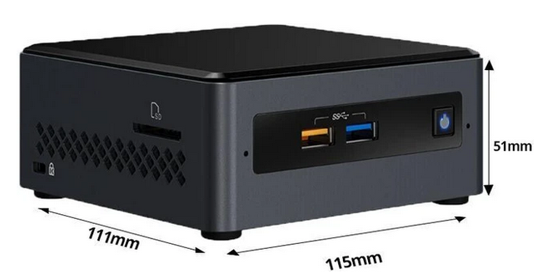

Chess Board

Magnetic sheet

Chess board decal

Chess board bone

Chess Board plane

Button board

Hardware Design

Power supply

Power divider

Power button

Software Design

RobotController

ChessPlayer

Keyboard

