Item | Count | Price (VND)
Total:
1.656.818
Servo 20kg  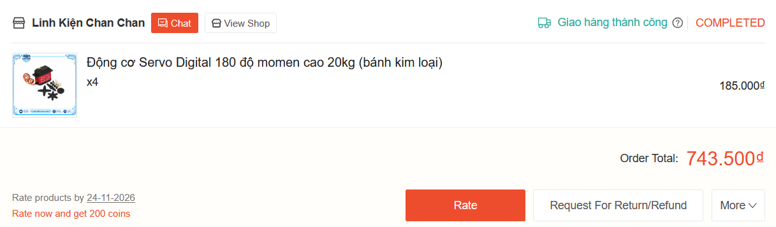 | 4 | 743.500
DC  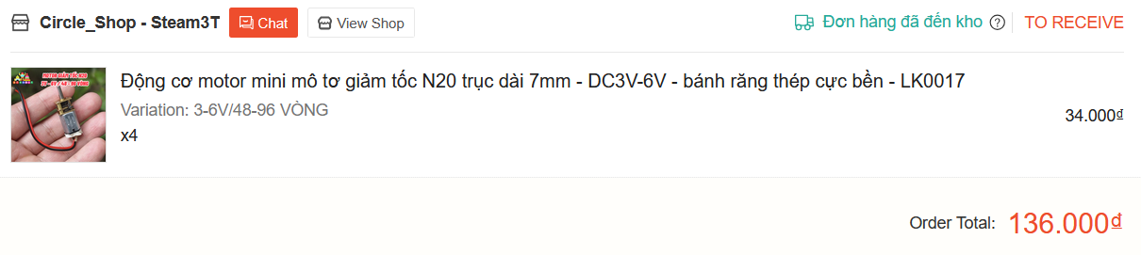 | 4 | 136.000
Wheel  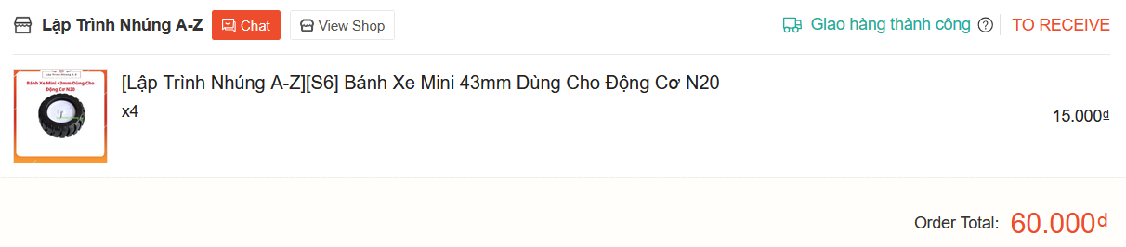 | 4 | 60.000
DC driver  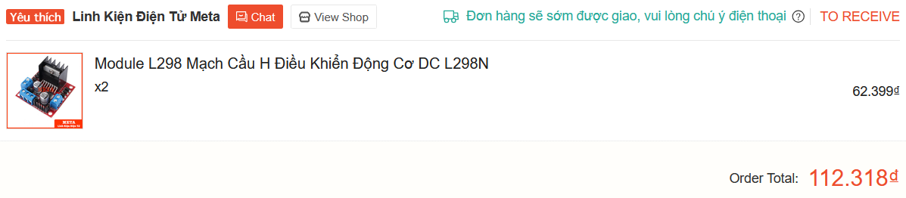 | 4 | 112.318
In 3D  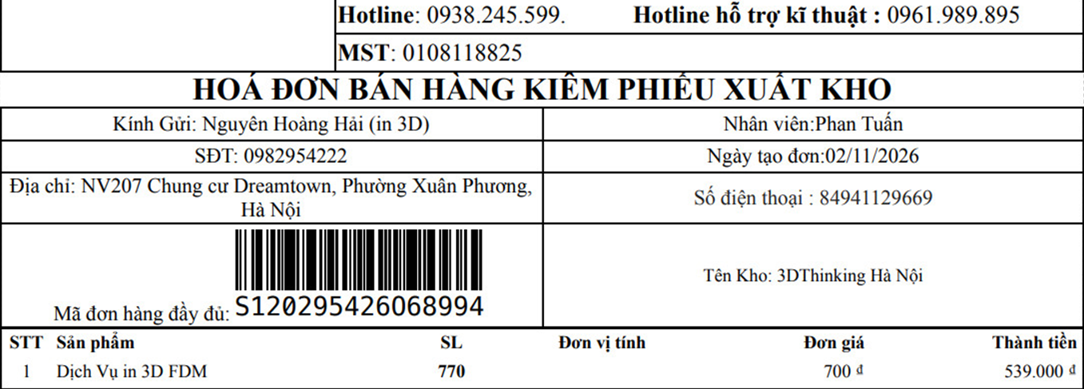 | 1 | 539.000
Ship   | 1 | 66.000
Battery | 1
Battery converter | 1

