The training dataset consists more than one million of data records. However, there are only around 8900 records with “Yes” value in the field “went_on_backorder” (or Yes class), or less than 1% of the whole dataset.

This might lead to a problem when we train the machine learning models on the original training dataset, since it might cause bias against Yes class. Besides, the original dataset can also cause the Overfitting phenomenon to the trained models, which could negatively impact the predictive capability of these models.

To overcome such situation, we could do data preprocessing by reproduce a smaller training dataset. This could be achieved by selecting all 8900 records of Yes class, and withdraw another 8900 records of No class (data records with “No” in “went_on_backorder” field). The record are selected randomly from original training dataset and the numbers of both classes are kept equal so our model could be free from bias.

After preparing train data, we load it to our python program using Pandas. To fully optimize our training, we remove unnecessary columns. This data cleansing step help to reduce the training dataset’s size and remove redundancy in our data (some columns are dependent with other ones, for example: forecast_3_month, forecast_6_month, and forecast_9_month…) . The remaining columns are: national_inv, lead_time, forecast_3_month, sales_6_month, min_bank, perf_6_month_avg, went_on_backorder.

Some records have missing values in the field “lead_time”, which is intepreted as NA, so we replace those missing values with numeric 0. After preprocessing and cleansing data, we split the training dataset into 2 parts: train data and train target. Because our goal is to classify all the test data into 2 classes: class 1 for backorder records and class -1 for non-backorder records. So, we replace the associated values of column “went_on_backorder” from “Yes” and “No” to “1” and “-1” respectively.

Predict the test_set_sample.csv (the predicted values are in square brackets)

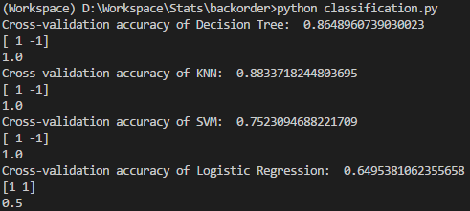

Test with another 100 records withdrawn redomly from original dataset:

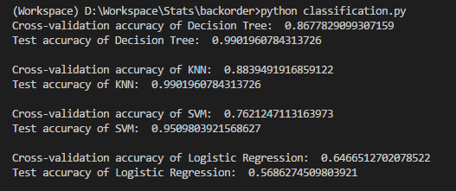

Conclusion: in this problem, the simple classifiers such as KNN or Decision Tree perform more efficiently than other algorithms such as SVM or Logistic Regression.