VetCare Platform
Feature Analysis & Implementation Plan

Global Competitive Research — 15+ Platforms Across 8 Countries

March 2026 | Version 2.0 | Confidential

Table of Contents
1. Executive Summary
2. Research Sources Overview
2.1 India — animall.in & pashushala.com
2.2 USA — CattleRange, Breedr, Farmbrite, Herdwatch
2.3 Australia — AuctionsPlus & StockLive
2.4 Europe — Agriaffaires, CowManager, Connecterra, AGRIVI
2.5 Turkey — MilkingCloud
2.6 Global — Allflex/Merck, DairyGlobal
3. Global Platform Feature Matrix
4. Gap Analysis — VetCare vs Global Leaders
5. Architecture Diagram (Post-Integration)
6. New Feature Specifications (from Global Research)
6.1 Live Online Auction System
6.2 Market Price Intelligence Dashboard
6.3 IoT Ear Sensor Monitoring
6.4 Weather & Drought Integration
6.5 Conception-to-Carcass Supply Chain
6.6 Pasture Management & Farm Mapping
6.7 Livestock Finance Integration
6.8 RFID/EID Tag Integration
6.9 Feed Ration Management (Enhanced)
6.10 Farm Accounting & eCommerce
7. Original 14 Features (from India Research)
8. Database Schema Additions (Updated)
9. Permission System Changes (Updated)
10. Cross-Module Integration Map
11. Innovation Differentiators (Global)
12. Implementation Roadmap (5 Phases)
13. Impact Summary

1. Executive Summary
This document presents a comprehensive competitive analysis of 15+ livestock and farm management platforms across 8 countries — India, USA, Australia, UK/Ireland, Netherlands, France/Europe, Turkey, and global providers. It identifies unique features from each platform and proposes their integration into VetCare with significant innovations that NO SINGLE competitor currently offers.
The VetCare platform already possesses a robust foundation with 50+ pages, 44 backend services, 55+ routes, and 5 supported languages. The proposed enhancements will transform VetCare from a veterinary consultation platform into a comprehensive global livestock ecosystem platform — combining the best features from Indian marketplaces, Australian live auctions, European IoT monitoring, American farm management, and more.

Key Metrics (Updated):
Metric | Original (India Only) | Updated (Global)
Platforms researched | 2 | 15+
Countries covered | 1 (India) | 8+
New features to implement | 14 | 19
New frontend pages | 8-10 | 12-15
Existing pages to enhance | 3-4 | 6-8
New backend services | 4 | 8
New database tables | 8 | 12
Extended database tables | 2 | 3
New permission keys | 9 | 13
Implementation phases | 4 | 5

2. Research Sources Overview
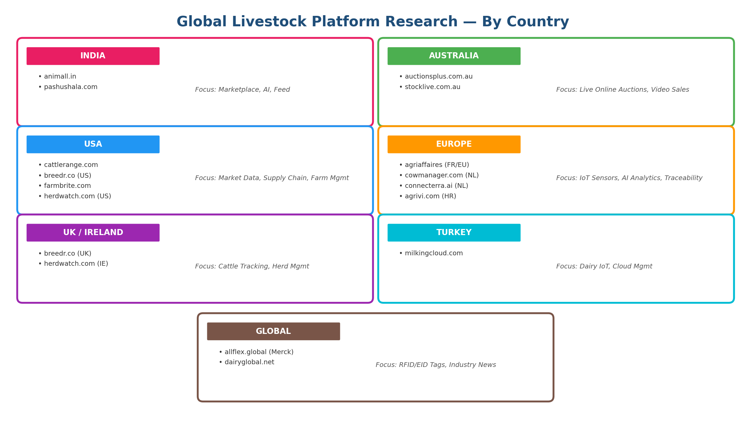

2.1 India — animall.in & pashushala.com

animall.in
India's largest livestock trading platform with 1 Crore+ (10 million+) farmers. Primarily mobile-first with Hindi-language focus.
- Livestock Buy/Sell Marketplace by location (cow, buffalo, heifer, bull)
- Multi-Step Sell Form with animal type, calving number, daily milk, price, photos (side + udder), GPS
- Pashu Chat — Community forum for farmers ("1 Crore+ farmers trusted")
- Video Tutorials ("How to buy from Animall", "How to sell")
- Prime Listings — Featured/boosted animal listings for faster sales
- Tipping System, Nearby Animals discovery, Live Buyer Count

pashushala.com
"Most Trusted Livestock Marketplace" with detailed animal cards, AI integration, and multiple e-commerce verticals.
- Rich Livestock Cards — Breed-specific IDs (SAH-1613, HF-2721), price, lactation, milk yield, pregnancy, location
- PashuGuru.AI — AI-powered agricultural assistant
- Aahar (Feed), Upchar (Medicine), Upkaran (Equipment), Utpad (Dairy Products) — 4 e-commerce verticals
- SmartFeed — AI-based intelligent feed optimization
- Pashu Vet — "Anytime Vet Support" consultation service
- Partner Program — Rural entrepreneurship network
- "Hot Deal" + "Book Now" badges on premium listings

2.2 USA — CattleRange, Breedr, Farmbrite, Herdwatch

cattlerange.com (USA)
Comprehensive US cattle market intelligence platform with listings, market data, and analysis tools.
- Cattle for Sale indexed by Breed, Cattle Class, and State
- Daily & Weekly Market Summaries with price indices (fed cattle, feeder cattle, cow-calf)
- Regional Cattle Auction Results by state with historical comparison
- Cattle Calculators — Bred Heifer & Cow Value Estimator based on market data
- Weekly Drought Monitor integration (map-based drought severity by county)
- USDA Monthly Reports — Cold Storage, Livestock Slaughter, Cattle on Feed data
- Production Sale Calendar — Upcoming auction events with calendar view
- Feeder & Stocker Cattle Marketings data with trend analysis
- Industry news categorization (MCOOL, Beef Imports, Processing, Wildfires)

breedr.co (UK/USA)
"Powering the Future of Beef" — The world's most ambitious cattle management app. Tracks animals from conception to carcass, enabling supply chain optimization.
- Lifetime Cattle Tracking — Conception to carcass, every animal, every step
- Supply Chain Collaboration — Independent producers collaborate within a supply chain
- Premium Beef Programs — Exclusive calf buy-back, retained ownership, preferential pricing grids
- Exponential Performance Gains — 30% feed conversion efficiency, 16% prime beef increase, $8/cwt premium
- Operation Types — Seedstock, Cow-Calf, Calf Nursery, Feedyard, Packers & Retailers
- Smart Beef Supply Chain management with data-driven decision making
- Case Studies & Producer Community platform

farmbrite.com (USA)
All-in-one farm management software for multi-species and biodiverse farms. Trusted by 5,000+ farmers worldwide with 8,000+ app integrations.
- Livestock Management — End-to-end animal records, wellness, yields, analytics, herd management
- Farm Accounting & Bookkeeping — Receipt capture, split transactions, invoices, bank import
- Crop Planning & Management — Season planning from seed to sale
- Farm Sales & eCommerce — Direct-to-consumer sales, POS, order management, fulfillment
- Climate & Weather — Historic weather trends, satellite imagery for soil/livestock wellness
- Farm Mapping — Customized farm map builder for compliance and planning
- 100+ Pre-built Reports — Operations, financial, and compliance reporting
- Resource & Input Management — Equipment utilization tracking, maintenance schedules
- Team Task Management — Kanban boards, recurring tasks, automated reminders
- 8,000+ Zapier Integrations + Custom API

herdwatch.com (Ireland/USA)
Livestock management software used by 22,000+ producers globally. 3 solutions in one platform: Cattle, Sheep, Pasture.
- Cattle Management — Calving records, treatments, weights, breeding events, sales/purchases
- Sheep Management — Lamb recording, flock health, breeding performance tracking
- Pasture Management — Ranch mapping, fertilizer tracking, grazing tasks
- Offline-first with sync — Works without internet, syncs when connected
- Bluetooth EID Reader Integration — Connect to electronic ID readers and scale heads
- Multi-device support (phone, tablet, laptop) with cloud sync
- Breed Association Integration — Pedigree registrations, market declarations
- Bulk data upload — Send records to support team for batch import
- Recently acquired VetDrive (veterinary practice management system)

2.3 Australia — AuctionsPlus & StockLive

auctionsplus.com.au (Australia)
Australia's largest online livestock auction platform. 497+ upcoming auctions, 24,488 head offered weekly, covering cattle, sheep, goats, equine, and machinery.
- Live Online Auctions — Real-time bidding with Watch or Bid options per auction
- Commodities — Cattle, Sheep, Goats, Equine, Machinery all on one platform
- Feeder Cattle Listings — Dedicated section for feeder/stocker cattle
- Trade Now — Instant purchase lots (no auction needed)
- Livestock Finance (StockCo) — Integrated financing for livestock purchases
- Trade & Finance Calculator — Calculate financing and trading costs
- Livestock Assessors — Find accredited assessors by region
- AuctionsPlus Young Cattle Indicator (AYCI) — Custom market index at 505c/kg
- Weekly Market Reports — Detailed reports with clearance rates, value-over-reserve
- Weather integration (temperature, wind, rain, cloud) on homepage
- Featured Lots with detailed breeding descriptions and pedigree data
- Forward+ Sheep — Forward contract marketplace for sheep
- Biosecurity Awareness resources and compliance
- Mobile App (iOS & Android) for bidding on-the-go

stocklive.com.au (Australia)
"When you can't get to the auction, StockLive takes you there." Live-streamed livestock auctions across Australia (formerly Elite Livestock Auctions).
- Live Video Auction Streaming — Watch real-time auction with video feed
- Online Bidding — Bid remotely in real-time during live auctions
- Auction Calendar — Upcoming auctions by date, state (NSW, QLD, VIC, etc.)
- Commercial & Seedstock categories
- Per-page auction results with breed details, weights, and lot descriptions

2.4 Europe — Agriaffaires, CowManager, Connecterra, AGRIVI

agriaffaires.co.uk (France/Europe)
Major European farm equipment marketplace present in 20+ countries with 20+ languages. 208,684 classified ads with 15,000 new ads daily.
- Livestock Equipment — Milking parlour, milk tanks, livestock trailers, head locks, water tanks, mixers
- Animals & Feed section — Live animals, straw & forage, feed, board
- Price Observatory — Average price trends tracking per equipment/animal category
- Equipment Transport — Request quotation based on distance for purchases
- Professional Directory — Searchable directory of agricultural businesses
- Property Sales — Farm land and property marketplace
- Geolocation Search — "All equipment around me" with radius filter
- Multi-country, multi-language support (20+ each)

cowmanager.com (Netherlands)
IoT-based cow monitoring system using ear sensors for lifetime monitoring from calf to cow. Headquartered in Netherlands, offices in USA.
- Ear Sensor Technology — Measures ear temperature + eating + rumination + activity patterns
- Health Monitoring — Alerts up to 3 days before clinical illness signs, mastitis detection
- Fertility/Heat Detection — Know exactly when cow is in heat, optimal insemination timing
- Transition Monitoring — Track dry period to calving transition health
- Nutrition Monitoring — Feed management optimization, heat stress prevention
- Youngstock Monitor — Calf health management for future milk production
- "Find My Cow" — Locator/Flash tools to find specific cows in herd within seconds
- MultiView — Give staff, vets, nutritionists access to selected cow data
- "Sort My Cow" — Automated cow separation with sorting gates for health/heat alerts
- Auto-Drafting — Automated separation of cows with alerts from herd

connecterra.ai (Netherlands)
AI-powered dairy analytics platform that removes data silos and provides AI-driven decision support for farms, advisors, and enterprises.
- Farm Data Analytics — Visualize, compare, analyze all farm data in one platform
- AI Copilot — Weekly operational summaries powered by AI, delivered to inbox
- Decision Support — Automatic impact analysis with AI-powered predictions
- Scenario Modeling — Model different decision scenarios with AI predictions
- Farm Timeline — Auto-track decisions and their outcomes over time
- ROI Calculator — Calculate impact of every decision on key metrics
- Multi-stakeholder — Solutions for farm leadership, dairy advisors, and enterprises
- Data Integration — Connects with all existing farm management systems

agrivi.com (Croatia/Global)
Comprehensive digital agriculture solutions supporting the entire agri-food value chain. Partners include Nestle, Kaufland. UN and FAO affiliated.
- AGRIVI AI Engage — White-labeled WhatsApp/Viber AI agronomic advisor for farmer engagement
- Farm Management Software (FMS) — Data-driven tools for agronomic and economic decisions
- Food Traceability — Complete food production traceability from seed to shelves, QR code scanning
- IoT Integration (Connect) — Weather stations, soil sensors, machinery data plug & play
- ROI Calculator — Free farm digitalization assessment tool
- Multi-Industry — Farms, Enterprise Farms, Cooperatives, Food & Beverages, Banks, Retail, Public Sector
- Supply Chain Intelligence — Agriculture supply chain management for contracted farmers

2.5 Turkey — MilkingCloud

milkingcloud.com (Turkey)
Cloud-based dairy and beef farm management platform with integrated IoT devices. Available in English, Spanish, French, Turkish and more.
- Solutions — Dairy Farm, Beef Cattle/Feedlot, Cow-Calf Operations, Enterprise
- Devices — Mastitis Detection Device (MastiPro), Calving Sensor (PartuSense), Heat Detection (M2Moo ear tag), Wash Quality Monitor (WashLog)
- Modules — Dairy/Beef Cow Management, Group Management, Milk Yield Records, Weight Monitoring, Feed Management, Milk Ration Management, Beef Ration Management, Health Management, Heat/Breeding Operations, Pregnancy/Gestation Monitoring
- Freelance Veterinarian App — Multiple farms on single screen for traveling vets
- Enterprise Solutions — Multi-farm corporate management capabilities

2.6 Global — Allflex/Merck, DairyGlobal

allflex.global (Merck — Global)
65 years of livestock identification experience. Global leader in RFID tags, visual tags, tissue sampling, and SenseHub monitoring systems.
- Visual ID Tags — Various colors, print options for cattle, sheep, goats, zoo, wildlife
- Electronic ID (RFID) — Species-specific RFID tags for traceability programs
- Tissue Sampling — Ear biopsies for health status, genomic insights, disease eradication
- SenseHub Monitoring — Cow-Calf, Dairy, Feedlot, and Poultry monitoring systems
- DataFlow II — Data management and flow for livestock intelligence
- Milking Automation — Automated milking system integration
- Tag Applicators + Readers — Hardware ecosystem for livestock identification
- Compliance — Supports national traceability and biosecurity regulatory programs

dairyglobal.net (Netherlands)
Gateway to the global dairy industry — comprehensive dairy news, expert opinions, webinars, digital magazines, and outbreak monitoring.
- Outbreak Updates — Real-time FMD (Foot-and-Mouth) and HPAI tracking globally
- Global Dairy Market Prices — Live price data across global markets
- Expert Opinions — Authored insights from industry leaders
- Webinars & Digital Magazine — Educational content for dairy professionals
- Focus Topics — Hoof health, Cows & Climate, Best practices

3. Global Platform Feature Matrix
Comparison of key feature categories across all researched platforms. This reveals which features are most common globally and where VetCare can differentiate.

Feature Category | India | USA | Australia | Europe | VetCare Status
Livestock Marketplace | animall, pashushala | Breedr | AuctionsPlus | Agriaffaires | Existing (enhance)
Live Online Auctions | — | — | AuctionsPlus, StockLive | — | NEW
Herd/Cattle Management | — | Herdwatch, Farmbrite | — | CowManager | Existing (enhance)
Milk Recording/Dairy | pashushala (basic) | Farmbrite | — | MilkingCloud | NEW
AI Advisory/Copilot | PashuGuru.AI | Connecterra Copilot | — | AGRIVI AI | Existing (enhance)
IoT Sensor Monitoring | — | — | — | CowManager, MilkingCloud | Existing (enhance)
Feed/Ration Management | SmartFeed | Farmbrite | — | MilkingCloud | Existing (enhance)
Market Price Intelligence | — | CattleRange | AuctionsPlus AYCI | — | NEW
Weather/Drought Monitor | — | CattleRange, Farmbrite | — | AGRIVI Connect | NEW
Supply Chain Traceability | — | Breedr | — | AGRIVI Food | Existing (enhance)
RFID/EID Integration | — | Herdwatch | — | Allflex, CowManager | NEW
Farm eCommerce/Sales | — | Farmbrite | — | — | NEW
Livestock Finance | — | — | AuctionsPlus StockCo | — | NEW
Pasture Management | — | Herdwatch, Farmbrite | — | — | NEW
Community Forum | Pashu Chat | — | — | — | NEW
Farm Mapping | — | Farmbrite | — | — | Existing (enhance)
Farm Accounting | — | Farmbrite | — | AGRIVI | NEW
Vet Practice Management | — | — | — | MilkingCloud | Existing
Multi-language | Hindi only | English only | English only | 20+ (Agriaffaires) | Existing (5 langs)

4. Gap Analysis — VetCare vs Global Leaders

4.1 Already Covered (Enhancement Only)
Feature | VetCare Equivalent | Enhancement Needed
Livestock Marketplace | Marketplace (7 categories, auctions) | Add livestock-specific fields + live auction
Feed Management | Feed Inventory (tracking) | Add ration management + cost optimization
AI Copilot | AI Copilot (4 tools) | Add decision support + weekly summaries
Vet Consultation | Vet Hospitals + Consultations + Video | Add emergency 24/7 + vet app
Animal Records | Animals module | Add RFID/EID + pasture groups
Multi-language | 5 languages | Already ahead of competitors
Financial Tracking | Financial Analytics | Add farm accounting + auto milk revenue
IoT Sensors | IoT Sensors module | Add ear sensor + calving sensor support
Geospatial | Geospatial Analytics | Add farm mapping + pasture management
Supply Chain | Supply Chain module | Add conception-to-carcass tracking

4.2 Genuinely New Features Required (Global)
# | Feature | Source Platform(s) | Priority
1 | Live Online Auction System | AuctionsPlus, StockLive (AU) | HIGH
2 | Market Price Intelligence Dashboard | CattleRange (US), AuctionsPlus | HIGH
3 | IoT Ear Sensor Monitoring (Health/Heat/Nutrition) | CowManager (NL) | HIGH
4 | Weather & Drought Integration | CattleRange, Farmbrite (US), AGRIVI | MEDIUM
5 | Conception-to-Carcass Supply Chain | Breedr (UK/US) | MEDIUM
6 | Pasture Management & Farm Mapping | Herdwatch, Farmbrite (US) | MEDIUM
7 | Livestock Finance Integration | AuctionsPlus StockCo (AU) | MEDIUM
8 | RFID/EID Tag Integration | Allflex (Global), Herdwatch | MEDIUM
9 | Feed Ration Management (Dairy + Beef) | MilkingCloud (TR) | MEDIUM
10 | Farm eCommerce & Direct Sales | Farmbrite (US) | LOW
Note: These 10 NEW features are IN ADDITION to the original 14 features identified from Indian platform research (animall.in + pashushala.com). See Section 7 for original features.

5. Architecture Diagram (Post-Integration)
Updated architecture showing all proposed features from global research integrated. Enhanced existing modules in top row, new modules from global research in second row.
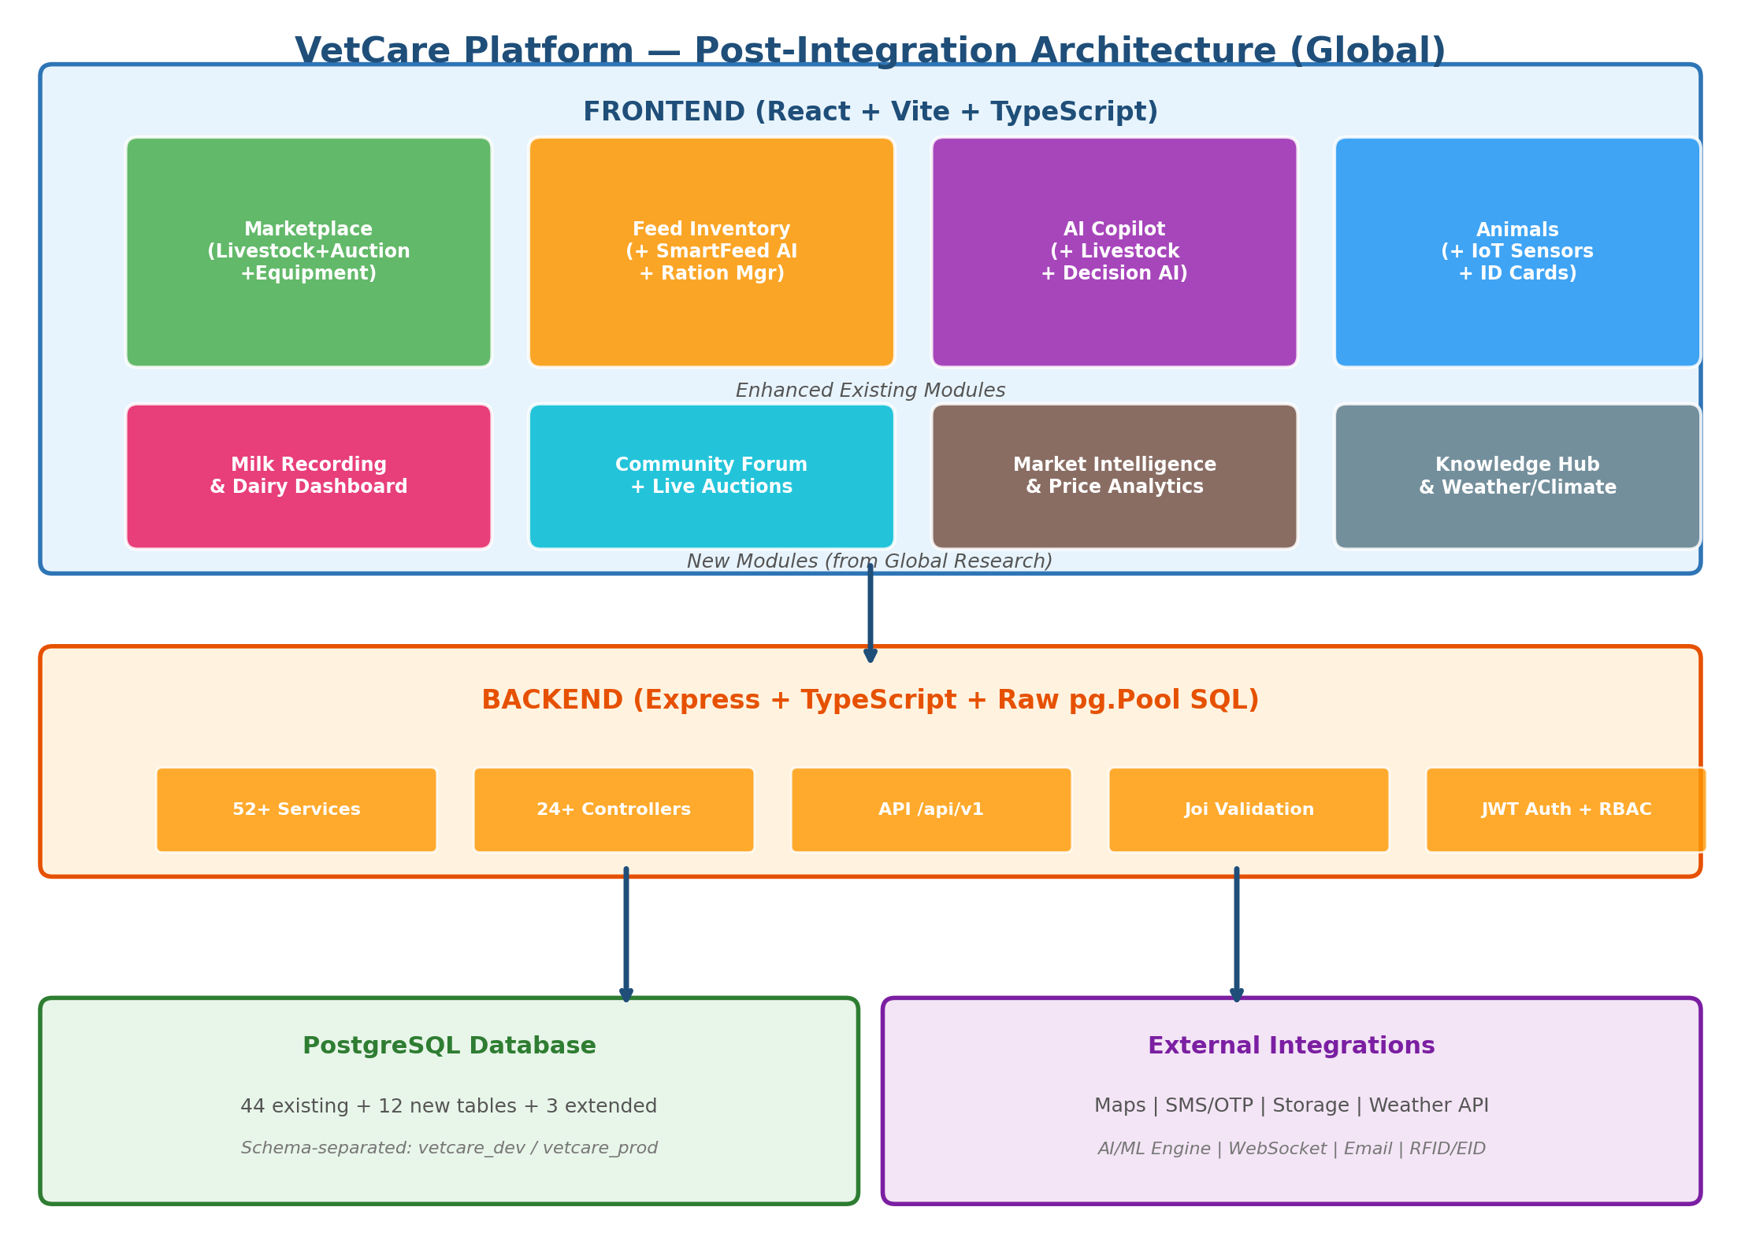

6. New Feature Specifications (from Global Research)
These 10 features are uniquely inspired by global platforms beyond India. Each specification details what the competitor does, how VetCare will implement it, and what innovations VetCare adds that the original platform lacks.

6.1 Live Online Auction System
Source: AuctionsPlus (Australia), StockLive (Australia) | New module
What Competitors Do:
- AuctionsPlus: 497+ live auctions weekly, 24,488 head offered, real-time bidding with "Watch" or "Bid" options
- StockLive: Live video-streamed auctions, remote bidding during physical sales

VetCare Implementation:
Component | Description
Auction Scheduler | Sellers/admins schedule auctions with date, time, lot list, reserve prices
Live Bid Engine | Real-time WebSocket bidding (leverages existing SocketProvider)
Video Stream | Optional live video stream of animals during auction (WebRTC/embed)
Watch Mode | Users can watch auction progress without bidding (builds engagement)
Auction Types | Timed auction (online-only), Live+Online (simulcast), Buy-Now (fixed price)
Post-Sale Settlement | Automated invoicing, payment via Wallet, delivery coordination
Market Indicators | Custom VetCare Cattle Index (like AYCI) based on auction results

VetCare Innovation (Beyond Competitors):
- AI-Verified Animal Data on auction lots (medical records, milk yield, vaccination history auto-attached)
- Video Call with Seller before bidding (not just video stream of sale)
- Multi-language auction interface (5 languages) — AuctionsPlus is English only

6.2 Market Price Intelligence Dashboard
Source: CattleRange (USA), AuctionsPlus AYCI (Australia) | New module
What Competitors Do:
- CattleRange: Daily/weekly market summaries, price indices, USDA monthly reports, regional auction results
- AuctionsPlus: Weekly cattle market reports, value-over-reserve tracking, Young Cattle Indicator (AYCI)
- Agriaffaires: Price Observatory tracking average prices by equipment/category

VetCare Implementation:
- Price Dashboard — Regional average prices by species, breed, age class, weight class
- Price History Charts — Daily/weekly/monthly trend lines, seasonal patterns, YoY comparison
- Market Reports — Auto-generated weekly summaries from VetCare platform transactions + external data
- Cattle Value Calculator — Input: breed, age, weight, lactation, location -> Estimated fair market value
- Price Alerts — Notify farmers when market price for their breed exceeds threshold
- Market Benchmarking — Compare your listing price vs regional average (helps sellers price competitively)

VetCare Innovation:
- AI Price Prediction — ML model predicts price trends based on Season + Breed + Region + Supply data
- Embedded in Listing Flow — When seller creates listing, dashboard shows "Your price is X% above/below market"

6.3 IoT Ear Sensor Monitoring
Source: CowManager (Netherlands), MilkingCloud (Turkey), Allflex SenseHub | Enhancement to IoT Sensors
What Competitors Do:
- CowManager: Ear sensor measures temperature + eating + rumination + activity => 3-day early illness alerts, heat detection, transition monitoring, youngstock monitoring, "Find My Cow", auto-drafting/sorting gates
- MilkingCloud: Mastitis detector (MastiPro), calving sensor (PartuSense), heat detection ear tag (M2Moo), wash quality monitor (WashLog)
- Allflex SenseHub: Cow-Calf, Dairy, Feedlot monitoring with RFID + health alerts

VetCare Implementation:
- Sensor Dashboard — Real-time display of eating, rumination, activity, and temperature per animal
- Health Alert Engine — 3-day early illness warning (rumination decline + temperature spike = flag)
- Heat Detection — Automated fertility alerts with optimal insemination window
- Calving Prediction — Sensor-based calving alert (PartuSense-style) with SMS/push notification
- Mastitis Early Warning — Abnormal milking patterns + temperature = mastitis risk score
- "Find My Cow" — GPS/locator within farm using sensor proximity data
- Transition Monitoring — Track dry period to calving health metrics

VetCare Innovation:
- IoT data feeds into Marketplace listings — Buyer sees "IoT-Verified: Health Score 95/100"
- Disease Prediction AI uses IoT data + regional outbreak data for predictive alerts
- No competitor combines IoT ear sensor data WITH marketplace AND vet consultation in one platform

6.4 Weather & Drought Integration
Source: CattleRange (drought monitor), Farmbrite (climate), AGRIVI (weather stations) | New feature
- Farm Weather Dashboard — Current conditions, 7-day forecast, historical trends for farm location
- Drought Severity Map — Regional drought monitoring with impact on livestock feed availability
- Heat Stress Alerts — When temperature-humidity index exceeds threshold, alert about livestock risk
- Seasonal Feed Planning — Weather forecast integrated with Feed Inventory for proactive procurement
- Satellite Imagery — Pasture health assessment via NDVI (Normalized Difference Vegetation Index)
- Climate Risk Score — Rate farm locations for climate resilience (drought, flood, extreme heat risk)

6.5 Conception-to-Carcass Supply Chain
Source: Breedr (UK/USA) | Enhancement to Supply Chain module
- Lifetime Animal Timeline — Every event from conception to final processing in one view
- Supply Chain Roles — Seedstock > Cow-Calf > Nursery > Feedyard > Packer/Retailer chain
- Cross-Producer Collaboration — Independent producers share data within a supply chain
- Calf Buy-Back Programs — Seedstock sellers offer buy-back agreements to cow-calf operators
- Retained Ownership Models — Track animals through chain while maintaining breeder ownership
- Performance Feedback Loop — Carcass data flows back to breeder for genetic improvement
- Premium Pricing Grids — Data-driven preferential pricing for consistent quality producers
VetCare Innovation:
- Breedr tracks supply chain but has NO vet consultation, NO disease prediction, NO marketplace auction. VetCare combines all.

6.6 Pasture Management & Farm Mapping
Source: Herdwatch (Pasture), Farmbrite (Farm Mapping) | Enhancement to Geospatial
- Interactive Farm Map Builder — Draw paddocks, buildings, water sources, lanes on satellite map
- Grazing Rotation Planner — Track which paddock each group is in, plan rotation schedule
- Fertilizer Application Tracking — Record what, when, how much applied per paddock
- Pasture Task Management — Create tasks for fencing, mowing, spraying with due dates
- Stocking Rate Calculator — Animals per hectare with carrying capacity recommendations

6.7 Livestock Finance Integration
Source: AuctionsPlus StockCo (Australia) | New feature integrated with Marketplace
- Livestock Purchase Financing — Buyer applies for financing during auction/purchase flow
- Trade & Finance Calculator — Estimate repayment schedule, interest, total cost before bidding
- Financing Status Tracking — Dashboard showing active loans, payments due, balance
- Partner Bank Integration — Connect with agricultural lenders/banks for loan processing
- Credit Scoring — Platform activity and transaction history build a livestock credit score

6.8 RFID/EID Tag Integration
Source: Allflex (Global), Herdwatch (EID reader), CowManager | Enhancement to Animals module
- EID Tag Registration — Register RFID/EID tag numbers against animal profiles
- Bluetooth EID Reader Support — Scan tags via smartphone-connected reader
- Batch Scanning — Scan multiple animals for weighing, treatment recording, movement
- Traceability Compliance — Meet national livestock traceability regulatory requirements
- Automatic Animal Lookup — Scan tag -> instant animal profile with full history

6.9 Feed Ration Management (Enhanced)
Source: MilkingCloud (Turkey), Farmbrite (USA) | Enhancement to Feed Inventory
- Dairy Ration Formulation — Create balanced rations for milk production optimization
- Beef Ration Management — Growth-optimized rations for feedlot cattle
- Nutritional Requirements Engine — Species + breed + weight + production stage = daily nutrient targets
- Ingredient Cost Optimizer — Least-cost ration that meets all nutritional requirements
- Ration Templates — Pre-built rations for common breed/stage combinations
- Feed Conversion Ratio Tracking — Measure efficiency (feed consumed vs output produced)

6.10 Farm eCommerce & Direct Sales
Source: Farmbrite (USA) | Enhancement to Marketplace
- Farm Storefront — Each farmer gets a customizable online shop page
- Point-of-Sale (POS) — In-person sales recording at farm gate or market
- Order Management — Multi-channel order aggregation and fulfillment tracking
- Pick & Pack Lists — Automated picklists integrated with inventory
- Subscription Orders — Recurring delivery schedules for dairy products

7. Original 14 Features (from India Research)
These features were identified from the initial research of animall.in and pashushala.com. They remain part of the implementation plan and are detailed in the original analysis. Summary table below:

# | Feature | Source | Priority
1 | Livestock-Specific Listing Cards + Multi-Step Sell Flow | Both | HIGH
2 | Milk Recording & Dairy Dashboard | pashushala | HIGH
3 | Community Forum (Pashu Chat) | animall | HIGH
4 | Smart Feed AI Recommendations | pashushala | MEDIUM
5 | Veterinary Medicine E-Commerce (Upchar) | pashushala | MEDIUM
6 | Farm Equipment E-Commerce (Upkaran) | pashushala + agriaffaires | MEDIUM
7 | Dairy Products Marketplace (Utpad) | pashushala | MEDIUM
8 | Premium / Hot Deal Listings | Both | MEDIUM
9 | Partner & Entrepreneurship Network | pashushala | LOW
10 | Video Knowledge Hub (Tutorials) | animall | LOW
11 | Live Activity Indicators | animall | LOW
12 | Phone OTP Authentication | animall | LOW
13 | Animal ID Card System | pashushala | LOW
14 | Tipping / Platform Support | animall | LOW
Full specifications for these 14 features are in the original analysis document (V1). The combined total is 24 features across both phases of research.

8. Database Schema Additions (Updated)
Updated schema showing 12 new tables and 3 extended tables to support both Indian and global feature sets.
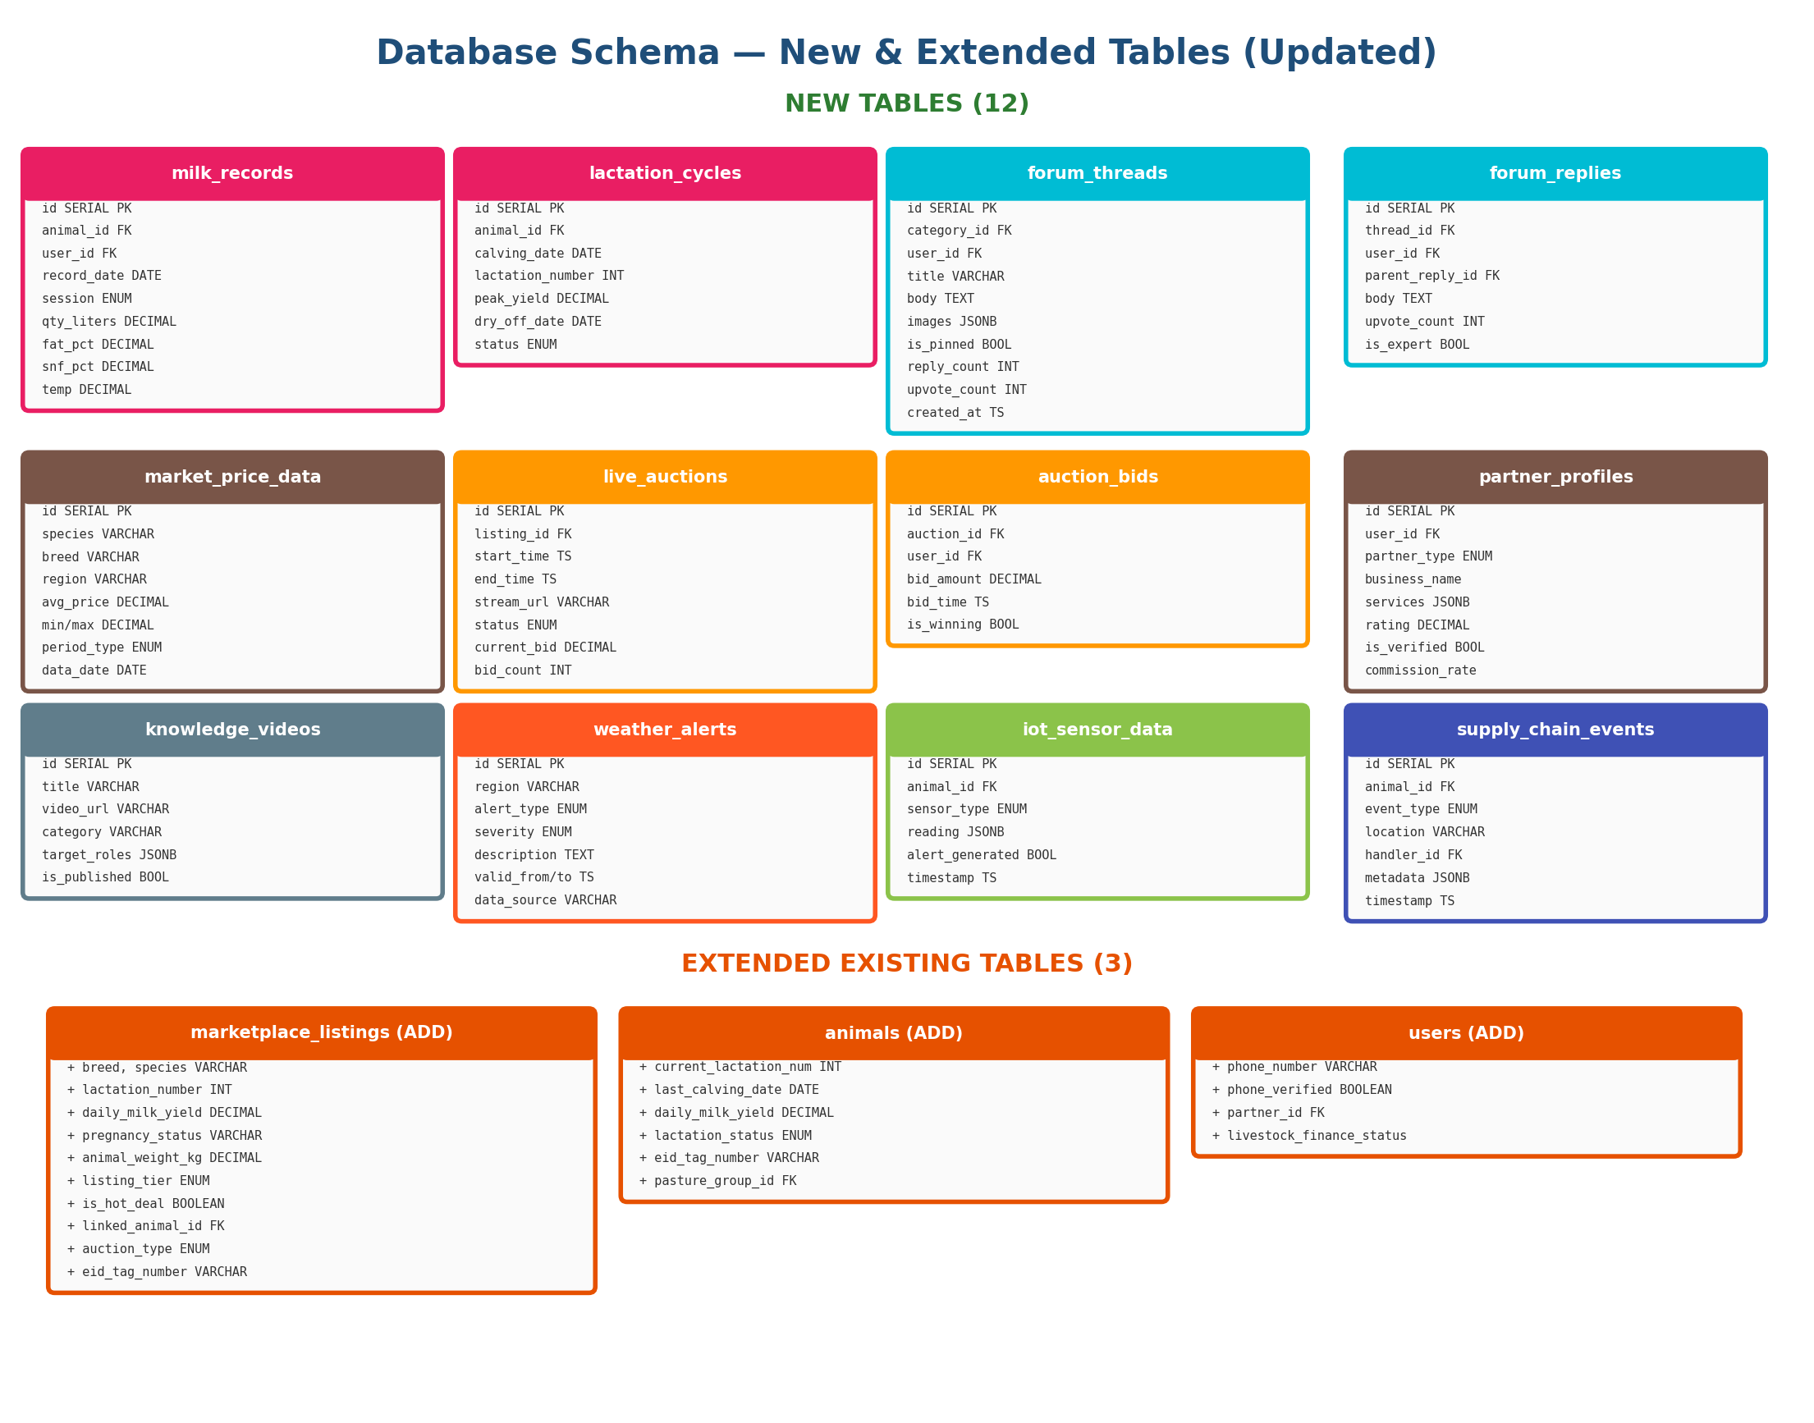

8.1 New Tables Summary (12)
Table | Purpose | Source Feature
milk_records | Per-animal, per-session milk recording | Milk Recording (India)
lactation_cycles | Track lactation lifecycle per animal | Milk Recording (India)
forum_threads | Community discussion threads | Community Forum (India)
forum_replies | Thread replies with nesting | Community Forum (India)
market_price_data | Regional market price intelligence | CattleRange (USA)
live_auctions | Live auction events with streaming | AuctionsPlus (AU)
auction_bids | Real-time bids for live auctions | AuctionsPlus (AU)
partner_profiles | Partner registration and directory | pashushala (India)
knowledge_videos | Video tutorials with categories | animall (India)
weather_alerts | Regional weather and drought alerts | CattleRange/Farmbrite
iot_sensor_data | IoT ear sensor readings and alerts | CowManager (NL)
supply_chain_events | Conception-to-carcass event tracking | Breedr (UK/USA)

9. Permission System Changes (Updated)
Updated permission matrix with 13 new permission keys covering both Indian and global features. All 4 files must be updated in sync per VetCare architecture rules.
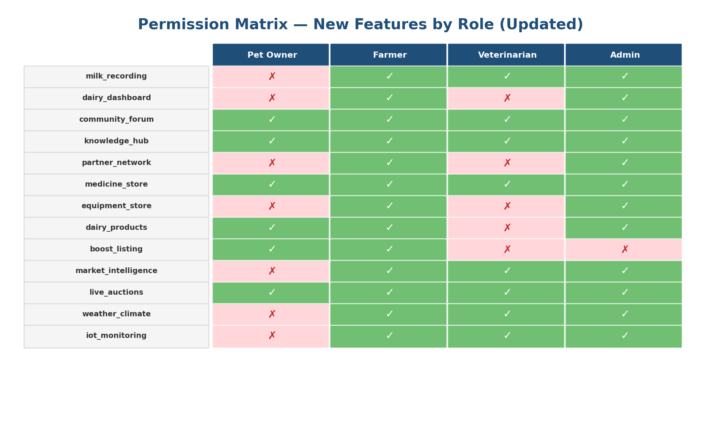

Permission Key | pet_owner | farmer | vet | admin | Source
milk_recording | — | Y | Y | Y | India
dairy_dashboard | — | Y | — | Y | India
community_forum | Y | Y | Y | Y | India
knowledge_hub | Y | Y | Y | Y | India
partner_network | — | Y | — | Y | India
medicine_store | Y | Y | Y | Y | India
equipment_store | — | Y | — | Y | India
dairy_products | Y | Y | — | Y | India
boost_listing | Y | Y | — | — | India
market_intelligence | — | Y | Y | Y | USA/AU
live_auctions | Y | Y | Y | Y | Australia
weather_climate | — | Y | Y | Y | USA/EU
iot_monitoring | — | Y | Y | Y | Netherlands

10. Cross-Module Integration Map
Updated integration map showing the enhanced Marketplace at center with connections to 14 modules including new global features (Market Intelligence, Weather, IoT Sensors, Livestock Finance).
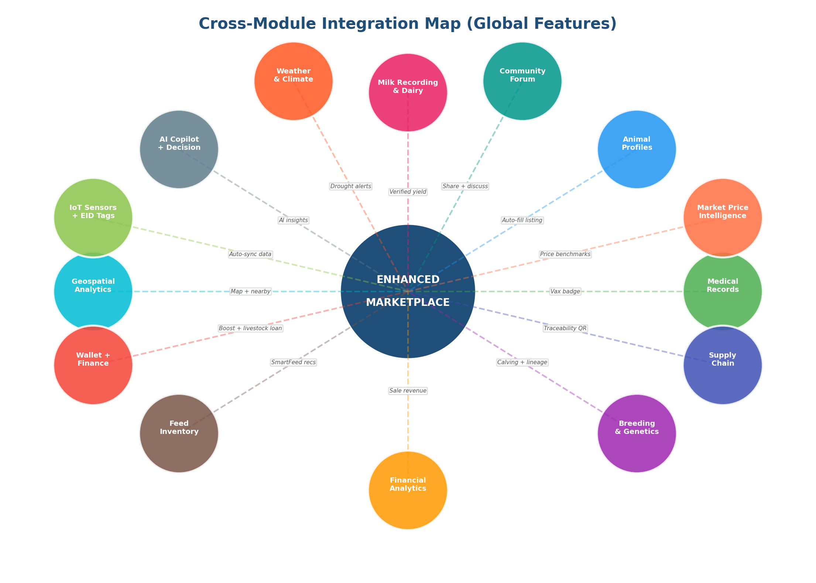

Key Integration Flows (Updated):
- Animal Profile -> Auto-fill listing when marking animal "For Sale"
- Medical Records -> Vaccination badge on listing cards
- Milk Recording -> Verified daily yield on livestock listings (trust signal)
- Breeding Module -> Calving data + genetic lineage visible to buyers
- IoT Ear Sensors -> Real-time health score + "IoT-Verified" badge on listings
- Market Intelligence -> Price benchmark shown during listing creation + buyer comparison
- Weather/Climate -> Drought risk alerts on listings in affected regions
- Supply Chain -> Conception-to-carcass traceability QR on dairy products
- Live Auctions -> WebSocket real-time bidding integrated with marketplace
- Livestock Finance -> "Finance This Purchase" button on auction lots
- Community Forum -> Share listings for visibility + ask community about market prices
- AI Copilot -> Decision support with AI-powered weekly farm summaries
- Wallet -> Boost listing payments + auction escrow + finance repayments

11. Innovation Differentiators (Global)
These 14 innovations make VetCare SIGNIFICANTLY SUPERIOR to ALL global competitors. No single platform worldwide combines all these capabilities.
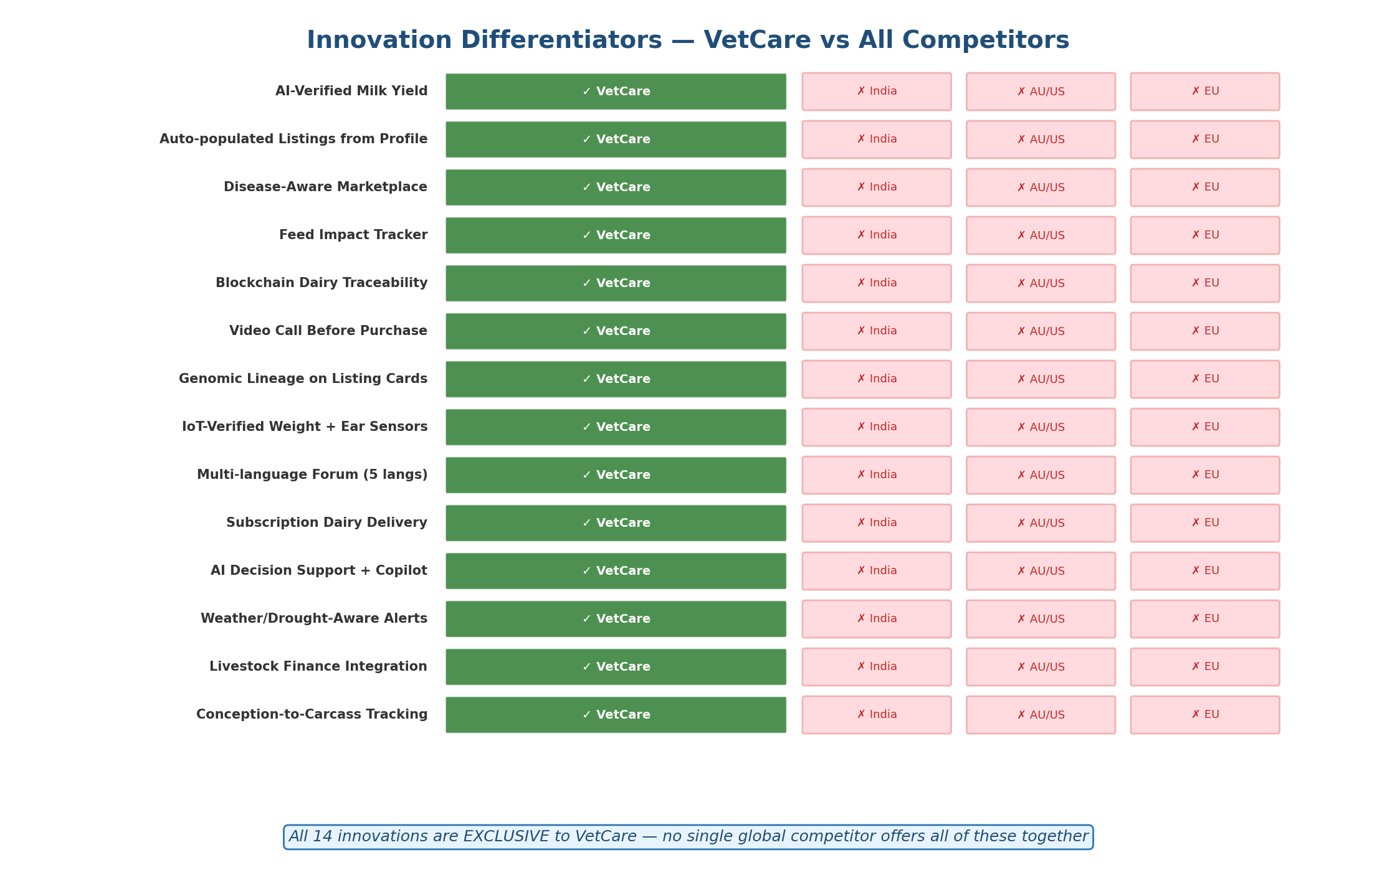

# | Innovation | Why Unique
1 | AI-Verified Milk Yield | ML validates claimed yield vs breed avg. No competitor verifies milk data.
2 | Auto-populated Listings | Seller selects animal -> listing pre-filled from profile + records. All others require manual entry.
3 | Disease-Aware Marketplace | Listings in outbreak zones get warning badges. Zero disease visibility on any competitor.
4 | Feed Impact Tracker | Change feed -> measure milk yield change over time. No feed-milk correlation anywhere.
5 | Blockchain Dairy Traceability | QR on dairy product -> full traceability. Neither India nor AU/US platforms offer this.
6 | Video Call Before Purchase | Buyer video-calls seller to see animal live. Not available on any platform.
7 | Genomic Lineage on Cards | Breeding quality score visible on listing. No genetic data shown on any marketplace.
8 | IoT-Verified Weight + Health | IoT ear sensor health score ON marketplace listing. CowManager monitors but has NO marketplace.
9 | Multi-language Forum | Auto-translate posts across 5 languages. Competitors are single-language only.
10 | Subscription Dairy | Full subscription management for daily delivery. No competitor has this.
11 | AI Decision Support + Copilot | Weekly AI summaries + scenario modeling (like Connecterra) PLUS vet consultation. Unique combo.
12 | Weather/Drought-Aware Alerts | CattleRange has drought map. VetCare integrates it WITH feed planning + listing alerts.
13 | Livestock Finance in Auction | AuctionsPlus has StockCo finance. VetCare adds it WITH AI credit scoring + vet records.
14 | Conception-to-Carcass + Vet | Breedr tracks supply chain. VetCare adds vet consultation + disease prediction at every stage.

12. Implementation Roadmap (5 Phases)
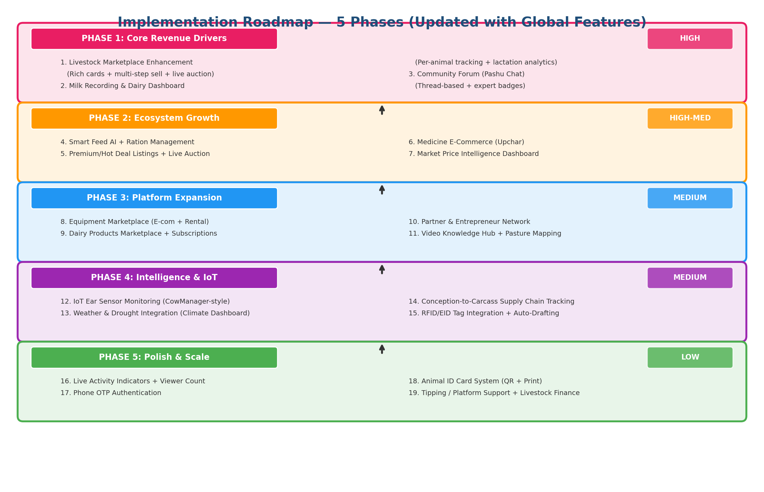

Phase 1 — Core Revenue Drivers (HIGH)
# | Feature | Source | Complexity
1 | Livestock Marketplace Enhancement (rich cards + multi-step + live auction) | India + AU | HIGH
2 | Milk Recording & Dairy Dashboard | India + MilkingCloud | HIGH
3 | Community Forum (Pashu Chat) | India | HIGH

Phase 2 — Ecosystem Growth (HIGH-MEDIUM)
# | Feature | Source | Complexity
4 | Smart Feed AI + Ration Management | India + MilkingCloud | MEDIUM
5 | Premium/Hot Deal + Live Auction System | India + AuctionsPlus | MEDIUM
6 | Medicine E-Commerce (Upchar) | India | MEDIUM
7 | Market Price Intelligence Dashboard | CattleRange + AuctionsPlus | MEDIUM

Phase 3 — Platform Expansion (MEDIUM)
# | Feature | Source | Complexity
8 | Equipment Marketplace (E-commerce + Rental) | India + Agriaffaires | MEDIUM
9 | Dairy Products Marketplace + Subscriptions | India | MEDIUM
10 | Partner & Entrepreneur Network | India | MEDIUM
11 | Video Knowledge Hub + Pasture Management | India + Herdwatch/Farmbrite | LOW-MEDIUM

Phase 4 — Intelligence & IoT (MEDIUM)
# | Feature | Source | Complexity
12 | IoT Ear Sensor Monitoring (CowManager-style) | CowManager (NL) | HIGH
13 | Weather & Drought Integration | CattleRange + Farmbrite | MEDIUM
14 | Conception-to-Carcass Supply Chain | Breedr (UK/USA) | HIGH
15 | RFID/EID Tag Integration + Auto-Drafting | Allflex + Herdwatch | MEDIUM

Phase 5 — Polish & Scale (LOW)
# | Feature | Source | Complexity
16 | Live Activity Indicators + Viewer Count | animall | LOW
17 | Phone OTP Authentication | animall | MEDIUM
18 | Animal ID Card System (QR + Print) | pashushala | LOW
19 | Tipping / Platform Support + Livestock Finance | animall + AuctionsPlus | LOW-MEDIUM

13. Impact Summary

Technical Impact
Metric | Before | After (All Phases)
Frontend Pages | ~50 | ~65
Backend Services | 44 | 52+
Database Tables | ~44 | ~56
API Routes | 55+ | 80+
Permission Keys | ~40 | ~53
Marketplace Categories | 7 | 12+
Nav Menu Items | 48 | 60+
IoT Device Types Supported | 3 | 8+
Languages | 5 | 5 (ahead of all competitors)

Business Impact
- Revenue Streams: Boost listings, marketplace commissions, auction fees, livestock finance commissions, partner commissions, subscription dairy, equipment rental commissions
- User Engagement: Community forum + milk recording create daily login habits; live auctions create event-based engagement
- Trust & Verification: AI-verified milk yield, IoT-verified health scores, vaccination badges, RFID traceability — unprecedented buyer confidence
- Market Intelligence: Price benchmarking helps sellers price competitively and buyers make informed decisions
- Ecosystem Lock-in: 14+ interconnected modules create deep data value impossible to replicate on any single competitor
- Geographic Expansion: 5-language support (EN, HI, TA, TE, KN) means immediate reach across India; global feature set attracts international users

Competitive Advantage Summary
VetCare will be the ONLY platform globally that combines: veterinary consultation, livestock marketplace with live auctions, dairy management, IoT sensor monitoring, AI-powered decision support, market price intelligence, weather/drought integration, conception-to-carcass supply chain, community forum, multi-vertical e-commerce (medicine + equipment + dairy products), livestock finance, and full traceability — all in a single integrated ecosystem with deep cross-module data flow in 5 languages.

No single competitor worldwide comes close to this level of integration:
- animall.in/pashushala.com (India) — Marketplace only, no IoT, no auctions, no weather, single language
- AuctionsPlus (Australia) — Auctions only, no vet consultation, no IoT monitoring, no AI copilot
- CowManager (Netherlands) — IoT only, no marketplace, no community, no auctions
- Breedr (UK/USA) — Supply chain only, no vet consultation, no marketplace, no IoT dashboard
- Farmbrite (USA) — Farm management only, no auctions, no vet consultation, no IoT sensors
- Herdwatch (Ireland) — Herd management only, no marketplace, no AI copilot, no supply chain
- Connecterra (Netherlands) — AI analytics only, no marketplace, no auctions, no e-commerce
- MilkingCloud (Turkey) — Dairy IoT only, no marketplace, no community, no supply chain

--- End of Document ---
VetCare Platform | Global Feature Analysis & Implementation Plan | V2.0 | March 2026

