

*Performance Marketing Software*

***Performance Marketing***

***Solution Right for You***

Adrack

# Every Lead. Every Channel. Every Opportunity

Adrack is the latest in SaaS innovation that supports the complete management of your entire affiliate network from a single platform. Optimize your campaigns with an eye on revenue and efficiency targets for affiliate traffic, leads, and the analytics you need to verify each result.

Experience a system created specifically for lead buyers, affiliate networks, advertisers and agencies to track, understand, and automate their marketing activities in real time, for tangible results.

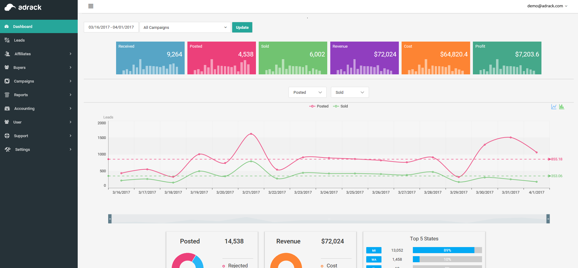

# Ensure ROI on Every Lead

Marketers just like you need a solution that makes it easy to understand every aspect of each conversion your network generates. Knowledge allows you to focus on the affiliates, campaigns, and channels that provide the greatest value.

Give yourself the knowledge and tools to create and use that intelligence for optimal marketing efforts, affiliate payments, lead management, and to generate greater sales. Adrack helps you do all that and more all in one place.

Through an intuitive cloud dashboard, you’ll be able to automate your entire lead generation process and network. Manage it on your schedule and adjust as often as you’d like with the latest real-time data capture on campaign success and spend, lead generation and verification, affiliate and lead scoring, buyer data, and overall performance.

Adrack goes beyond what’s possible to make it easy for you to generate high-quality leads, maximize your monetization efforts, and build better, more lucrative relationships with your affiliates and lead buyers.

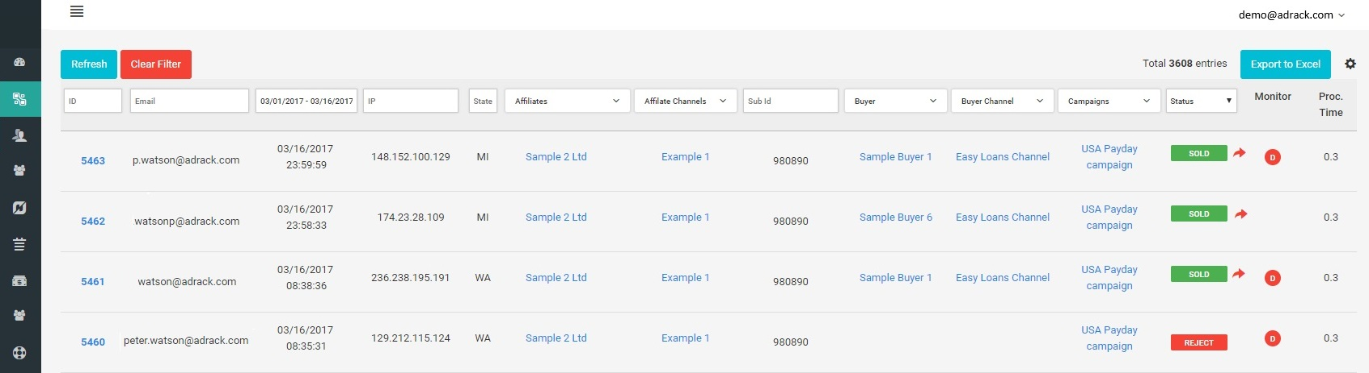

# Adrack Core Capabilities

* Manage your entire affiliate network in one place
* Create, manage, and optimize multiple campaigns with unlimited filtering options
* Control each channel and activity based on real-time analytics
* Monitor, verify, and prioritize affiliates and affiliate traffic with support for any location, device, or browser
* Validate and distribute leads, delivering them to buyers in a proven ping tree model
* Optimize buyer channels with complex rules and filters
* Integrate with all of your lead buyers — no advanced programming know-how required
* Customized, integrated form builder that supports all browsers and screens
* Refine targeting with geolocation and other data to generate and verify profitable, trackable clicks

# Here’s What Sets Adrack Apart From The Rest

* Granular controls through tracking the real-time location, device information, and browser usage with traffic caps and redirection.
* Detailed reports and tools for an in-depth look at every element of your campaign.
* Quick dashboards to show you exactly how your campaigns and affiliates are performing.
* Set and easily adjust prices per buyer channel with CPA, CPC, CPM and RevShare models
* API development for simple integration with systems and business partners.
* Only buy leads that match your specific criteria thanks to leading, advanced filters from detailed location, age, marital status and other demographic information.

We empower you to automate interactions with a wide range of lead generation tools so that you can work directly with your lead buyers and partners exactly how you want. Adrack gives you the tools and controls you need to build better campaigns and optimize your lead distribution.

It’s time to maximize profitability for you and your partners.

# Accounting Made Easy: Always Understand Your Business at a Glance

One of your biggest challenges is organizing your costs and making sure your accounting is keeping up with the flurry of activity your network generates each day. Adrack helps with a complete accounting dashboard and leading tools designed to make it simple to:

* Create and comprehend Buyer Invoices
* Generate and manage Buyers Payments
* Manage Affiliate Invoices and process Payments
* Track and approve Refunds plus see lifetime refunds per partner
* Visualize real-time Balance Reports from Affiliates *and* Buyers
* Capture and edit information on any member of your network
* Make sure payments adhere to permissions you’ve given each partner
* Generate reports on company performance each day, week, month, quarter and more

Take full control of your accounts to see all the revenue flowing through your network and optimize payments, commissions, and profit tiers. We back every element by lead and activity verification, so you’re protecting your affiliate program against fraudulent activity and transactions.

Adrack provides peace of mind so you can focus on creating consistent revenue and building a profitable platform for every partner. Understand your opportunities, costs, growth potential, and always know what incentives or rewards you can provide to top affiliates and boost your revenues.

# Adrack Doesn’t Just Solve Problems. We Create Solutions for Better Networks

We built Adrack with your network in mind. Our goal is to deliver the easiest platform on the market for managing leads through your entire acquisition and sales cycle. We make it easy for you, your affiliates, and your buyers to have visibility into every aspect of the network, without giving up control or sacrificing your ability to generate revenue. Try a free demo to see what benefits Adrack provides and the problems we solve.

**Focus on You**

Adrack allows you to address the biggest challenge of affiliate marketing: why should a partner join **your** network?

We give you a platform that makes it easy to onboard affiliates, track and optimize the traffic, manage digital campaigns, and control your affiliate and buyer channels in a single platform. Adrack makes the business of running your affiliate network simple so you and your team can work to create the best products, services, and affiliate advantages.

Simplify, serve, and succeed when you choose a platform that lets you focus on growing your network.

**Understand Your Market**

Your market is among the most complex facing marketers today because you need to balance leads, network partners, buyers, and people who move between categories. Adrack prevents this intricacy from overwhelming your staff by making it easy to visualize each segment, see where they intersect, and optimize interactions with a focus on revenue generation.

**Know Where Your Leads Are Coming From**

Lead quality matters. Ensure you always understand where your leads originate and verify their demographic information to give you complete control over the leads you purchase and use.

**Control Enforceable Marketing Restrictions**

Keep your budget on track and adjust your spend in each channel and with each partner in real-time so you can make the most out of the leads that are working best for your network right now. You control every budget and aspect of your network, helping you focus on what matters most to your business.

**Generate Knowledge in Real-Time**

Give your affiliates all the support they need and give yourself an on-going understanding of your business at a moment’s notice. With Adrack’s real-time visibility into buyer balances, network activity, and traffic analytics you can know your best-performing affiliates, referral services, and channels to optimize your spend and rewards.

**Support Any Device or Browser**

Your leads aren’t sticking to one device, so your campaign shouldn’t either. Adrack allows you to build campaigns and work with media buyers and lead buyers across any channel or traffic source. And, we’ll help you understand how your targeting is performing, so you optimize metrics and goals on each channel to reach high-quality options and top conversion rates.

**Target, Execute, and Perform on Different Goals**

Give each affiliate group the benefits and advantages they need to boost their goals and yours. Prioritize sales and reach among small and large affiliates with tools and customizable options that allow each to scale and address their own audiences. Help your affiliates scale and grow, so they continue to provide qualified leads and desirable traffic that boosts your revenue.

**Fill Demand Intelligently**

Route leads using the smartest technology and analytics available to fill demand across all lead buyers while providing exactly what they need. Manage prospects, payments, and lines of credit all while providing buyers with the portal and tools required to keep their business running.

**Make Every Lead Count**

You need a platform that’s smart enough to track and predict existing purchase behaviors to quantify the value of your leads. Adrack goes past this with analysis and visualization across verticals to help you know the value of your current inventory, understand lead criteria to target next, and build out a high-quality private exchange.

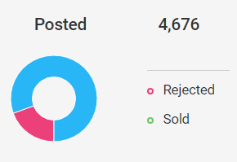 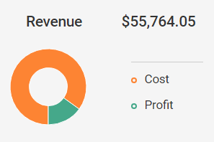 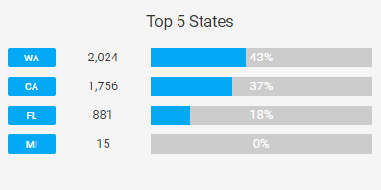

# Lead Distribution Elevated

Adrack provides a sophisticated cloud platform that makes it easy to run a profitable affiliate network. Understand everything from your best lead generation channels and most effective campaigns to overall digital marketing spending and profit relative to buyers, affiliates, and lead demographics in one core system.

Not only can you gain insight into what channels and practices are driving traffic that your buyers desire, but you’ll see exactly where you need to invest to generate even more lucrative leads and partnerships. Adrack is your best SaaS option to maximize your lead monetization and get you the pricing you deserve for your network’s success.

When you’re ready to experience the benefits of a comprehensive platform that makes it easy to secure the traffic that’s most lucrative for your affiliate network, Adrack is here for you.

You can request a free demo on <http://adrack.com>

Contact us at [admin@adrack.com](mailto:admin@adrack.com)

1111 N. Brand Blvd., Suite 401, Glendale, CA 91202