**How to do phishing attack**

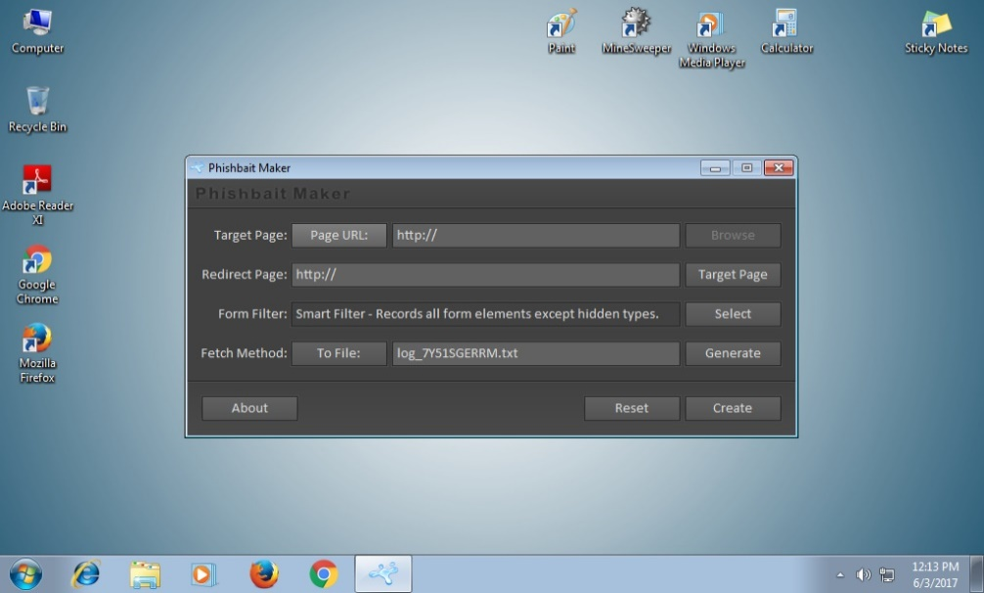Step 1: First of all, you have to download and install two software XAMPP and PBMKR (Phis bait Maker) from Internet.



Step 2: After installing software’s now go to any website which you want use for phishing (see Figure 1).

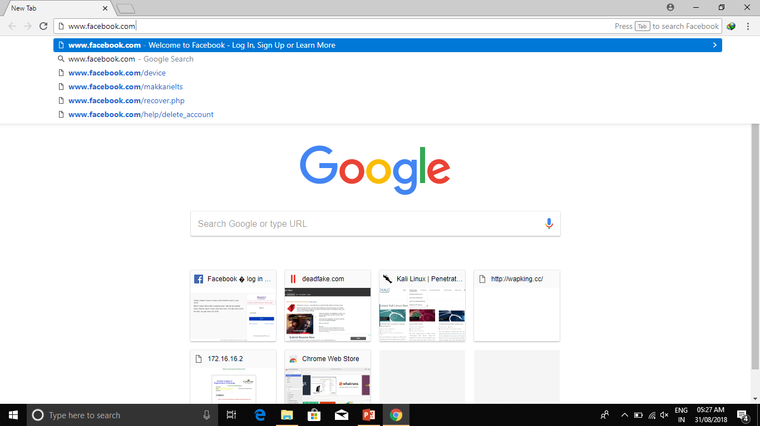

Figure 1

Step 2: Now after opening website right click on anywhere and open “Resource” (see Figure 2).

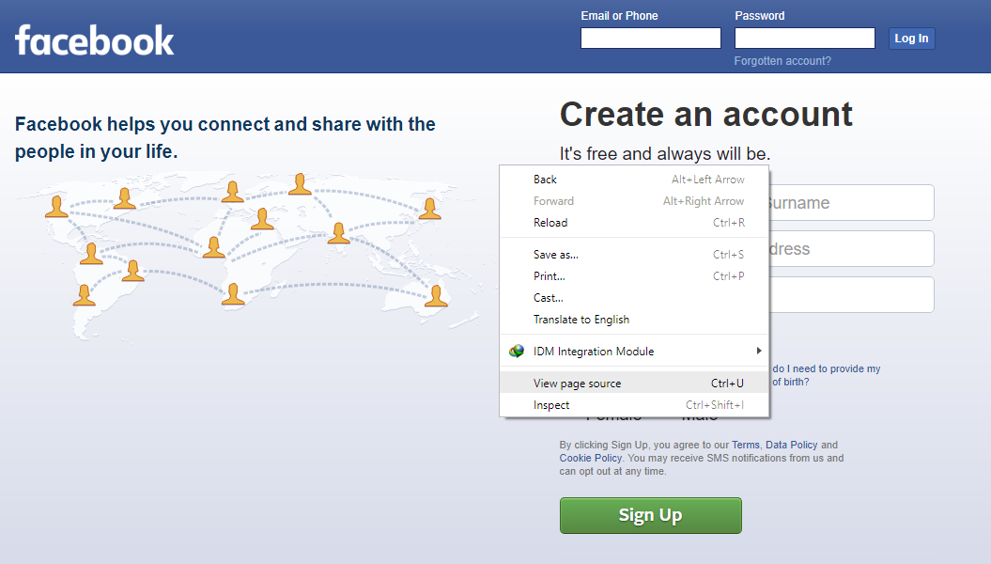

Figure 2.

Step 3: When a long resource sheet opens just copy all the script and paste it on your system by making a new notepad file and save that file with the extension of .html (see Figure 3.1, 3.2, 3.3).

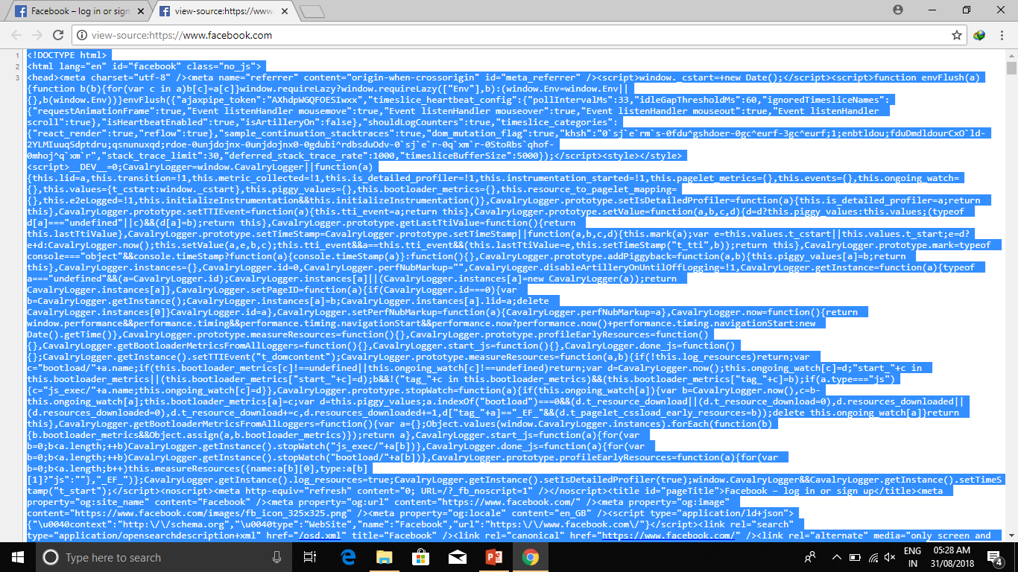

Figure 3.1

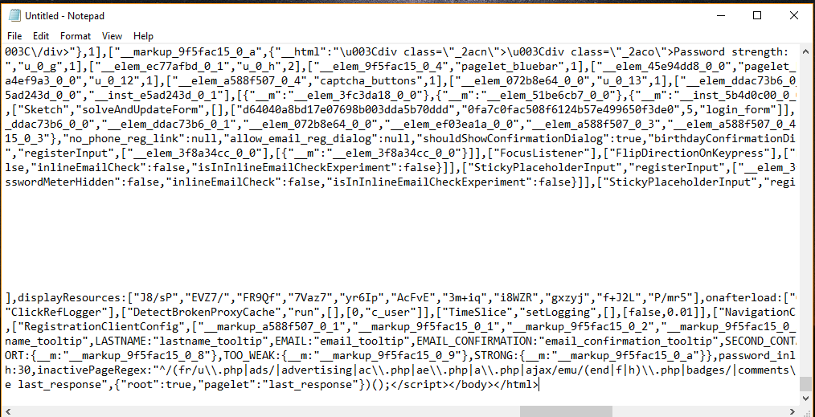

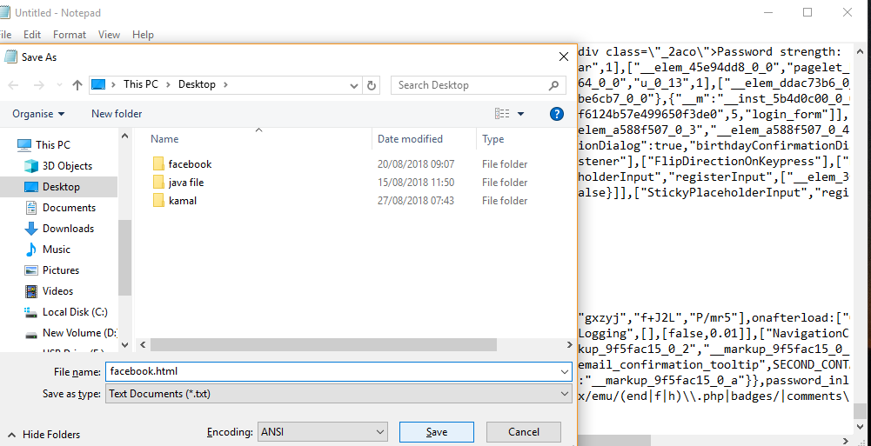Figure 3.2

Figure 3.3

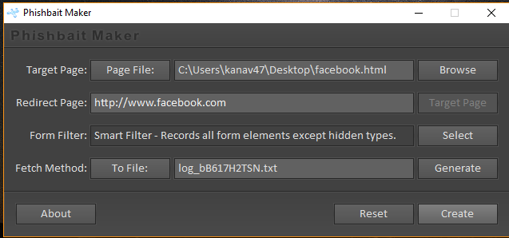Step 4: After this open PBMKR software now browse your html file and in next tab select any website to redirect your target. In third tab choose log file and then click on create. Now you can see a PHP file is created on your system this is a phishing page (see Figure 4.1 and 4.2).

Figure 4.2

Step 5: Now after creating a. PHP page now go to to location where xampp is located (see Figure 5).

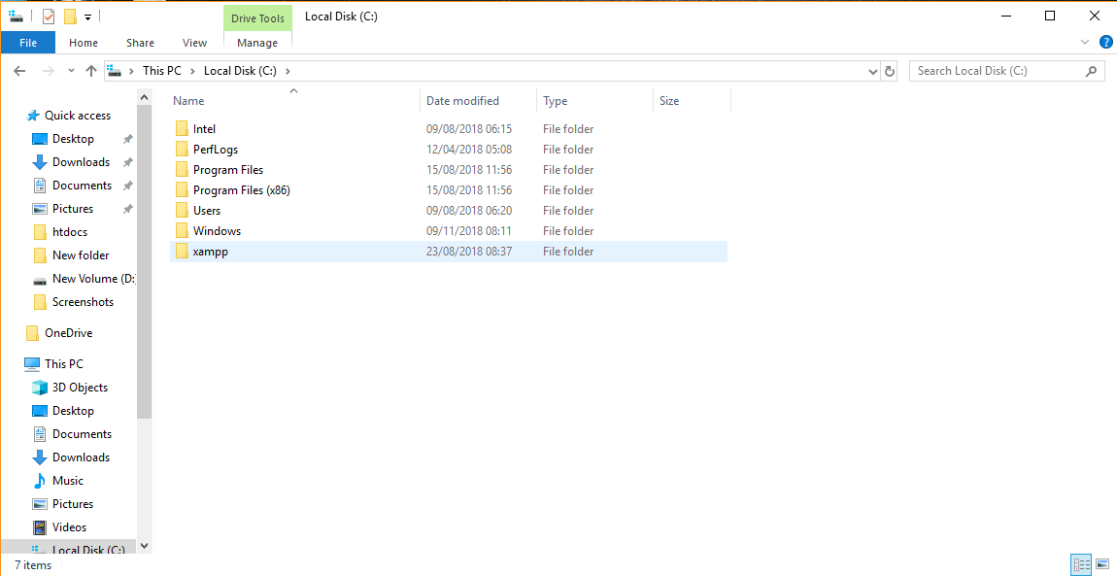

Figure 5.

Step 6: And now search for “htdocs” folder (see Figure 6).

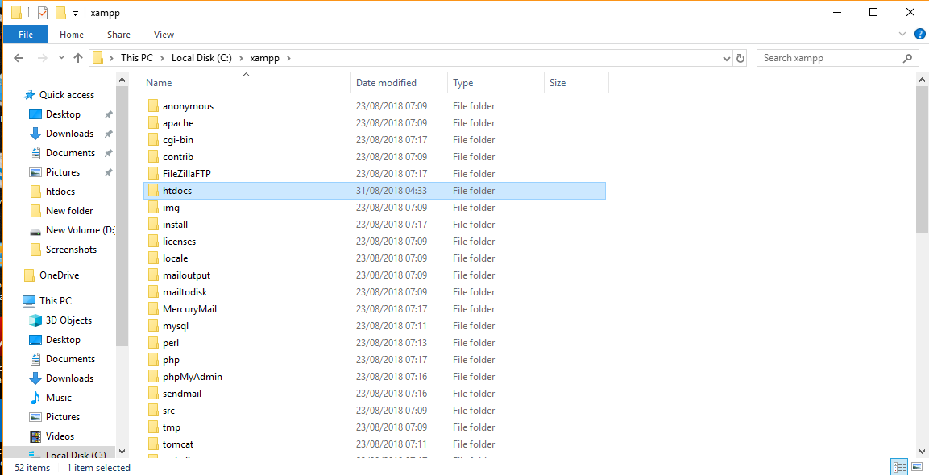

Figure 6.

Step 7: Copy your PHP file and paste it into htdocs folder. Copy your php file and paste it into htdocs folder (see Figure 7.1 and 7.2).

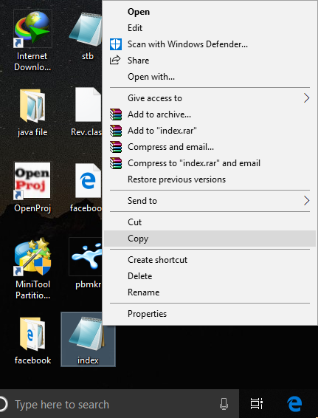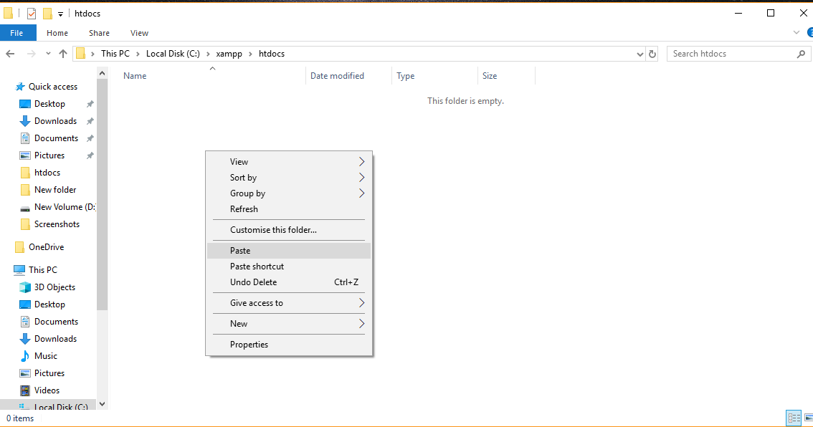

Figure 7.1 Figure 7.2

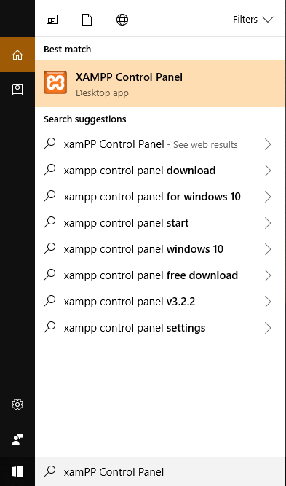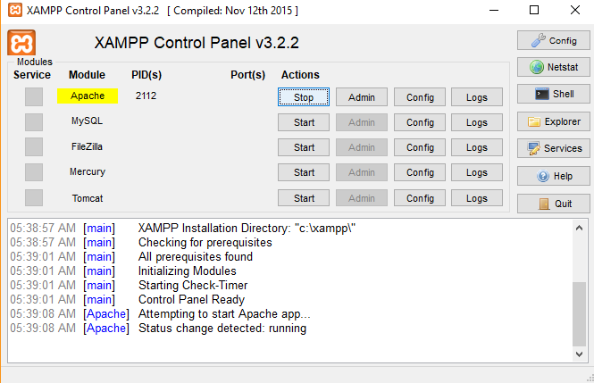Step 8: Now open xampp and start the service of apache by clicking on start. After starting now open any browser a type “localhost” (see Figure 8.1 and 8.2).

Figure 8.1 Figure 8.2

Step 9: Now you can see same to same like original your phishing page is open now open. Just enter your details. And then click on login (see Figure 9).

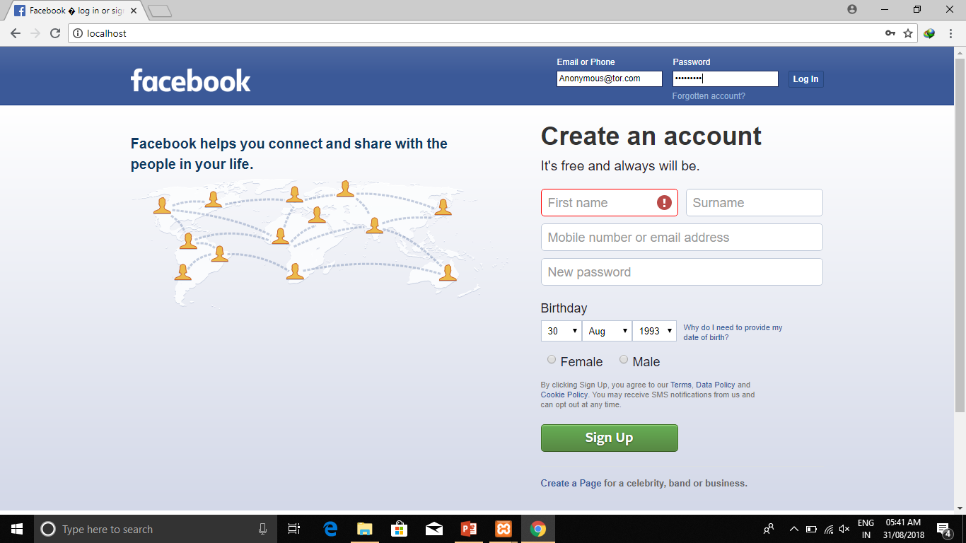Figure 9

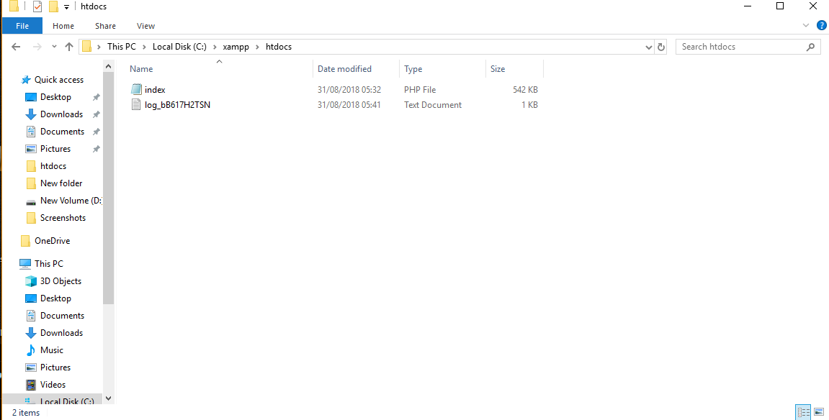Step 10: Now open that file and now you can see all the data which you enter (see Figure 10.1, 10.2).

Figure 10.1

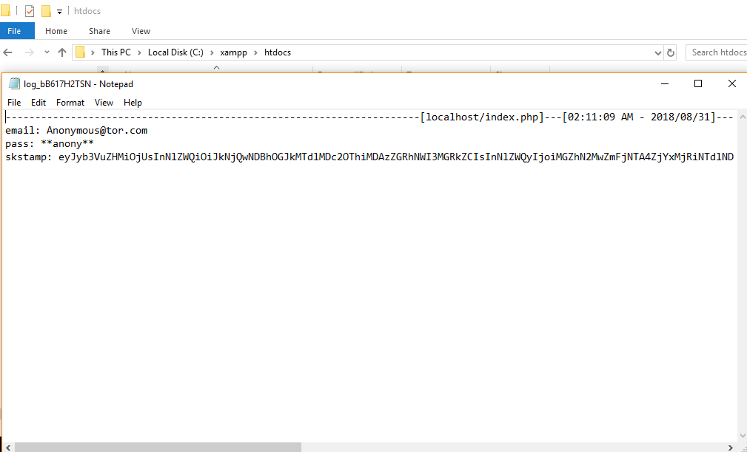

Figure 10.2