**Eqra Tech IP Camera**

**Software installation steps for Ubuntu**

1- Open your terminal

2- Execute this command to install requirement and run the program

$ cd ~ && sudo apt-get update && sudo apt-get install wget && wget -O - https://hafiz.s3.amazonaws.com/demo/hikvision/ubuntu.setup.sh | bash

Press ‘Enter’ if this message appears



Press ‘Enter’ if this message appears

  
  
3- Execute this command to run the program

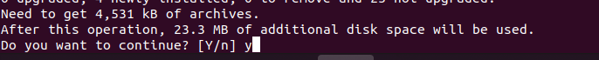  
$ cd ~/EqraTech-IPCam

$ sh ubuntu.run.sh