**Eqra Tech IP Camera**

**Software installation steps for Windows**

**1- Download main folder using by any browser available on your device for PC or LP**

**https://hafiz.s3.amazonaws.com/demo/hikvision/EqraTech-IPCam.zip**

**2- Please Extract to ‘EqraTech-IPCam’ zip file and move it on the Desktop Directory as ‘EqraTech-IPCam’ Folder**

**3- Install Microsoft Visual C++ 2015**

* Go to ‘{{yourDesktop}}/EqraTech-IPCam/Setup/Windows’
* Double click on ‘Microsoft Visual C++ 2015-64bit.exe’ or ‘Microsoft Visual C++ 2015-32bit.exe’

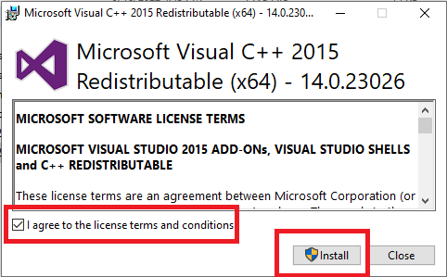

**4- Install python version 3.7.2 (you need internet access)**

* Go to ‘{{yourDesktop}}/**EqraTech-IPCam/Setup/Windows**’
* Double click on ‘python-3.7.2.exe’
  + inside setup file
* Activate the following option
  + 'Install launcher for all users'
  + 'Add Python 3.7 to Path'

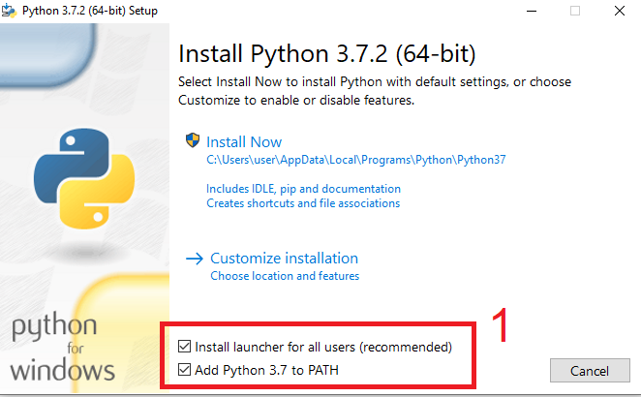

* press on ‘Install Now’

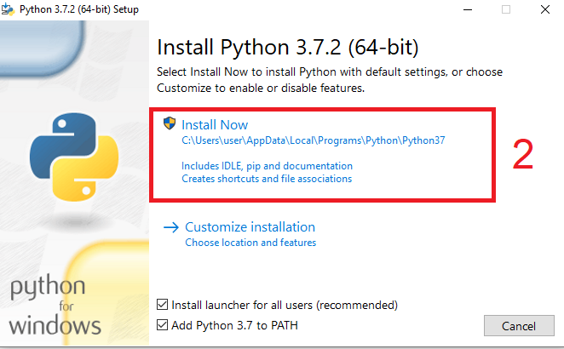

* Wait for the installation to finish

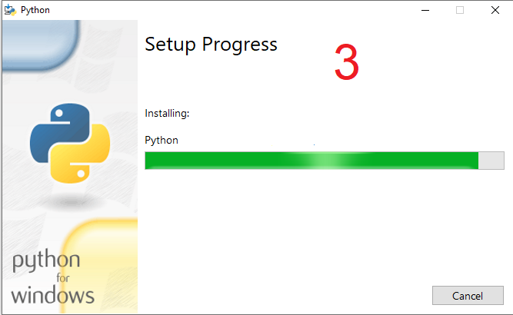

* When the installation is finished, press ‘Close’

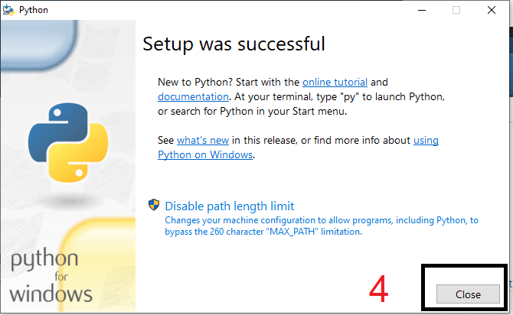

**5- Install Python Extra packages (you need internet access)**

* Go to ‘{{yourDesktop}}/**EqraTech-IPCam/Setup/Windows**’
* Double click on ‘pip.python.bat’
* Wait for the installation to finish
  + It might take 30 minutes

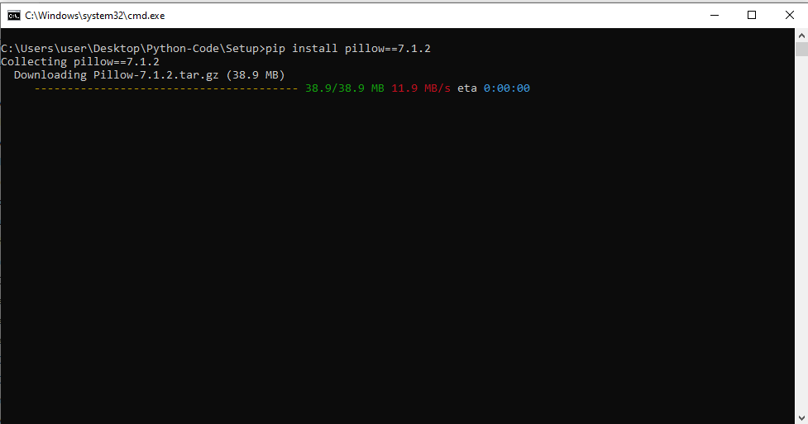

**6- Run the program**

* Go to ‘{{yourDesktop}}/EqraTech-IPCam/’
* Double click on ‘windows.run.bat’