**Overview**

LowesYang edited this page on 2 Nov, 2017 · [12 revisions](https://github.com/polaris-gslb/polaris-gslb/wiki/Overview/_history)

**Pages 5**



• [Home](https://github.com/polaris-gslb/polaris-gslb/wiki)

• • [Building packages from source.](https://github.com/polaris-gslb/polaris-gslb/wiki/Building-packages-from-source.)

• • [Installation](https://github.com/polaris-gslb/polaris-gslb/wiki/Installation)

• • [LB configuration](https://github.com/polaris-gslb/polaris-gslb/wiki/LB-configuration)

* •

[Overview](https://github.com/polaris-gslb/polaris-gslb/wiki/Overview)

[Add a custom sidebar](https://github.com/polaris-gslb/polaris-gslb/wiki/_new?wiki%5Bname%5D=_Sidebar)

**Clone this wiki locally**



The solution is implemented in a form of PowerDNS Authoritative Server enhancement and consists of:

1. Polaris health - takes in a configuration dictionary specifying pools of backend servers, associated health checks etc., builds a health state table, iterates over it periodically and issues health probes that get processed asynchronously by a pool of workers. State information is propagated into a shared memory(memcache). Runs as a daemon.
2. Polaris PDNS - PowerDNS Remote Backend JSON-API plugin, performs DNS query distribution according to the health state(sync-ed periodically from memcache) and the load balancing algorithm selected.

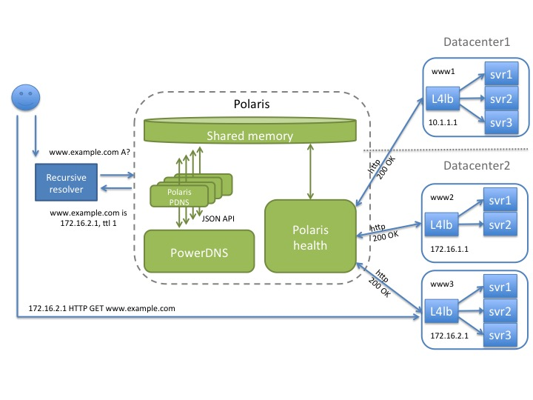

Configuration example:

polaris-lb.yaml

pools:

www-example:

monitor: http

monitor_params:

use_ssl: true

hostname: www.example.com

url_path: /healthcheck?check_all=true

lb_method: twrr

fallback: any

members:

- ip: 10.1.1.1

name: www1-dc1

weight: 3

- ip: 172.16.1.1

name: www2-dc2

weight: 2

- ip: 172.16.1.2

name: www3-dc2

weight: 3

globalnames:

www.example.com:

pool: www-example

ttl: 1

polaris-topology.yaml

datacenter1:

- 10.1.1.0/24

datacenter2:

- 172.16.0.0/16

Updating the configuration(involves the Polaris health restart) does not impact the front-end DNS resolution and is seamless to the clients.