1. **Description and Feature of the Game**

Flappy Fish is a mono game developed by Hyerim Kim. The goal of this game is to controller Fish not to touch any sharks. If you reach 400 m, you can move to level 2 where you can see the faster sharks with different background. After your fish dies, you can save your name and score into text file so when you go to the HighSocre Menu, You can see your name and score if you are in top 10 !

1. **Class Diagram**

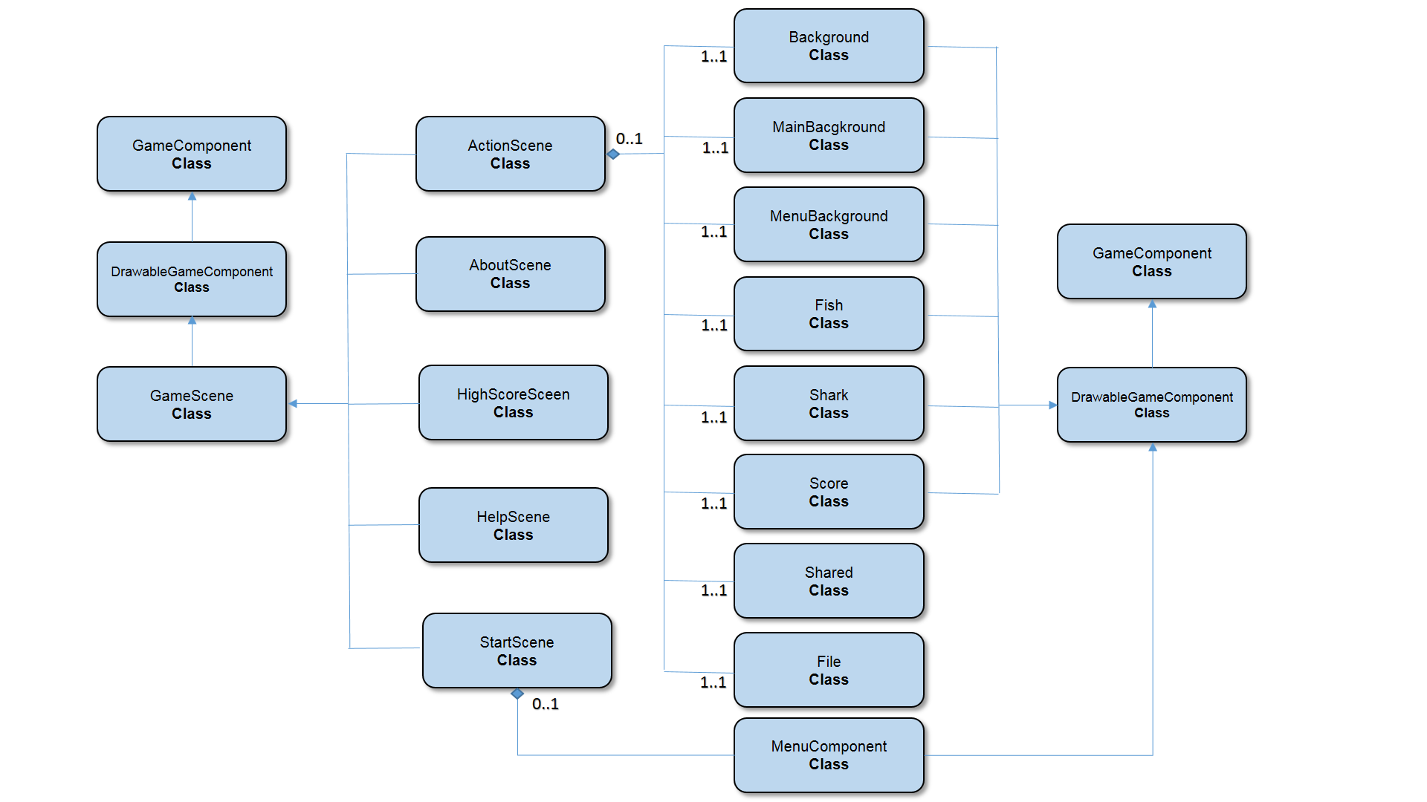

1. **References**
2. Reference for main Menu Component :

→ <https://conestoga.desire2learn.com/d2l/le/content/166182/viewContent/3768922/View>

1. Reference for how to draw sharks in different timing :

→ <https://www.youtube.com/watch?v=_TlnUM-uhSI>