Portfolio Site Plan

Robert Vaile

WDD 130

Overview

Purpose
To educate others on my work

Audience
Everyone that is interested in my work

Branding

Website Logo


Style Guide

Color Palette
Lighter | Light | Dark | Darker
#fbf5ef | #f2d3ab | #494d7e | #272744

Typography

Heading Font: Share Tech

Paragraph Font: Sans-serif

Navigation
Home Page2 Page3

Instructions

For images please just use stock tech images this is a portfolio site so I just want the images to be future projects so please just use a place holder(s)

Within the Wire Frames there is a home page and 2 portfolio pages (hopefully 3 in the future) the portfolio pages are pretty much identical

Within the Wire frame there are 3 Links and the names are Link 1: Web Development, Link 2: Programs, and Link 3: Art projects (don’t do the page for this one because you only need to make 3 for the project)

Wireframes
Below Pages V

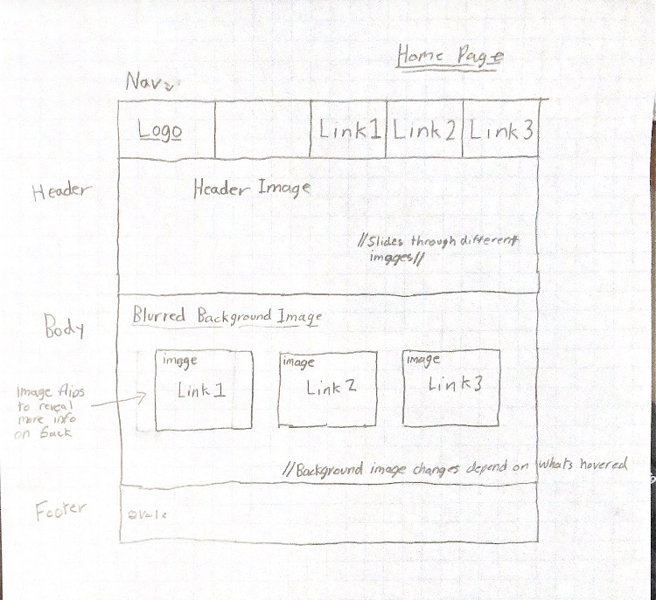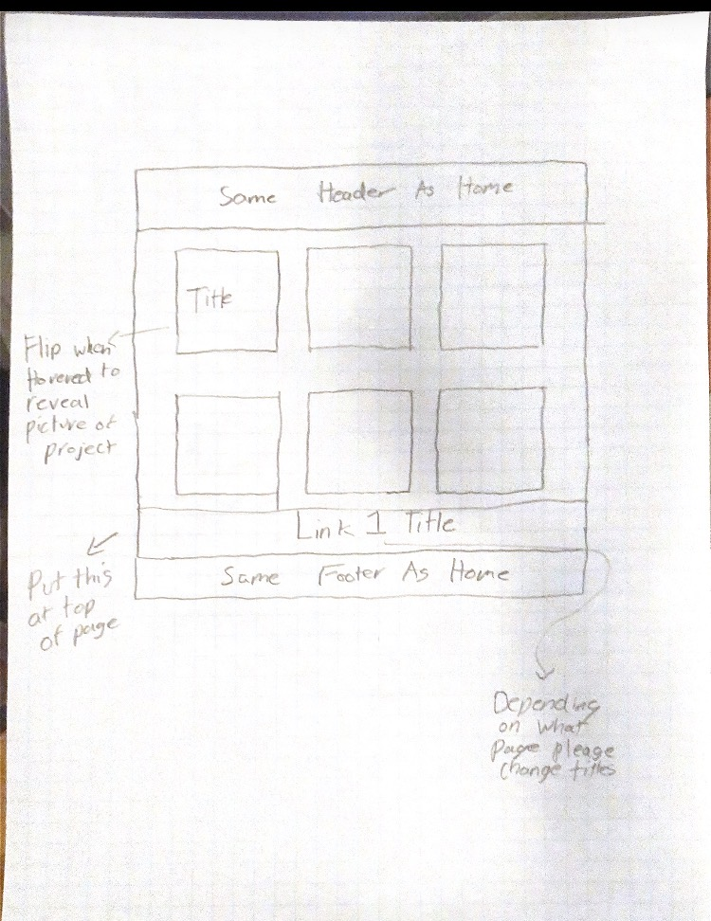
2 of these with slight differences in the title

