Introductory Networking THM

OSI Model

OSI: Conceptual framework used to describe the functions of a networking system.

OSI Layers: Application, Presentation, Session, Transport, Network, Data Link, Physical

7. Application:

Provides networking options to programs on computer and gives interface for them to use to be able to transmit data.

6. Presentation:

Receives data from application layer and translates the data into a standardized format, handling any transformations to the data.

5. Session:

Receives data from presentation layer, looks for connection with other computer, and maintains it, as well as co-operate with session layer of remote computer to synchronize communications.

4. Transport:

Chooses protocol the data will be transmitted by (i.e TCP and UDP are common ones. TCP: transmission is connection-based, UDP is the opposite. TCP: favors accuracy, UDP: favors speed). Divides transmission into bite-sized pieces.

3. Network:

Responsible for locating destination of your request. Finds best route to take. Logical addressing.

2. Data Link:

Focuses on physical addressing of the transmission. Receives packet from network layer and adds in physical address of receiving endpoint. Checks received info to make sure it hasn’t been corrupted during transmission.

1. Physical:

Converts binary data of transmission into signals and transmit them across the network and receives incoming signals and converts them back into binary.

TCP/IP Model

Four Layers: Application, Transport, Internet, and Network Interface

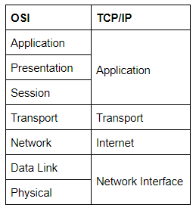

TCP/IP:

Transmission Control Protocol controls the flow of data between two endpoints.

Internet Protocol controls how packets are address and sent.

TCP: connection-based protocol. First must have stable connection.

Three-way handshake: process of forming this connection. Your computer first sends special request, containing a SYN (synchronize) bit, to remote server to say it wants a connection. SYN bit makes first contact. Next, server responds with packet containing SYN bit and ACK (acknowledgement) bit. Lastly, your computer sends packet with ACK bit only, confirming successful connection.

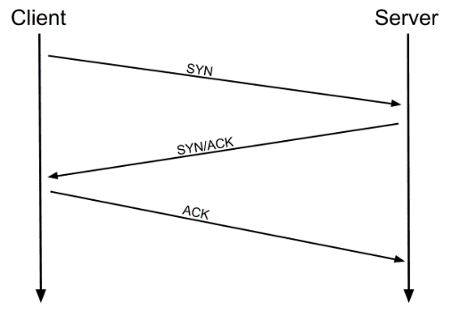

Three-way handshake must be carried out before connection can be established using TCP.

Networking Tools

-Ping:

Ping is used to test for a connection with a remote resource.

Pinging Google -- it is possible

This pings google’s site and returns it’s IP address.

-Traceroute: maps the path your request takes to its target machine.

-WHOIS: Allows you to query who a domain name is registered to.

A domain translates into an IP address so we don’t need to remember it.

-Dig: allows us to manually query recursive DNS servers of our choice for information about domains:

dig <domain> @<dns-server-ip>

DNS (Domain Name System) converts a URL into an IP address.

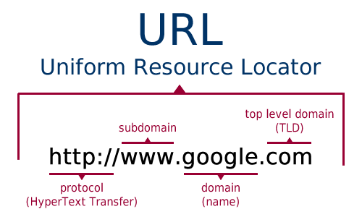

Top-Level Domain (TLD) servers are split up into extensions.

TLD servers keep track of the next level down: Authoritative name servers.

Authoritative name servers are used to store DNS records for domains directly.

The TTL (Time To Live) of the record tells your computer when to stop considering the record as being valid -- i.e. when it should request the data again, rather than relying on the cached copy.