# Question 2

## Part A

* The neural network has 5 layers with 8, 8, 8, 8, 2 neurons each. A RELU activation function is used in the hidden layers and SoftMax in the output layer.
* Weights are initialized from a uniform distribution in the range [-2, 2].
* Stopping criteria is 40,000 epochs or an accuracy of 0.92

The data can be plotted like this.

The results are as follows.

**The model trains to a loss of 0.22 and accuracy of 0.94**

**The predictions are plotted below and look fairly similar to the original classification.**

**Decision boundary**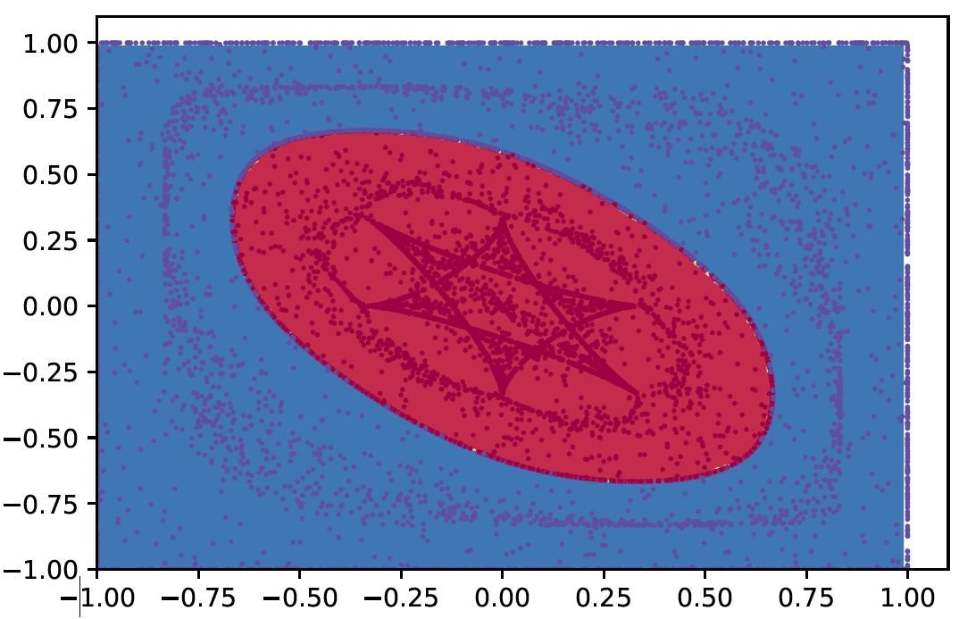

## Part B

* The neural network has 6 layers with 15, 15, 15, 15, 15 and 2 neurons each. A RELU activation function is used in the hidden layers and SoftMax in the output layer.
* Weights are initialized from a uniform distribution in the range [-2, 2].
* Stopping criteria is 20,000 epochs or an accuracy of 0.97

The data can be plotted like this.

The results are as follows.

**The model trains to a loss of 0.19 and accuracy of 0.91**

**The predictions are plotted below and look fairly similar to the original classification.**

**Decision boundary**

