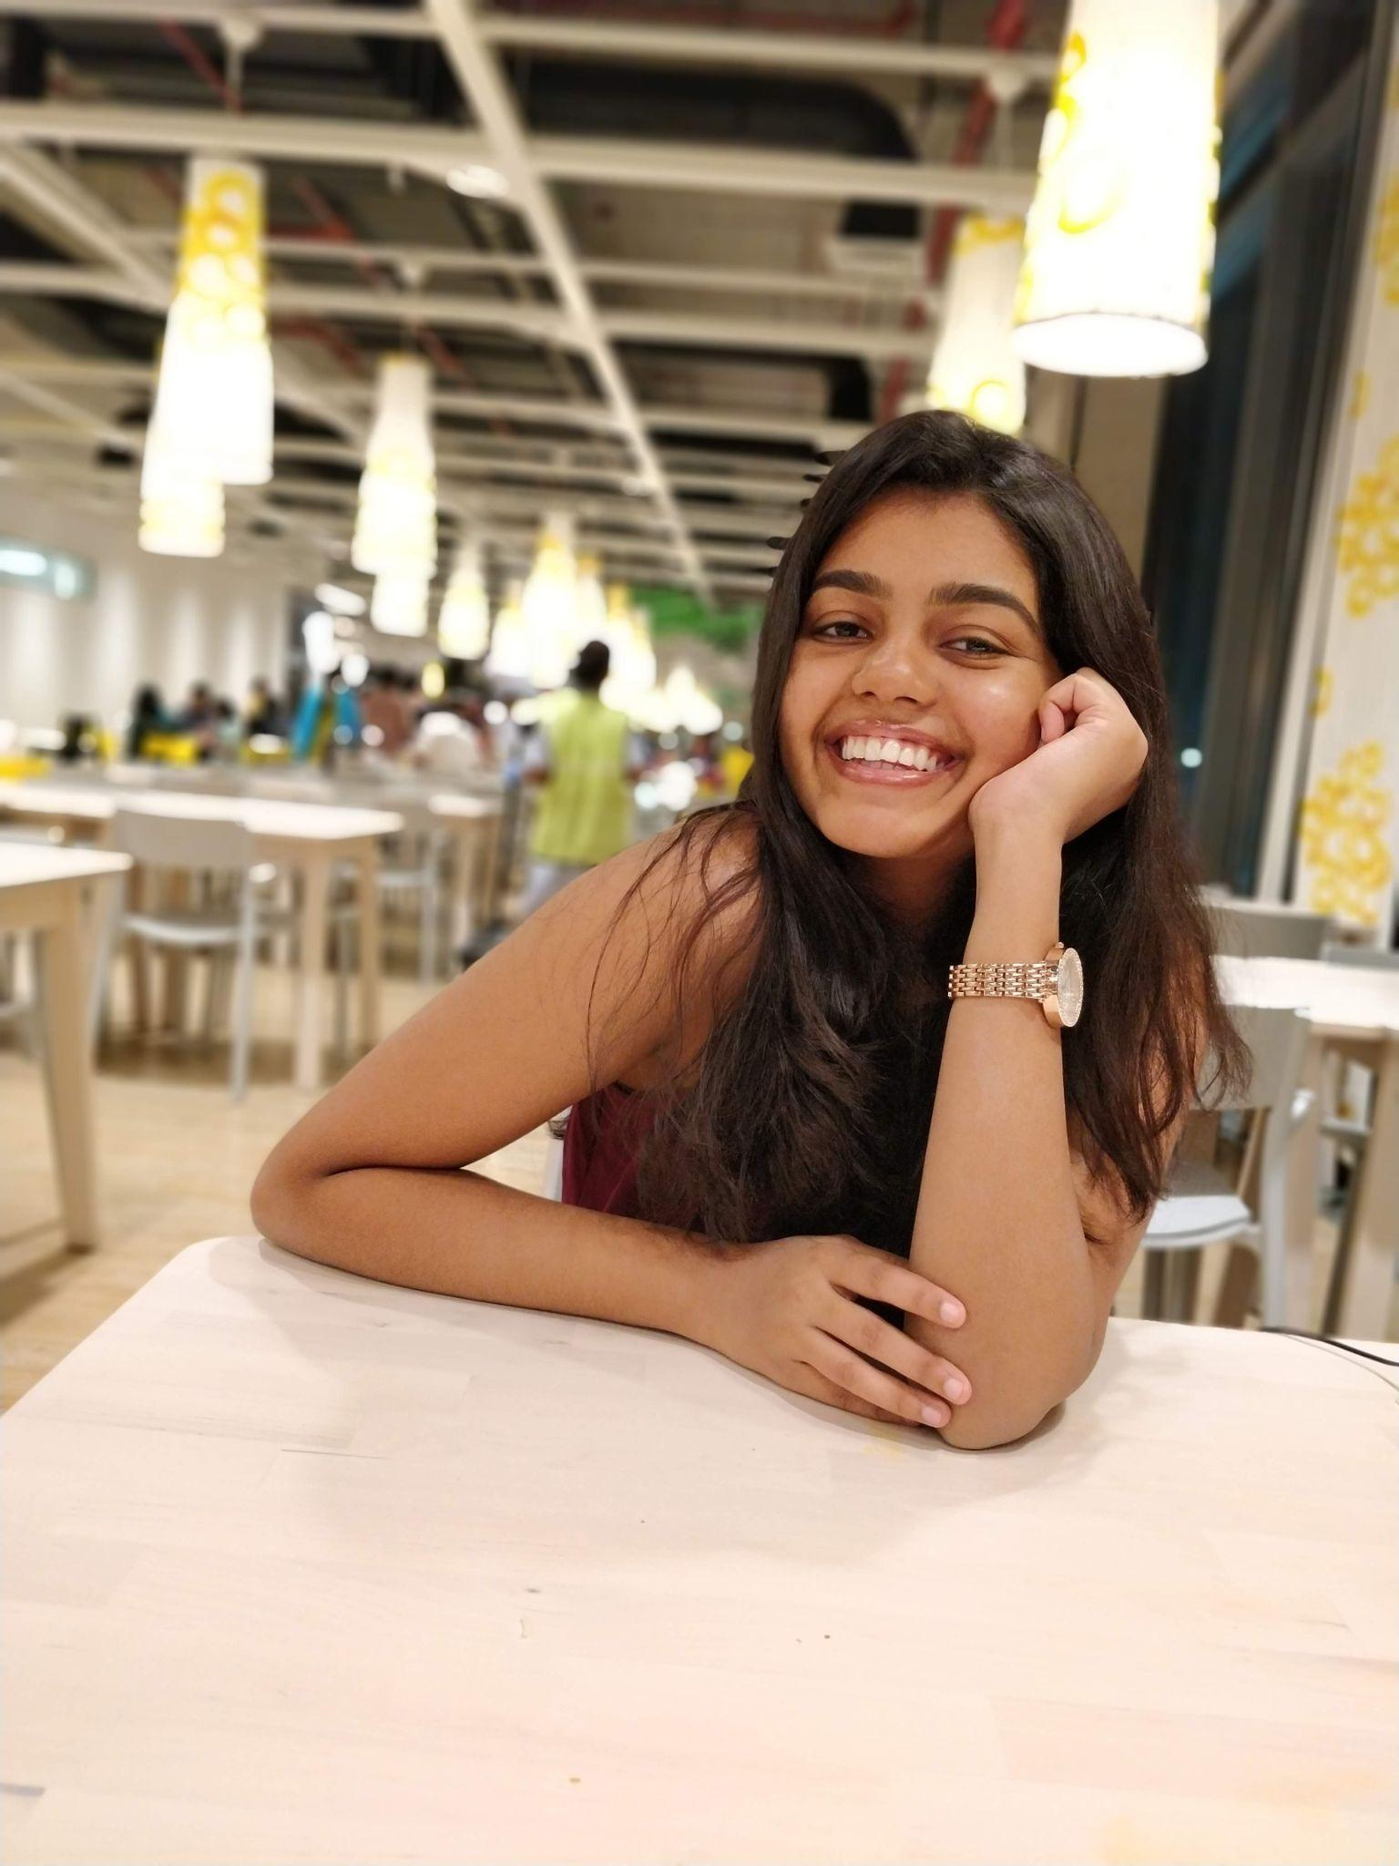

e-mail address: hailey.thanki99@gmail.com

Hi! I’m Hailey. I am from India. I am pursuing a Masters in Data Science. I am very interested in Behavioural Data Science currently. I’m really looking forward to exploring new topics in this course and meeting you all! Really excited to be here! :D