Cross entropy



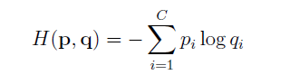

Voi pi la xac suat du doan va qi la gia tri trong tap du lieu traning.

So sanh giua ham entropy (mau xanh) va binh phuong khoang cach (mau do)

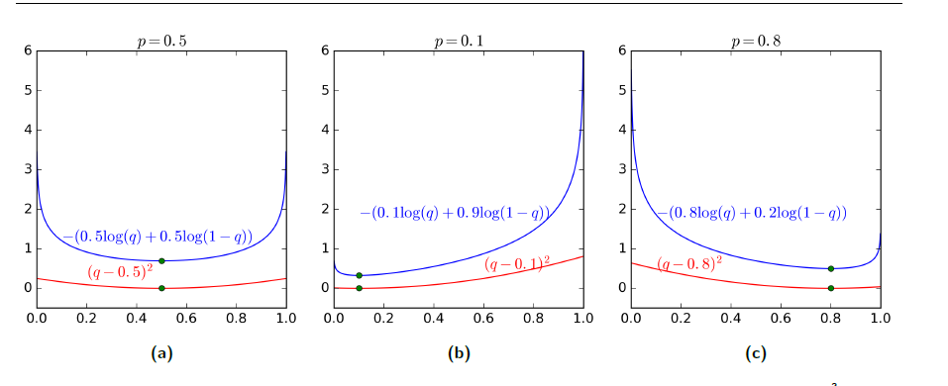

Xet hinh (b): N = 2, truc hoanh la p, ta co:

* p1 = 0.1, p2 = 0.9
* q1 = p, q2 = 1 – p

ta thay ro do lon ham loi se bang 0 neu pi = qi. Tuy nhien do doc cua ham Entropy lon hon khi gia tri cua pi cach xa gia tri cua qi va do do neu su dung gradient descent thi ham **Entropy se tien dan ve diem cuc tieu nhanh hon.**