Compilers [Fall 2011]
Practice Test I

NAME: ______________________________________________

Instructions:

1) This test is 7 pages in length.

2) You have 75 minutes to complete and turn in this test.

3) Short answer questions include a guideline for how many sentences to write. Respond in complete English sentences.

4) This test is closed books, notes, papers, friends, neighbors, etc.

5) Use the backs of pages in this test packet for scratch work. If you write more than a final answer in the area next to a question, circle your final answer.

6) Write and sign the following: “I pledge my Honor that I have not cheated, and will not cheat, on this test.”

_______________________________________________________________________

_______________________________________________________________________

Signed: ______________________________________________
1. [5 points]
What is a compiler? [1 sentence]

2. [5 points]
What is lex (or flex)? [1-3 sentences]

3. [5 points]
Java (unlike DJ) has separate types for booleans and ints, so expressions like true==1 are not allowed. Also, Java allows the expression 1==0==false==true but does not allow the expression true==false==0==1. Is the == operator in Java left-associative, right-associative, or non-associative?

4. [5 points]
Draw a diagram showing all the major phases of a standard compiler and the result of each phase.

5. [25 points]
Consider the following NFA N over alphabet {x}.
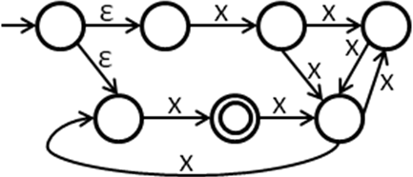

a) Draw a DFA that is equivalent to N.

b) Write a regular expression that matches exactly the same set of strings that N accepts. Keep your response simple enough that it cannot be simplified in any significant ways.

6. [55 points]
Consider the following CFG G: 0 S -> L$
1 L -> TLT
2 L -> ε
3 T -> x

a) Write a regular expression that matches exactly those strings that are derivable from S, or briefly explain why no such regular expression exists.

b) Is G ambiguous? If so, prove it.

G is: 0 S -> L$
1 L -> TLT
2 L -> ε
3 T -> x

c) Draw an LL(1) parse table for G. It will have at least one conflict.

d) Rewrite G into an equivalent grammar G’ that is in LL(1). Draw the LL(1) parse table for G’.

G is: 0 S -> L$
1 L -> TLT
2 L -> ε
3 T -> x
e) G is not in LR(1). Rewrite G into an equivalent grammar G’’ that is in LR(0). Draw the LR(0) parse table for G’’.

f) Draw the SLR parse table for your grammar G’’ from Part (f) above.
Undergraduates stop here. The remaining problem is for graduate students only.

7. [25 points]
Consider the following context-free grammar C:

0 S -> E$
1 E -> Ex
2 E -> 0

Draw an LALR(1) parse table for C.

