Programming Languages [Fall 2010]
Test I

NAME: ______________________________________________________

Instructions:

1) This test is 9 pages in length.

2) You have 75 minutes to complete and turn in this test.

3) Short-answer questions include a guideline for how many sentences to write. Respond in complete English sentences.

4) This test is closed books, notes, papers, friends, neighbors, etc.

5) Use the backs of pages in this test packet for scratch work. If you write more than a final answer in the area next to a question, circle your final answer.

6) Write and sign the following: “I pledge my Honor that I have not cheated, and will not cheat, on this test.”

_______________________________________________________________________

_______________________________________________________________________

Signed: ______________________________________________
1. [4 points]
What are first-class functions? [1-2 sentences]

2. [7 points]
a) Provide an example of an ML program that violates the value restriction.

b) Rewrite your example from Part (a) into an equivalent program that does not violate the value restriction.

3. [16 points]
Recall from Assignment 1 that we can represent two-variable polynomials having integer coefficients as int list lists. For example, the list:
[[1], [0,~2,0,0,3], [], [], [], [], [~5,0,7]]
represents the polynomial:
1 - 2xy + 3x⁴y - 5y⁶ + 7x²y⁶.

Also, recall the function smult2, which multiplies a 2-variable polynomial by an integer scalar. For example, smult2([[1],[0,~2,0,0,3],[],[],[],[],[~5,0,7]], 4) returns the value [[4],[0,~8,0,0,12],[],[],[],[],[~20,0,28]].

a) Implement smult2 without using any built-in functions (and without implementing your own versions of built-in functions). As always, keep your solution simple and in good ML style (using appropriate ML syntax).

b) Complete the following one-line, alternative implementation of smult2.

fun smult2(L,c)=map(map

4. [8 points]
Consider the following let-expression E.

let
val y = 2
val y = y+1
fun f(x) = y + 3 + x
fun g(y) = f(4)
val y = 6
in
g(y+1)
end

a) To what value does E evaluate, assuming dynamic scoping?

b) To what value does E evaluate, assuming lexical scoping?

5. [8 points]
a) Complete the following implementation of function f, which is a one-line function that returns the same list it receives as an argument.

fun f L=foldl

b) Complete function g to make it also return the same list it receives as an argument.

fun g L=foldr
6. [15 points]
a) Using a built-in fold function, implement in ML a function called count, which counts the number of elements in an option list that match a given value. For example:

- count [SOME 3, NONE, SOME 4, SOME 3] 3;
val it = 2 : int
- count [NONE, SOME true, SOME true] false;
val it = 0 : int

b) What is the type of count?

c) What is the type of the expression count [SOME([(#"4",())])] ?

7. [12 points]
Consider a new function fold2l that works just like foldl but folds through two equal-length lists simultaneously.

For example:
- fold2l (fn(x,y,z)=>print(x^y)) () ["1","2","3"] ["4","5","6"];
142536val it = () : unit
- fold2l (fn(x,y,z)=>z+2) 0 ["1","2","3"] [(),(),()];
val it = 6 : int

When the lists passed to fold2l have unequal lengths, we do not care how fold2l behaves.

a) What is the type of fold2l?

b) Implement fold2l in ML, without using any built-in functions (e.g., foldl).

8. [30 points]
Consider the following deductive system for adding natural numbers.
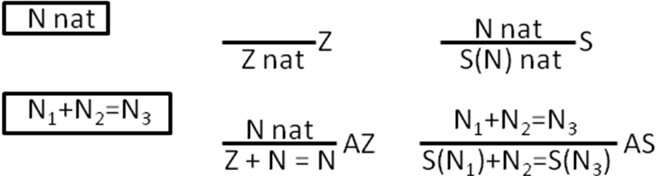

Prove that addition is commutative.
Theorem. For all N₁, N₂, and N₃: if N₁ + N₂ = N₃ then N₂ + N₁ = N₃.

Hint 1: You may need to state and prove some “helper” lemmas. For example, I found it useful to prove, as a helper lemma, that for all natural numbers N, N + Z = N.

Hint 2: Partial credit is possible; if you get stuck at some point, please explain informally whatever ideas you’re having trouble stating formally.

Two pages of work space are available after this one.

[Undergraduates stop here. The following question is only for graduate students.]

9. [12 points]
Re-implement smult2 so that it uses two (built-in) fold functions to accomplish its task.

fun smult2(L,c)=

