## USER INTERFACE DESIGN

### LOGIN SCREEN

#### Screen Images

#### Objects and Actions

##### Data fields - Login screen

|  |  |  |  |  |  |  |
| --- | --- | --- | --- | --- | --- | --- |
| **Field No** | **Field name** | **Type** | **Mandatory** | **Data type** | **Max length** | **Description** |
| 1 | Username | Textbox | Y | String |  | Contain user name to login |
| 2 | Password | Password | Y | String |  | Contain password to login |

##### Actions – Register screen

|  |  |  |  |  |  |
| --- | --- | --- | --- | --- | --- |
| **Field No** | **Field name** | **Type** | **Action** | **Description** | **Validation** |
| 3 | Login | Button | On click | Send inputted username and password to server |  |
| 4 | Forget password | Link | On click | Forward to Forget Password Screen |  |
| 5 | Signup | Link | On click | Forward to Register Screen |  |

### REGISTER SCREEN

#### Screen Images

#### Objects and Actions

##### Data fields - Register screen

|  |  |  |  |  |  |  |
| --- | --- | --- | --- | --- | --- | --- |
| **Field No** | **Field name** | **Type** | **Mandatory** | **Data type** | **Max length** | **Description** |
| 1 | Username | Textbox | Y | String | 20 | Contain user name to register |
| 3 | Email Address | Textbox | Y | String | 50 | Contain email address to register |
| 4 | Password | Textbox | Y | String | 50 | Contain password to register |
| 5 | Confirm Password | Textbox | Y | String | 50 | Contain the confirm password |
| 6 | First name | Textbox | N | String | 25 | Contain user's first name |
| 7 | Last name | Textbox | N | String | 25 | Contain user's last name |
| 8 | Birthday | Textbox | N | Date |  | Contain user's birth day |
| 9 | Language | DDL | N | String |  | Contain user's selected language |
| 10 | Level | DDL | N | String |  | Contain user's selected level |

##### Actions – Register screen

|  |  |  |  |  |  |
| --- | --- | --- | --- | --- | --- |
| **Field No** | **Field name** | **Type** | **Action** | **Description** | **Validation** |
| 2 | Check available | Button | On click | Check if selected user name is available. If not, request user to select a new one |  |
| 5 | Confirm Password | Textbox | On leave | Check the inputted value | Must matched with the inputted password |
| 11 | Signup | Button | On click | Submit inputted data to server | Inputted data must be valid |
| 12 | Cancel | Button | On click | Cancel the registration. Back to previous page |  |
| 13 | *Already have an account? Sign in here | Link | On click | Forward to Login screen |  |

### HOMEPAGE SCREEN

#### Screen Images

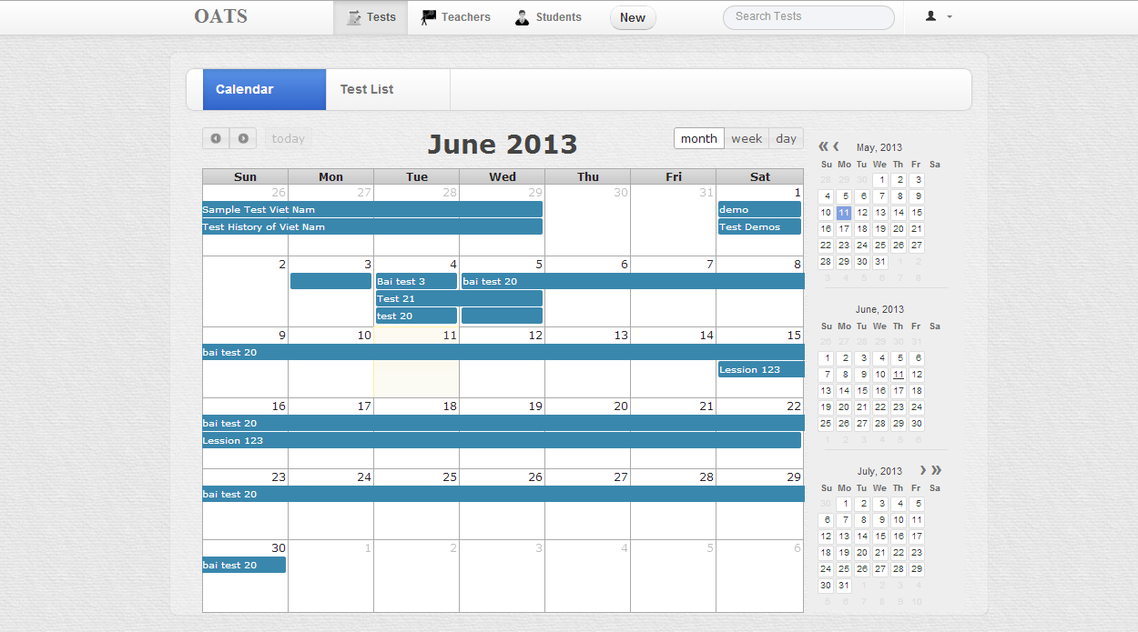

#### Objects and Actions

##### Data fields – Home page screen

|  |  |  |  |  |  |  |
| --- | --- | --- | --- | --- | --- | --- |
| **Field No** | **Field name** | **Type** | **Mandatory** | **Data type** | **Max length** | **Description** |
| 1 | Search Condition | Textbox | N | String | 50 | Contain search condition to find some user account |
| 3 | Welcome message | Text |  | String |  | Welcome message  <Username> is replaced by actual logged in user's last name |

##### Actions – Home page screen

|  |  |  |  |  |  |
| --- | --- | --- | --- | --- | --- |
| **Field No** | **Field name** | **Type** | **Action** | **Description** | **Validation** |
| 1 | Search Condition | Textbox | On submit | Send inputted search condition to server |  |
| 2 | Search | Button | On click | Send inputted search condition to server |  |
| 4 | Home | Button | On click | Reload Homepage |  |
| 5 | My activities | Menu | On click | Forward to "My activities" screen |  |
| 6 | Account Setting | Menu | On click | Forward to "Account setting" screen |  |
| 7 | Learn | Image | On click | Forward to "Learning" screen |  |
| 8 | Teach | Image | On click | Forward to "Teaching" screen |  |
| 9 | Community | Image | On click | Forward to "Community" screen |  |

### TEST LIST SCREEN

#### Screen Images

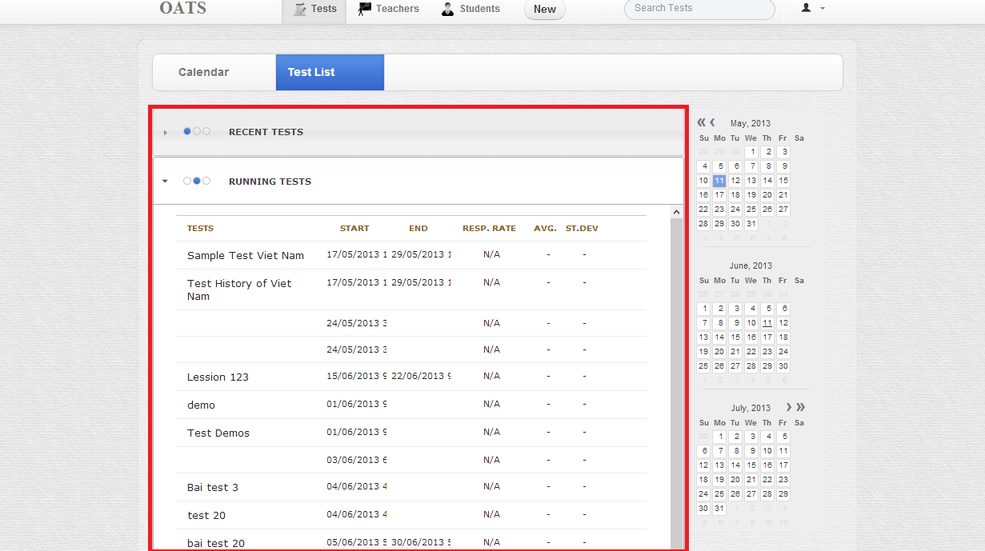

#### Objects and Actions

##### Data fields – Select Language screen

|  |  |  |  |  |  |  |
| --- | --- | --- | --- | --- | --- | --- |
| **Field No** | **Field name** | **Type** | **Mandatory** | **Data type** | **Max length** | **Description** |
| 1 | Language | Text |  | String |  | List of available languages |
| 2 | Language Type | List |  | String |  | Contain all language types which belong to selected language. |

##### Actions – Select language screen

|  |  |  |  |  |  |
| --- | --- | --- | --- | --- | --- |
| **Field No** | **Field name** | **Type** | **Action** | **Description** | **Validation** |
| 1 | Language | List | On click | Show/Hide list of language types which belong to the selected language |  |
| 3 | Language Type | List | On click | Send selected language type to server |  |

### TESTS SEARCH SCREEN

#### Screen Images

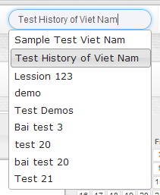

#### Objects and Actions

##### Data fields – Friend List screen

|  |  |  |  |  |  |  |
| --- | --- | --- | --- | --- | --- | --- |
| **Field No** | **Field name** | **Type** | **Mandatory** | **Data type** | **Max length** | **Description** |
| 2 | Friend | List |  | String |  | List contains all user's friends |
| 4 | All friend | Link |  | Number |  | Number of all user’s friends – not count which are displayed on screen |

##### Actions – Friend List screen

|  |  |  |  |  |  |
| --- | --- | --- | --- | --- | --- |
| **Field No** | **Field name** | **Type** | **Action** | **Description** | **Validation** |
| 1 | Friend List | Label | On click | Show/Hide list of user's friends |  |
| 2 | Friend | List | On click | Forward to personal page of selected friend |  |
| 3 | Delete | Button | On click | Remove selected friend from friend List |  |
| 4 | All friend | Link | On click | Show full list of friends |  |
| 5 | Find friend | Link | On click | Forward to User list screen |  |

### NEW TESTS SCREEN

#### Screen Images

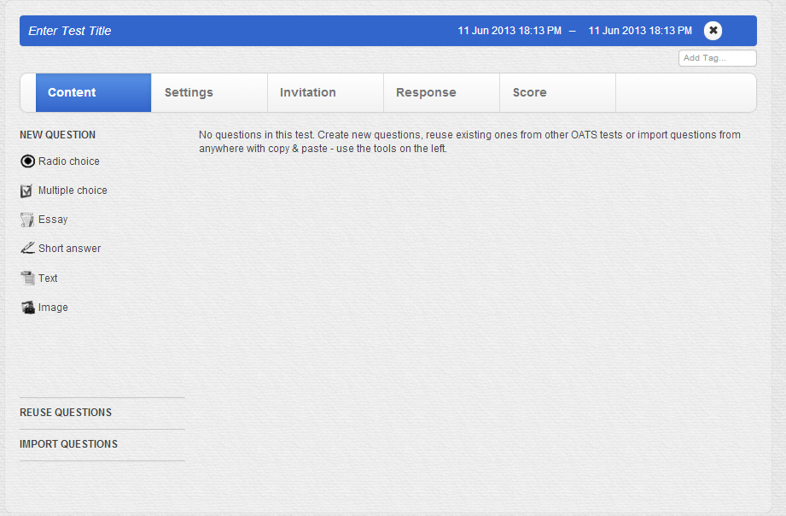

#### Objects and Actions

##### Data fields – Recent courses screen

|  |  |  |  |  |  |  |
| --- | --- | --- | --- | --- | --- | --- |
| **Field No** | **Field name** | **Type** | **Mandatory** | **Data type** | **Max length** | **Description** |
| 2 | Recent class | List |  | String |  | Contain all the classes' name which user has enrolled in |
| 3 | Final Score | Text |  | Number |  | Final score of user in one class |

##### Actions – Recent courses screen

|  |  |  |  |  |  |
| --- | --- | --- | --- | --- | --- |
| **Field No** | **Field name** | **Type** | **Action** | **Description** | **Validation** |
| 1 | Recent courses | Label | On click | Show/Hide list of classes' name |  |
| 2 | Recent class | List | On click | Forward to selected class’ page | Validate if class is expired |
| 4 | Overall report | Link | On click | Get overall report of user's activities |  |

##### 

##### Data fields – Reuse Question screen

|  |  |  |  |  |  |  |
| --- | --- | --- | --- | --- | --- | --- |
| **Field No** | **Field name** | **Type** | **Mandatory** | **Data type** | **Max length** | **Description** |
| 2 | Recent class | List |  | String |  | Contain all the classes' name which user has enrolled in |
| 3 | Final Score | Text |  | Number |  | Final score of user in one class |

##### Actions – Reuse Question screen

|  |  |  |  |  |  |
| --- | --- | --- | --- | --- | --- |
| **Field No** | **Field name** | **Type** | **Action** | **Description** | **Validation** |
| 1 | Recent courses | Label | On click | Show/Hide list of classes' name |  |
| 2 | Recent class | List | On click | Forward to selected class’ page | Validate if class is expired |
| 4 | Overall report | Link | On click | Get overall report of user's activities |  |

##### 

##### Data fields – Import Question screen

|  |  |  |  |  |  |  |
| --- | --- | --- | --- | --- | --- | --- |
| **Field No** | **Field name** | **Type** | **Mandatory** | **Data type** | **Max length** | **Description** |
| 2 | Recent class | List |  | String |  | Contain all the classes' name which user has enrolled in |
| 3 | Final Score | Text |  | Number |  | Final score of user in one class |

##### Actions – Import Question screen

|  |  |  |  |  |  |
| --- | --- | --- | --- | --- | --- |
| **Field No** | **Field name** | **Type** | **Action** | **Description** | **Validation** |
| 1 | Recent courses | Label | On click | Show/Hide list of classes' name |  |
| 2 | Recent class | List | On click | Forward to selected class’ page | Validate if class is expired |
| 4 | Overall report | Link | On click | Get overall report of user's activities |  |

### QUESTIONS CONTENT SCREEN

#### Screen Images

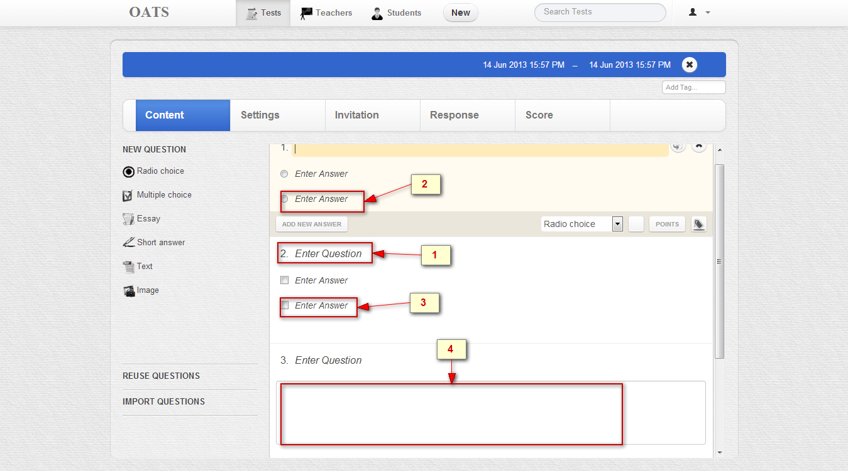

#### Objects and Actions

##### Data fields – Language Type screen

|  |  |  |  |  |  |  |
| --- | --- | --- | --- | --- | --- | --- |
| **Field No** | **Field name** | **Type** | **Mandatory** | **Data type** | **Max length** | **Description** |
| 2 | Question content | Text |  | String |  | Question content |
| 4 | Text area answer | Text |  | String |  | Text area answer |

##### Actions – Language Type screen

|  |  |  |  |  |  |
| --- | --- | --- | --- | --- | --- |
| **Field No** | **Field name** | **Type** | **Action** | **Description** | **Validation** |
| 1 | Radio question | Button | On click | Choose the answer |  |
| 3 | Multiple question | Button | On click | Choose one or any answers |  |

### SCORE ON TEST SCREEN

#### Screen Images

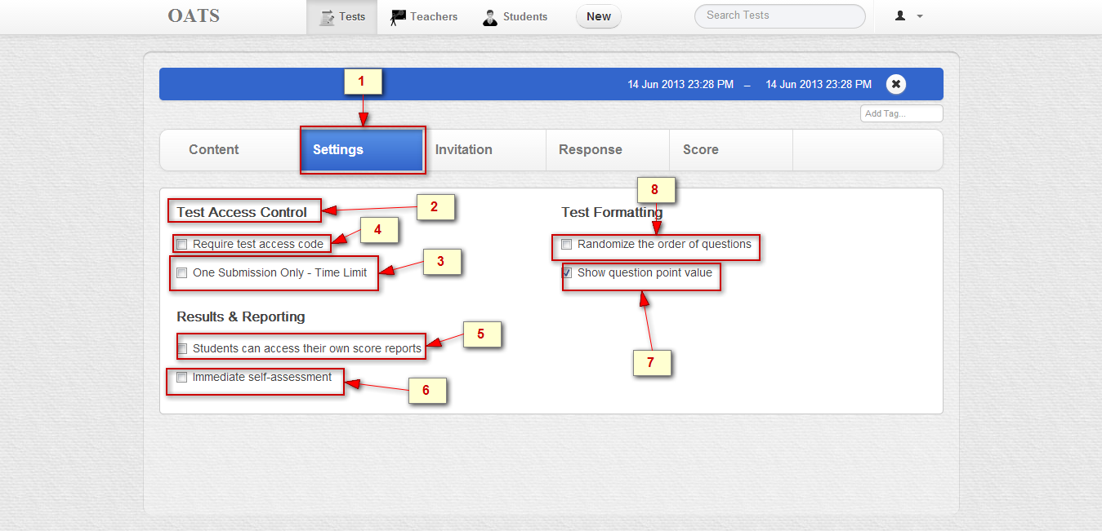

#### Objects and Actions

##### Data fields – Class page: Unit screen

|  |  |  |  |  |  |  |
| --- | --- | --- | --- | --- | --- | --- |
| **Field No** | **Field name** | **Type** | **Mandatory** | **Data type** | **Max length** | **Description** |
| 2 | Setting names | Text |  | String |  | Setting names |

##### Actions – Class page: Unit screen

|  |  |  |  |  |  |
| --- | --- | --- | --- | --- | --- |
| **Field No** | **Field name** | **Type** | **Action** | **Description** | **Validation** |
| 1 | Setting | Link | On click | Set option to fine-tune the test taker’s experience and their access to scores and reports |  |
| 3 | One submission Only – Time limit | Checkbox | Click | Limit student to review only once they submitted their test |  |
| 4 | Require test access code | Checkbox | Click | When enabled, a test specific code is generated and displayed here |  |
| 5 | Student can access own their report | Checkbox | Click | Student can only see their scores a test if it end time has passed and its option is enabled. Allows them to open past test and see their own(but only their and no others’)score report and test responses |  |
| 6 | Immediate self- assessment | Checkbox | Click | Provide students a score report on their performance right the moment they submit the test |  |
| 7 | Show question point value | Checkbox | Click | Show student the mark point of each question. |  |
| 8 | Randomize the orders of questions | Checkbox | Click | Present all questions in random order to student |  |

### TEST SETTING SCREEN

#### Screen Images

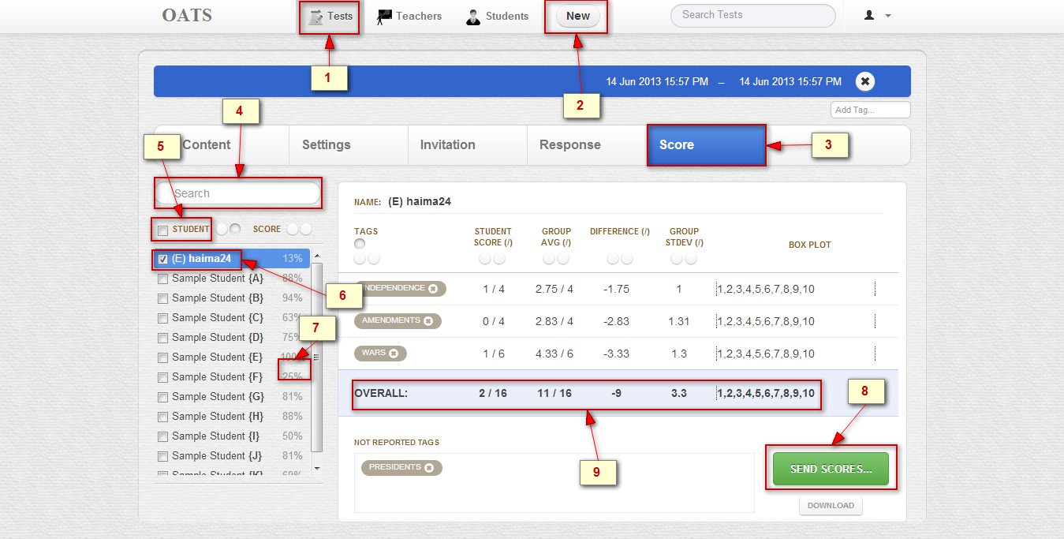

#### Objects and Actions

##### Data fields – Class page: Unit screen

|  |  |  |  |  |  |  |
| --- | --- | --- | --- | --- | --- | --- |
| **Field No** | **Field name** | **Type** | **Mandatory** | **Data type** | **Max length** | **Description** |
| 7 | Score achieved for rate percent of a student | Text |  | String |  |  |
| 9 | Overall | Text |  | String |  | Overall |

##### Actions – Class page: Unit screen

|  |  |  |  |  |  |
| --- | --- | --- | --- | --- | --- |
| **Field No** | **Field name** | **Type** | **Action** | **Description** | **Validation** |
| 1 | Test | Link | On click | Creates, modify and manages tests , test content(questions), assign students and educators , respones and scores |  |
| 2 | New | Link | On click | Create a new test |  |
| 3 | Score | Link | On click | Analyze overall and partial scores of one, all or any subset of student who took this test |  |
| 4 | Search student | Textbox | On submit | Search student |  |
| 5 | Check all students | Checkbox | Check | Choose all student |  |
| 6 | Check a student | Checkbox | Check | Choose a student |  |
| 8 | Send Score | Button | On click | Send Score |  |

### RESPONSES ON TEST SCREEN

#### Screen Images

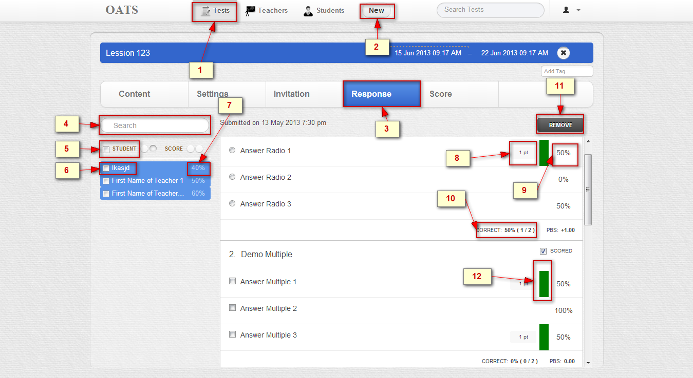

#### Objects and Actions

##### Data fields – Class page: Unit screen

|  |  |  |  |  |  |  |
| --- | --- | --- | --- | --- | --- | --- |
| **Field No** | **Field name** | **Type** | **Mandatory** | **Data type** | **Max length** | **Description** |
| 7 | Score achieved for rate percent of a student | Text |  | String |  | Score achieved for rate percent of a student |
| 8 | Mark for a question | Text |  | String |  | Mark for a question |
| 9 | Rate percent for answer of users | Text |  | String |  | Rate percent for answer of users |
| 10 | Rate percent for true answer of users | Text |  | String |  | Rate percent for true answer of users |
| 12 | Image for true answers | Image |  | Image |  | Image for true answers |

##### Actions – Class page: Unit screen

|  |  |  |  |  |  |
| --- | --- | --- | --- | --- | --- |
| **Field No** | **Field name** | **Type** | **Action** | **Description** | **Validation** |
| 1 | Test | Link | On click | Creates, modify and manages tests , test content(questions), assign students and educators , respones and scores |  |
| 2 | New | Link | On click | Create a new test |  |
| 3 | Responses | Link | On click | Review individual student response and item analytics for any subset of test responses from all or some of the students |  |
| 4 | Search student | Textbox | On submit | Search student |  |
| 5 | Check all students | Checkbox | Check | Choose all student |  |
| 6 | Check a student | Checkbox | Check | Choose a student |  |
| 11 | Remove | Button | On click | Remove a test |  |

### INVITE USERS TO TEST SCREEN

#### Screen Images

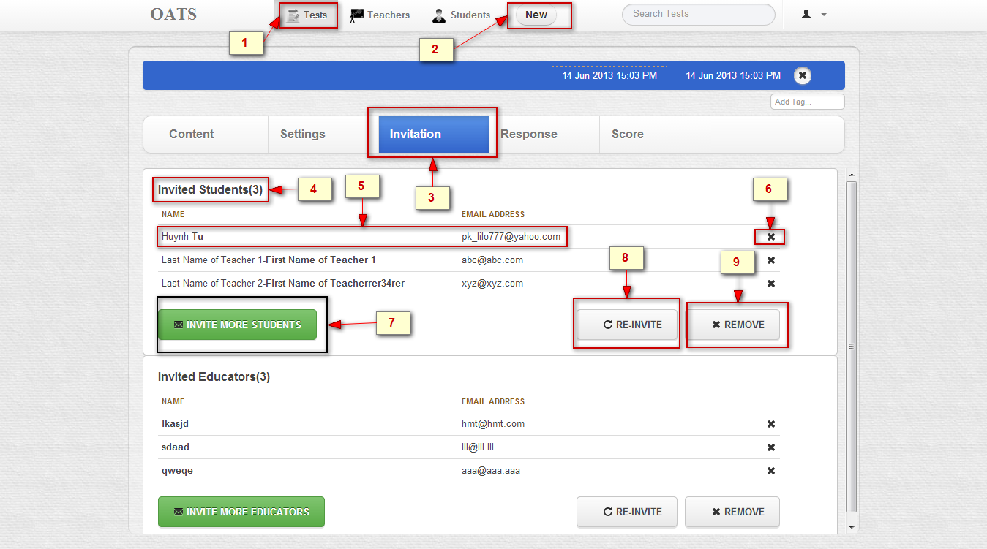

#### Objects and Actions

##### Data fields – Class page: Discussion Forum

|  |  |  |  |  |  |  |
| --- | --- | --- | --- | --- | --- | --- |
| **Field No** | **Field name** | **Type** | **Mandatory** | **Data type** | **Max length** | **Description** |
| 4 | Invited user | Text |  | String |  | Number of invited user |
| 5 | Username and email | Text |  | String |  | Username and email of invited user |

##### Actions – Class page: Discussion Forum

|  |  |  |  |  |  |
| --- | --- | --- | --- | --- | --- |
| **Field No** | **Field name** | **Type** | **Action** | **Description** | **Validation** |
| 1 | Test | Link | On click | Creates, modify and manages tests , test content(questions), assign students and educators , respones and scores |  |
| 7 | Invite more users | Button | On click | Invites more users |  |
| 8 | Reinvite more users | Button | On click | Reinvites users invited |  |
| 9 | Remove users | Button | On click | Remove users |  |
| 2 | New | Link | On click | Create a new test |  |
| 6 | Delete user | Button | On click | Delete user |  |
| 3 | Invitation | Link | On click | Control who can access this test with student and teacher invitations |  |

### 

### ASSIGN TESTS TO STUDENT SCREEN

#### Screen Images

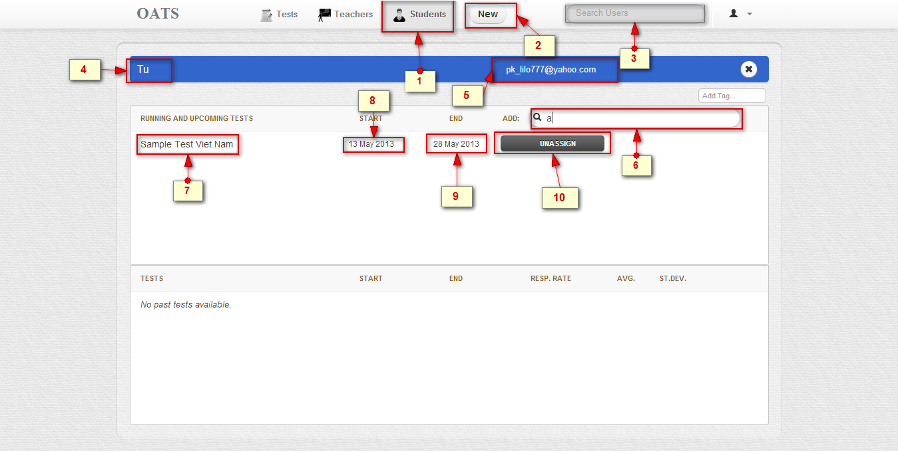

#### Objects and Actions

##### Data fields – Unit Lesson Screen

|  |  |  |  |  |  |  |
| --- | --- | --- | --- | --- | --- | --- |
| **Field No** | **Field name** | **Type** | **Mandatory** | **Data type** | **Max length** | **Description** |
| 4 | Student’s user name | Text |  | String |  | Student’s user name |
| 5 | Student’s user email | Text |  | String |  | Student’s user email |
| 7 | Test’s name | Text |  | String |  | Test’s name |
| 8 | Start date | Text |  | Date |  | Start date |
| 9 | End date | Text |  | Date |  | End date |

##### Actions – Unit Lesson Screen

|  |  |  |  |  |  |
| --- | --- | --- | --- | --- | --- |
| **Field No** | **Field name** | **Type** | **Action** | **Description** | **Validation** |
| 2 | New | Link | On click | Create a new Student |  |
| 3 | Search Student | Textbox | On submit | Searcher Student |  |
| 10 | Unassign a test | Button | On submit | Remove a test |  |
| 6 | Search test | Textbox | On submit | Searcher test |  |
| 1 | Student | Link | On click | Create , modify and look up student login and assign them to test to collaborate |  |

### ASSIGN TESTS TO TEACHER SCREEN

#### Screen Images

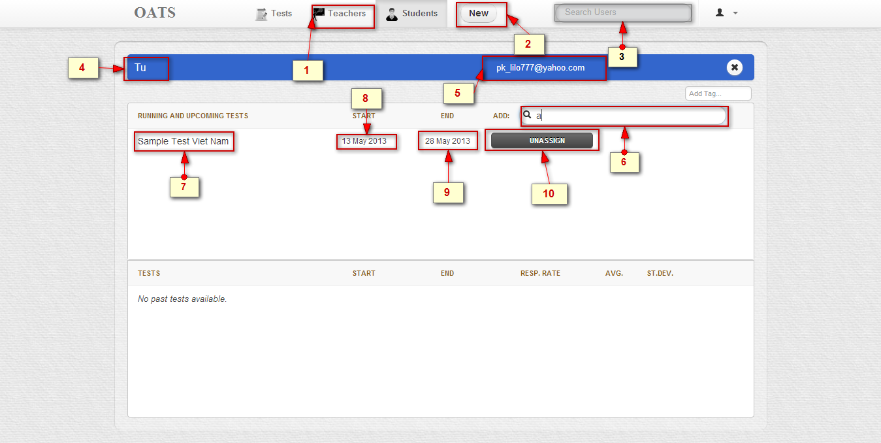

#### Objects and Actions

##### Data fields – Unit Quiz Screen

|  |  |  |  |  |  |  |
| --- | --- | --- | --- | --- | --- | --- |
| **Field No** | **Field name** | **Type** | **Mandatory** | **Data type** | **Max length** | **Description** |
| 4 | Teacher’s user name | Text |  | String |  | Teacher’s user name |
| 5 | Teacher’s user email | Text |  | String |  | Teacher’s user email |
| 7 | Test’s name | Text |  | String |  | Test’s name |
| 8 | Start date | Text |  | Date |  | Start date |
| 9 | End date | Text |  | Date |  | End date |

##### Actions – Unit Lesson Screen

|  |  |  |  |  |  |
| --- | --- | --- | --- | --- | --- |
| **Field No** | **Field name** | **Type** | **Action** | **Description** | **Validation** |
| 1 | Teacher | Link | On click | Create , modify and look up teacher login and assign them to test to collaborate |  |
| 2 | New | Link | On click | Create a new teacher |  |
| 3 | Search teacher | Textbox | On submit | Searcher teacher |  |
| 10 | Unassign a test | Button | On submit | Remove a test |  |
| 6 | Search test | Textbox | On submit | Searcher test |  |

### DO TEST SCREEN

#### Screen Images

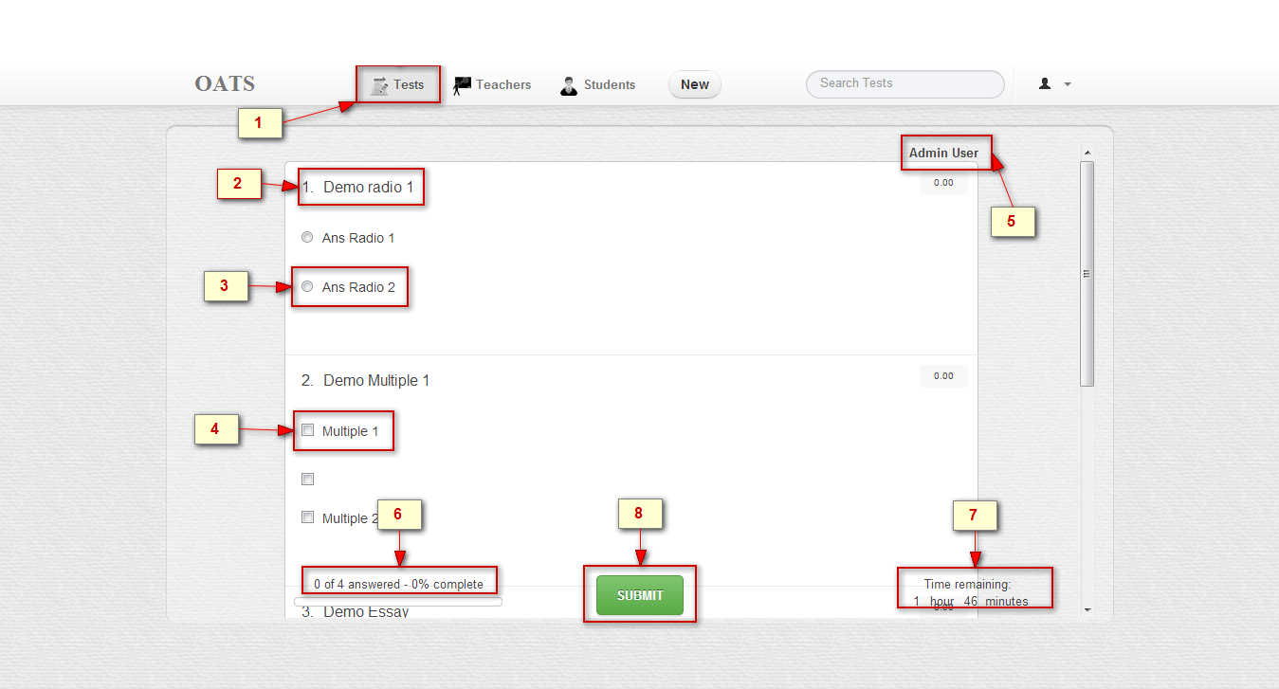

#### Objects and Actions

##### Data fields – Unit Quiz Screen

|  |  |  |  |  |  |  |
| --- | --- | --- | --- | --- | --- | --- |
| **Field No** | **Field name** | **Type** | **Mandatory** | **Data type** | **Max length** | **Description** |
| 2 | Question | Text |  | String |  | Question's content |
| 3 | Answer Radio List | List |  | Object |  | List of questions belong to one question |
| 4 | Answer Multiple List | List |  | Object |  | List of questions belong to one question |
| 5 | User |  |  | Object |  |  |
| 6 | Number of Answer and number of question | Text |  | String |  | Answer number and question number |
| 7 | Time remaining | Text |  | Date |  | Time remaining |
| 7 | Answer List | List |  | Object |  | List of questions belong to one question |

##### Actions – Unit Lesson Screen

|  |  |  |  |  |  |
| --- | --- | --- | --- | --- | --- |
| **Field No** | **Field name** | **Type** | **Action** | **Description** | **Validation** |
| 1 | Test | Link | On click | Creates, modify and manages tests , test content(questions), assign students and educators , respones and scores |  |
| 8 | Submit | Button | On click | Submit user answer to server |  |