## DATABASE DESIGN

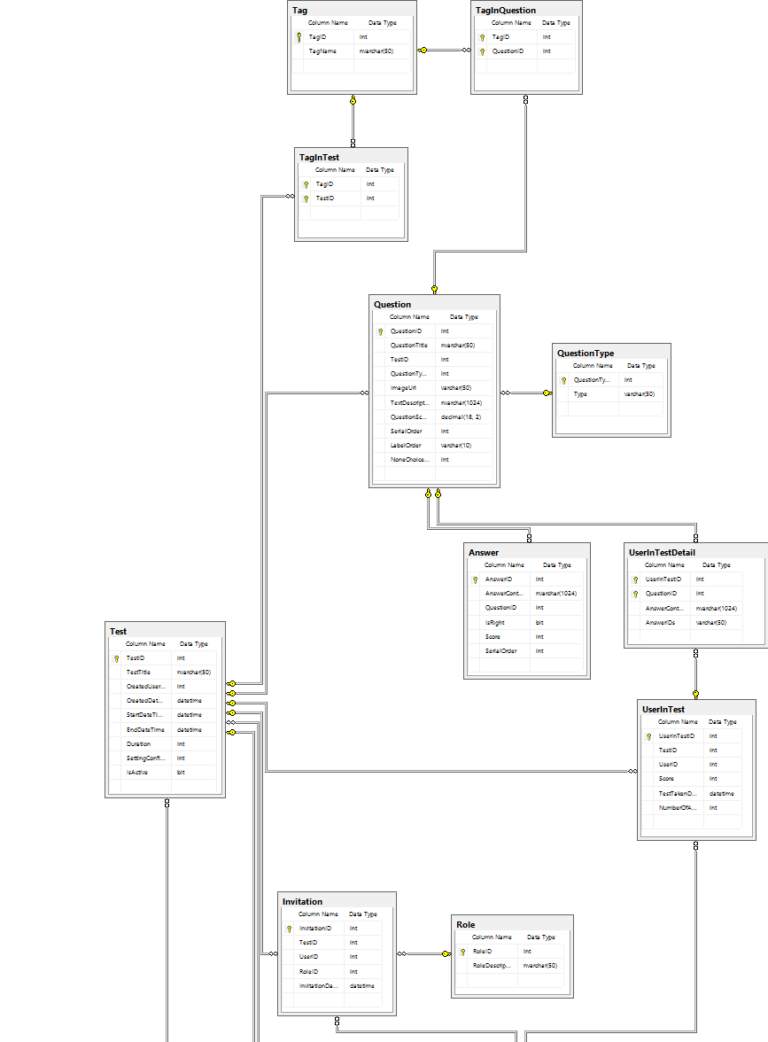

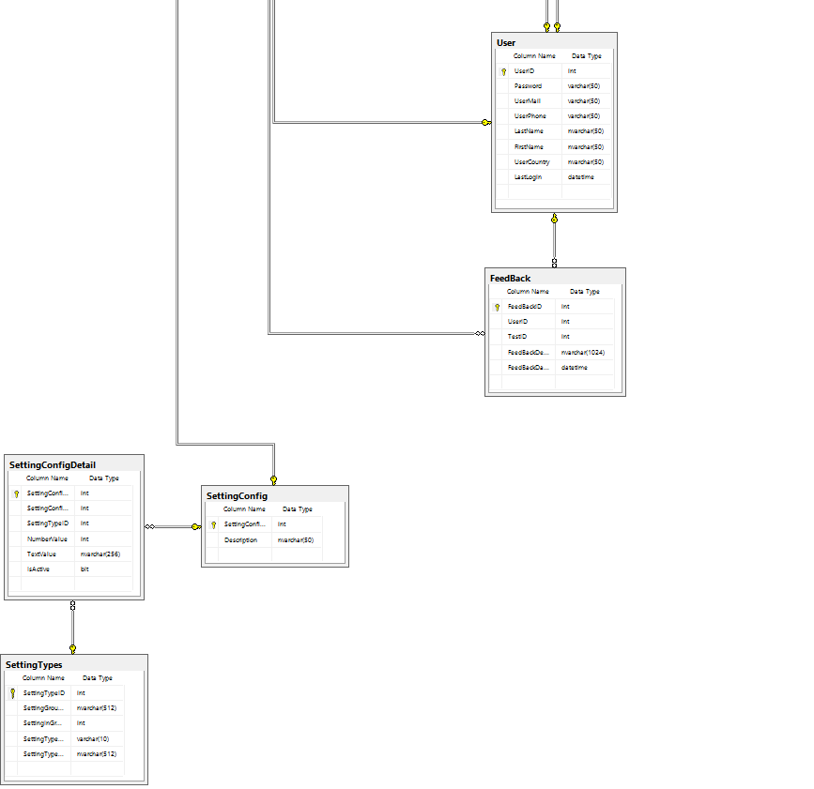

|  |
| --- |
| **Table Activity** |
| |  |  |  |  |  |  | | --- | --- | --- | --- | --- | --- | | **Field** | **Type** | **Null** | **Key** | **Default** | **Extra** | | idactivity | bigint(10) unsigned | NO | PRI |  | auto_increment | | idowner | bigint(10) unsigned | NO | MUL |  |  | | Name | varchar(45) | YES |  |  |  | | Content | text | NO |  |  |  | | Link | varchar(255) | YES |  |  |  | | timecreated | datetime | NO |  |  |  | | timeupdated | datetime | NO |  |  |  | |
| **Table Capability** |
| |  |  |  |  |  |  | | --- | --- | --- | --- | --- | --- | | Field | Type | Null | Key | Default | Extra | | idcapability | bigint(10) unsigned | NO | PRI |  | auto_increment | | name | varchar(255) | NO | UNI |  |  | | contextlevel | bigint(10) | NO |  | 0 |  | | component | varchar(100) | NO |  |  |  | |
| **Table Chat** |
| |  |  |  |  |  |  | | --- | --- | --- | --- | --- | --- | | Field | Type | Null | Key | Default | Extra | | idchat | bigint(10) unsigned | NO | PRI |  | auto_increment | | chattime | bigint(10) unsigned | NO |  |  |  | | timecreated | datetime | NO |  |  |  | | timeupdated | datetime | NO |  |  |  | | version | varchar(45) | NO |  |  |  | |
| **Table chat_users** |
| |  |  |  |  |  |  | | --- | --- | --- | --- | --- | --- | | Field | Type | Null | Key | Default | Extra | | idchat_users | bigint(10) unsigned | NO | PRI |  | auto_increment | | idchat | bigint(10) unsigned | NO | MUL |  |  | | iduser | bigint(10) unsigned | NO | MUL |  |  | | ip | varchar(45) | NO |  |  |  | | pingtime | datetime | NO |  |  |  | | message | varchar(45) | NO |  |  |  | | mode | varchar(45) | YES |  |  |  | |
| **Table Class** |
| |  |  |  |  |  |  | | --- | --- | --- | --- | --- | --- | | Field | Type | Null | Key | Default | Extra | | idclass | bigint(10) unsigned | NO | PRI |  | auto_increment | | idowner | bigint(10) unsigned | NO | MUL |  |  | | idcourse | bigint(10) unsigned | NO | MUL |  |  | | classcode | varchar(100) | NO | UNI |  |  | | name | varchar(255) | NO |  |  |  | | description | longtext | YES |  |  |  | | image | varchar(255) | NO |  |  |  | | icon | varchar(255) | NO |  |  |  | | timecreated | datetime | NO |  |  |  | | timeupdated | datetime | NO |  |  |  | | active | tinyint(1) unsigned | NO |  | 0 |  | | startdate | datetime | NO |  |  |  | | enddate | datetime | NO |  |  |  | | type | int(10) unsigned | NO |  | 0 |  | | enrollimit | int(10) | NO |  | 30 |  | |
| **Table classes_members** |
| |  |  |  |  |  |  | | --- | --- | --- | --- | --- | --- | | Field | Type | Null | Key | Default | Extra | | idclasses_members | bigint(10) unsigned | NO | PRI |  | auto_increment | | idclass | bigint(10) unsigned | NO | MUL |  |  | | iduser | bigint(10) unsigned | NO | MUL |  |  | | enrollkey | varchar(50) | YES |  |  |  | | status | int(10) | NO |  |  |  | | timecreated | datetime | NO |  |  |  | | timeupdated | datetime | NO |  |  |  | |
| **Table Comment** |
| |  |  |  |  |  |  | | --- | --- | --- | --- | --- | --- | | Field | Type | Null | Key | Default | Extra | | idcomment | bigint(10) unsigned | NO | PRI |  | auto_increment | | idowner | bigint(10) unsigned | NO | MUL |  |  | | idref | bigint(10) unsigned | NO |  |  |  | | reftype | varchar(50) | NO |  |  |  | | description | longtext | NO |  |  |  | | timecreated | datetime | NO |  |  |  | | timeupdated | datetime | NO |  |  |  | |
| **Table Configsystem** |
| |  |  |  |  |  |  | | --- | --- | --- | --- | --- | --- | | Field | Type | Null | Key | Default | Extra | | idconfig | bigint(10) unsigned | NO | PRI |  | auto_increment | | key | varchar(45) | NO | UNI |  |  | | value | varchar(45) | NO |  |  |  | | timecreated | datetime | NO |  |  |  | | timeupdated | datetime | NO |  |  |  | |
| **Table Context**   |  |  |  |  |  |  | | --- | --- | --- | --- | --- | --- | | Field | Type | Null | Key | Default | Extra | | idcontext | bigint(10) unsigned | NO | PRI |  | auto_increment | | level | bigint(10) unsigned | NO |  | 0 |  | | path | varchar(255) | NO |  |  |  | |
| **Table Course**   |  |  |  |  |  |  | | --- | --- | --- | --- | --- | --- | | Field | Type | Null | Key | Default | Extra | | idcourse | bigint(10) unsigned | NO | PRI |  | auto_increment | | idcategory | bigint(10) unsigned | NO | MUL |  |  | | iduser | bigint(10) unsigned | YES | MUL |  |  | | coursecode | varchar(100) | NO | UNI |  |  | | name | varchar(255) | NO |  |  |  | | description | longtext | YES |  |  |  | | active | tinyint(1) | NO |  | 0 |  | | lang | varchar(45) | NO |  | en |  | | timecreated | datetime | NO |  |  |  | | timeupdated | datetime | NO |  |  |  | | usercreated | varchar(100) | NO |  |  |  | | userupdated | varchar(100) | NO |  |  |  | | type | int(11) | YES |  |  |  | |
| **Table course_category**   |  |  |  |  |  |  | | --- | --- | --- | --- | --- | --- | | Field | Type | Null | Key | Default | Extra | | idcourse_category | bigint(10) unsigned | NO | PRI |  | auto_increment | | name | varchar(255) | NO |  |  |  | | description | longtext | YES |  |  |  | | idparent | bigint(10) unsigned | YES | MUL |  |  | | hlevel | int(10) unsigned | NO |  | 1 |  | | vlevel | int(10) unsigned | NO |  | 1 |  | | active | tinyint(1) unsigned | NO |  | 0 |  | | timeupdated | datetime | NO |  |  |  | | userupdated | varchar(100) | NO |  |  |  | | icon | varchar(255) | NO |  |  |  | | image | varchar(255) | NO |  |  |  | |
| **Table course_connect** |
| |  |  |  |  |  |  | | --- | --- | --- | --- | --- | --- | | Field | Type | Null | Key | Default | Extra | | idcourse_connect | bigint(10) unsigned | NO | PRI |  | auto_increment | | idcourse_1 | bigint(10) unsigned | NO | MUL |  |  | | idcourse_2 | bigint(10) unsigned | NO | MUL |  |  | | status | tinyint(10) | NO |  |  |  | | timecreated | datetime | NO |  |  |  | | timeupdated | datetime | NO |  |  |  | |
| **Table course_lesson** |
| |  |  |  |  |  |  | | --- | --- | --- | --- | --- | --- | | Field | Type | Null | Key | Default | Extra | | idcourse_lesson | bigint(10) unsigned | NO | PRI |  | auto_increment | | idcourse | bigint(10) unsigned | NO | MUL |  |  | | idlesson | bigint(10) unsigned | NO | MUL |  |  | | timecreated | datetime | NO |  |  |  | | timeupdated | datetime | NO |  |  |  | | forsharing | tinyint(1) | NO |  |  |  | |