## USER INTERFACE DESIGN

### LOGIN SCREEN

#### Screen Images C:\Users\THIBT\Desktop\11.png

#### Objects and Actions

##### Data fields - Login screen

|  |  |  |  |  |  |  |
| --- | --- | --- | --- | --- | --- | --- |
| **Field No** | **Field name** | **Type** | **Mandatory** | **Data type** | **Max length** | **Description** |
| 1 | Email Address | Textbox | Y | String |  | Contain email address to login |
| 3 | Password | Password | Y | String |  | Contain password to login |

##### Actions – Register screen

|  |  |  |  |  |  |
| --- | --- | --- | --- | --- | --- |
| **Field No** | **Field name** | **Type** | **Action** | **Description** | **Validation** |
| 2 | Remember Email | Checkbox | On click | Remember email address for next login |  |
| 4 | Login | Button | On click | Send inputted username and password to server |  |
| 5 | Forget password | Link | On click | Forward to Forget Password Screen |  |

### REGISTER SCREEN

#### Screen ImagesC:\Users\THIBT\Desktop\10.png

#### Objects and Actions

##### Data fields - Register screen

|  |  |  |  |  |  |  |
| --- | --- | --- | --- | --- | --- | --- |
| **Field No** | **Field name** | **Type** | **Mandatory** | **Data type** | **Max length** | **Description** |
| 1 | First Name | Textbox | N | String | 20 | Contain first name to register |
| 2 | Last Name | Textbox | N | String | 20 | Contain first name to register |
| 3 | Email Address | Textbox | Y | String | 50 | Contain email address to register |
| 4 | Password | Textbox | Y | String | 50 | Contain password to register |
| 5 | Confirm Password | Textbox | Y | String | 50 | Contain the confirm password |
| 6 | Phone Number | Textbox | N | Number | 25 | Contain user's phone number |
| 7 | Country | Textbox | N | String | 50 | Contain user's country |

##### Actions – Register screen

|  |  |  |  |  |  |
| --- | --- | --- | --- | --- | --- |
| **Field No** | **Field name** | **Type** | **Action** | **Description** | **Validation** |
| 3 | Email Checking | Textbox | On leave | Check the inputted email | Must in the right format and |
| 4 | Password Checking | Textbox | On leave | Check the inputted password | Must be in range of [8,50] characters |
| 5 | Confirm Password | Textbox | On leave | Check the inputted text | Must matched with the inputted password |
| 8 | Registration Confirm | Checkbox | On click | Confirm that user has read and understand the policy | Has been Checked to signup |
| 9 | Signup | Button | On click | Submit inputted data to server | Inputted data must be valid |

### HOMEPAGE SCREEN

#### Screen Images

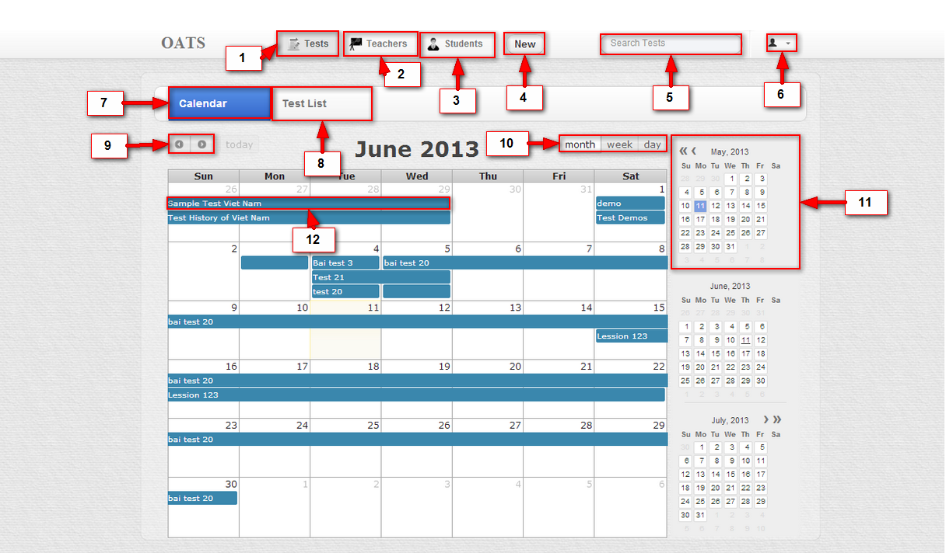

#### Objects and Actions

##### Data fields – Home page screen

|  |  |  |  |  |  |  |
| --- | --- | --- | --- | --- | --- | --- |
| **Field No** | **Field name** | **Type** | **Mandatory** | **Data type** | **Max length** | **Description** |
| 5 | Search Condition | Textbox | N | String | N/A | Contain search condition to find the test |

##### Actions – Home page screen

|  |  |  |  |  |  |
| --- | --- | --- | --- | --- | --- |
| **Field No** | **Field name** | **Type** | **Action** | **Description** | **Validation** |
| 1 | Tests Tab | Textbox | On click | Forward to Test page |  |
| 2 | Teachers Tab | Button | On click | Forward to Teacher page |  |
| 4 | New | Button | On click | Forward to Test page to allow user create new test |  |
| 5 | Search Condition | Textbox | submit | Send inputted text to server to search test |  |
| 6 | User menu setting | Menu | On click | Forward to "Account setting" screen |  |
| 7 | Calendar | Menu | On click | Forward to "Calendar" screen |  |
| 8 | Test list | Menu | On click | Forward to "Test list" screen |  |
| 9 | Move | Button | On click | Show next or previous month ( week or date ) with available Tests list |  |
| 10 | List Show | Button | On click | Show available tests on the month, week or date |  |
| 11 | Month View | Table | On click | Choose the month to show off |  |
| 12 | Test information | Label | On click | N/A |  |

### TEST LIST SCREEN

#### Screen Images

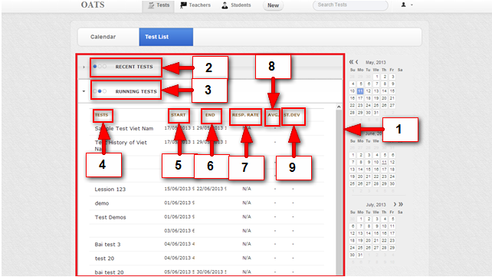

#### Objects and Actions

##### Data fields – Select Language screen

|  |  |  |  |  |  |  |
| --- | --- | --- | --- | --- | --- | --- |
| **Field No** | **Field name** | **Type** | **Mandatory** | **Data type** | **Max length** | **Description** |
| 1 | Test All | Text |  | String |  | List of available Tests |

##### Actions – Select language screen

|  |  |  |  |  |  |
| --- | --- | --- | --- | --- | --- |
| **Field No** | **Field name** | **Type** | **Action** | **Description** | **Validation** |
| 2 | Recent Tests | Label | On click | Show/Hide list of recent test (no longer open to student to take it) |  |
| 3 | Running Tests | Label | On click | Show/Hide list of running test (currently open to assigned students to take them) |  |
| 4 | Test Name | Text |  | Name of Test |  |
| 5 | Start Date | Date time |  | Start date of Test |  |
| 6 | End Date | Date time |  | End date of Test |  |
| 7 | Respond Rate | Text |  |  |  |
| 8 | Average | Text |  |  |  |
| 9 | <ST.DEV> | Text |  |  |  |

### TESTS SEARCH SCREEN

#### Screen Images

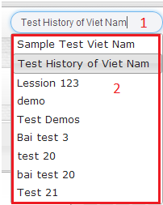

#### Objects and Actions

##### Data fields – Friend List screen

|  |  |  |  |  |  |  |
| --- | --- | --- | --- | --- | --- | --- |
| **Field No** | **Field name** | **Type** | **Mandatory** | **Data type** | **Max length** | **Description** |
| 1 | Search Condition | Textbox | N | String |  | List all available Tests |

##### Actions – Friend List screen

|  |  |  |  |  |  |
| --- | --- | --- | --- | --- | --- |
| **Field No** | **Field name** | **Type** | **Action** | **Description** | **Validation** |
| 2 | TestsPopUp | Pop-up | On click | Forward to page of this Test |  |

### NEW TESTS SCREEN

#### Screen Images

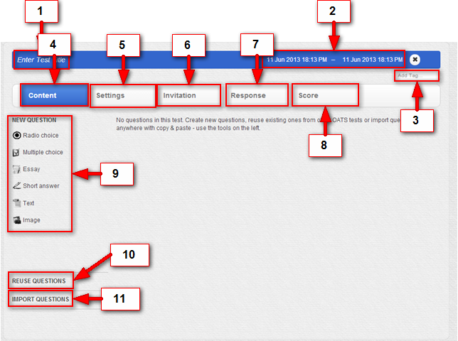

#### Objects and Actions

##### Data fields – Recent courses screen

|  |  |  |  |  |  |  |
| --- | --- | --- | --- | --- | --- | --- |
| **Field No** | **Field name** | **Type** | **Mandatory** | **Data type** | **Max length** | **Description** |
| 1 | Test Title | Textbox | Y | String | 50 | Enter name for current Test |
| 2 | Available Date | Textbox | N | Date time |  | Set time for current Test |
| 3 | Tag | Textbox | N | String |  | Add tag for current Test |

##### Actions – Recent courses screen

|  |  |  |  |  |  |
| --- | --- | --- | --- | --- | --- |
| **Field No** | **Field name** | **Type** | **Action** | **Description** | **Validation** |
| 4 | Content | Label | On click | Allow user to Create content of test |  |
| 5 | Setting | Label | On click |  |  |
| 6 | Invitation | Label | On click | Allow invite, re-invite or remove invitations to a user. |  |
| 7 | Response | Label | On click |  |  |
| 8 | Score | Label | On click | Forward to selected class’ page |  |
| 9 | New Question | Label | On click | Allow user create question with these kinds. |  |
| 10 | Reuse Question | Label | On click | Allow user reuse question that’s already created. |  |
| 11 | Import Question | Label | On click | Allow user import questions from other sources. |  |

##### C:\Users\THIBT\Desktop\Images For Screen\6.2.png

##### Data fields – Reuse Question screen

|  |  |  |  |  |  |  |
| --- | --- | --- | --- | --- | --- | --- |
| **Field No** | **Field name** | **Type** | **Mandatory** | **Data type** | **Max length** | **Description** |
| 1 | Search Condition | Text |  | String | 50 | Search questions to reuse |

##### Actions – Reuse Question screen

|  |  |  |  |  |  |
| --- | --- | --- | --- | --- | --- |
| **Field No** | **Field name** | **Type** | **Action** | **Description** | **Validation** |
| 2 | Match questions. | Label | On click | Add question to current test. |  |

##### C:\Users\THIBT\Desktop\Images For Screen\5.2.png

##### Data fields – Import Question screen

|  |  |  |  |  |  |  |
| --- | --- | --- | --- | --- | --- | --- |
| **Field No** | **Field name** | **Type** | **Mandatory** | **Data type** | **Max length** | **Description** |
| 1 | Import Area | Object |  | Object |  | Add questions from other source to current test by drag and drop here. |

##### Actions – Import Question screen

|  |  |  |  |  |  |
| --- | --- | --- | --- | --- | --- |
| **Field No** | **Field name** | **Type** | **Action** | **Description** | **Validation** |
| 1 | Recent courses | Label | On click | Show/Hide list of classes' name |  |
| 2 | Recent class | List | On click | Forward to selected class’ page | Validate if class is expired |
| 4 | Overall report | Link | On click | Get overall report of user's activities |  |

### QUESTIONS CONTENT SCREEN

#### Screen Images

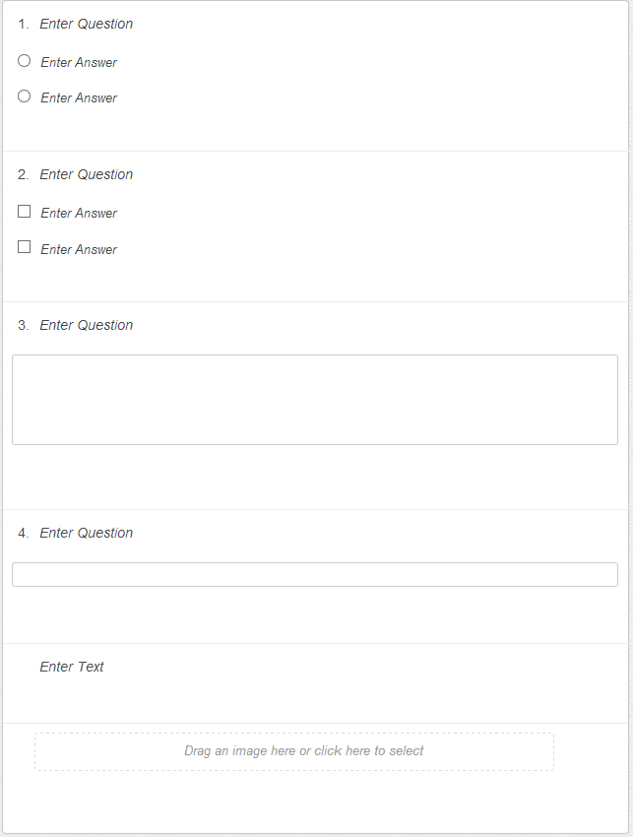

#### Objects and Actions

##### Data fields – Language Type screen

|  |  |  |  |  |  |  |
| --- | --- | --- | --- | --- | --- | --- |
| **Field No** | **Field name** | **Type** | **Mandatory** | **Data type** | **Max length** | **Description** |
| 1 | Language type | Label |  | String |  | Language type |
| 2 | Language type | Image |  | Image |  | Language type's image |
| 5 | Language type Introduction | Text |  | String |  | Introduction of the language type |
| 6 | Placement test score | Text |  | Number |  | Score user got on Placement Test for this language type.  The text contains user score is displayed only when user has done the test. |
| 7 | Level | Image |  | Image |  | Image of the selected learning level |
| 8 | Level introduction | Text |  | String |  | Introduction of the selected learning level |
| 9 | Course List | List |  | Object |  | List of courses belong to this learning level |

##### Actions – Language Type screen

|  |  |  |  |  |  |
| --- | --- | --- | --- | --- | --- |
| **Field No** | **Field name** | **Type** | **Action** | **Description** | **Validation** |
| 1 | Course name | Link | On click | Forward to Class detail screen |  |
| 7 | Enrolled students | Link | On click | Show list of students who has enrolled in one class |  |

### SCORE ON TEST SCREEN

#### Screen Images

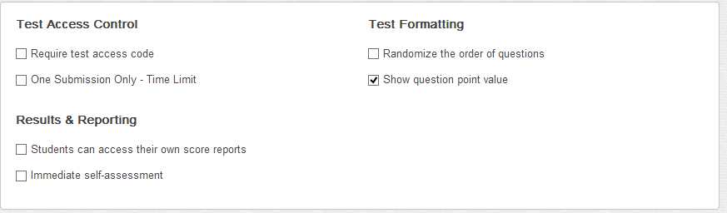

#### Objects and Actions

##### Data fields – Class page: Unit screen

|  |  |  |  |  |  |  |
| --- | --- | --- | --- | --- | --- | --- |
| **Field No** | **Field name** | **Type** | **Mandatory** | **Data type** | **Max length** | **Description** |
| 1 | Course name | Text |  | String |  | Course name |
| 2 | Member | Text |  | Number |  | Number of members in this class |
| 4 | Member list | List |  | Object |  | List of members in this class |
| 5 | User avatar | Image |  | Image |  | Member's avatar |
| 6 | User name | Text |  | String |  | Member's name |
| 11 | Unit | List |  | String |  | List of all units in learning program of this class |
| 13 | Lesson | Text |  | String |  | Lesson's name |
| 14 | Lesson Introduction | Text |  | String |  | Short introduction or objective of the lesson |
| 19 | Quiz time | Text |  | Date |  | Available time of quiz, include open time and close time |
| 20 | Quiz Introduction | Button |  |  |  | Short introduction or objective of the unit quiz |
| 21 | Quiz Report | Table |  | Object |  | Report of all user attempts.  Visible only when user has attempted to do the unit quiz |
| 22 | Attempt No | Text |  | Number |  | Order number of user's attempt |
| 23 | Completed Time | Text |  | Date |  | Time user has finished this attempt |
| 24 | Mark | Text |  | Number |  | User's mark for this attempt. Mark is counted based on total mark of unit quiz |
| 25 | Grade | Text |  | Number |  | User's grade for this attempt. Grade is counted on 10 |
| 26 | Attempt Status | Text |  | String |  | User's submit status for this attempt |
| 27 | Quiz Status | Text |  | String |  | Notification of remaining attempts the unit quiz allow user to do |
| 28 | Final Grade | Text |  | Number |  | User's final grade for the unit quiz |

##### Actions – Class page: Unit screen

|  |  |  |  |  |  |
| --- | --- | --- | --- | --- | --- |
| **Field No** | **Field name** | **Type** | **Action** | **Description** | **Validation** |
| 3 | View all | Link | On click | Show full list of members in this class |  |
| 5 | User avatar | Image | On click | Forward to personal page of selected user |  |
| 7 | Units | Link | On click | Reload the page |  |
| 8 | Recent activities | Link | On click | Forward to Report screen show recent activities of user in this class |  |
| 9 | Special Topics | Link | On click | Forward to Special Topics Screen |  |
| 10 | Discussion Forum | Link | On click | Forward to Discussion Forum screen |  |
| 11 | Unit | Link | On click | Display content of selected unit |  |
| 12 | Course Test | Link | On click | Forward to "Course Test" screen |  |
| 13 | Lesson | Link | On click | Forward to Lesson content screen |  |
| 15 | Video Dialog | Link | On click | Forward to Lesson content screen - Video dialog part is displayed. Available only when lesson contain Video Dialog part |  |
| 16 | Vocabulary | Link | On click | Forward to Lesson content screen - Vocabulary part is displayed. Available only when lesson contain Vocabulary part |  |
| 17 | Vocabulary | Link | On click | Forward to Lesson content screen - Grammar part is displayed. Available only when lesson contain Grammar part |  |
| 18 | Unit quiz | Link | On click | Forward to Unit Quiz screen. Available only when unit has any unit quiz |  |

### TEST SETTING SCREEN

#### Screen Images

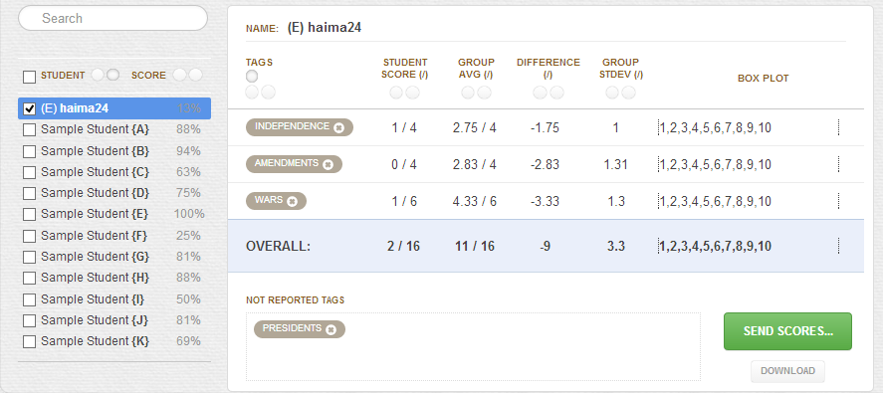

#### Objects and Actions

##### Data fields – Class page: Unit screen

|  |  |  |  |  |  |  |
| --- | --- | --- | --- | --- | --- | --- |
| **Field No** | **Field name** | **Type** | **Mandatory** | **Data type** | **Max length** | **Description** |
| 1 | Course name | Text |  | String |  | Course name |
| 2 | Member | Text |  | Number |  | Number of members in this class |
| 4 | Member list | List |  | Object |  | List of members in this class |
| 5 | User avatar | Image |  | Image |  | Member's avatar |
| 6 | User name | Text |  | String |  | Member's name |
| 11 | Unit | List |  | String |  | List of all units in learning program of this class |
| 13 | Lesson | Text |  | String |  | Lesson's name |
| 14 | Lesson Introduction | Text |  | String |  | Short introduction or objective of the lesson |
| 19 | Quiz time | Text |  | Date |  | Available time of quiz, include open time and close time |
| 20 | Quiz Introduction | Button |  |  |  | Short introduction or objective of the unit quiz |
| 21 | Quiz Report | Table |  | Object |  | Report of all user attempts.  Visible only when user has attempted to do the unit quiz |
| 22 | Attempt No | Text |  | Number |  | Order number of user's attempt |
| 23 | Completed Time | Text |  | Date |  | Time user has finished this attempt |
| 24 | Mark | Text |  | Number |  | User's mark for this attempt. Mark is counted based on total mark of unit quiz |
| 25 | Grade | Text |  | Number |  | User's grade for this attempt. Grade is counted on 10 |
| 26 | Attempt Status | Text |  | String |  | User's submit status for this attempt |
| 27 | Quiz Status | Text |  | String |  | Notification of remaining attempts the unit quiz allow user to do |
| 28 | Final Grade | Text |  | Number |  | User's final grade for the unit quiz |

##### Actions – Class page: Unit screen

|  |  |  |  |  |  |
| --- | --- | --- | --- | --- | --- |
| **Field No** | **Field name** | **Type** | **Action** | **Description** | **Validation** |
| 3 | View all | Link | On click | Show full list of members in this class |  |
| 5 | User avatar | Image | On click | Forward to personal page of selected user |  |
| 7 | Units | Link | On click | Reload the page |  |
| 8 | Recent activities | Link | On click | Forward to Report screen show recent activities of user in this class |  |
| 9 | Special Topics | Link | On click | Forward to Special Topics Screen |  |
| 10 | Discussion Forum | Link | On click | Forward to Discussion Forum screen |  |
| 11 | Unit | Link | On click | Display content of selected unit |  |
| 12 | Course Test | Link | On click | Forward to "Course Test" screen |  |
| 13 | Lesson | Link | On click | Forward to Lesson content screen |  |
| 15 | Video Dialog | Link | On click | Forward to Lesson content screen - Video dialog part is displayed. Available only when lesson contain Video Dialog part |  |
| 16 | Vocabulary | Link | On click | Forward to Lesson content screen - Vocabulary part is displayed. Available only when lesson contain Vocabulary part |  |
| 17 | Vocabulary | Link | On click | Forward to Lesson content screen - Grammar part is displayed. Available only when lesson contain Grammar part |  |
| 18 | Unit quiz | Link | On click | Forward to Unit Quiz screen. Available only when unit has any unit quiz |  |

### RESPONSES ON TEST SCREEN

#### Screen Images

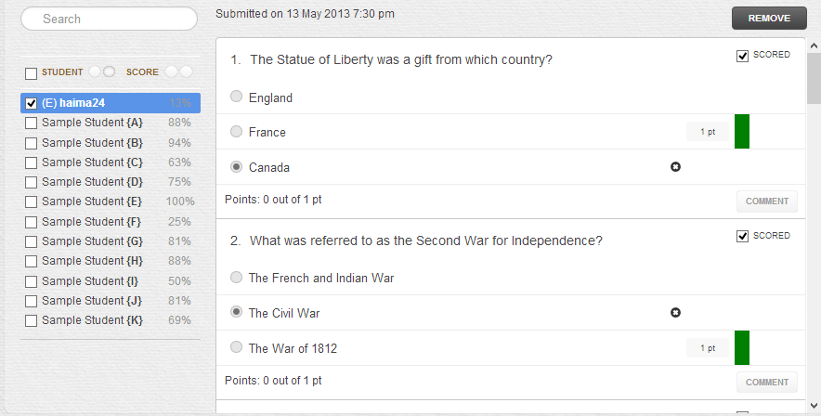

#### Objects and Actions

##### Data fields – Class page: Unit screen

|  |  |  |  |  |  |  |
| --- | --- | --- | --- | --- | --- | --- |
| **Field No** | **Field name** | **Type** | **Mandatory** | **Data type** | **Max length** | **Description** |
| 1 | Course name | Text |  | String |  | Course name |
| 2 | Member | Text |  | Number |  | Number of members in this class |
| 4 | Member list | List |  | Object |  | List of members in this class |
| 5 | User avatar | Image |  | Image |  | Member's avatar |
| 6 | User name | Text |  | String |  | Member's name |
| 11 | Unit | List |  | String |  | List of all units in learning program of this class |
| 13 | Lesson | Text |  | String |  | Lesson's name |
| 14 | Lesson Introduction | Text |  | String |  | Short introduction or objective of the lesson |
| 19 | Quiz time | Text |  | Date |  | Available time of quiz, include open time and close time |
| 20 | Quiz Introduction | Button |  |  |  | Short introduction or objective of the unit quiz |
| 21 | Quiz Report | Table |  | Object |  | Report of all user attempts.  Visible only when user has attempted to do the unit quiz |
| 22 | Attempt No | Text |  | Number |  | Order number of user's attempt |
| 23 | Completed Time | Text |  | Date |  | Time user has finished this attempt |
| 24 | Mark | Text |  | Number |  | User's mark for this attempt. Mark is counted based on total mark of unit quiz |
| 25 | Grade | Text |  | Number |  | User's grade for this attempt. Grade is counted on 10 |
| 26 | Attempt Status | Text |  | String |  | User's submit status for this attempt |
| 27 | Quiz Status | Text |  | String |  | Notification of remaining attempts the unit quiz allow user to do |
| 28 | Final Grade | Text |  | Number |  | User's final grade for the unit quiz |

##### Actions – Class page: Unit screen

|  |  |  |  |  |  |
| --- | --- | --- | --- | --- | --- |
| **Field No** | **Field name** | **Type** | **Action** | **Description** | **Validation** |
| 3 | View all | Link | On click | Show full list of members in this class |  |
| 5 | User avatar | Image | On click | Forward to personal page of selected user |  |
| 7 | Units | Link | On click | Reload the page |  |
| 8 | Recent activities | Link | On click | Forward to Report screen show recent activities of user in this class |  |
| 9 | Special Topics | Link | On click | Forward to Special Topics Screen |  |
| 10 | Discussion Forum | Link | On click | Forward to Discussion Forum screen |  |
| 11 | Unit | Link | On click | Display content of selected unit |  |
| 12 | Course Test | Link | On click | Forward to "Course Test" screen |  |
| 13 | Lesson | Link | On click | Forward to Lesson content screen |  |
| 15 | Video Dialog | Link | On click | Forward to Lesson content screen - Video dialog part is displayed. Available only when lesson contain Video Dialog part |  |
| 16 | Vocabulary | Link | On click | Forward to Lesson content screen - Vocabulary part is displayed. Available only when lesson contain Vocabulary part |  |
| 17 | Vocabulary | Link | On click | Forward to Lesson content screen - Grammar part is displayed. Available only when lesson contain Grammar part |  |
| 18 | Unit quiz | Link | On click | Forward to Unit Quiz screen. Available only when unit has any unit quiz |  |

### INVITE USERS TO TEST SCREEN

#### Screen Images

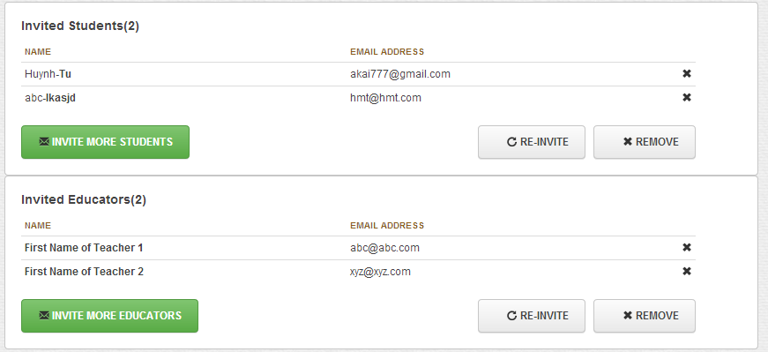

#### Objects and Actions

##### Data fields – Class page: Discussion Forum

|  |  |  |  |  |  |  |
| --- | --- | --- | --- | --- | --- | --- |
| **Field No** | **Field name** | **Type** | **Mandatory** | **Data type** | **Max length** | **Description** |
| 1 | New Post | Textbox | N | String | 250 | Contain the post's content which user want to create |
| 3 | Post Owner | Image |  | Image |  | Avatar of the post's owner |
| 4 | Post Owner | Text |  | String |  | Name of the post's owner |
| 5 | Post | Text |  | String |  | Content of user's post |
| 6 | Comments Number | Link |  | Number |  | Number of comments following selected post |
| 7 | Comment Owner | Image |  | String |  | Avatar of the comment's owner |
| 8 | Comment Owner | Link |  | String |  | Name of the comment's owner |
| 9 | Comment | Text |  | String |  | Content of user's comment |
| 10 | New Comment | Textbox | N | String | 150 | Contain the comment's content which user want to create |

##### Actions – Class page: Discussion Forum

|  |  |  |  |  |  |
| --- | --- | --- | --- | --- | --- |
| **Field No** | **Field name** | **Type** | **Action** | **Description** | **Validation** |
| 2 | Post | Button | On click | Send inputted content to server. Request to create a new post |  |
| 6 | All comments | Link | On click | Show full list of comments following the selected post |  |
| 10 | New Comment | Textbox | On Submit | Send inputted content to server. Request to create a new comment |  |

##### Data fields – Class page: Discussion Forum

|  |  |  |  |  |  |  |
| --- | --- | --- | --- | --- | --- | --- |
| **Field No** | **Field name** | **Type** | **Mandatory** | **Data type** | **Max length** | **Description** |
| 1 | New Post | Textbox | N | String | 250 | Contain the post's content which user want to create |
| 3 | Post Owner | Image |  | Image |  | Avatar of the post's owner |
| 4 | Post Owner | Text |  | String |  | Name of the post's owner |
| 5 | Post | Text |  | String |  | Content of user's post |
| 6 | Comments Number | Link |  | Number |  | Number of comments following selected post |
| 7 | Comment Owner | Image |  | String |  | Avatar of the comment's owner |
| 8 | Comment Owner | Link |  | String |  | Name of the comment's owner |
| 9 | Comment | Text |  | String |  | Content of user's comment |
| 10 | New Comment | Textbox | N | String | 150 | Contain the comment's content which user want to create |

##### Actions – Class page: Discussion Forum

### ASSIGN TESTS TO STUDENT SCREEN

#### Screen Images

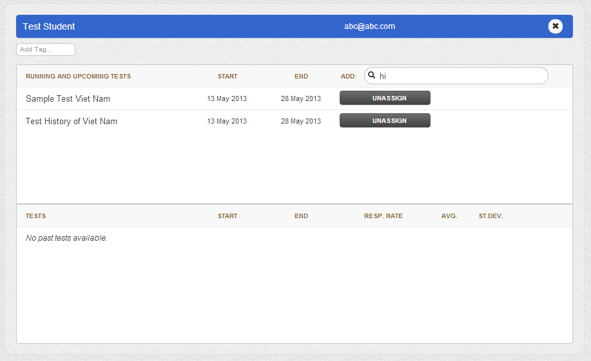

#### Objects and Actions

##### Data fields – Unit Lesson Screen

|  |  |  |  |  |  |  |
| --- | --- | --- | --- | --- | --- | --- |
| **Field No** | **Field name** | **Type** | **Mandatory** | **Data type** | **Max length** | **Description** |
| 1 | Unit Title | Text |  | String |  | Title of the unit |
| 2 | Lesson Contain | Link |  | String |  | All lesson parts |
| 4 | Current part | Text |  | String |  | Index of the current displayed part |
| 7 | Content | Text |  | String |  | Content of current lesson's part |

##### Actions – Unit Lesson Screen

|  |  |  |  |  |  |
| --- | --- | --- | --- | --- | --- |
| **Field No** | **Field name** | **Type** | **Action** | **Description** | **Validation** |
| 2 | Lesson Part | Link | On click | Display content of selected lesson part |  |
| 3 | Previous | Button | On click | Go to previous lesson part Activate only when there's some parts before |  |
| 4 | Next | Textbox | On Submit | Go to next lesson part Activate only when there's some parts after |  |

### ASSIGN TESTS TO TEACHER SCREEN

#### Screen Images

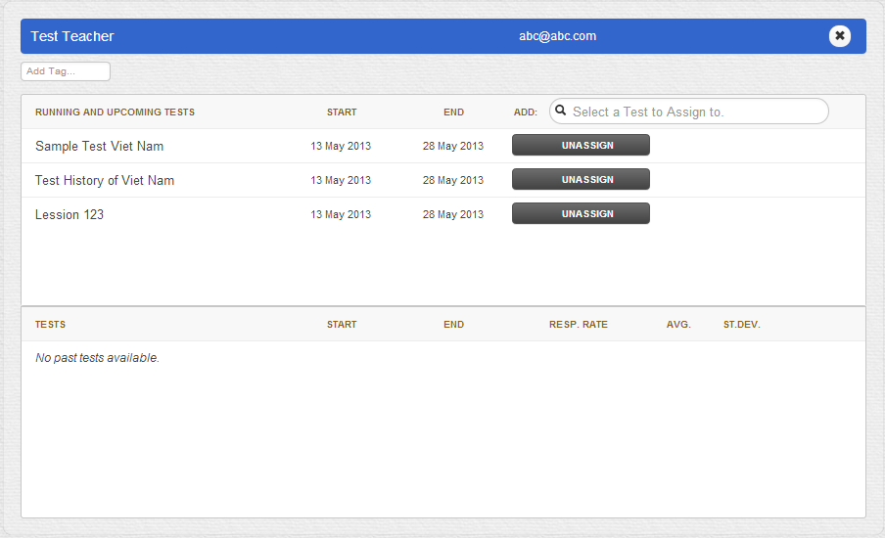

#### Objects and Actions

##### Data fields – Unit Quiz Screen

|  |  |  |  |  |  |  |
| --- | --- | --- | --- | --- | --- | --- |
| **Field No** | **Field name** | **Type** | **Mandatory** | **Data type** | **Max length** | **Description** |
| 1 | Unit Title | Text |  | String |  | Title of the unit lesson |
| 2 | Quiz Part | Link |  | String |  | All parts belongs to this unit quiz |
| 3 | Current Question | Text |  | String |  | Index of the current displayed question |
| 4 | Time | Text |  | Time |  | Remaining time before quiz is closed |
| 5 | Question No | Label |  | Number |  | Question number |
| 6 | Question | Text |  | String |  | Question's content |
| 7 | Answer List | List |  | Object |  | List of questions belong to one question |

##### Actions – Unit Lesson Screen

|  |  |  |  |  |  |
| --- | --- | --- | --- | --- | --- |
| **Field No** | **Field name** | **Type** | **Action** | **Description** | **Validation** |
| 2 | Quiz Part | Link | On click | Display content of selected unit quiz part |  |
| 8 | Previous | Button | On click | Go to previous unit quiz part Activate only when there's some parts before |  |
| 9 | Next | Button | On click | Go to next unit quiz part Activate only when there's some parts after |  |
| 10 | Submit | Button | On click | Submit user answer to server |  |

### DO TEST SCREEN

#### Screen Images

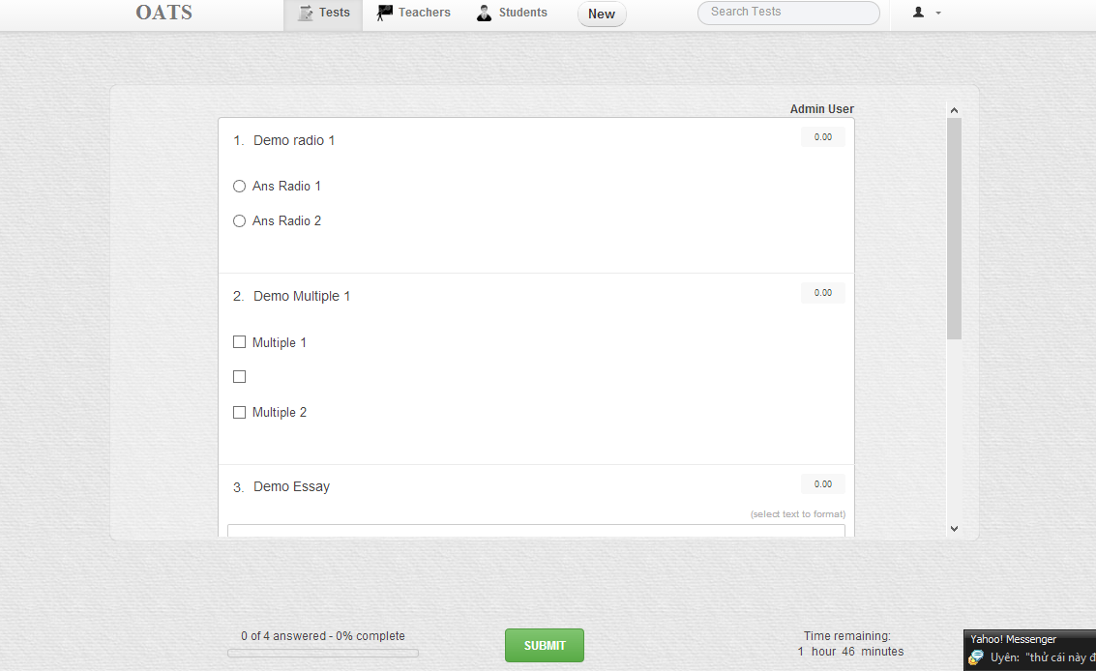

#### Objects and Actions

##### Data fields – Unit Quiz Screen

|  |  |  |  |  |  |  |
| --- | --- | --- | --- | --- | --- | --- |
| **Field No** | **Field name** | **Type** | **Mandatory** | **Data type** | **Max length** | **Description** |
| 1 | Unit Title | Text |  | String |  | Title of the unit lesson |
| 2 | Quiz Part | Link |  | String |  | All parts belongs to this unit quiz |
| 3 | Current Question | Text |  | String |  | Index of the current displayed question |
| 4 | Time | Text |  | Time |  | Remaining time before quiz is closed |
| 5 | Question No | Label |  | Number |  | Question number |
| 6 | Question | Text |  | String |  | Question's content |
| 7 | Answer List | List |  | Object |  | List of questions belong to one question |

##### Actions – Unit Lesson Screen

|  |  |  |  |  |  |
| --- | --- | --- | --- | --- | --- |
| **Field No** | **Field name** | **Type** | **Action** | **Description** | **Validation** |
| 2 | Quiz Part | Link | On click | Display content of selected unit quiz part |  |
| 8 | Previous | Button | On click | Go to previous unit quiz part Activate only when there's some parts before |  |
| 9 | Next | Button | On click | Go to next unit quiz part Activate only when there's some parts after |  |
| 10 | Submit | Button | On click | Submit user answer to server |  |