ASSIGNMENT 1: AWS INFRASTRUCTURE

- Create 2 repositories on github
https://github.com/haima24/sd1087_msa - Application code
https://github.com/haima24/sd1087_aws_infrastructure - Infrastructure code
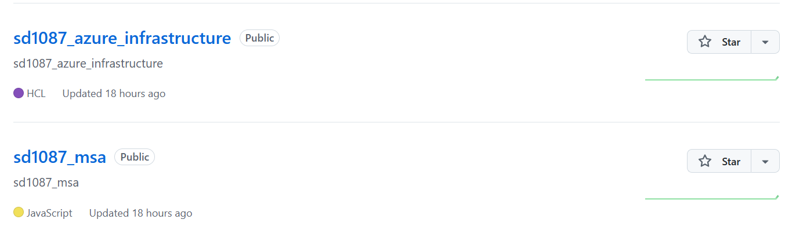

- Upload code to repo sd1087-msa
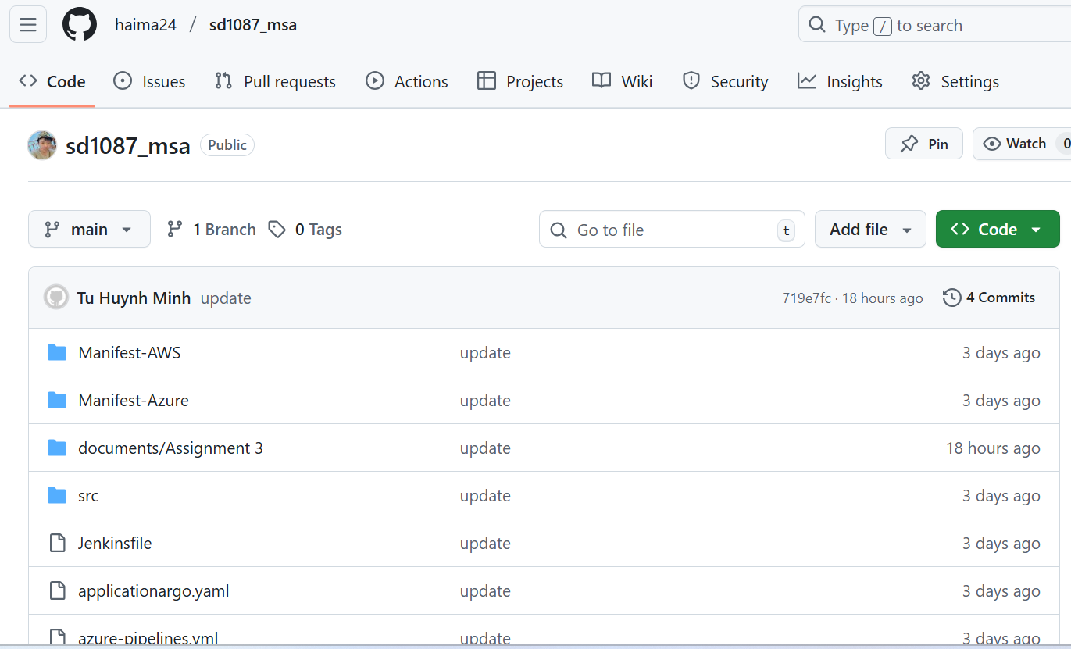

- In repo sd1087_aws_infrastructure
- Add 1 folder Provision

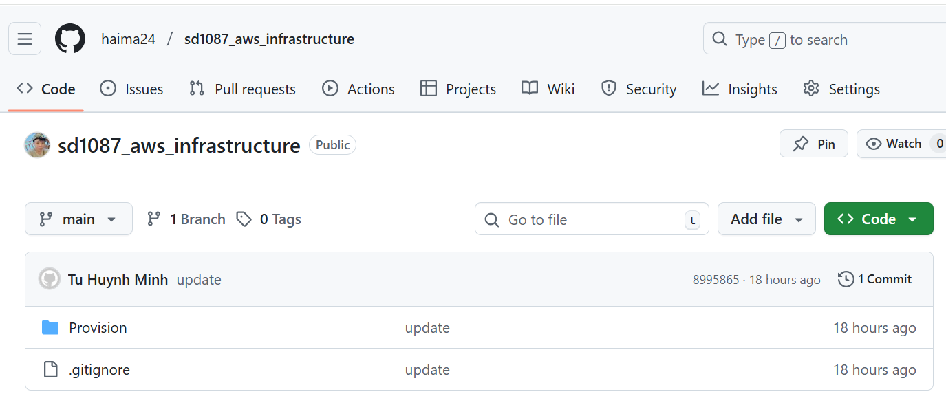

LOGIN into AWS
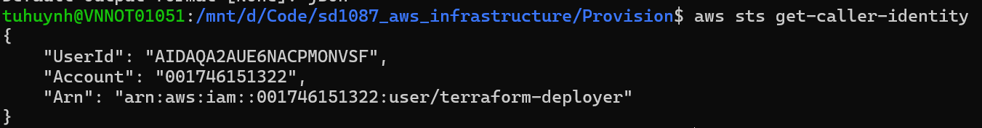

Inside folder Provision we have Terraform code to provision VPC, EC2, ECR, EKS

VPC
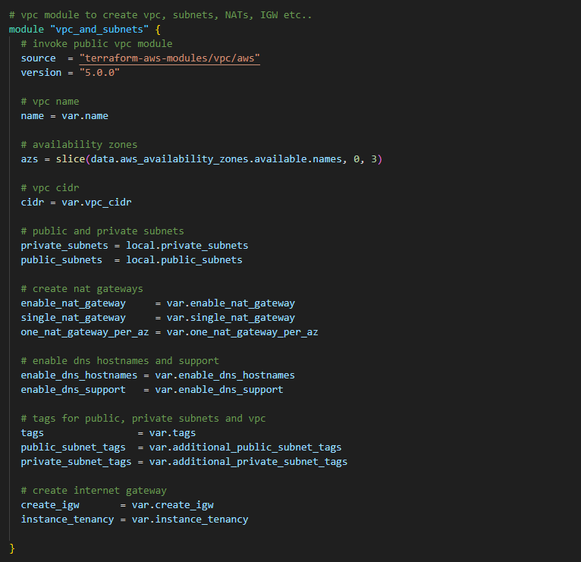

EC2 with user_data to install Docker, Jenkins
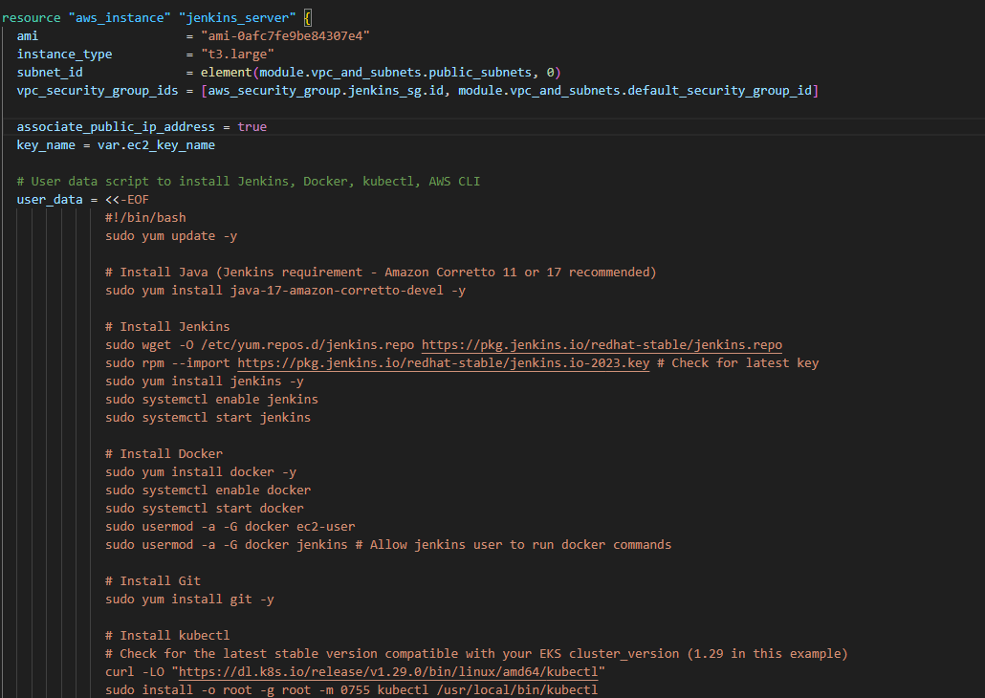

ECR
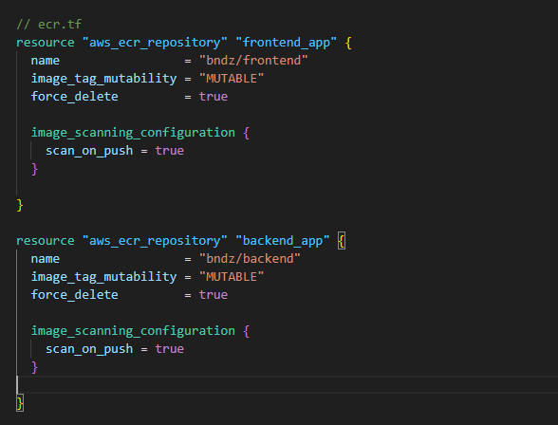

EKS
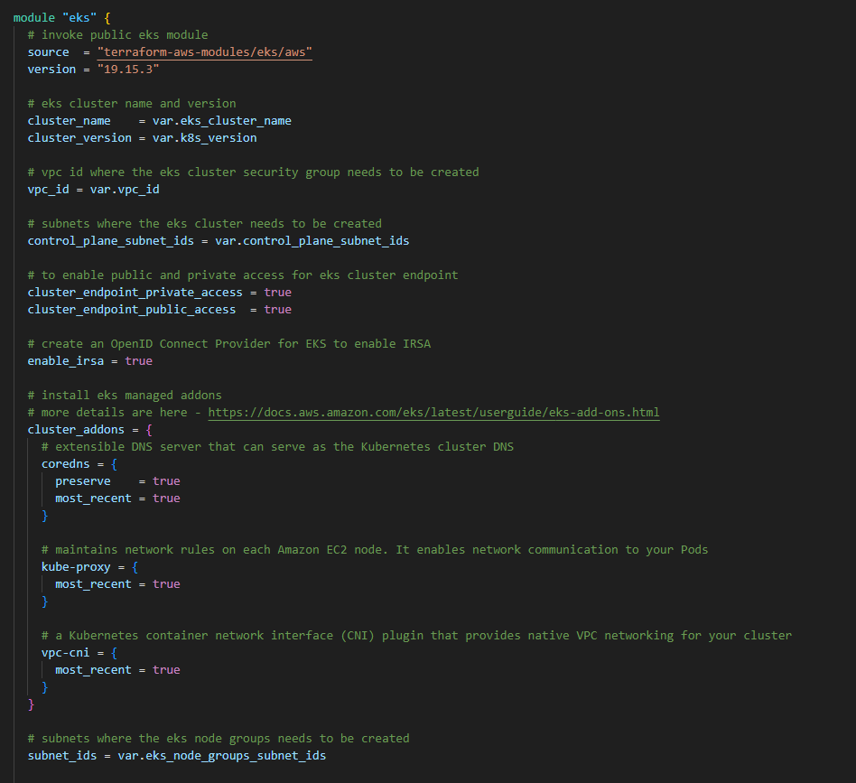

- Run Terraform command to create resource in AWS

Initialize:
terraform init
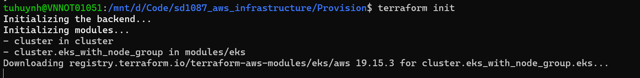
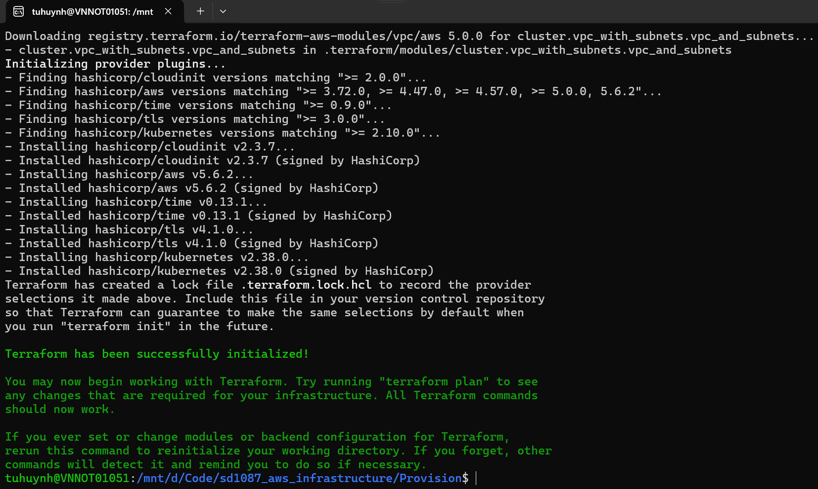

Format and Validate:
terraform fmt
terraform validate

Plan:
terraform plan -var-file="sample.tfvars"
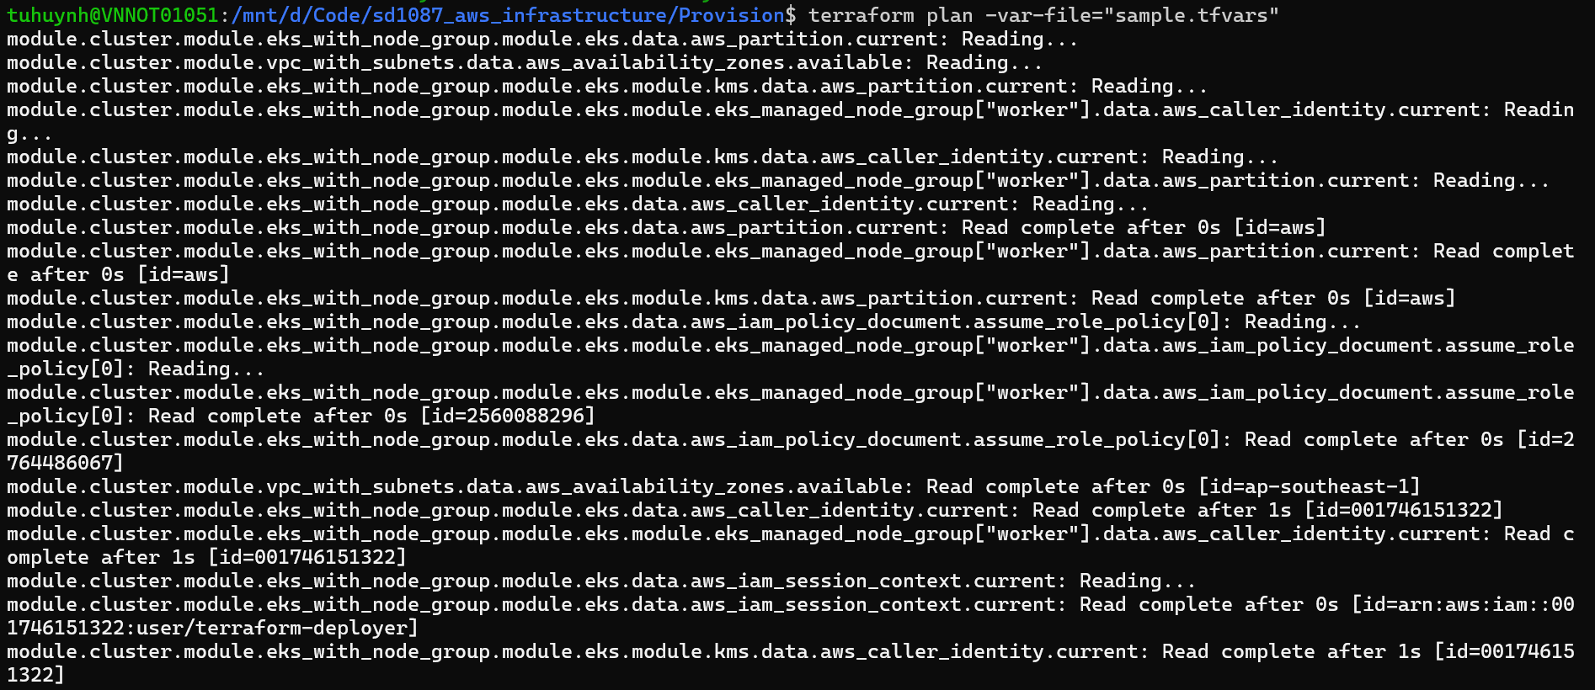

Apply
terraform apply -var-file="sample.tfvars"

After finish we will have these resources
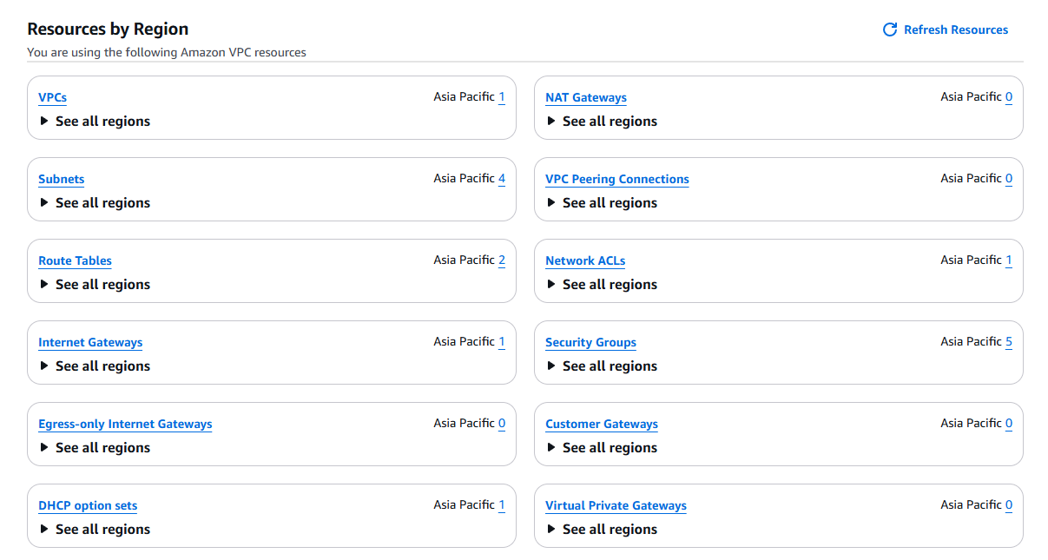

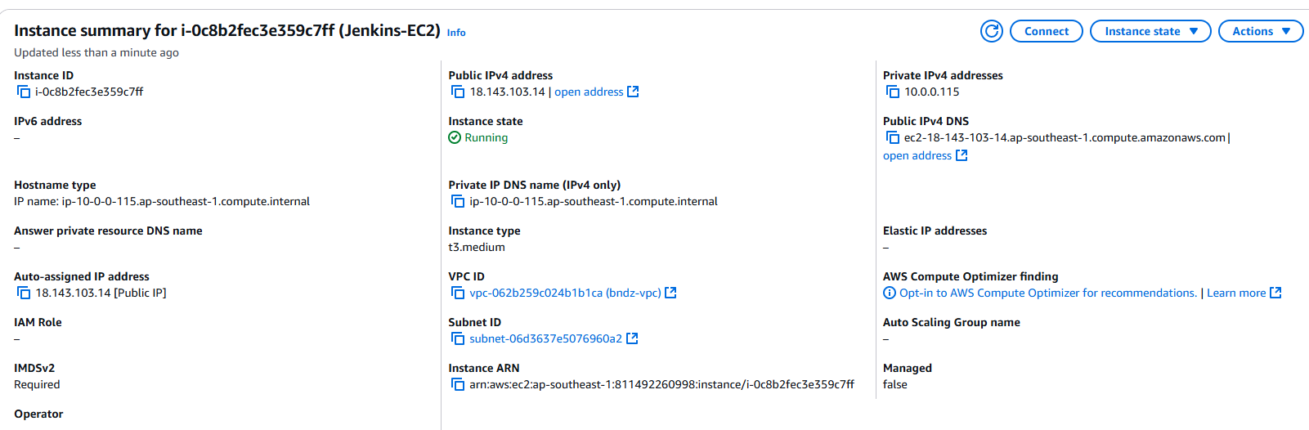

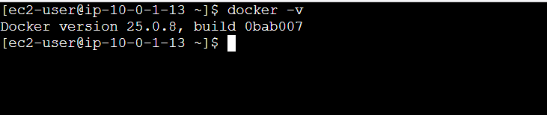

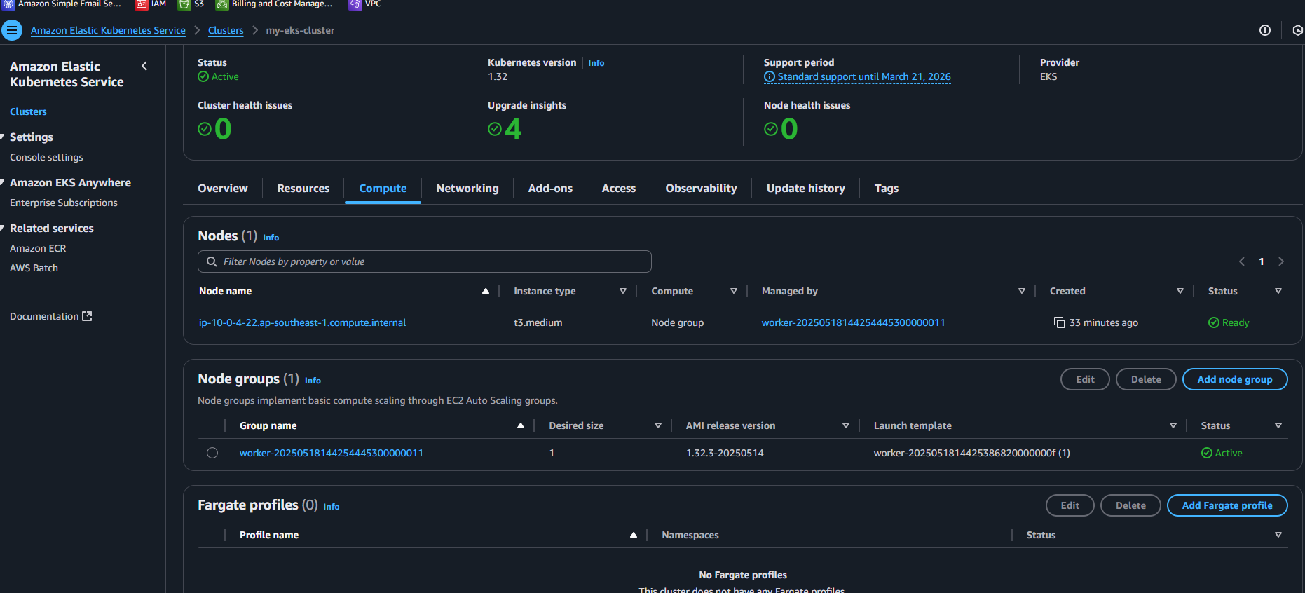

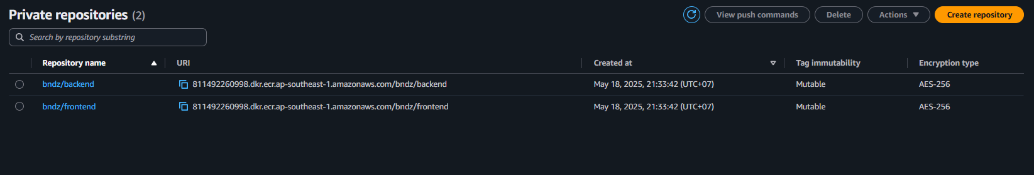

- Jenkins Installation and Configuration on EC2

Open your browser and navigate to http://47.129.239.20:8080/
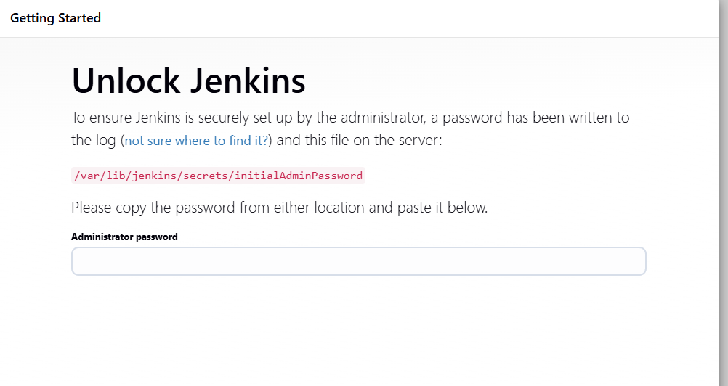

Unlock Jenkins: SSH into your Jenkins EC2 instance and get the initial admin password:
ssh -i bndz-key-pair.pem ec2-user@47.129.239.20
sudo cat /var/lib/jenkins/secrets/initialAdminPassword
Paste the password into the Jenkins UI
Click "Install suggested plugins."

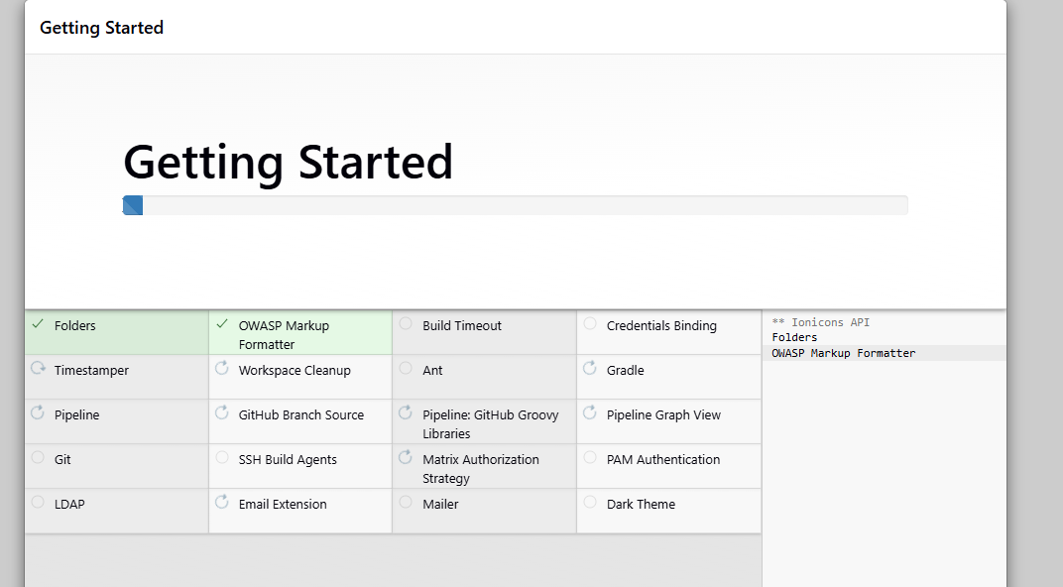

Create Admin User then go to Jenkins Dashboard
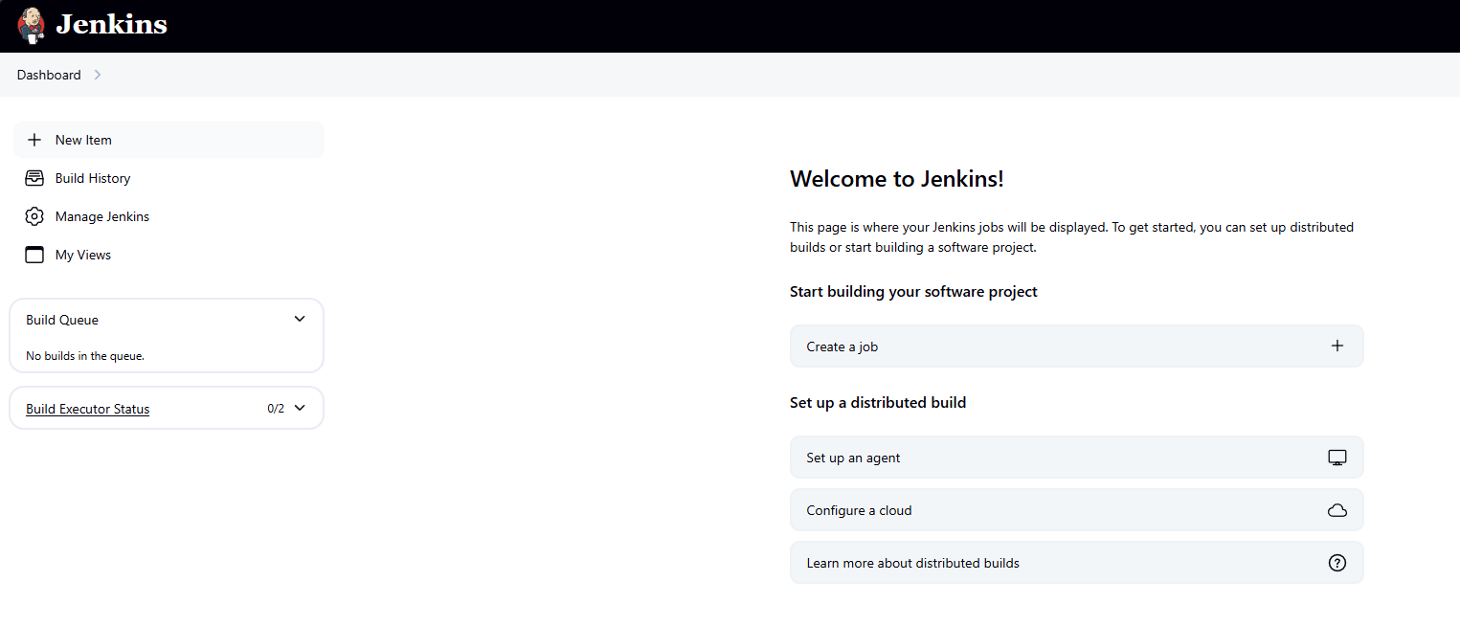

Next to Install Necessary Jenkins Plugins:
Go to "Manage Jenkins" > "Plugins" > "Available" tab.
Install:
- Docker Pipeline
- Kubernetes CLI
- Amazon ECR
- Pipeline: AWS Steps
- Git
- NodeJS Plugin
Restart Jenkins if prompted after installations.
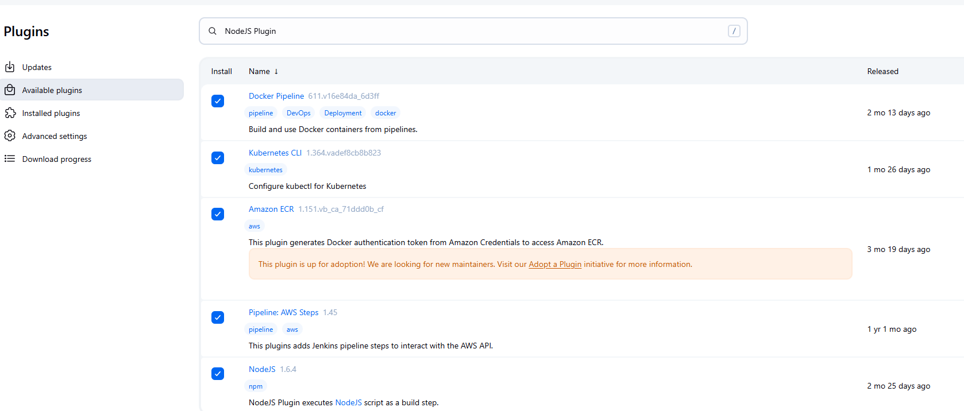

- Create Jenkin CI Pipeline
In github repo click Settings -> Click Web hook -> Fill Payload URL -> Save

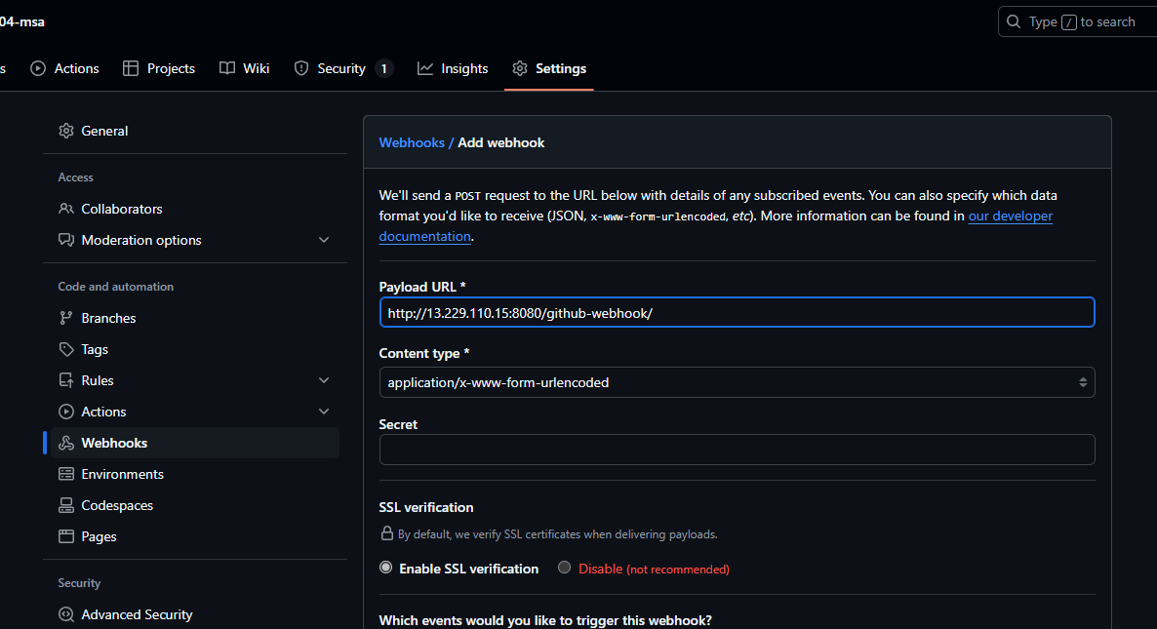

In Jenkins, click "New Item" -> Enter name “Jenkin-CI”
Select "Pipeline" and click "OK".

Tick Github hook trigger for GITScm polling
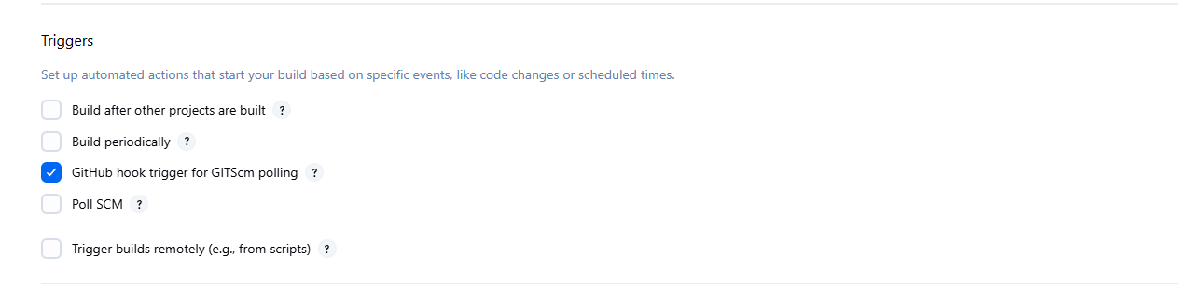

Select SCM -> Fill github repo -> Branch */main
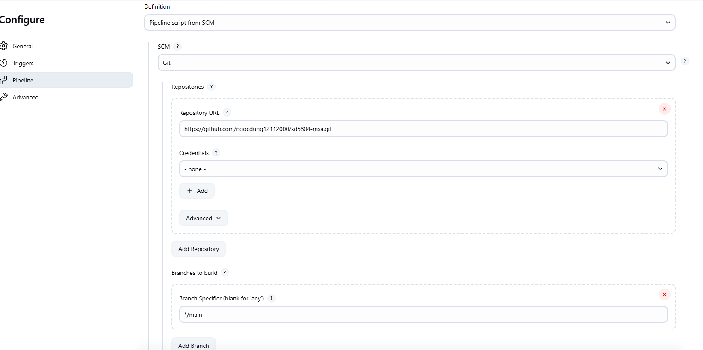

Script Path: Jenkinsfile
Save the job.

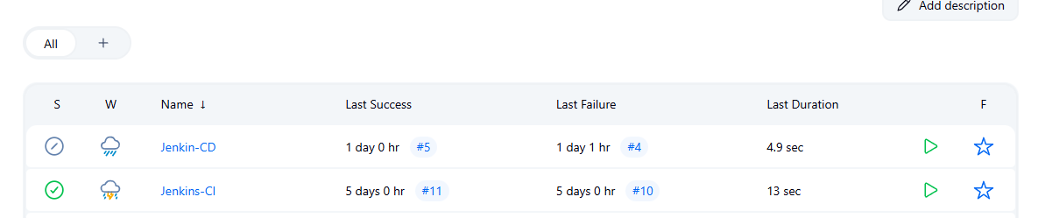

- Add commit to test Jenkins-CI pipeline through webhook

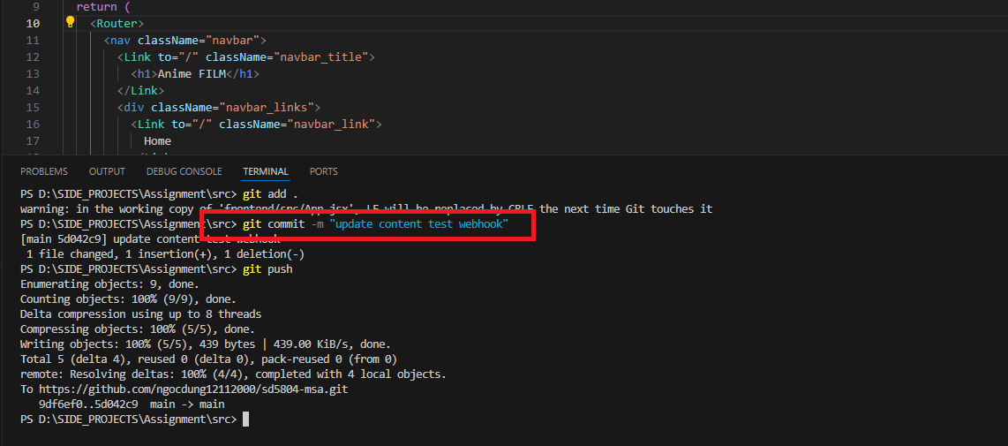

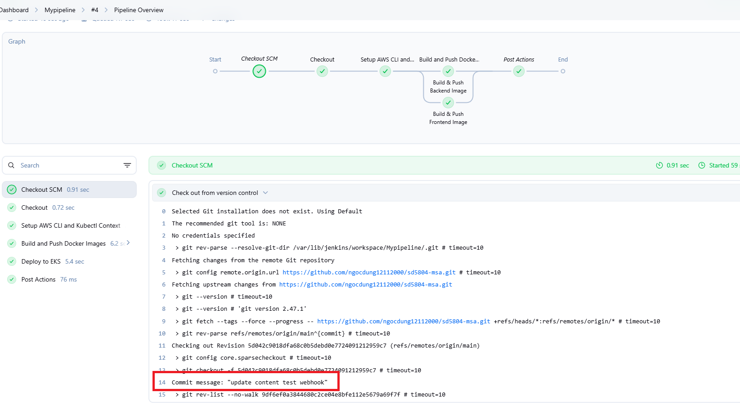

- Click build now in Jenkin-CD to deploy to EKS


Connect to Jenkin server instance
run command kubectl get services
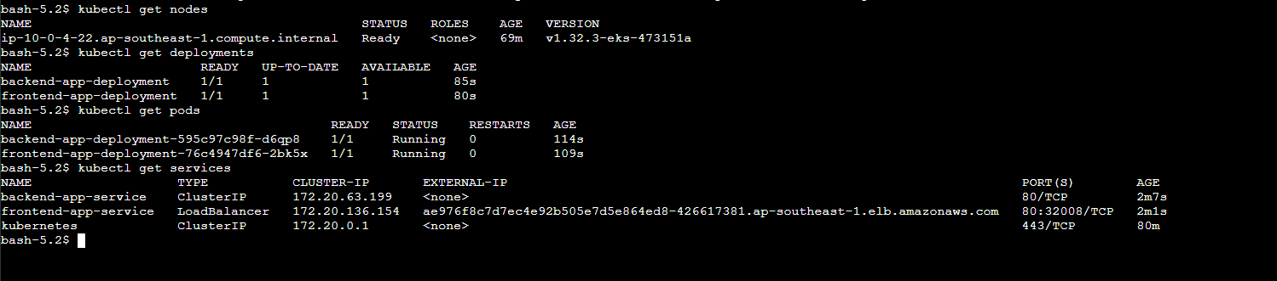

Copy external IP in frontend-app-service -> Paste to browser

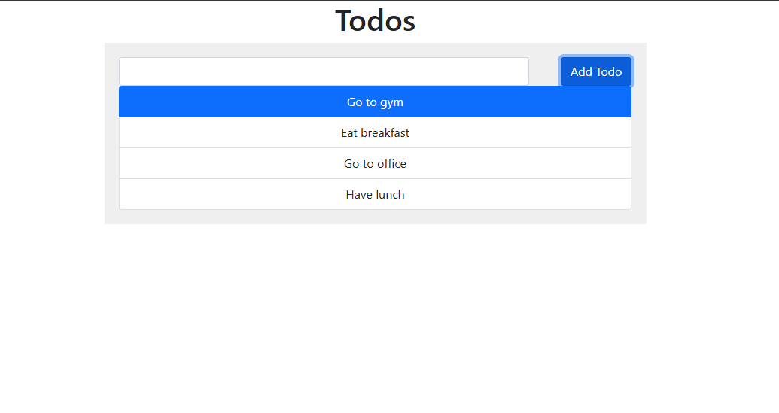

- Set up Prometheus and Grafana

Run command to connect EKS cluster
aws eks update-kubeconfig --region "ap-southeast-1" --name "my-eks-cluster"

- Set up Metrics Server
Deploy the Metrics Server with the following command:
kubectl apply -f https://github.com/kubernetes-sigs/metrics-server/releases/latest/download/components.yaml

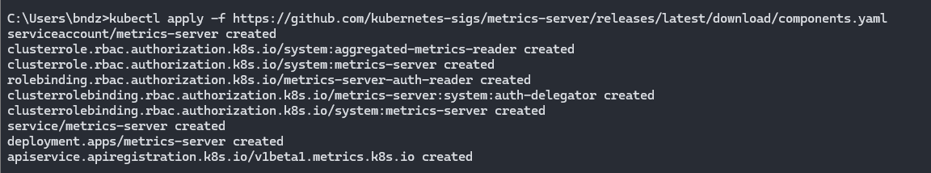

Verify that the metric-server
kubectl get deployment metrics-server -n kube-system
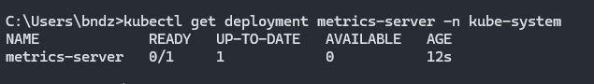

- Deploy Prometheus using Helm
Create a Prometheus namespace.
kubectl create namespace prometheus

Add the prometheus-community chart repository.
helm repo add prometheus-community https://prometheus-community.github.io/helm-charts

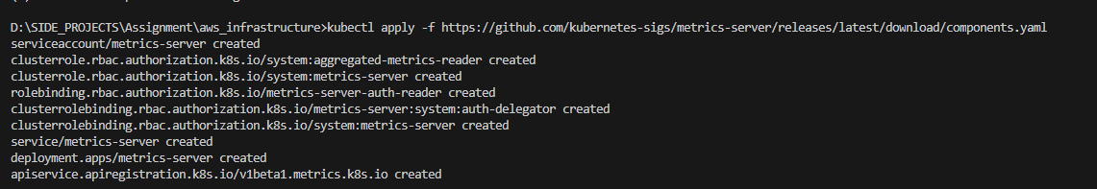

Install prometheus
helm install prometheus prometheus-community/prometheus
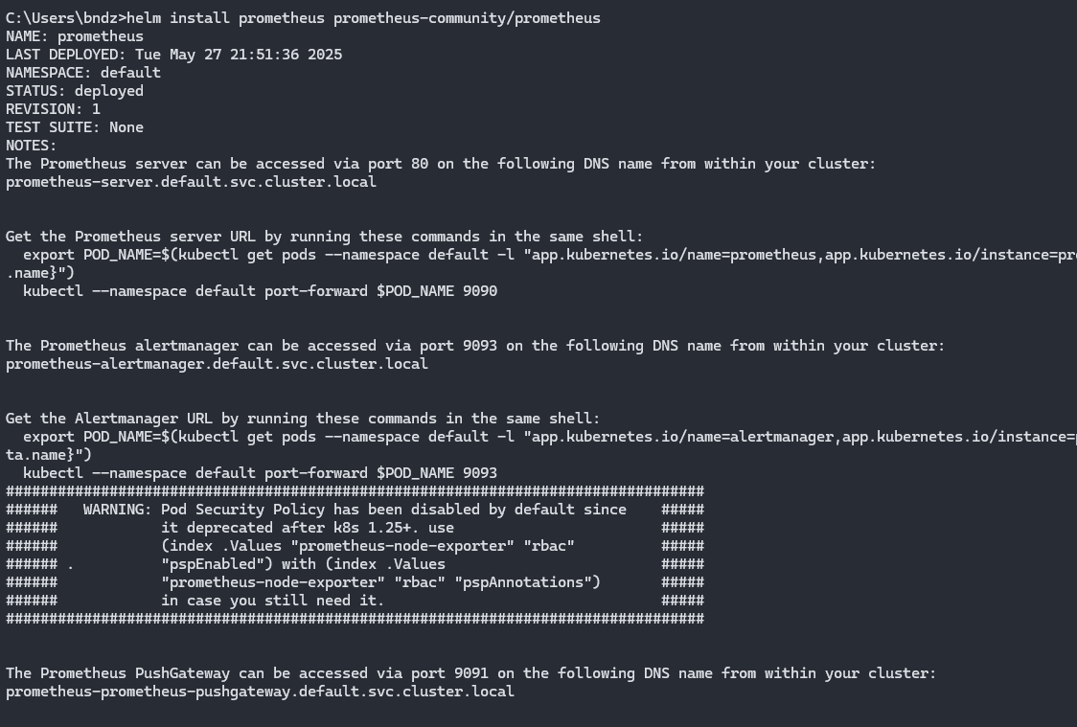

kubectl get pods
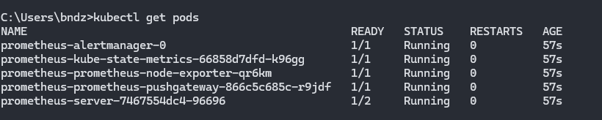

Expose service prometheus
kubectl expose service prometheus --type=NodePort --target-port=9090 --name=prometheus-server-ext

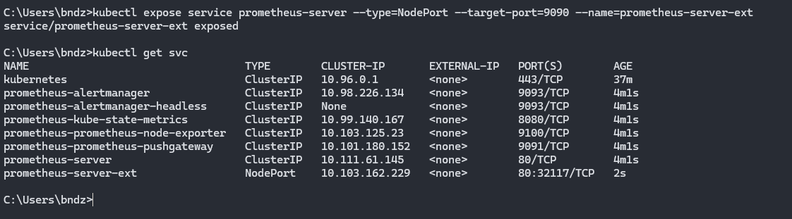

Open in browser
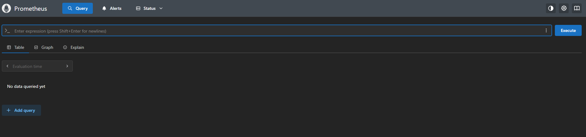

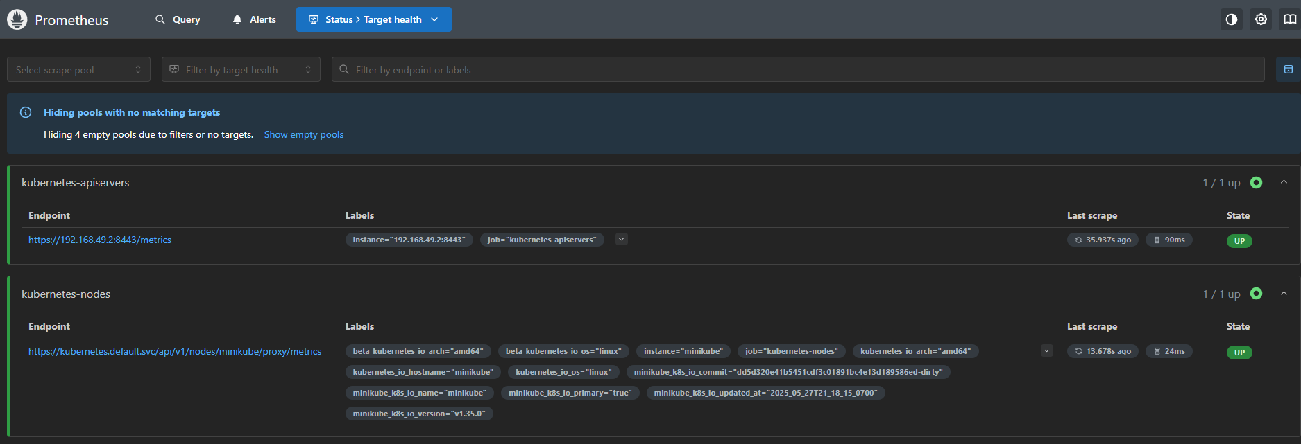
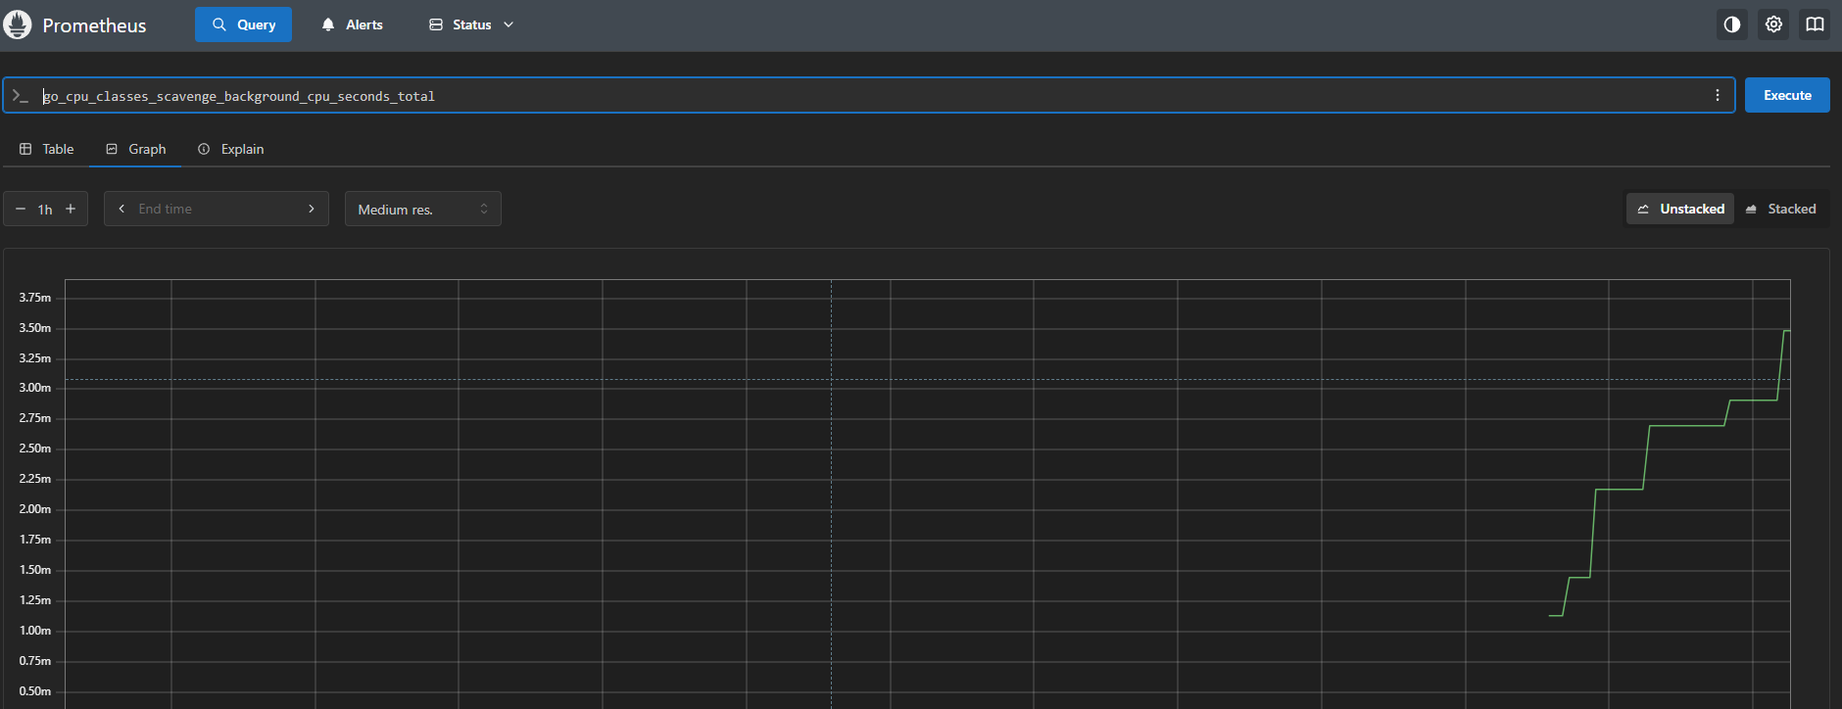

Install grafana
Add repo
helm repo add grafana https://grafana.github.io/helm-charts

Install
helm install my-grafana grafana/grafana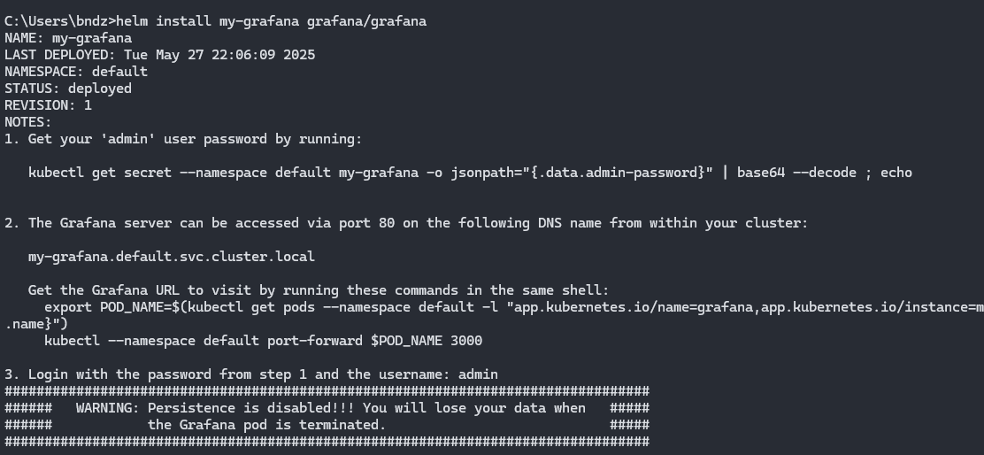

Expose grafana service
kubectl expose service my-grafana --type=NodePort --target-port=3000 --name=grafana-ext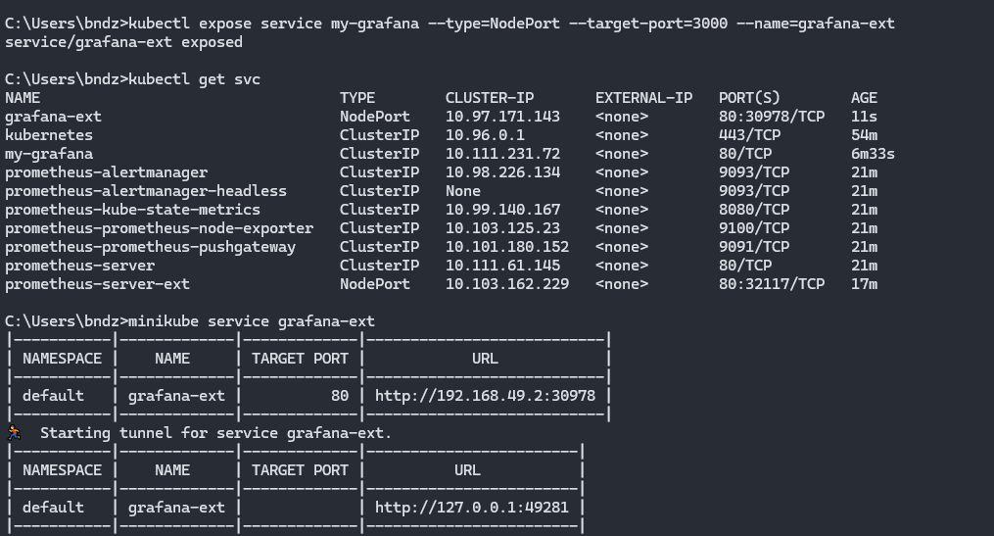

Get secret
kubectl get secret --namespace monitoring my-grafana -o jsonpath="{.data.admin-password}" | base64 --decode ; echo

-> Password: CUnxmrxBuKFcWUm8HERWxZbqgRQiB2a2ruOr1VVn

Open browser
Login with
username: admin
password: CUnxmrxBuKFcWUm8HERWxZbqgRQiB2a2ruOr1VVn
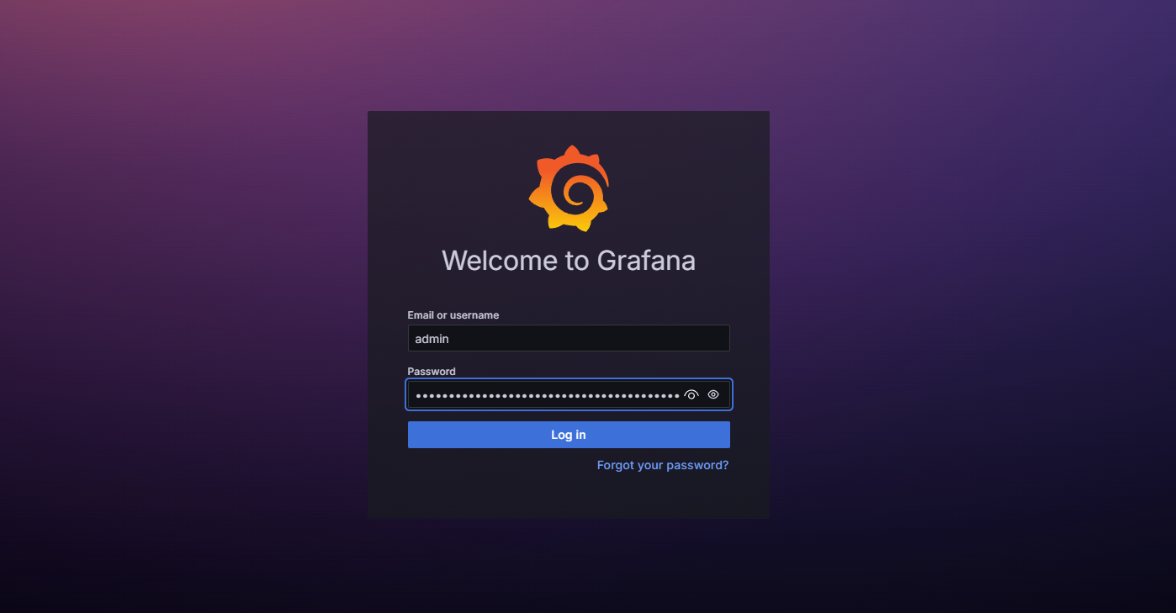

Add first data
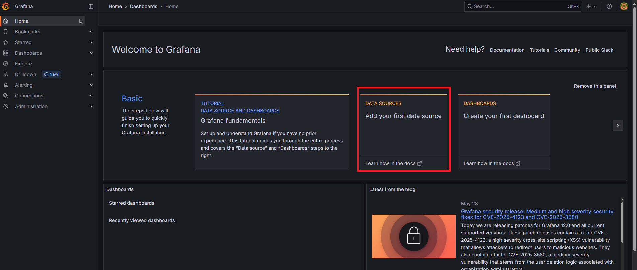

Select Prometheus
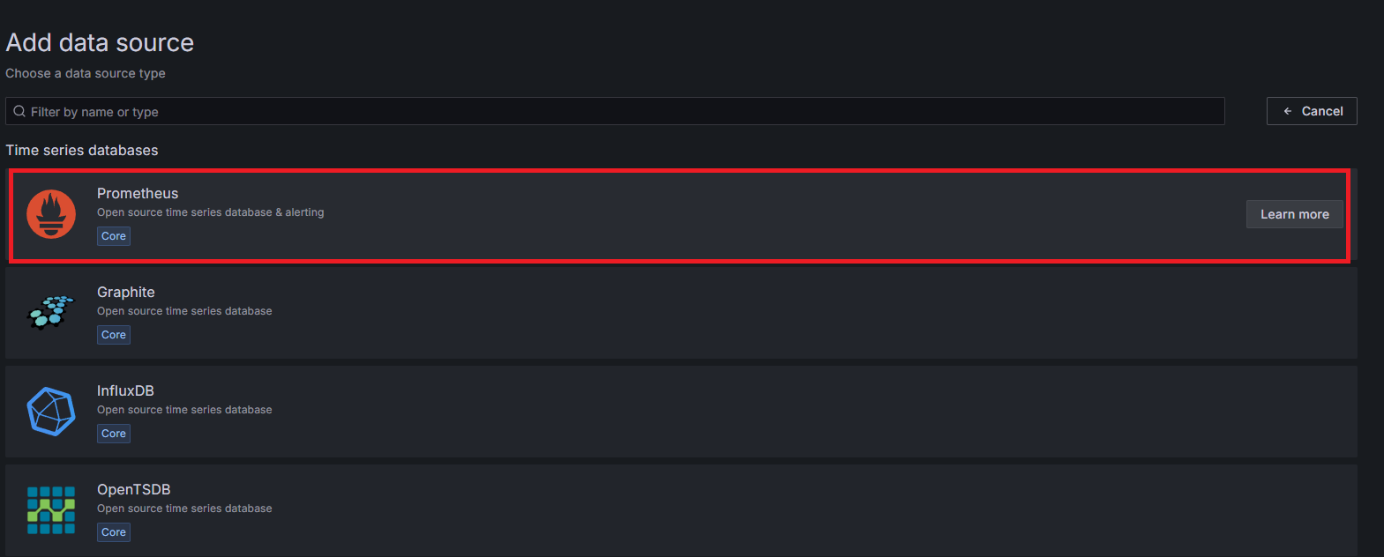

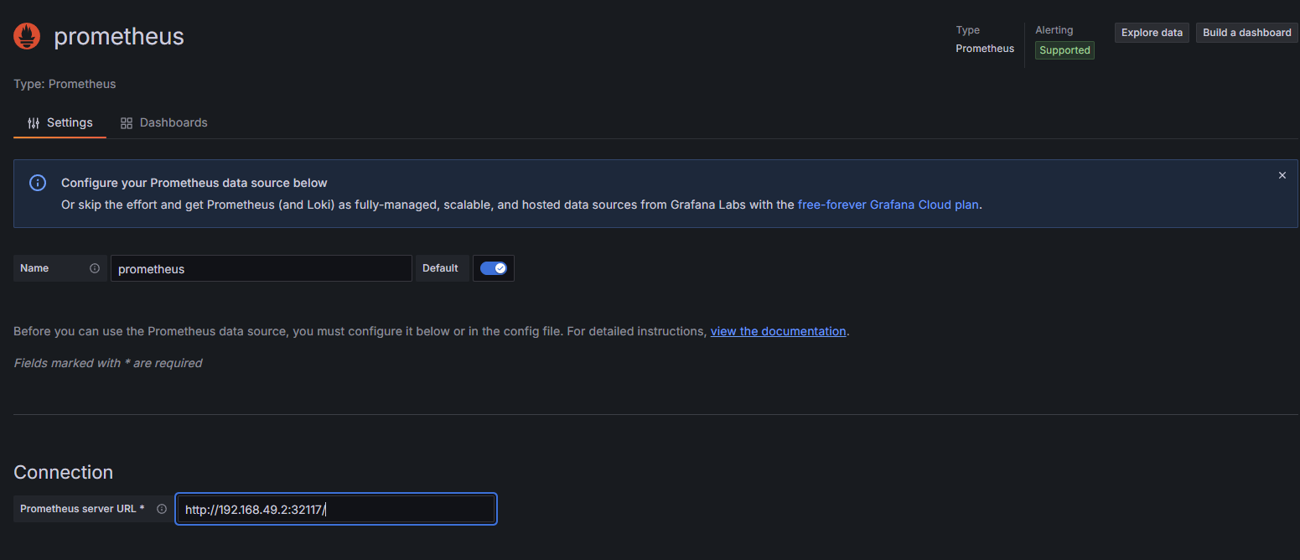

Import dashboard

