

MEKELLE UNIVERSITY
MEKELL INSTITUTE OF TECHNOLOGY(MIT)

DATA BASE MANAGEMENT SYSTEM GROUP PROJECT

Course code:
Department: Cse 3rd year
Academic year:2018

Group-1 members:

no | Student name | Student id
01 | Haimanot Gebrekidan | Ugr/190730/16
02 | Shewit Selomun | Mit/ur/190627/16
03 | Meseret yemane | Mit/ur/188375/16
04 | Mahder Halefom | Mit/ur/188468/16
05 | Bereket Hadush | Mit/ur/190689/16

project title: library management system

this project is about library management system it specifies the ER diagram, entities relationship and the MySQL code to implement how the libraries system is work. and how the data are Stord on database and managed easily by the managements.

Here below how some steps how we can prepare the library system
Step 1: understand the project and identify what are entries used in the library system.
Step 2: what are the characteristics or attributes of each entity in the system.

Step 3: identify the what is the relationships between the entities Step 4: Drow the ER diagram
Step 5: convert the ER diagram in to relation using all the rules of how to convert ER diagram to a relation.
Step 6: write MySQL code to implement the system

Step 1: identify the appropriate entities for the library system project based on this We have six entries.

1, library: - has an attribute such as library name as primary key, library address, library contact number.
2, librarian: - has an attribute librarian code, librarian name, resignation, contact number, date of birth, age.
3, publisher: - has an attribute like publisher code, publisher name, publisher address.
4, Books: - has an attribute book code, user id, book price, book status, published date.
5, members: - has an attribute user id, name (first name, middle name, last name), address, contact number.
6, authors: - has an attribute author code, author contact number, author name.

Then when the members borrow a book it has due date, return date, issue (for what reason do take the book).

Based on this information we have the following ER diagram.

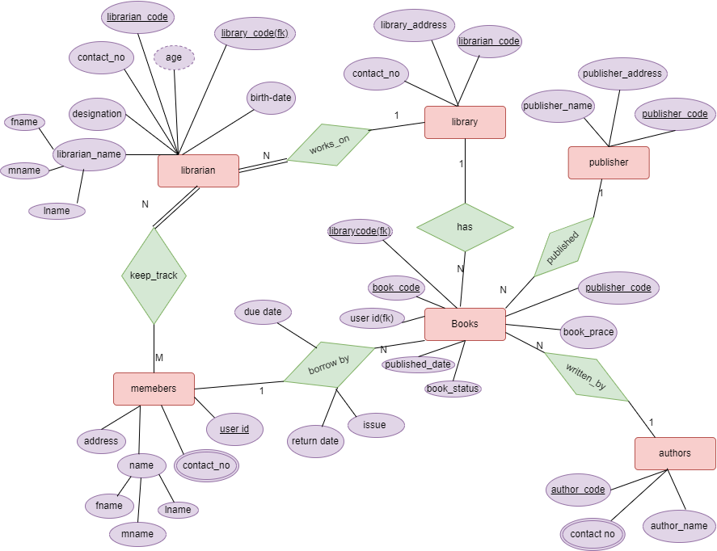

Figure 1.: library system ER diagram.

Then equivalent relational model for the above ER diagram is here below.

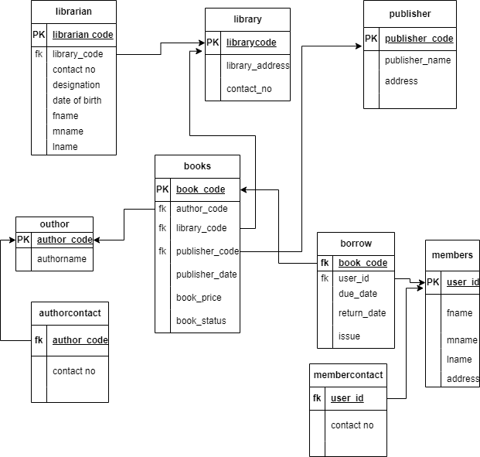

Figure 2:relational model for library system

The MySQL equivalent code is here below.

CREATE DATABASE librarysystem;
USE librarysystem;

-- Library Table
CREATE TABLE library (
library_code VARCHAR(25) NOT NULL PRIMARY KEY,
library_address VARCHAR(50),
contact_no VARCHAR(25)
);

-- Librarian Table
CREATE TABLE librarian (
librarian_code VARCHAR(30) NOT NULL PRIMARY KEY,
fname VARCHAR(50),
mname VARCHAR(50),
lname VARCHAR(50),
library_code VARCHAR(30),
contact_no VARCHAR(60),
designation VARCHAR(120),
date_of_birth VARCHAR(30),
FOREIGN KEY (library_code) REFERENCES library(library_code)
);

-- Publisher Table
CREATE TABLE publisher (
publisher_cod VARCHAR(30) NOT NULL PRIMARY KEY,
publisher_name VARCHAR(50),
address VARCHAR(50)
);

-- Members Table
CREATE TABLE members (
user_id VARCHAR(30) NOT NULL PRIMARY KEY,
m_fname VARCHAR(50),
m_mname VARCHAR(50),
m_lname VARCHAR(50),
m_address VARCHAR(50)
);

-- Member Contact Table
CREATE TABLE membercontact (
user_id VARCHAR(30) NOT NULL,
contact_no VARCHAR(30),
FOREIGN KEY (user_id) REFERENCES members(user_id)
);

-- Author Table
CREATE TABLE author (
author_code VARCHAR(45) NOT NULL PRIMARY KEY,
author_name VARCHAR(50)
);

-- Author Contact Table
CREATE TABLE authorcontact (
author_code VARCHAR(45) NOT NULL,
contact_no VARCHAR(50),
FOREIGN KEY (author_code) REFERENCES author(author_code)
);

-- Books Table
CREATE TABLE books (
book_code VARCHAR(45) NOT NULL PRIMARY KEY,
author_code VARCHAR(45),
library_code VARCHAR(25),
publisher_cod VARCHAR(30),
publish_date VARCHAR(50),
book_price DECIMAL(8,2),
book_status VARCHAR(120),
FOREIGN KEY (author_code) REFERENCES author(author_code),
FOREIGN KEY (library_code) REFERENCES library(library_code),
FOREIGN KEY (publisher_cod) REFERENCES publisher(publisher_cod)
);

-- Borrow Table
CREATE TABLE borrow (
book_code VARCHAR(45),
user_id VARCHAR(30),
due_date VARCHAR(25),
return_date VARCHAR(25),
issue VARCHAR(120),
FOREIGN KEY (book_code) REFERENCES books(book_code),
FOREIGN KEY (user_id) REFERENCES members(user_id)
);

-- Insert Library Data
INSERT INTO library VALUES
('mit-104','mit campus','mitlibrary@gmail.com'),
('mit-102','arid campus','aridlibrary@gmail.com'),
('mit-103','ayder campus','ayderlibrary@gmail.com');

-- Insert Librarian Data
INSERT INTO librarian VALUES
('M001','kidane','mebrahtu','negash','mit-104','0956365414','manager','19-05-1999'),
('A001','mengesha','meresa','negash','mit-102','0964532356','manager','29-08-2009'),
('AY001','ksanet','megersa','mekonen','mit-103','0976845332','manager','06-05-1985'),
('M002','letemeskel','mebrahtu','fkadu','mit-104','0956443356','member','19-05-2010'),
('A002','kdst','muugeta','asmelash','mit-104','0956376543','member','16-08-2011'),
('AY002','somhal','kebede','abebe','mit-102','0955764646','member','17-03-2012');

-- Insert Publisher Data
INSERT INTO publisher VALUES
('201','d.r ankle norge','USA'),
('202','mamo noh','addis abeba'),
('203','sbhat g/heir','mekelle'),
('204','d.r kudus belay','bahrdar'),
('205','taka abebe','axum'),
('206','samrawit mulu','wdawa');

-- Insert Members
INSERT INTO members VALUES
('301','mesel','nega','girmay','aynalem campus'),
('302','mebrat','teklu','girmay','aynalem campus'),
('303','temesgen','mulu','welu','ayder campus'),
('304','meresa','nega','tsehaye','arid campus'),
('305','abebe','mola','girmay','arid campus'),
('306','teklit','welu','guesh','ayder campus');

-- Insert Member Contacts
INSERT INTO membercontact VALUES
('301','0974653232'),
('302','0975564247'),
('301','09788743'),
('302','0974653232'),
('301','065382990'),
('303','0974321635'),
('304','098754346'),
('305','0954635346'),
('301','0974653443'),
('306','0976454654');

-- Insert Authors
INSERT INTO author VALUES
('401','tesfu beley'),
('402','seyfe beyene'),
('403','mulu kasa'),
('404','mututs beruhu'),
('405','ayale abebe'),
('406','tekeste nru');

-- Insert Author Contacts
INSERT INTO authorcontact VALUES
('401','0976343565'),
('402','0975666553'),
('401','0976968764'),
('403','0977553542'),
('404','0973543227'),
('405','0985765986'),
('406','0976348554'),
('406','0977456542'),
('403','0976765540');

-- Insert Books
INSERT INTO books VALUES
('11','401','mit-104','201','2008',150.23,'social science'),
('22','402','mit-102','202','2009',405.76,'natural science'),
('33','403','mit-103','203','2002',202.54,'maths science'),
('44','404','mit-104','204','2003',654.63,'natural science'),
('55','405','mit-102','205','2010',259.23,'social science'),
('66','406','mit-103','206','2011',645.23,'psychology');

-- Insert Borrow Records
INSERT INTO borrow VALUES
('11','301','13-06-2016','03-08-2016','for reading'),
('22','302','23-04-2016','23-05-2016','for teaching'),
('33','303','23-04-2016','23-05-2016','for homework'),
('44','304','23-05-2016','23-06-2016','for reading'),
('55','305','23-07-2016','23-08-2016','for reading');

SELECT * FROM author;

THE END!

