External Project Report on
Modern Computing Systems Design
(CSE 2221)

Design and Implementation of a One-Accumulator Assembly Language Interpreter in Python


Submitted by
Name 01 Srijoni Ghosh | Reg. No.: | 24E107A23
Name 02 Ayantika Jana | Reg. No.: | 24E110A09
Name 03 Alankruta Mishra | Reg. No.: | 24E113B07
Name 04 Sneha Kumari Poddar | Reg. No.: | 24E116C68
B. Tech. CSE (Specialization) 3rd Semester (Section – 24E1O2)
INSTITUTE OF TECHNICAL EDUCATION AND RESEARCH
(FACULTY OF ENGINEERING)
SIKSHA ‘O’ ANUSANDHAN (DEEMED TO BE UNIVERSITY), BHUBANESWAR,
ODISHA

Declaration
We, the undersigned students of B. Tech. of (Write your Branch) Department, hereby declare that we own the full responsibility for the information, results etc. provided in this PROJECT titled “(TOPIC NAME)” submitted to Siksha ‘O’ Anusandhan Deemed to be University, Bhubaneswar for the partial fulfillment of the subject Modern Computing Systems Design (CSE2221). We have taken care in all respect to honor the intellectual property right and have acknowledged the contribution of others for using them in academic purpose and further declare that in case of any violation of intellectual property right or copyright we, as the candidate(s), will be fully responsible for the same.

(Student’s Signature1)  Name: Srijoni Ghosh  Registration No.: 24E107A23 | (Student’s Signature3)  Name: Alankruta Mishra  Registration No.: 24E113B07
(Student’s Signature2)  Name: Ayantika Jana  Registration No.: 24E110A09 | (Student’s Signature4)  Name: Sneha Kumari Poddar  Registration No.: 24E116C68

DATE:
PLACE:

Abstract
(to be written in one paragraph with 100 – 200 words)
This project focuses on the design and implementation of a simple interpreter for an assembly-like language based on a one-accumulator machine architecture using Python. The machine model consists of a single register, known as the accumulator, while all operands are stored in memory locations. The interpreter supports a basic instruction set including arithmetic operations (ADD, SUB, MUL, DIV), logical operations (AND, OR, NOT), and data transfer instructions (LD, ST). The primary objective of this work is to simulate low-level instruction execution and demonstrate how assembly instructions are decoded, executed, and reflected in changes to the accumulator and memory. Memory is modelled using a high-level data structure, and instructions are processed sequentially to mirror real machine execution. This interpreter provides a clear understanding of accumulator-based CPU design and serves as an educational tool for learning fundamental concepts of computer organization, instruction execution, and interpreter construction using a high-level programming language.

Contents

Serial No. | Title of the Chapter | Page No.
 | Introduction | 1
 | Problem Statement | 2
 | System Architecture | 3
 | Instruction set description | 4
 | CPU Execution Model | 5
 | Program Implementation | 6
 | Sample Program and Output | 8
 | Limitations | 12
 | Future Enhancements | 13
 | Conclusion | 14
 | References | 15

1. Introduction
(Write a Brief Introduction of the project)
Assembly language interpreters play an important role in understanding how high-level instructions are translated into low-level machine operations. A one-accumulator machine represents one of the simplest processor architectures, where all computations are performed using a single register and memory-based operands. Studying such a model helps in grasping fundamental concepts of computer organization, instruction execution, and data manipulation. This project presents a brief and clear implementation of a one-accumulator assembly language interpreter using Python. By simulating instruction execution step by step, the interpreter demonstrates how arithmetic, logical, and data transfer operations affect the accumulator and memory. The simplicity of the design makes it suitable for educational purposes and provides a foundation for understanding more complex CPU architectures and interpreter designs.

2. Problem Statement
(write objectives of the design)

The objective of this project is to design and implement an interpreter in Python for a simple assembly language based on a one-accumulator machine architecture. The machine contains only a single register, called the accumulator, and all data operands reside in memory locations. The interpreter must be capable of reading and executing a predefined set of instructions, including arithmetic, logical, and data transfer operations, by appropriately updating the accumulator and memory contents. The challenge lies in accurately simulating low-level instruction execution, decoding opcodes, handling memory access, and maintaining correct execution flow. This problem aims to provide practical insight into how basic processor architectures operate and how assembly-level instructions are interpreted using a high-level programming language.

3. System Architecture
(Include Block Diagram/ Flow chart of your design)

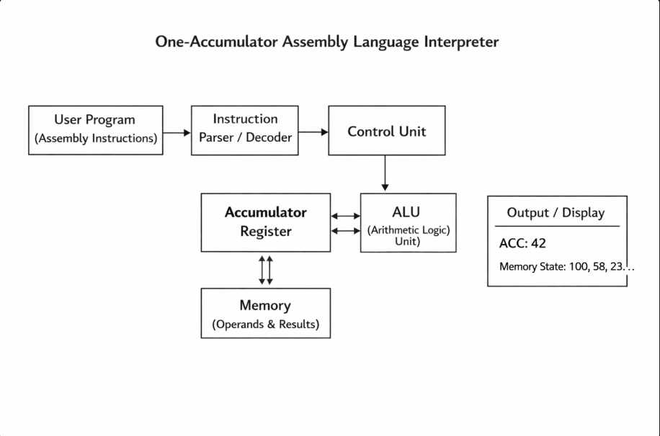

4. Instruction Set Description

(Description of Instructions)

The one-accumulator machine supports a small and well-defined set of instructions designed to perform data movement, arithmetic operations, and logical operations using a single register called the accumulator (ACC). All instructions operate sequentially, and operands are always referenced from memory locations. The LD (Load) instruction loads the contents of a specified memory location into the accumulator, while ST (Store) saves the current value of the accumulator back to a given memory address. Arithmetic instructions such as ADD, SUB, MUL, and DIV perform addition, subtraction, multiplication, and division respectively between the accumulator and a memory operand, storing the result in the accumulator. Logical instructions including AND and OR carry out bitwise logical operations between the accumulator and memory data, whereas NOT performs a unary bitwise complement on the accumulator itself. This simple instruction set effectively demonstrates how basic computations and data handling are achieved in accumulator-based processor architectures.

5. CPU Execution model
(write about CPU execution Cycles)
- The CPU follows a repetitive sequence of steps known as the instruction execution cycle.
- Fetch Phase: The CPU fetches the next instruction from memory using the Program Counter (PC).
- Decode Phase: The fetched instruction is decoded to identify the opcode and the required operation. The CPU determines whether a memory operand is needed.
- Execute Phase: The specified operation is performed using the accumulator and memory data. Arithmetic and logical results are stored in the accumulator. Store instructions update the contents of memory.
- Update Phase: The Program Counter is incremented to point to the next instruction.
- The cycle repeats until all instructions in the program are executed.

6. Program Implementation
(Write the Program)
class AccumulatorMachine:
def __init__(self, memory):
self.ACC = 0 # Accumulator
self.memory = memory # Memory dictionary

def execute(self, program):
for instruction in program:
parts = instruction.split()
opcode = parts[0]
operand = int(parts[1]) if len(parts) > 1 else None

if opcode == "LD":
self.ACC = self.memory.get(operand, 0)
elif opcode == "ST":
self.memory[operand] = self.ACC
elif opcode == "ADD":
self.ACC += self.memory.get(operand, 0)
elif opcode == "SUB":
self.ACC -= self.memory.get(operand, 0)
elif opcode == "MUL":
self.ACC *= self.memory.get(operand, 0)
elif opcode == "DIV":
if self.memory.get(operand, 0) == 0:
print("Error: Division by zero")
return
self.ACC //= self.memory.get(operand, 0)

elif opcode == "AND":
self.ACC &= self.memory.get(operand, 0)
elif opcode == "OR":
self.ACC |= self.memory.get(operand, 0)
elif opcode == "NOT":
self.ACC = ~self.ACC
else:
print("Invalid Instruction")
return

print(f"{instruction} -> ACC = {self.ACC}")

memory = {
100: 10,
101: 5,
102: 0
}
program = [
"LD 100",
"ADD 101",
"MUL 101",
"ST 102",
"NOT"
]
machine = AccumulatorMachine(memory)
machine.execute(program)

print("Final Memory Contents:", memory)

7. Results & Interpretation
1. Paste the screenshot of Program
2. Screenshot of the results with different input values(minimum 4/5)
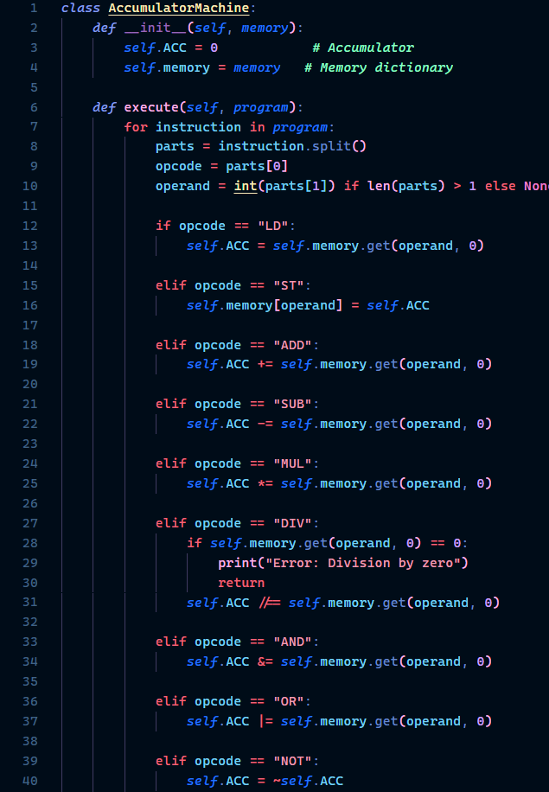

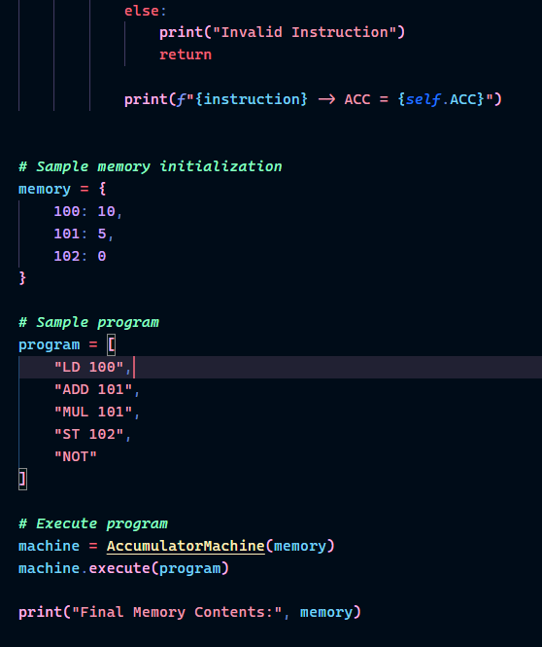

Test Case 1:
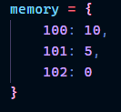
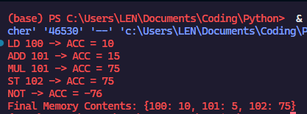
Test Case 2:
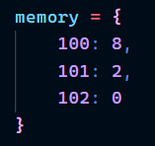
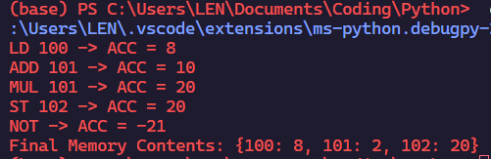

Test Case 3:
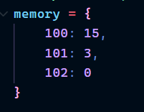
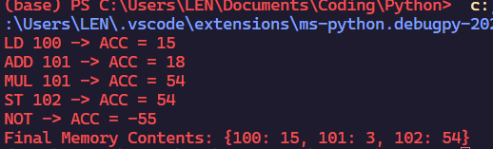
Test Case 4:
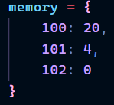
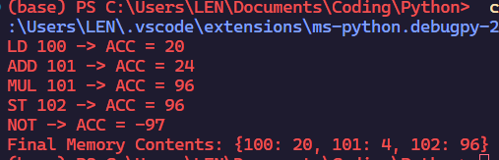

8. Limitations
If any
- The one-accumulator architecture uses only a single register, which limits performance and makes complex computations less efficient.
- The instruction set is minimal and does not support advanced operations such as conditional branching, loops, or function calls.
- All operands must be accessed from memory, increasing memory access time compared to multi-register architectures.
- The interpreter executes instructions sequentially without optimization, making it unsuitable for large or complex programs.
- Error handling is basic and does not cover all possible runtime or logical errors.
- The system is designed for educational purposes and does not represent a complete or real-world processor implementation.

- Future Enhancements

- The instruction set can be extended to include control flow operations such as conditional branching, looping instructions, and jump statements to support more complex programs.
- Additional registers can be introduced alongside the accumulator to improve computational efficiency and reduce frequent memory access.
- Support for input and output instructions can be added to allow user interaction during program execution.
- The interpreter can be enhanced with a graphical user interface (GUI) to visualize memory contents, accumulator changes, and execution steps more clearly.
- Error handling can be made more robust by incorporating detailed exception reporting and debugging features.
- File-based program loading can be implemented so that assembly programs can be read directly from external text files instead of being hardcoded.

- Conclusion
This project successfully demonstrates the design and implementation of a simple one‑accumulator machine using a Python‑based interpreter. By simulating an accumulator‑based CPU architecture, the project provides practical insight into how low‑level assembly instructions are fetched, decoded, and executed using a single register and memory‑based operands. The implemented instruction set effectively illustrates fundamental arithmetic, logical, and data transfer operations, helping bridge the gap between theoretical concepts of computer organization and their practical realization.
The project serves as a valuable educational tool for understanding processor architecture, instruction execution cycles, and interpreter design. Although the system is limited in scope and complexity, it achieves its primary objective of clearly demonstrating the working principles of an accumulator‑based machine. Overall, this implementation lays a strong foundation for further exploration into more advanced processor architectures, instruction sets, and system enhancements.

- References
(as per the IEEE recommendations)
[1] M. M. Mano, Computer System Architecture, 3rd ed. New Delhi, India: Pearson Education, 2016.
[2] J. P. Hayes, Computer Architecture and Organization, 3rd ed. New York, NY, USA: McGraw-Hill, 2012.
[3] A. S. Tanenbaum and T. Austin, Structured Computer Organization, 6th ed. Boston, MA, USA: Pearson, 2013.
[4] D. A. Patterson and J. L. Hennessy, Computer Organization and Design: The Hardware/Software Interface, 5th ed. Burlington, MA, USA: Morgan Kaufmann, 2014.
[5] Python Software Foundation, “Python Language Reference,” 2024. [Online]. Available: https://www.python.org. Accessed: Jan. 6, 2026.

