**VIETNAM NATIONAL UNIVERSITY – HOCHIMINH CITY**

**INTERNATIONAL UNIVERSITY**

**SCHOOL OF ELECTRICAL ENGINEERING** 

**Term Project Report**

**Topic: Voltage regulator**

**Submitted by**

Group’s number: 2

Students’ Name: Trần Quang Duy ID EEACIU19004 (Team leader)

Students’ Name: Nguyễn Thiên Ân ID EEACIU19022

Students’ Name: Lê Hoàng Hải Nam ID EEACIU19004

Students’ Name: Nguyễn Trí Kiệt ID EEACIU19004

Date Submitted: 7/6/2021

Course Instructor: Lecturer Trần Văn Sư

Contents

**Team and Individual Contribution** 5

**Experimental Procedure** 5

**Introduction** 5

Component used in the project. 6

Transistors 6

Variable Resistor 200 Ohm 6

LED (Light Emitting Diode) 6

Analysis the circuit 6

Build the circuit 7

Simulation result 8

**Discussion of Results** 8

Role of TR1 (C2328A), TR4 (2N3055) and Darling’s pair 8

Role of capacitor 9

Role of LED 10

Role of TR2 (2N2222) 10

Foldback Current Limiting and role of TR3 (2N2222) 10

Operating Principles 13

**Self-Evaluation** 13

**References** 13

**Table of figure**

Figure 1. Schematic of project 4

Figure 2. PCB circuit of project 5

Figure 3. Transistor 2N2222 6

Figure 4. Voltage polarity 6

Figure 5. Variable Resitor 7

Figure 6. LED 7

Figure 7. Schematic of project 8

Figure 8. Simulation circuit of project 8

Figure 9. PCB circuit of project 9

Figure 10. Graph of output voltage versus time 10

Figure 11. Graph of output voltage versus input voltage 10

Figure 12. The value of output voltage when adjust potentiometer. 11

Figure 13. NPN Darling's pair 12

Figure 14. Transient sweep 13

Figure 15. Transient sweep without C2 13

Figure 16. Foldback characteristic 15

Figure 17. Voltage regulator circuit 17

Figure 18. Graph of dependence of Collector current of Base-Emitter voltage 18

Figure 19. Graph of dependence of Collector current on Collector-emitter voltage 19

**Team and Individual Contribution**

Table 1. Invidial contribution

|  |  |  |  |  |
| --- | --- | --- | --- | --- |
| Contribution  Members | PCB | Report | PowerPoint | Presentation |
| Lê Hoàng Hải Nam | X | X |  | X |
| Trần Quang Duy | X | X |  | X |
| Nguyễn Trí Kiệt | X |  | X | X |
| Nguyễn Thiên Ân | X |  | X | X |

**Experimental Procedure**

Introduction

A voltage regulator is used to regulate voltage levels. When a steady, reliable voltage is needed, then the voltage regulator is the preferred device. It generates a fixed output voltage that remains constant for any changes in an input voltage or load conditions. It acts as a buffer for protecting components from damages. A voltage regulator is a device with a simple feed-forward design and it uses negative feedback control loops

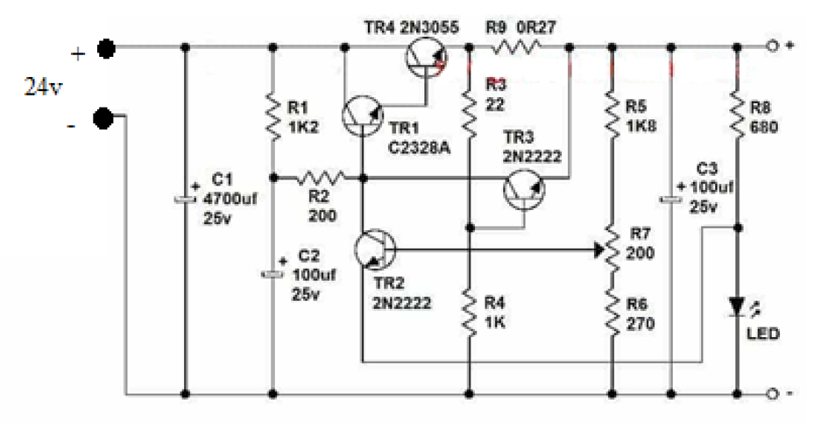

Figure 1. Schematic of project

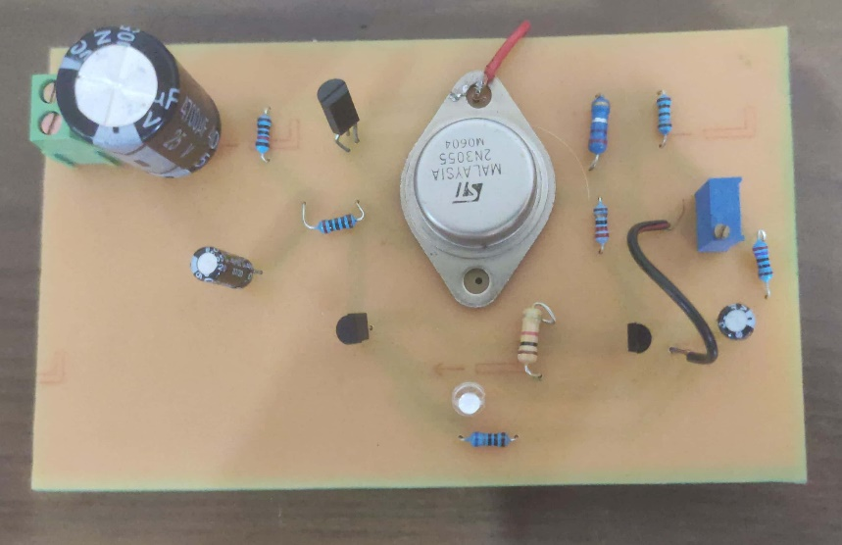

Figure 2. PCB circuit of project

# **Component used in the project.**

* 1 Led 5mm
* 2 Transistor 2N2222
* 1 Transistor 2SC2328
* 1 Transistor 2N3055
* Resistor: 1K2, 200, 22, 1K, 1K8, 270, 680, 0.27
* Capacitor: 4700F/25V, 100F/25V*2
* Variable resistor 200

# Transistors

In this circuit, we use transistor 2SC2328A, 2N2222 and 2N3055.

They are NPN Bipolar Junction Transistor. Mostly it is used for the switching purpose as well as for amplification purposes. Similar to the other transistors they are also used for the amplification of current. The smaller amount of current at the base is used to control the larger amount of currents at the collector and emitter as well. Its basic applications are switching and amplification.

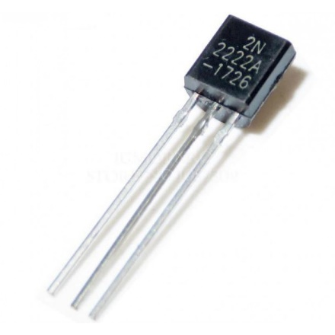

Figure 3. Transistor 2N2222

When the input voltage is applied at its terminal, some amount of current starts to flow from the base to the emitter and controls the current at the collector. The voltage between the base and the emitter (VBE), is negative at the emitter and positive at the base terminal for its NPN construction. The polarity of voltages applied for each junction is shown in the figure below.

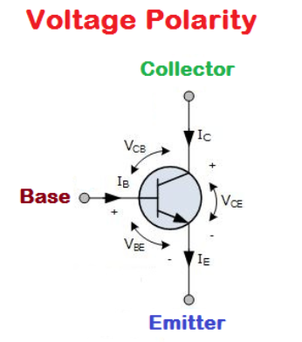

Figure 4. Voltage polarity

The reason we used different kind of transistor come from the different of absolute maximum rating and DC gain. So that, each transistor has a different function in this circuit.

# Variable Resistor 200 Ohm

A variable resistor is the type of resistor which changes the flow of current in a controlled manner by offering a wide range of resistances. As the resistance increases in the variable resistor the current through the circuit decreases and vice versa. They can also be used to control the voltage across devices in a circuit too. Therefore, in applications where current control or voltage control is needed, these types of resistors come handy.

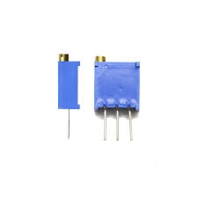

Figure 5. Variable Resitor

# **LED (Light Emitting Diode)**

A light-emitting diode (LED) is a semiconductor light source that emits light when current flows through it. Electrons in the semiconductor recombine with electron holes, releasing energy in the form of photons. The color of the light (corresponding to the energy of the photons) is determined by the energy required for electrons to cross the band gap of the semiconductor. White light is obtained by using multiple semiconductors or a layer of light-emitting phosphor on the semiconductor device.

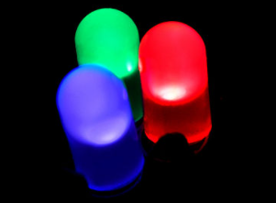

Figure 6. LED

# **Analysis the circuit**

To analysis this circuit, we need the assistant of simulation platform. We use NI Multisim to help us analysis the circuit.

Draw the simulation circuit as the schematic below.

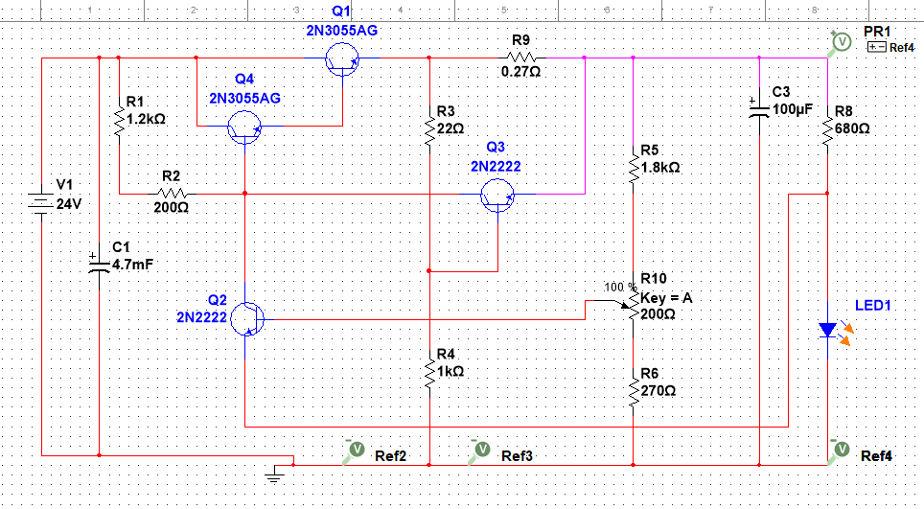

Figure 7. Schematic of project

Using voltmeter to measure the value of . Next, change the value of and observe the change of .

To determine the function of each component you can remove this component and compare the behavior of the circuit before and after remove the component.

# **Build the circuit**

Using ALTIUM DESIGNER to sketch the schematic circuit. You can download the library of component on Internet or create your own one.

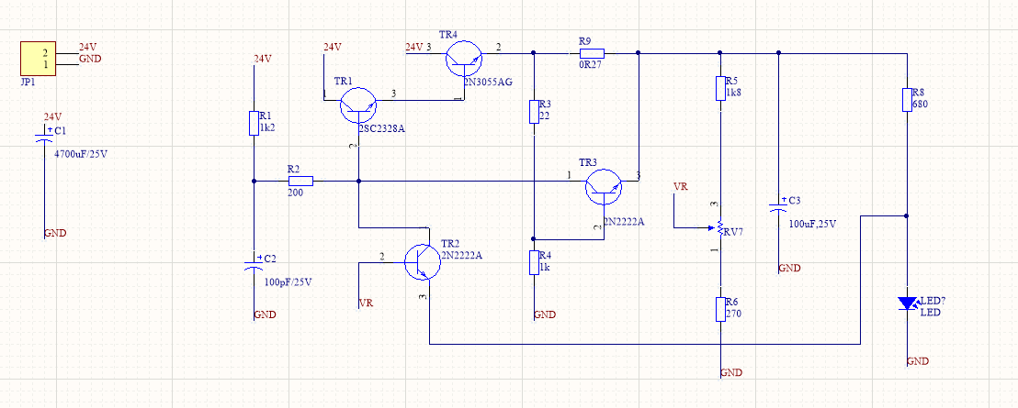

Figure 8. Simulation circuit of project

Update the sketch to PCB and route all the connection (you can use Auto Route)

Polygon your PCB and export the to pdf file.

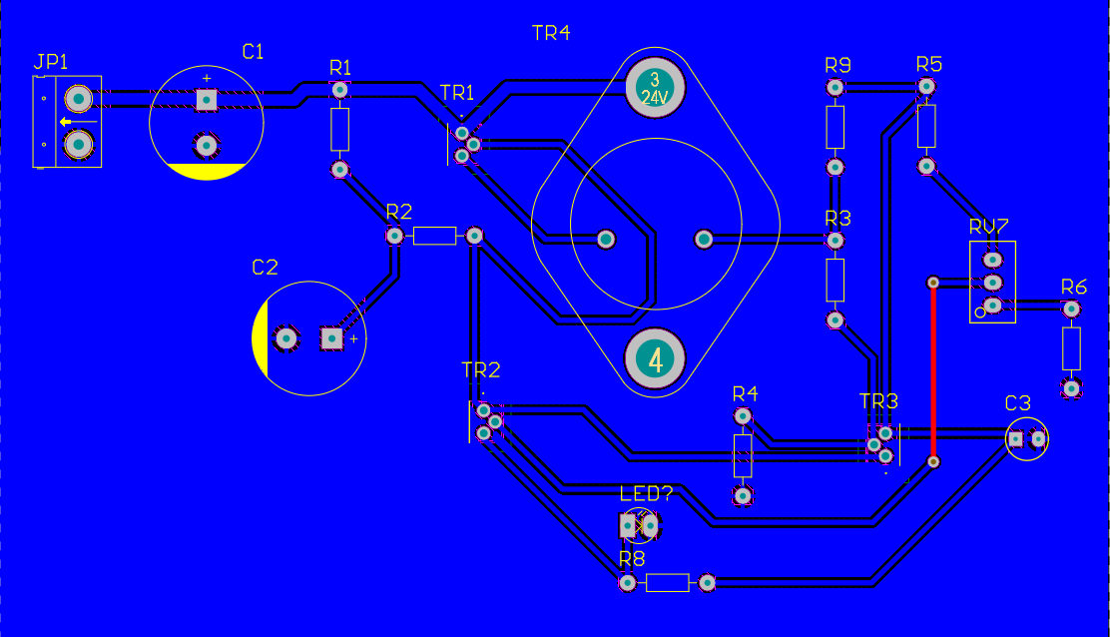

Figure 9. PCB circuit of project

Next, verify which pin is the anode and which is the cathode pin for the Led or diode; also the collector, base, emitter pins of the transistor.

Finally, solder all the component and check the if the circuit work as we expected.

**Experimental Results**

# Simulation result

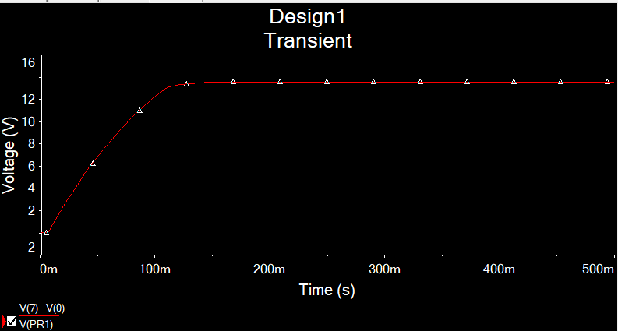

Figure 10. Graph of output voltage versus time

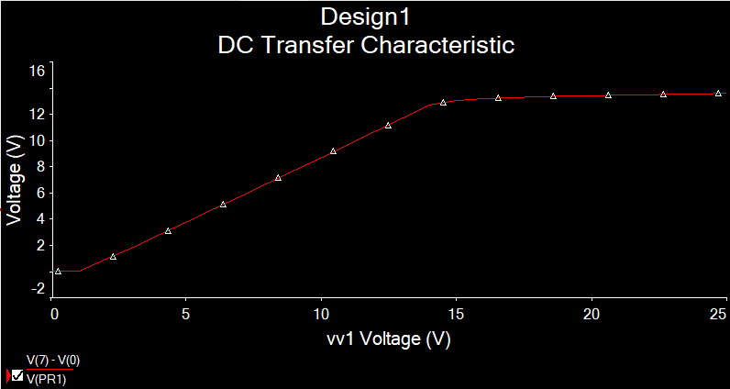

Figure 11. Graph of output voltage versus input voltage

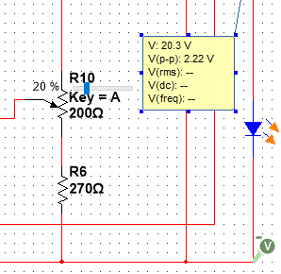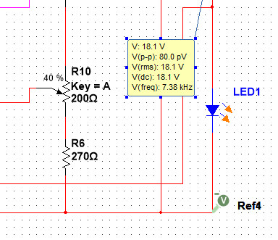

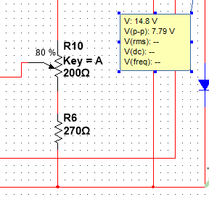 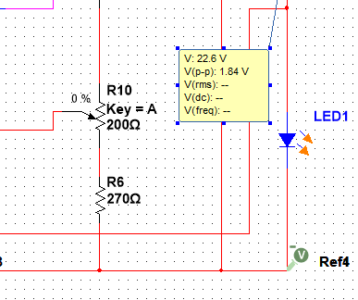

Figure 12. The value of output voltage when adjust potentiometer.

**Discussion of Results**

# Role of TR1 (C2328A), TR4 (2N3055) and Darling’s pair

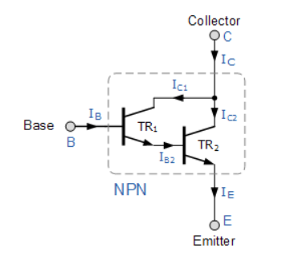

Figure 13. NPN Darling's pair

In electronics, a multi-transistor configuration called the Darlington configuration (commonly called a Darlington pair) is a circuit consisting of two bipolar transistors with the emitter of one transistor connected to the base of the other, in such a way that the current amplified by the first transistor is amplified further by the second one. The collectors of both transistors are connected together. This configuration has a much higher current gain than each transistor taken separately.

The current gain of Darling’s is given pair is given by

In this circuit TR1 (C2328A) and TR4 (2N3055) is a Darling’s pair. This will provide a high current gain for the circuit.

# Role of capacitor

In this circuit, the capacitor C1 and C2 have mission is decoupling capacitor. However, the capacitor C2 has another role. As you can see in the figures below, when the 24V is supply to the circuit, the voltage of output is increasing as an exponential function. When the capacitor is removed, the output voltage is suddenly change when you supply voltage. Thus, this capacitor has mission to not allowed the output voltage change so fast. The suddenly change of voltage can deal fatal damage to the other component and may lead to some electrical issues.

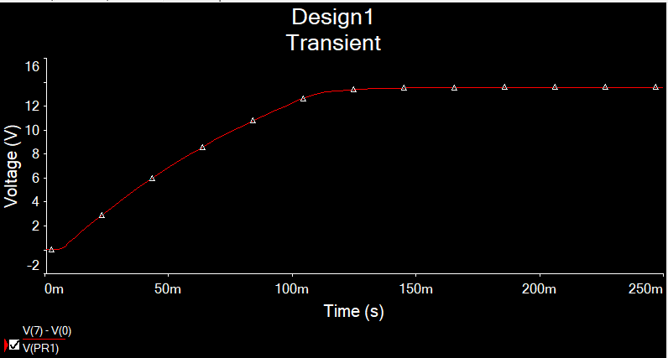

Figure 14. Transient sweep

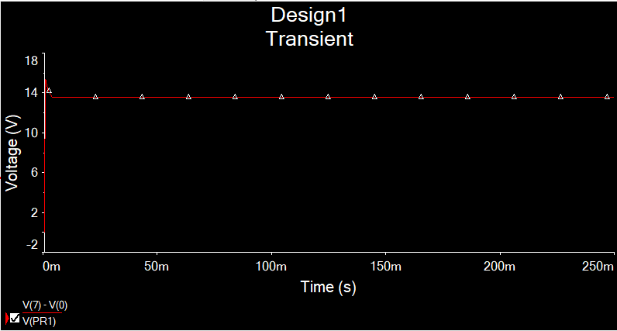

Figure 15. Transient sweep without C2

# Role of LED

LED is stand for light-emitting diode. So that, based on diode characteristic of LED, we can maintain the constant value of . Furthermore, it also the sign that the circuit is working.

# Role of TR2 (2N2222)

This transistor is work as the differential amplifier. The emitter terminal of this transistor TR2 is connected to the negative terminal of input supply through a LED. The base of this additional transistor is connected to the variable tap of a potentiometer. This transistor will feed the error voltage between the reference diode and the sensed output voltage which is a proportion of the output voltage as set by the potentiometer.

# Foldback Current Limiting and role of TR3 (2N2222)

Foldback is a type of current limiting that can be found in some linear power supplies. This can protect the unit from overcurrent and short circuit. This particular feature will reduce the current depending on the level of overload. When the load tries to draw more current from the supply beyond the current threshold of the power supply, foldback reduces both the output voltage and current below normal operating limits. Foldback in short circuits reduces the output voltage to zero and the current is limited to a small fraction of the maximum current. This current limiting can keep power dissipation within a safe limit and prevent thermal destabilization.

Let consider the circuit below as example:

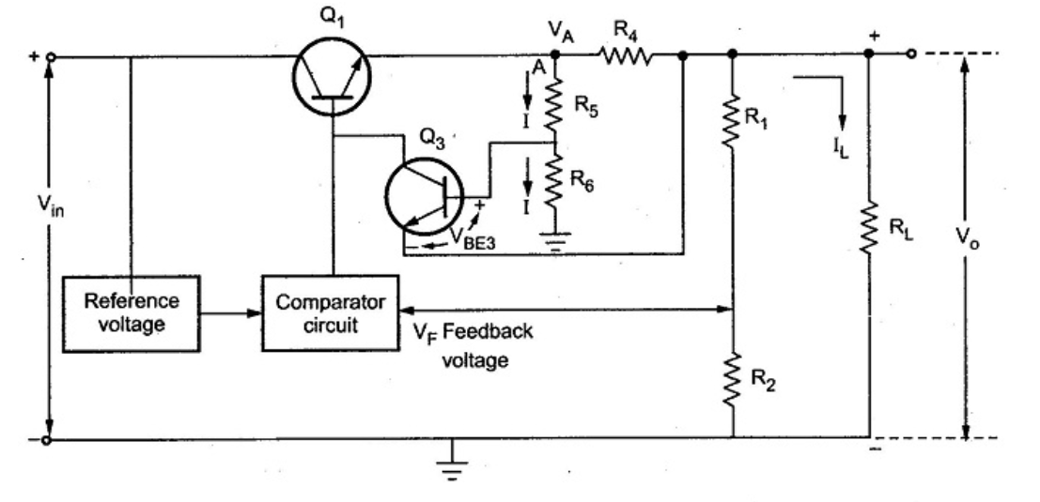

Let the voltage at point A be and the current flowing through R4 is almost .

Neglecting the base current of Q3, the current flowing through R5 and R6 is same as I.

Hence the voltage at the base of Q3 is the voltage across R6.

Let

The voltage at emitter is

Thus if the output terminals are shorted, the output voltage Vo reduces to zero. Hence we get shortcut current is

The rate current can be written as

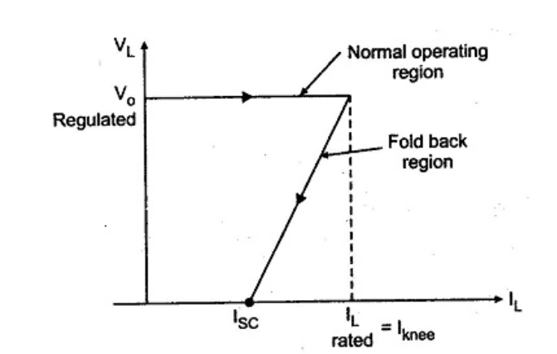

Figure 16. Foldback characteristic

In this circuit the transistor 3 (2N2222) has mission as foldback current limiting.

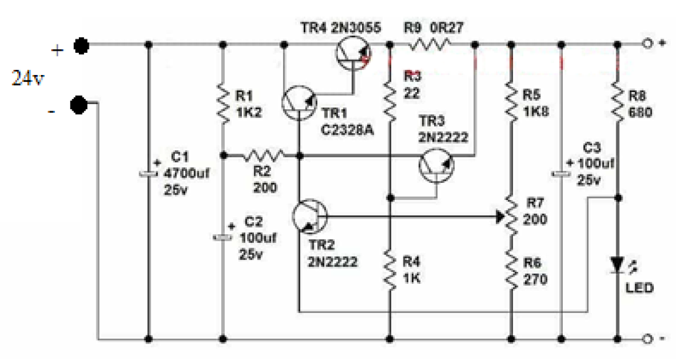

When the load current rises above a predetermined value, the small voltage developed across R9 and R3 will become sufficient (at about 0.7v) to turn TR3 on. As TR3 is connected across the base/emitter junction of the main control Darling’s pair transistor TR1+4, the action of turning TR3 on will reduce the base/emitter voltage of TR1+4 by an amount depending on the amount of excess current. The output current will not be allowed to increase above a predetermined amount, even if a complete short circuit occurs across the output terminals. In this case TR1+4 base/emitter voltage will be reduced to practically zero volts, preventing Tr1 from conducting. Under these conditions the output voltage will fall to zero for as long as the excess current condition persists, but the supply will be undamaged.

# Operating Principles

As you can see, our circuit is look like the figure below:

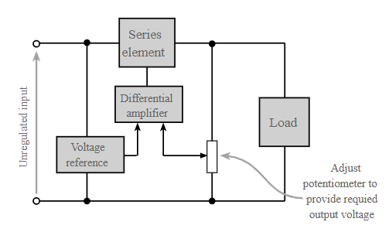

Figure 17. Voltage regulator circuit

The Darling’s pair work as Series element, transistor 2 is work as differential amplifier and the LED as a voltage reference.

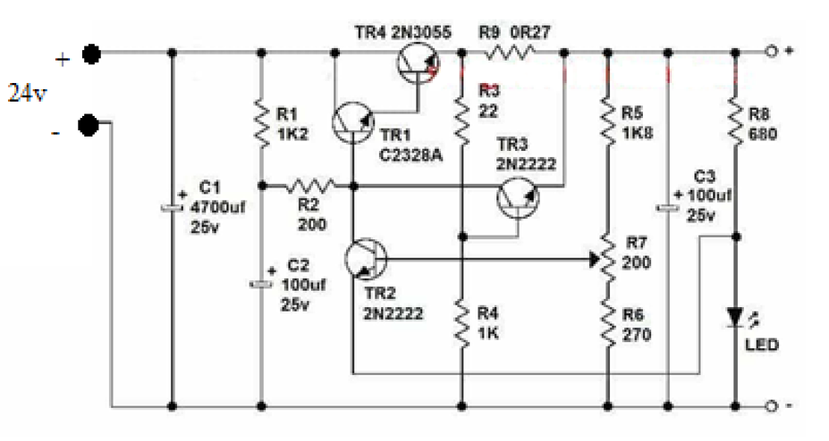

If for any reason the output voltage is increasing, the voltage at base of TR2 will increasing too based on the following formula:

and is separated by (R5+R7(1)) and (R6+R7(2))

Because the voltage at Emitter of TR2 is fixed by reference voltage of LED ( about 2V-3V)

Now, the TR2 will work as different amplifier and feed back to Base of TR1. We can explain how this transistor work as different amplifier: When is increasing, the value of will be increasing too. This leads to the increasing of

Figure 18. Graph of dependence of Collector current of Base-Emitter voltage

This increasing extra current of will reduce the voltage at Base of TR1. This leads to the value of reduce and so that by characteristic of transistor the value of will reduce. So that the output voltage is reduce too. This will make the output voltage stay in a constant value.

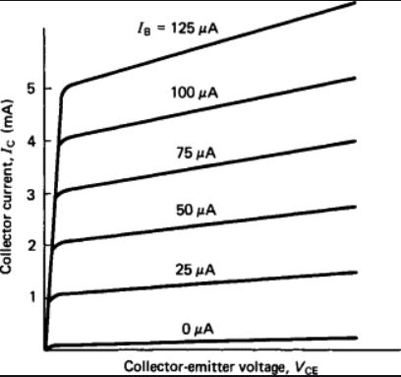

Figure 19. Graph of dependence of Collector current on Collector-emitter voltage

The value of output voltage is calculated by the formula below:

Thus, when you adjust the potentiometer, the value of output voltage is also change. This is reason why this circuit is also called Adjustable Linear Voltage Regulator.

**Self-Evaluation**

Thanks to the project, we have change to practice some skills and absorbed some new knowledge

* We have improved our team spirit so that we can work on project smoothly
* We have learn about time management skill. We have create a timeline about project ( Ex: PCB must be done before 2/6). This help us complete the project on time
* We have change to improve PCB skills such as: create SCB and PCB, solder,…
* Due to COVID-19, we also learn how to do project online using with assistance of some program (Ex: MS teams)
* Finally, we also know more about working principle of transistor and learn some new technical such as: Darling’s pair and Foldback current limiting.

**References**

[1] Regulated Power Supplies

Available at <[Regulated Power Supplies (learnabout-electronics.org)](https://learnabout-electronics.org/PSU/psu22.php)>

[2] Foldback Current Limiting

Available at <[Foldback Current Limiting | EEEGUIDE.COM](https://www.eeeguide.com/foldback-current-limiting/)>