E-Auction Project

Eauction Back-End Spring Containers are deployed to Aws EC2

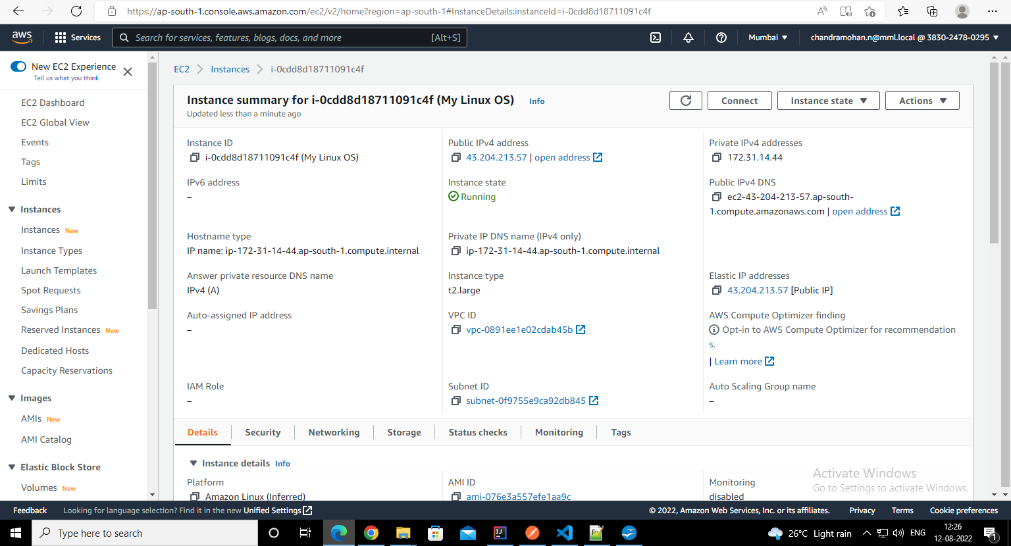
E-Auction Back-End Api Gateway URL:
https://app.43.204.213.57.nip.io/
E-Auction Service Discovery(Eureka Server) URL: http://app.43.204.213.57.nip.io:8761/
E-Auction Query Servcie Swagger API URL:
http://app.43.204.213.57.nip.io:8081/swagger-ui/index.html
E-Auction Command Service Swagger API URL:
http://app.43.204.213.57.nip.io:8082/swagger-ui/index.html

- Used Caddy Web server for SSL Certificate api gateway URL(HTTPS)
- Implemented OKTA based JWT token Authentication for Spring Boot Microservices.
- Implemented CQRS and Event Sourcing in micro services.

E-Auction Front-End React JS UI Deployed to AWS S3

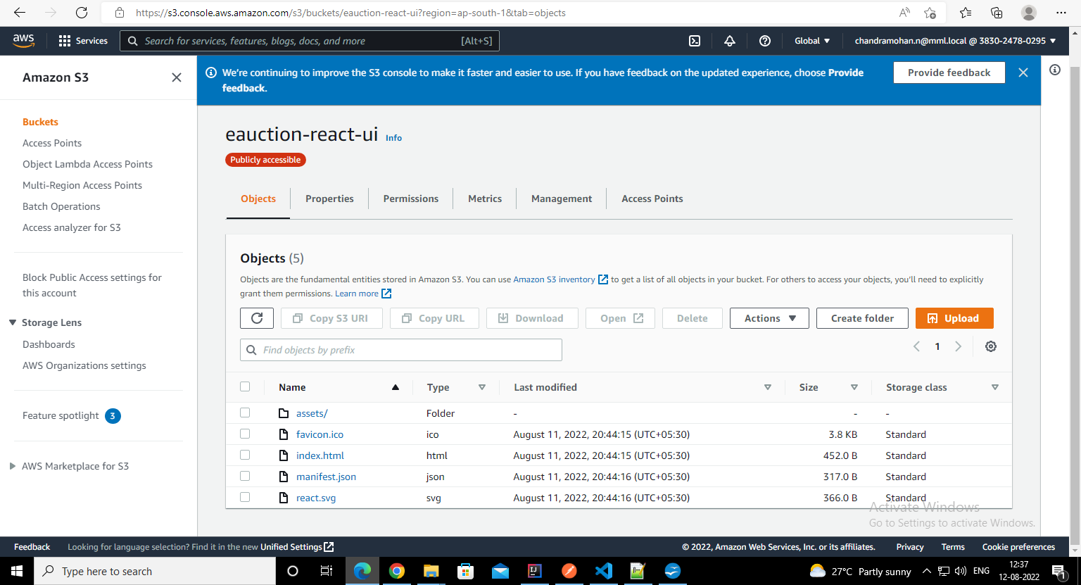

E-Auction Front-End URL: https://d25vqk2o5dz0r2.cloudfront.net/

- Implemented OKTA Authentication for React UI.
- Used AWS CloudFront for Content delivery and HTTPS for S3 bucket URL

