VŨ NGỌC HẢI

WEB DEVELOPER

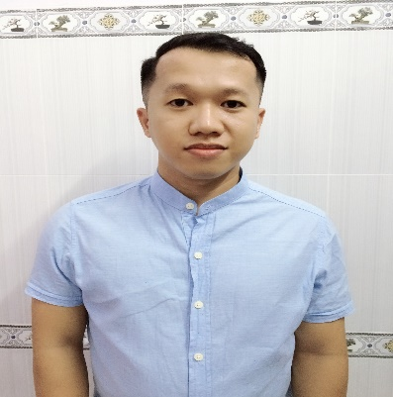

# Contact information

Date of birth February 20, 1990 Gender Male

Phone 0165 605 1963

Email haingocvu@hotmail.com

Address Vietnam

# Skills

PHP & MySQL OOP

Framework: Laravel

MVC

Frontend Development

ReactJS & Redux

Time Management

Team Work & Communication

# Education

**HCM City University of Science**

Major: Software Engineering

GPA: 6.7/10

# Objective

Take advantages of technical skills & experience to become a professional Web Developer and bring a lot value to company. From that, I will contribute to development of your company.

# Work experience

Feb 2014 – May 2015

## CSC Vietnam

Web Development

Mainly involved in front-end web development using js and css framework such as: angularjs, bootstrap, jquery, angular material.

# Certifications

2014

## CSC vietnam Internship Training Program Certificate

Attended all training courses and got the certificate.

© topcv.vn