# PLEXR SOCIAL NETWORK

Project size: 36 man-months

Team size: 4 members x 6 month & 2 members x 6 months

* + Sharing contents from Vine, Instagram, Youtube and watch your friends' reaction
  + Proposed many graphics design options to the Client
  + Real-time messaging with a high scalability XMPP system
  + Developed a balanced and scalable solution
  + Cloud based (Amazon Web Services)
  + Video recording & simultaneous playback
  + Sign up / log in with Facebook, Google Plus, LinkedIn; verified account by phone number; automatic log in.
  + Invite friend, sharing permission, block friend
  + Youtube / Instagram / Vine media link detection
  + Push notifications

Designs & Draft Requirement Specification: [folder]

URL: <https://itunes.apple.com/us/app/plexr-reaction-capture-media/id897781586?mt=8>

# UBER-LIKE PROJECT

**Project size:** 18 man-months

**Team size:** 06 members

* + An app that, while in the same overall category as Uber, is more focused on ride-sharing and green environmental initiatives
  + Learning routes, path matching, storing & querying path algorithms.

Designs & Function Specification: [folder]

# WADA STORE

**Project** **size**: 12 man-months

**Team** **size**: 4 members

* + A clone of App Store or Google Play system, for WADA firm (a Vietnamese Search Engine)
  + Installed apps with different methods (downloading to PC, OTA, via QR code scanning)
  + App rating & sharing
  + Bulk apps download / install
  + Recommended app
  + Facebook / Google login
  + Search
  + Statistics
  + Web, iOS and Android versions. Multiple OS version compatibility, multiple screens adoption, responsive web design.

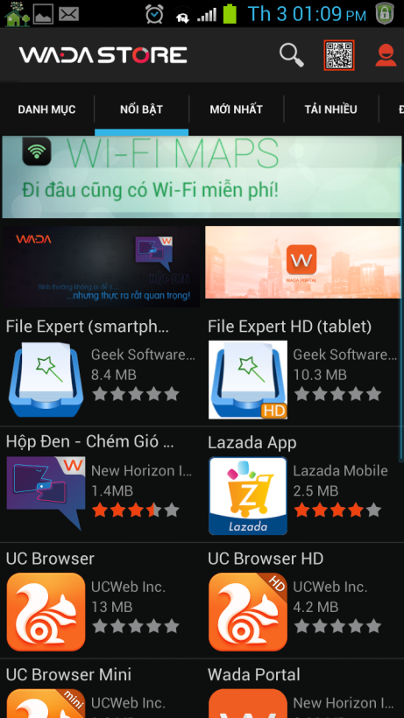

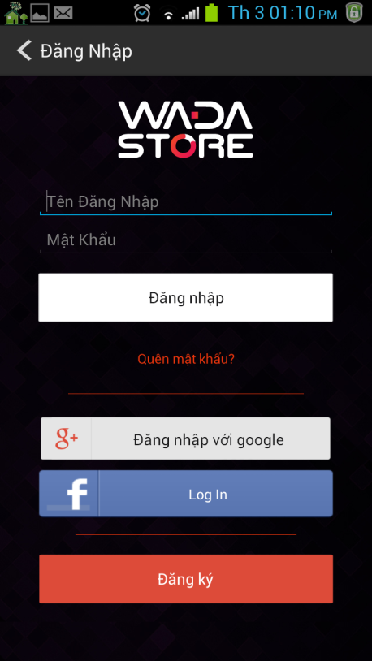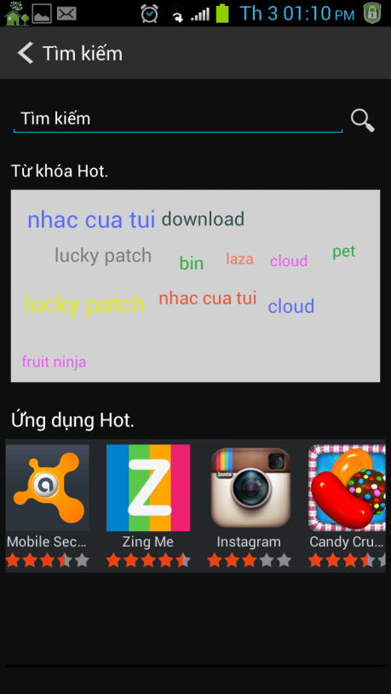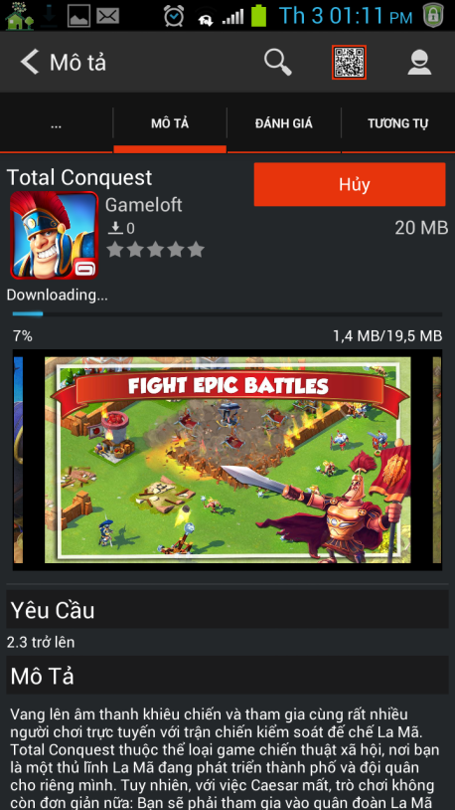

Web version:

<http://store.wada.vn/>

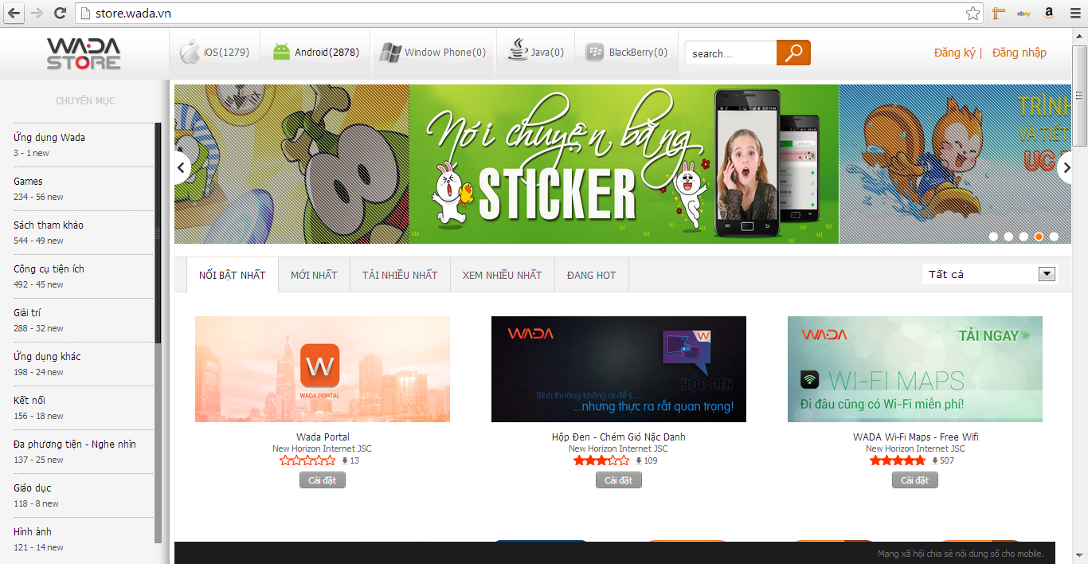

# WADA SINGLE SIGN-ON (SSO) SYSTEM

**Project size:** 06 man-months

**Team size:** 02 members

* + Users sign into the Wada Store and use Wada games or other products of Wada without signing in again
  + Technique: C++, Shared Memory, Thrift , TNonblockingServer, REST, PHP
  + Scalability: this system can serve up to 45.000 requests/second and 26M sessions with an 8GB RAM server
  + No need to change technology as the Wada user-base grows, just add more servers
  + No lose of user information when process (of server) overload and stop, because we use shared memory

# CHANNEL

**Project size:** 05 man-months

**Team size:** 02 members

**Realtime Group Messaging, Sub Room (Channel)**

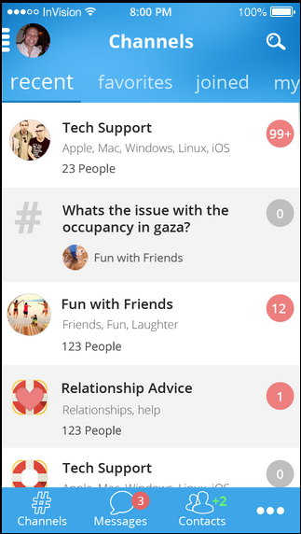 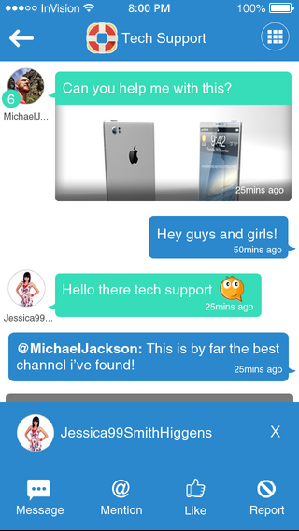

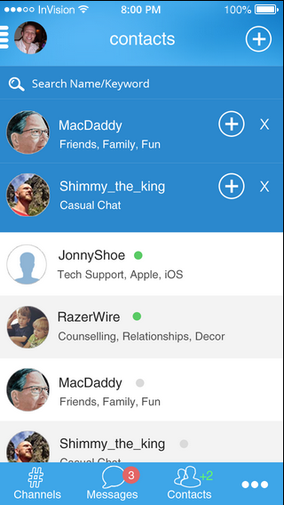

# EvA CRM based on vTiger5 and Asterisk

Build a CRM system for a Mitani Sangyo (from Japanese). The system helps manage customers, sales group, leads, reports, and make a phone call.

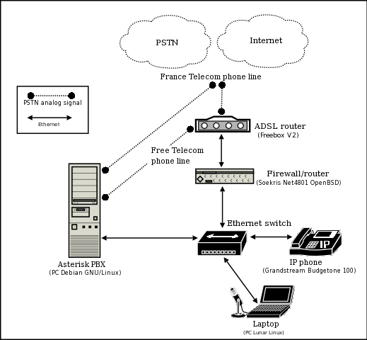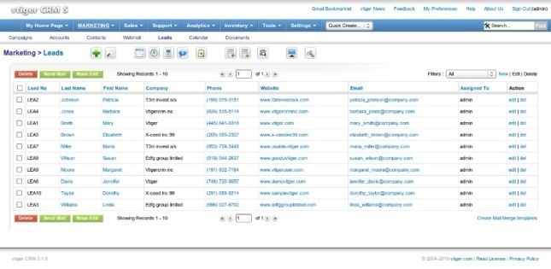

Project size: 12 man-months.

Team size: 3 members.

Technology: PHP, Asterisk, vTiger5, Cent OS 5, Fedora, Javascript, Smarty.

# [http://mangluoibds.vn](http://mangluoibds.vn/)

**Project size:** 06 man-months.

**Team size:** 2 members.

**Technology:** PHP, Cent OS 5, Javascript, Google Map API, SMS API.

**Highlights:**

Post / active land with SMS

Online payment with Visa & Master Card.

Quick & detailed search.

Google Map search.

Control panel for Broker.

Control panel for Agency.

Place an order and auto matching.

Statistic.

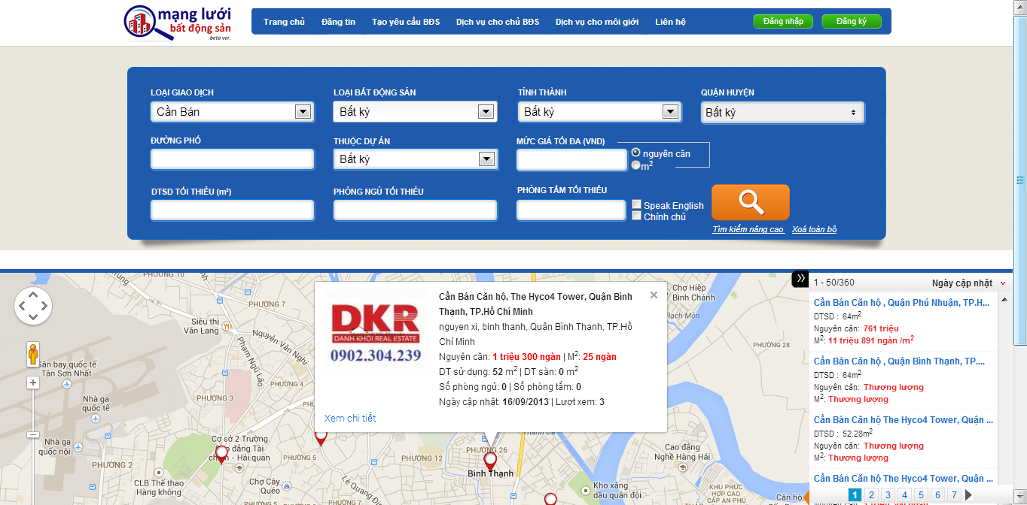

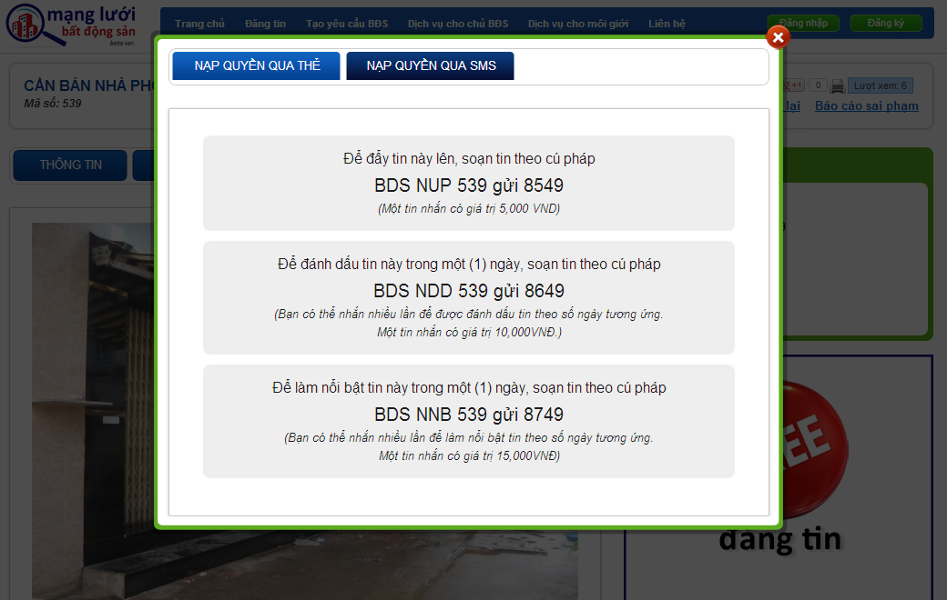

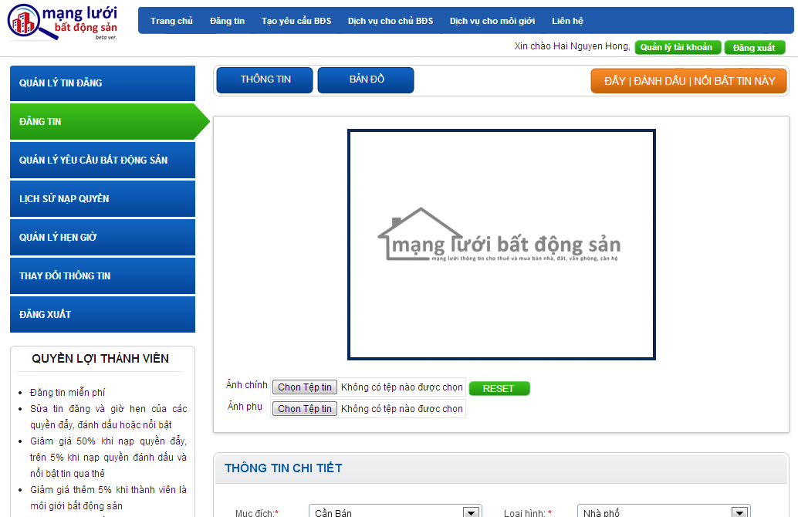

# 90+ real estate websites

Developed 90+ websites for famous real estate & construction companies in Vietnam. Handled all phases from designing to maintenance.