# M1, M2 and M3 fee calculation

## General calculation algorithm

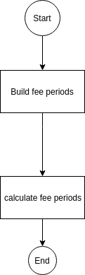

## For M1, the calculation as below

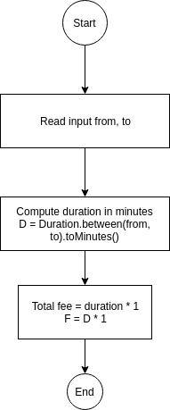

## For M2 and M3, the flow to calculate build periods as below

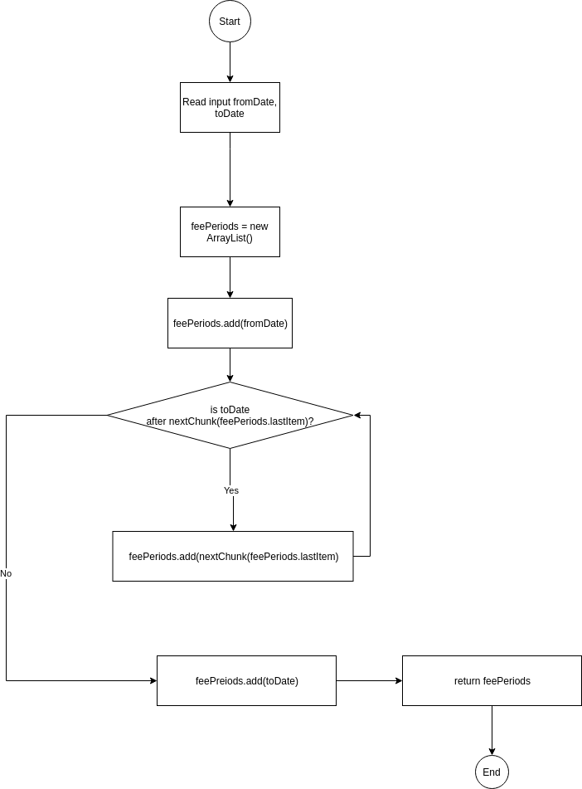

## Strategy to find *nextChunk* for M2 and M3

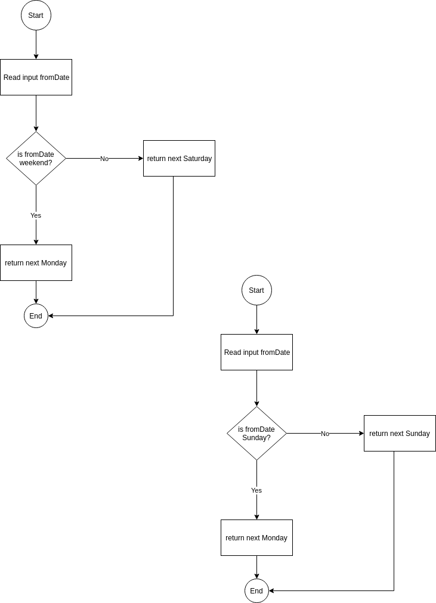

## M2 calculation fee period

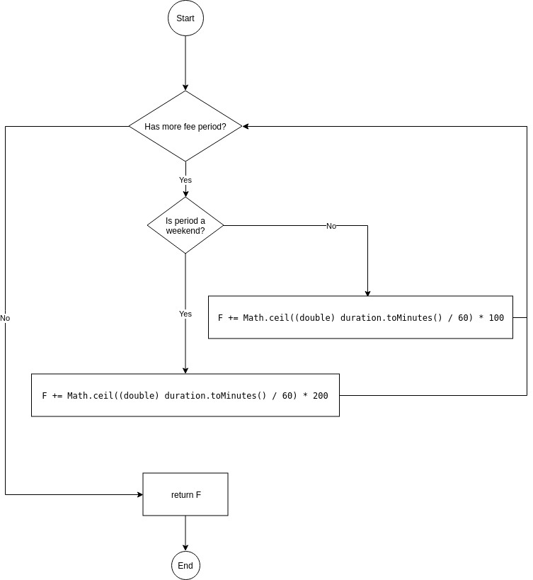

## M3 calculation fee periods

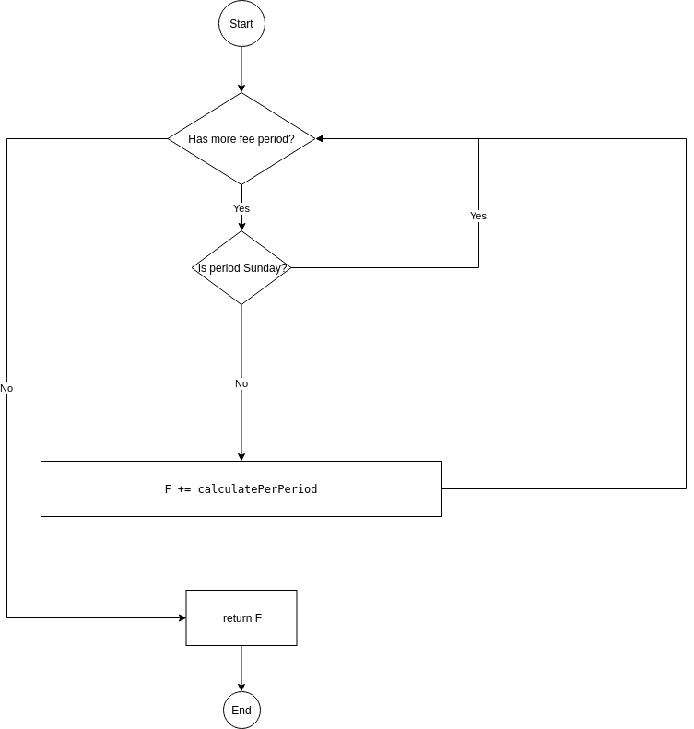

## M3 calculation per period

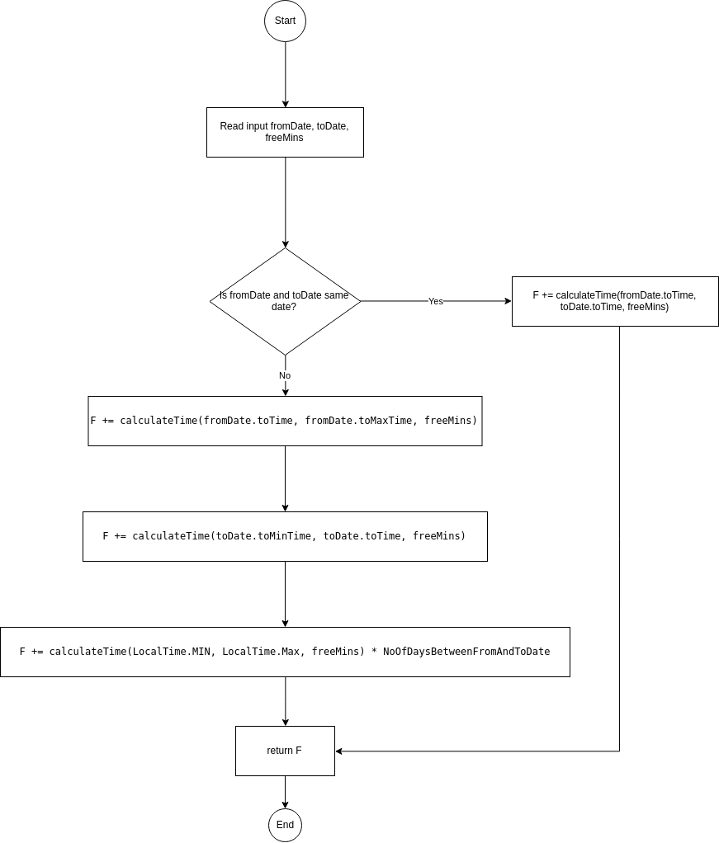

## M3 calculation per time (or per day)

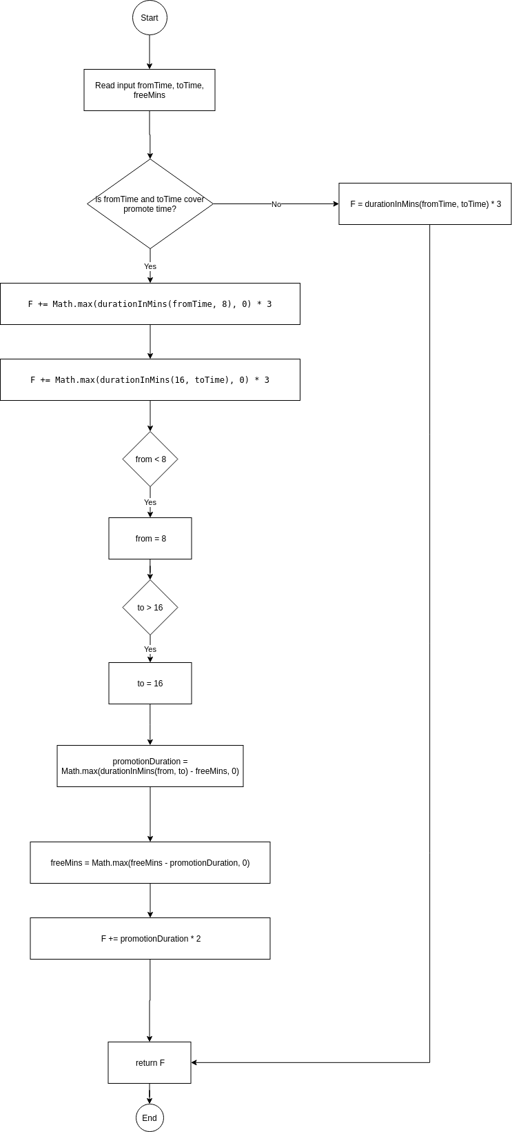

## Task 5, strategy to limit users’ requests

