INTRODUCE MYSELF

My name is PTH, I was born in 2002, that’s mean i’m 19 years old. Now, I’m living in HN with my family include 4 people : my mother, father, brother and me.

We live in a small village with friendly neighbours, I really love them, they are not simple neighbours, they’re also my friends, sometimes they like my family.

I’m a second year student of Thuy Loi university with my major is IT. That major has been hot for the past few years. Although I still have a lot of difficulties in learning, I will try because beside me , there are teachers and friends who always willing to help when I need.

I’m an ordinary person like everyone else, nothing special although I’m the type to think a lot and sensitive, I’m always happy, optimistic love life because my parents have brought me a perfect family and life has given me a lot of wonderful companions.



There are many ways to be healthy but for me, the activity that I do to stay healthy is eating healthily. I do it almost daily and in every meal. Usually 5 days a week, I will only eat low calories and low fat foods like tofu,bean, vegetables, lean meat,..

Because it's a healthy diet, I make it at home, in my meals, and my diet will be different from everyone in my family. I started dieting on July of this year, when I felt ashamed of my body for not being slim and having too much fat.

The first period was quite difficult and it took me about a month to get used to eating low-fat and low-sugar foods. There were times when I wanted to give up, but my mother supported and helped me through. My mother was always there to share and diet with me, so she understood the difficult feelings I had to go through .

Almost a year of dieting, my body gradually changed and became more beautiful. Thanks to the diet, my health has also improved a lot.



There are many places I have been, but the place I like the most is Da Nang city. It is one of big cities in Vietnam. Every year, many tourists come here to travel, go to the beach, visit famous sacred pagodas. Especially coming to Da Nang, visitors can not ignore the famous Sun World tourist area that is Ba Na Hills.

Coming to Ba Na hills, you will admire many outstanding beautiful scenes such as the Golden Bridge, the French village along with the indoor entertainment area.

On weekend, visitors also have the opportunity to enjoy cultural and artistic activities of France. In addition to beautiful scenery and interesting games, Ba Na hills also has special weather, we can feel the change of 4 seasons in 1 day.

It can be seen that it is no coincidence that Ba Na Hills has become one of the favorite destinations of domestic and foreign tourists.

Besides, Da Nang city also has many famous tourist attractions such as Hoi An ancient town, Cu Lao Cham island, ..

Every year, many tourists come to Da Nang, traffic is crowded, but the air in here is not polluted or dusty. The people of Da Nang are friendly, honest and likable. Maybe that’s why Da Nang is considered a livable city. If have chance, I want to come back here to travel with my family and friends.

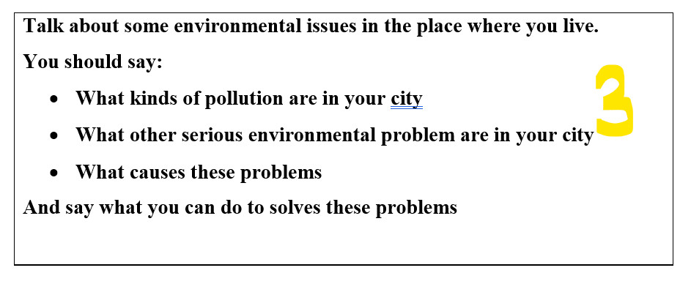

I live in Hanoi – the capital of Viet Nam.

Every year, many people come here to study and work,

which is also the reason why this place is heavily affected by air pollution and noise pollution.

Basically, noise pollution is not harmful to health but air pollution is.

Sometimes, the city is polluted by gas from the burning of straw by people living on the outskirts of the city.

But pollution originates mainly from emissions from vehicles and factories.

Why is the main cause due to emissions from vehicles and factories ?

It can be seen that :

during the recent covid 19 epidemic, people’s movement is limited, so the operation of vehicles and factories reduced capacity, then the air quality in the whole city is significantly improved.

So what I think to solve the problem is we should use public transport as much as possible, reduce private vehicles.

Factories also need to treat exhaust gas before discharging into the environment.



I used to travel to Da Nang by plane with my family last summer. Because it was a short trip, we did not prepare too many things, each person only had one suitcase in which there were few clothes and necessary personal belongings. Coming to Da Nang, we can not ignore the famous Sun World tourist area that is Ba Na Hills.

Coming to Ba Na hills, we admired many outstanding beautiful scenes such as the Golden Bridge, the French village along with the indoor entertainment area.

On weekend, we also have the opportunity to enjoy cultural and artistic activities of France. One thing what I like the most in Ba Na Hills is the weather in here, we can feel the change of 4 seasons in 1 day.

It can be seen that it is no coincidence that Ba Na Hills has become one of the favorite destinations of domestic and foreign tourists.

Besides, Da Nang city also has many famous tourist attractions such as Hoi An ancient town, Cu Lao Cham island, ..

Every year, many tourists come to Da Nang, traffic is crowded, but the air in here is not polluted or dusty. The people of Da Nang are friendly, honest and likable. Maybe that’s why Da Nang is considered a livable city. If have chance, I will come back here to travel with my family and friends.