

Toy management

* **Faculty:**
* **Batch:**
* **Team Member:**
  + - * **Phùng Ngọc Khương Duy**
      * **Phạm Duy Hải**
      * **Trần Thế Mĩ**

**Ho Chi Minh City, Nov 10 2018**

Table of Contents

1. Review 1

* **Problem Definition..………………………………………………01**
* **Software****Requirement** **Specifications…………………………………………………...…02**

1. Review 2

* ***Use Case Diagram* 04**
* ***Class Diagram* 15**
* ***Sequence Diagram* 16**
* ***ERD* 18**
* ***Entity Description* 19**
* ***Table Relationship Diagram* 26**

1. Review 3

* Interface Design…………………………………………………...27
* Site Map……………………………………………………………51
* Report ………………………………………………………53
* Tasksheet…………………………………………………………..56

REVIEW 1

Problem Definition

1. **The Object Of The Project**

This project will aim at creation of a toy management system. This will be accessible to who have a valid User Id and Password. This system provides the following facilities:

* Manage Employees
* Manage Products
* Manage Category
* Manage Supplier
* Manage Order

Software Requirement   
 Specification

1. **Functional Requirements**

## UC001 – Login

## UC002 – Manage Products

## UC002.1 – View Product

## UC002.2 – Add Product

## UC002.3 – Delete Product

## UC002.4 – Update Product

## UC003 – Manage Employees

## UC003.1 – View Employee

## UC003.2 – Add Employee

## UC003.3 – Delete Employee

## UC003.4 – Update Employee

## UC004 – Manage Customers

## UC004.1 – View Customer

## UC004.2 – Add Customer

## UC004.3 – Delete Customer

## UC004.4 – Update Customer

## UC005 – Manage Orders

## UC005.1 – View Order

## UC005.2 – Add Order

## UC005.3 – Delete Order

## UC005.4 – Update Order

# Hardware/ Software Requirements

1. **System Requirement**

* **For Users**
  + **Hardware**
    - CPU: Pentium IV 2.0 GHz or higher
    - RAM: 512 MB or higher
  + **Software**
    - OS: Windows 7/XP Professional/Server 2003…
    - Browser: Internet Explorer 8.0 or higher
* **For Software Developers**
  + **Hardware**
    - CPU: Pentium IV 2.0 GHz or higher
    - RAM: 512 MB or higher
  + **Software**
    - OS: Windows XP Professional/Server 2003…
    - Environment: Microsoft .NET Framework 4.5
    - Database Management System: Microsoft SQL Server 2008
    - IDE: Microsoft Visual Studio 2017
    - Web Server: Internet Information Services (IIS) JSP / Servlets Dev. Kit

|  |  |  |
| --- | --- | --- |
| **Date: Sep 10, 2012** | **Prepared by Project Group 4**  **Team Leader:** | **Approved by**  **Mr Ho Hoan Kiem** |
| **Signature** |  |  |

REVIEW 2

**USE CASE DIAGRAM**

**Administrators :**

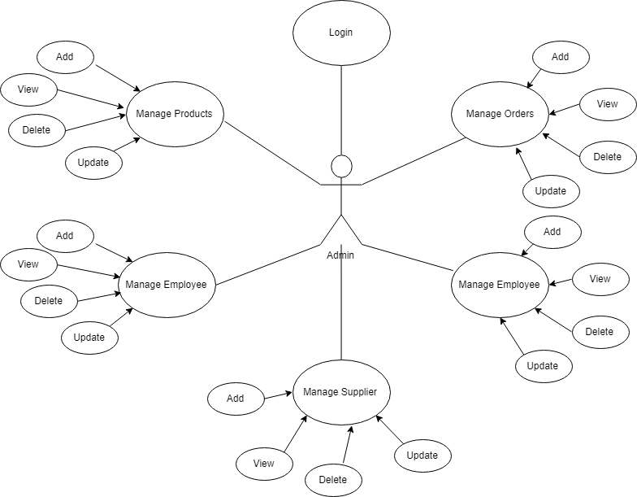

**USE CASE DESCRIPTION**

1. **Actor:**

* **Administrators :** The person(s) that manage and maintain this software.

1. **Usecase:**

|  |  |
| --- | --- |
| **Usecase** | Login |
| **Short Description** | Log in website to use any function of member. |
| **Pre-Conditions** |  |
| **Post-Conditions** |  |
| **Main flow** | _Guest inputs the login information :   * Login ID. * Password.   _Guest clicks on the Login button.  _System check the Login ID and Password.  _If Login ID and Password are valid, system form will display. |
| **Alternative flow(s)** | _If Login ID field or Password field is invalid form or blank when guest clicks on the “Login” button, system will notify the error. |

|  |  |
| --- | --- |
| **Usecase** | Manage Customers |
| **Short Description** | Manage all information about customer. |
| **Pre-Conditions** |  |
| **Post-Conditions** |  |
| **Main flow** | Administrator can view, insert, update, delete customer |
| **Alternative flow(s)** |  |

|  |  |
| --- | --- |
| **Usecase** | Manage Products |
| **Short Description** | Manage all information about product. |
| **Pre-Conditions** |  |
| **Post-Conditions** |  |
| **Main flow** | Administrator can view, insert, update, delete product |
| **Alternative flow(s)** |  |

|  |  |
| --- | --- |
| **Usecase** | Manage Employees |
| **Short Description** | Manage all information about employee. |
| **Pre-Conditions** |  |
| **Post-Conditions** |  |
| **Main flow** | Administrator can view, insert, update, delete employee |
| **Alternative flow(s)** |  |

|  |  |
| --- | --- |
| **Usecase** | Manage Orders |
| **Short Description** | Manage all information about order. |
| **Pre-Conditions** |  |
| **Post-Conditions** |  |
| **Main flow** | Administrator can view, insert, update, delete order |
| **Alternative flow(s)** |  |

**CLASS DIAGRAM**

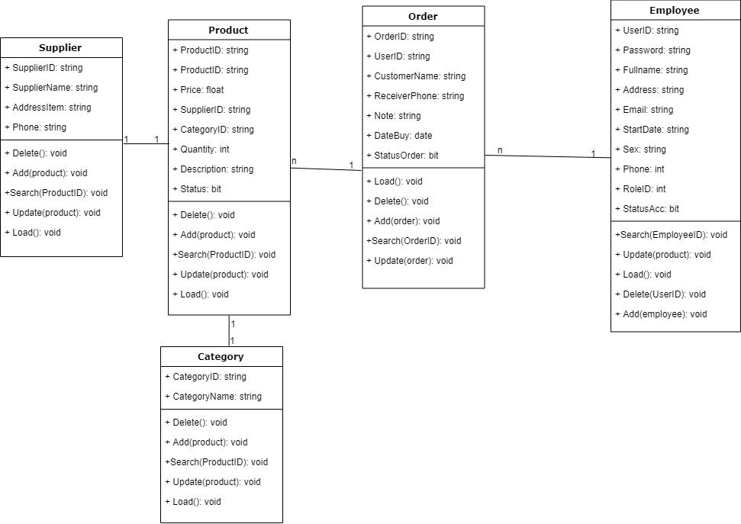

**ENTITY RELATIONSHIP DIAGRAM (ERD)**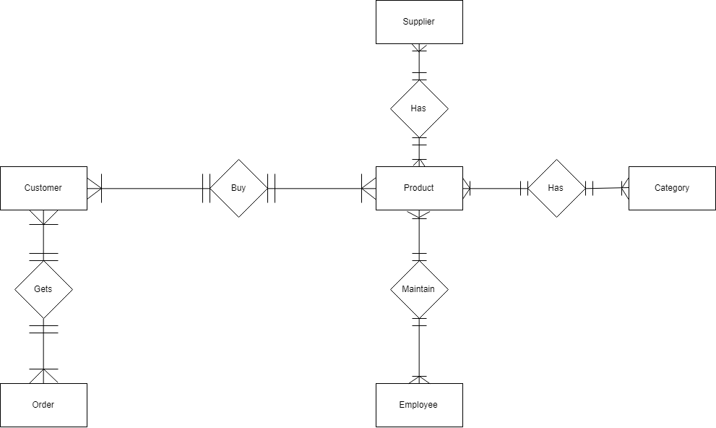  
 **Note:**

Entity

Entity Relationship

One to many relationship

**ENTITY DESCRIPTION**

**1.Account Customer :**

**TABLE DESIGN**

1. **Products :**

|  |  |  |  |  |  |
| --- | --- | --- | --- | --- | --- |
| **No** | **Column Name** | **Data Type** | **Size** | **Check** | **Description** |
| 1 | **ProductID** | nvarchar | 50 | Not Null |  |
| 2 | ProductName | nvarchar | 50 |  |  |
| 3 | Quantity | int |  |  |  |
| 4 | Price | float |  |  |  |
| 5 | SupplierID | nvarchar | 50 |  |  |
| 6 | Description | nvarchar | 50 |  |  |
| 7 | CategoryID | nvarchar | 50 |  |  |
| 8 | Status | bit |  |  |  |

1. **Account :**

|  |  |  |  |  |  |
| --- | --- | --- | --- | --- | --- |
| **No** | **Column Name** | **Data Type** | **Size** | **Check** | **Description** |
| 1 | UserID | nvarchar | 50 | Not Null |  |
| 2 | Password | nvarchar | 50 | Not Null |  |
| 3 | Fullname | nvarchar | 50 |  |  |
| 4 | Address | nvarchar | 50 |  |  |
| 5 | Phone | nvarchar | 50 |  |  |
| 6 | Email | nvarchar | 50 |  |  |
| 7 | StartDate | date |  |  |  |
| 8 | Sex | nvarchar | 50 |  |  |
| 9 | RoleID | int |  |  |  |
| 10 | Status | bit |  |  |  |

1. **Orders:**

|  |  |  |  |  |  |
| --- | --- | --- | --- | --- | --- |
| **No** | **Column Name** | **Data Type** | **Size** | **Check** | **Description** |
| 1 | **OrderID** | nvarchar | 50 | Not Null |  |
| 2 | UserID | nvarchar | 50 | Not Null |  |
| 3 | CustomerName | nvarchar | 50 | Not Null |  |
| 4 | ReceivingPhone | nvarchar | 50 |  |  |
| 5 | ReceivingAddress | nvarchar | 50 |  |  |
| 6 | Note | nvarchar | 50 |  |  |
| 7 | BuyDate | date |  |  |  |
| 8 | StatusOrder | bit |  |  |  |

1. **OrderDetails:**

|  |  |  |  |  |  |
| --- | --- | --- | --- | --- | --- |
| **No** | **Column Name** | **Data Type** | **Size** | **Check** | **Description** |
| 1 | ****OrderID | nvarchar | 50 | Not Null |  |
| 2 | ****ProductID | nvarchar | 50 | Not Null |  |
| 3 | Quantity | int |  | Not Null |  |

1. **Category:**

|  |  |  |  |  |  |
| --- | --- | --- | --- | --- | --- |
| **No** | **Column Name** | **Data Type** | **Size** | **Check** | **Description** |
| 1 | ****CategoryID | nvarchar | 50 | Not Null |  |
| 2 | CategoryName | nvarchar | 50 |  |  |

1. **Role:**

|  |  |  |  |  |  |
| --- | --- | --- | --- | --- | --- |
| **No** | **Column Name** | **Data Type** | **Size** | **Check** | **Description** |
| 1 | **RoleID** | int | 50 | Not Null |  |
| 2 | RoleName | nvarchar | 50 | Not Null |  |

1. **Status:**

|  |  |  |  |  |  |
| --- | --- | --- | --- | --- | --- |
| **No** | **Column Name** | **Data Type** | **Size** | **Check** | **Description** |
| 1 | ****StatusItemID | nvarchar | 50 | Not Null |  |
| 2 | StatusItemName | nvarchar | 50 | Not Null |  |

1. **Supplier:**

|  |  |  |  |  |  |
| --- | --- | --- | --- | --- | --- |
| **No** | **Column Name** | **Data Type** | **Size** | **Check** | **Description** |
| 1 | ****SupplierID | nvarchar | 50 | Not Null |  |
| 2 | SupplierName | nvarchar | 50 | Not Null |  |
| 3 | Address | nvarchar | 50 |  |  |
| 4 | Phone | nvarchar | 50 |  |  |

**Note**

**** Primary key

✓ Unique constraint

**TABLE RELATIONSHIP DIAGRAM**

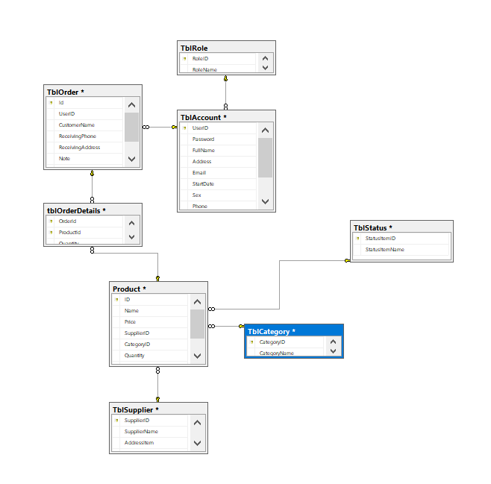

|  |  |  |
| --- | --- | --- |
| **Date: Sep 20, 2012** | **Prepared by Project Group 4**  **Team Leader:** | **Approved by**  **Mr. Ho Hoan Kiem** |
| **Signature** |  |  |

REVIEW 3

**INTERFACE DESIGN**

1. **Login From**

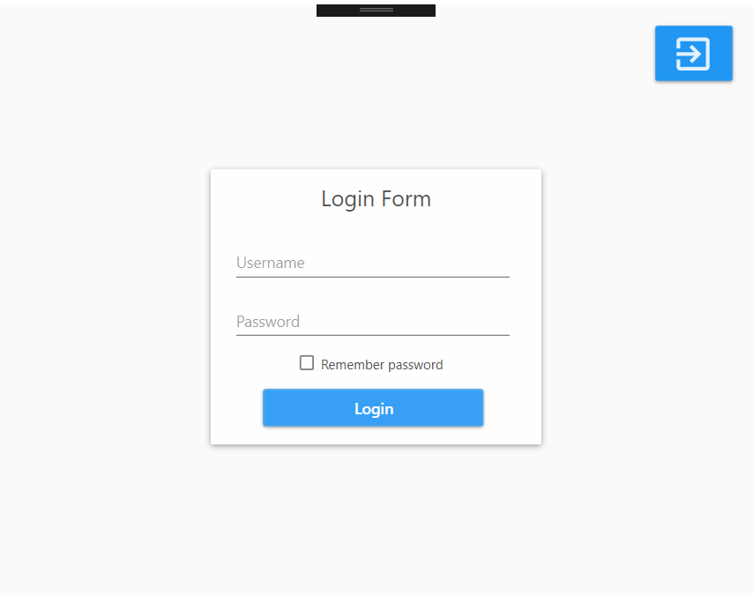

|  |  |  |  |  |  |
| --- | --- | --- | --- | --- | --- |
| **Name** | **Type** | **Event** | **Validation** | **Description** | **Status** |
| User Name | TextBox |  | String, not null | Input Customer’s user name |  |
| Password | TextBox |  | String, not null, | Input Customer’s password |  |
| Login | Button |  | Click | Choose Login |  |

1. **HomePage:**

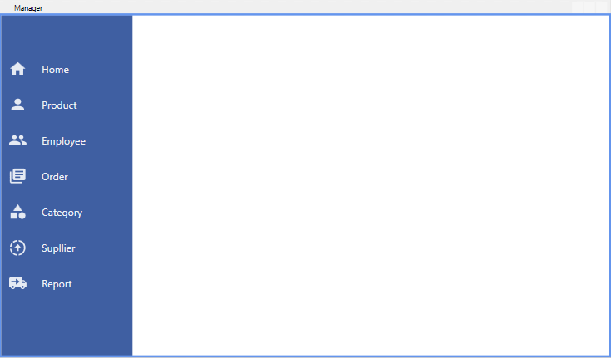

|  |  |  |  |  |  |
| --- | --- | --- | --- | --- | --- |
| **Name** | **Type** | **Event** | **Validation** | **Description** | **Status** |
| Home | ListViewItem | SelectedIndex |  | Return to HomePage |  |
| Product | ListViewItem | SelectedIndex |  | Go to Product Management |  |
| Employee | ListViewItem | SelectedIndex |  | Go to Employee Management |  |
| Order | ListViewItem | SelectedIndex |  | Go to Order Management |  |
| Category | ListViewItem | SelectedIndex |  | Go to Category Management |  |
| Supplier | ListViewItem | SelectedIndex |  | Go to Supplier Management |  |

**3. Product Management:**

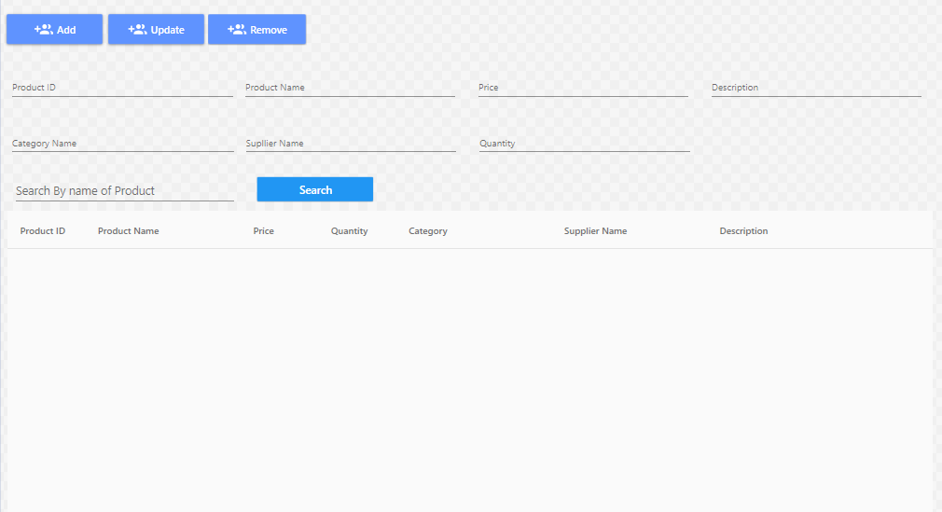

|  |  |  |  |  |  |
| --- | --- | --- | --- | --- | --- |
| **Name** | **Type** | **Event** | **Validation** | **Description** | **Status** |
| UserName | TextBox | Onchange | String, not null | Input UserName Customer |  |
| Password | TextBox |  | String, not null, | Input Customer’s New password |  |
| Config Password | TextBox |  | String,not null | Input Customer’s Config Password |  |
| Full Name | TextBox |  | String, not null | Input Full Name Customer |  |
| Birthday | BasicDate picker |  | Date,not null | Input BirthDay customer |  |
| Gender | DropdownList |  | Select Male,female | Input Male,Female |  |
| Identity Card | TextBox |  | Number, not null | Input Number Identity card |  |
| Email | TextBox |  | String ,not null, have Validation | Input Email Customer |  |
| Countries | Dropdownlist |  | Select | Input Countries Customer |  |
| City | TextBox |  | String, not null | Input City Customer |  |
| Address | TextBox |  | String, not null | Input Address Customer |  |
| Phone Number | TextBox |  | Number,not null | Input Phone Number Customer |  |
| Styte Card | DropDownList |  | Select | Input Styte Card Customer |  |
| CapChar | TextBox |  |  | Input number follow Image at above Text Box |  |
| Register | Button |  | Click | Register Customer |  |

**4.Add Product:**

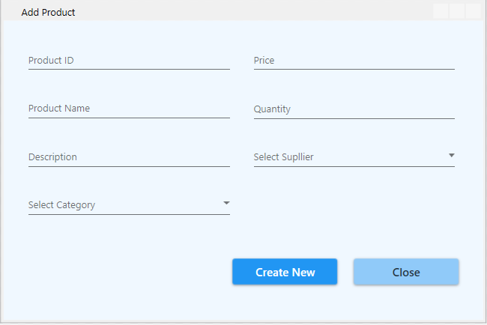

|  |  |  |  |  |  |
| --- | --- | --- | --- | --- | --- |
| **Name** | **Type** | **Event** | **Validation** | **Description** | **Status** |
| UserName | TextBox |  | String,not null | Input UserName Customer |  |
| Email | TextBox |  | String ,not null, have Validation | Input Email Customer |  |
| CapChar | TextBox |  |  | Input number follow Image at above Text Box |  |

**5.Update Product:**

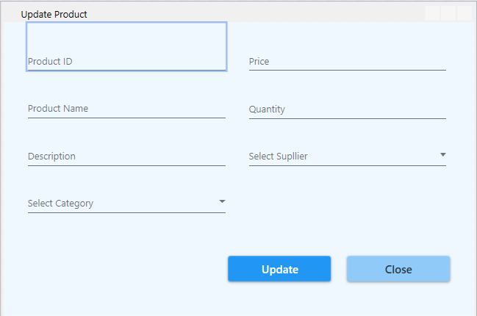

|  |  |  |  |  |  |
| --- | --- | --- | --- | --- | --- |
| **Name** | **Type** | **Event** | **Validation** | **Description** | **Status** |
| Password Old | TextBox |  | String, not null | Input Customer’s Password old |  |
| New Password | TextBox |  | String, not null, | Input Customer’s New password |  |
| Config Password | TextBox |  | String,not null | Input Customer’s Config Password |  |
| CapChar | TextBox |  |  | Input number follow Image at above Text Box |  |
| Change Password | Button |  | Click | Change Password |  |

**6. Employee Management:**

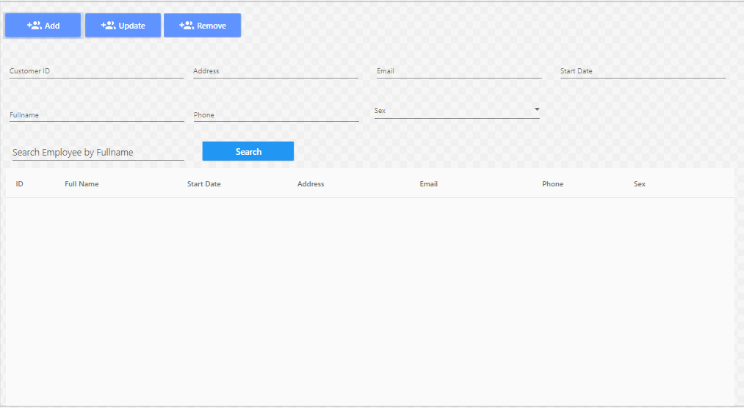

|  |  |  |  |  |  |
| --- | --- | --- | --- | --- | --- |
| **Name** | **Type** | **Event** | **Validation** | **Description** | **Status** |
| Number Credit Card | TextBox |  | int, not null | Input Customer’s Number Credit Card |  |
| Old Code Pin | TextBox |  | int, not null, | Input Customer’s Old Code Pin |  |
| New Code Pin | TextBox |  | int,not null | Input Customer’s New Code Pin |  |
| Config New Code Pin | TextBox |  | int, not null | Input Customer’s Config New Code Pin |  |
| CapChar | TextBox |  | int ,not null | Input number follow Image at above Text Box |  |
| Accept | LinkButton |  | Click | Accept Change code Pin . |  |

**7. Add Employee:**

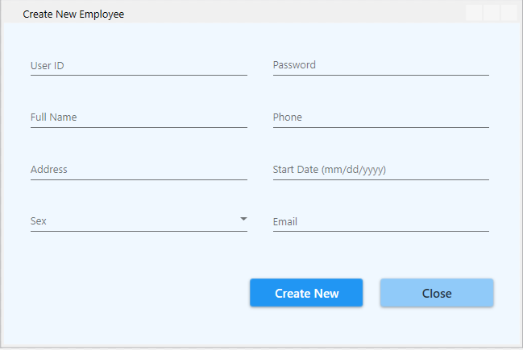

|  |  |  |  |  |  |
| --- | --- | --- | --- | --- | --- |
| **Name** | **Type** | **Event** | **Validation** | **Description** | **Status** |
| Number Credit Card | Label |  | Read Only | View Number Credit Card |  |
| Style Card | Drop Down List |  | Select | View and select Card |  |
| Day Create | Label |  | Read Only | View Day Create |  |
| Money | Label |  | Read Only | View Money |  |

**8.Update Employee:**

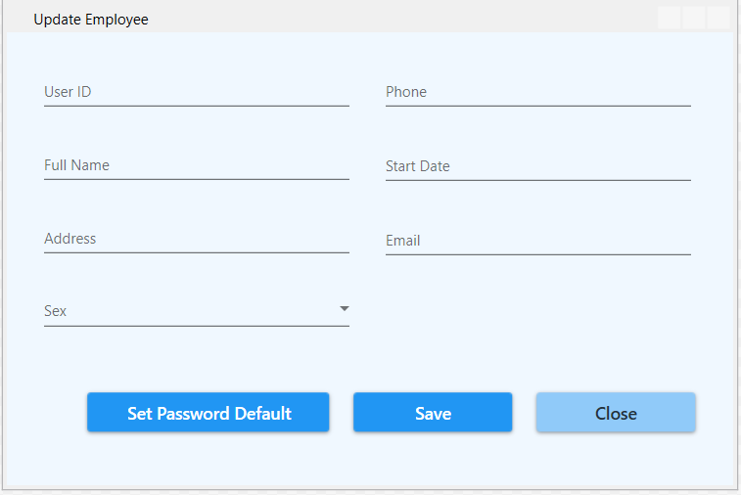

|  |  |  |  |  |  |
| --- | --- | --- | --- | --- | --- |
| **Name** | **Type** | **Event** | **Validation** | **Description** | **Status** |
| Full Name | TextBox |  | String, not null | Input Full Name |  |
| Birthday | TextBox |  | DatetTime | Input DateTime |  |
| Calendar Tool | Calendar |  | Select | Select Date on Calendar |  |
| Identity Card | TextBox |  | Int , not null | Input identity Card |  |
| Email | TextBox |  | String ,not null, have Validation | Input Customer’s Email |  |
| Country | DropDownList |  | Select | Select country |  |
| Address | TextBox |  | Int, not null | Input Customer’s Address |  |
| Number Phone | TextBox |  | Int, not null | Input Customer’s Number Phone |  |
| Save | Button |  | Click | click save edit enable |  |
| Edit | Button |  | Click | click edit Save unenable |  |

1. **Category Management:**

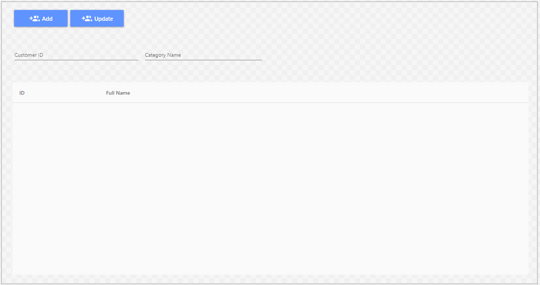

|  |  |  |  |  |  |
| --- | --- | --- | --- | --- | --- |
| **Name** | **Type** | **Event** | **Validation** | **Description** | **Status** |
| Date Tranfer | TextBox |  | DateTime, not null | Input Date Tranfer |  |
| Account From | TextBox |  | DatetTime | Input Account From |  |
| Code Pin | TextBox |  | Int, not null and Valiadaton | Input Code Pin |  |
| Account To | TextBox |  | DateTime, not null and Validation | Input Account To |  |
| Balance | TextBox |  | String ,not null, have Validation | Input Customer’s Balance |  |
| Transaction | Button |  | Click | Transaction |  |
| Check CodePin | LinkButton |  | Click | Check Codepin inval or not inval.. |  |
| Check Account To | LinkButton |  | Click | Check Account Inval or Not inval |  |
| CapChar | TextBox |  | int ,not null | Input number follow Image at above Text Box |  |

1. **Supplier Management:**

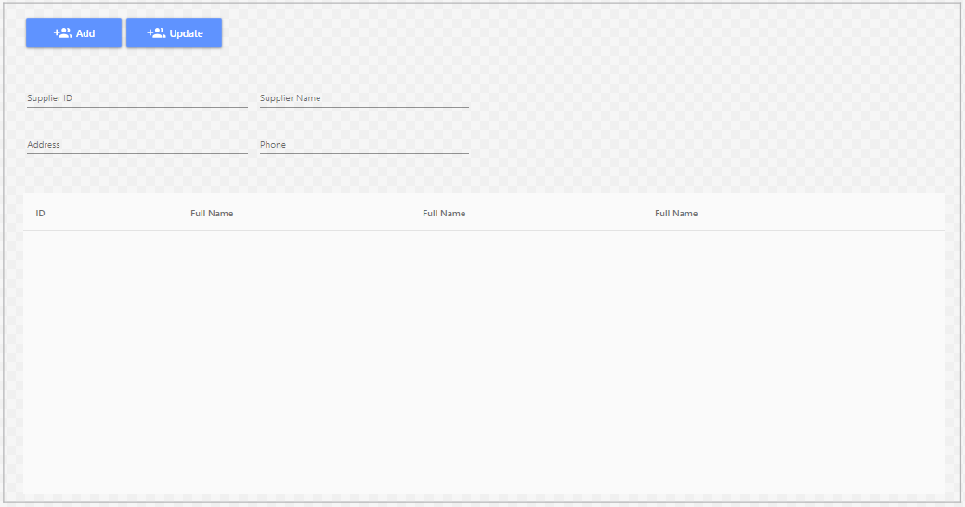

|  |  |  |  |  |  |
| --- | --- | --- | --- | --- | --- |
| **Name** | **Type** | **Event** | **Validation** | **Description** | **Status** |
| Log Out | LoginStatus |  | Click | Click Log Out |  |
| From Day | BasicdatePicker |  | Date time | Input From Date tranfer |  |
| To Day | BasicDatePicker |  | Date Time | Input To Date Tranfer |  |
| Transaction | Drop Down List |  | Select inform | Select Transaction |  |
| List Transaction | Grid view |  | Read Only | View inform Transaction |  |
| Select | LinkButton |  | Select | Select then view Detail |  |

**11. Order Management:**

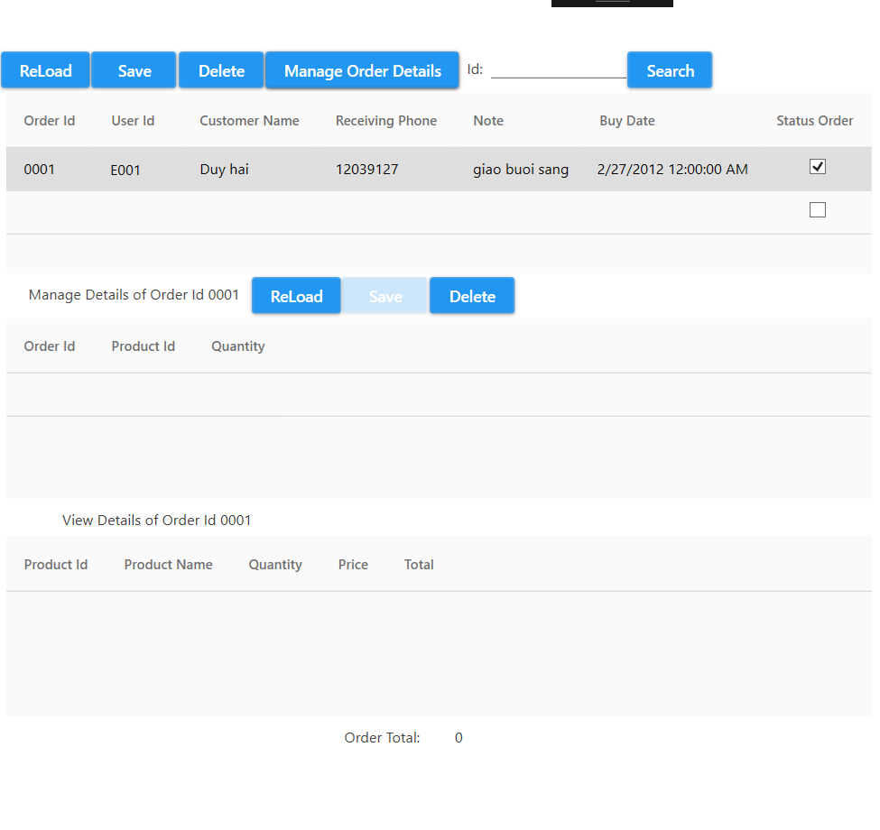

|  |  |  |  |  |  |
| --- | --- | --- | --- | --- | --- |
| **Name** | **Type** | **Event** | **Validation** | **Description** | **Status** |
| Search Date Transfer To | TextBox |  | DateTime , not null | Input DateTime |  |
| From Day | TextBox |  | DateTime , not null | Input DateTime |  |
| Search | Button |  | Click | Search |  |
| Transaction Detail | GridView |  | Read Only | View Inform of Detail’s Transaction |  |
| DownLoad Report | Button |  | Click | DownLoad Report |  |

|  |  |  |
| --- | --- | --- |
| **Date: Oct 10, 2012** | **Prepared by Project Group 4**  **Team Leader:** | **Approved by**  **Mr. Ho Hoan Kiem** |
| **Signature** |  |  |