PHUNG THANH HAI (馮清海)  
Student ID : 0880803

**REPORT  
DEEP LEARNING HOMEWORK III**

1. **RNN**
2. **Network structure**

* Instead of using one-hot vector, I used an embedding layer, which is use a vector of size 256 to represent a character, which is easy to extend to a word-level.
* Batch size: 64.
* Number of Epochs: 30.
* Optimize: Adam.
* Learning rate: Default.
* Size of sequence: 100.
* Size of Embedding layer: 256.
* Size of hidden states: 1024.
* Time per epochs: about 100s/epochs (Training + Validation)

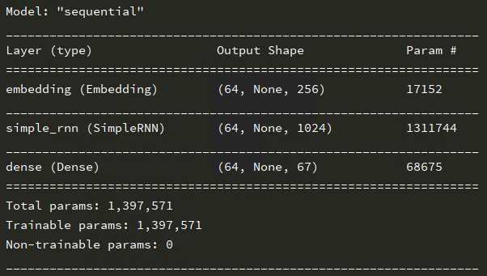

1. **Learning curve & Accuracy curve**

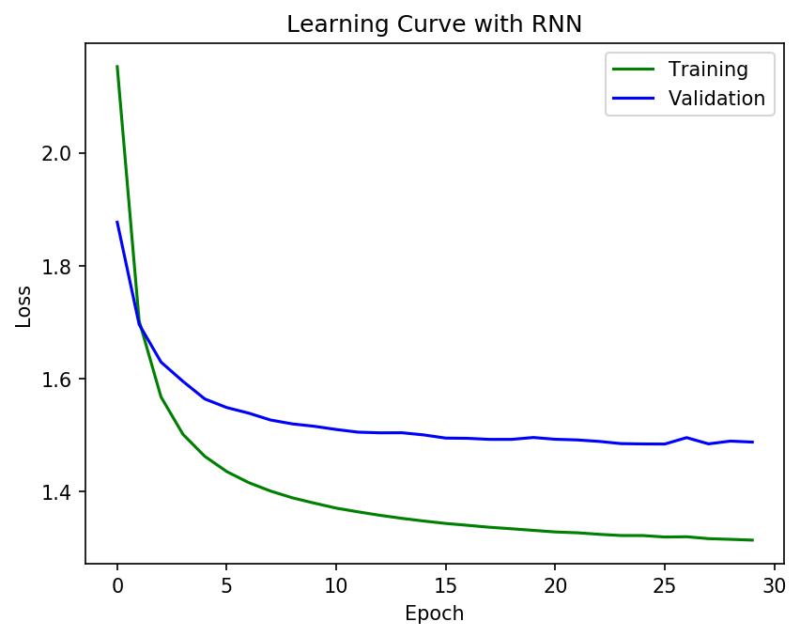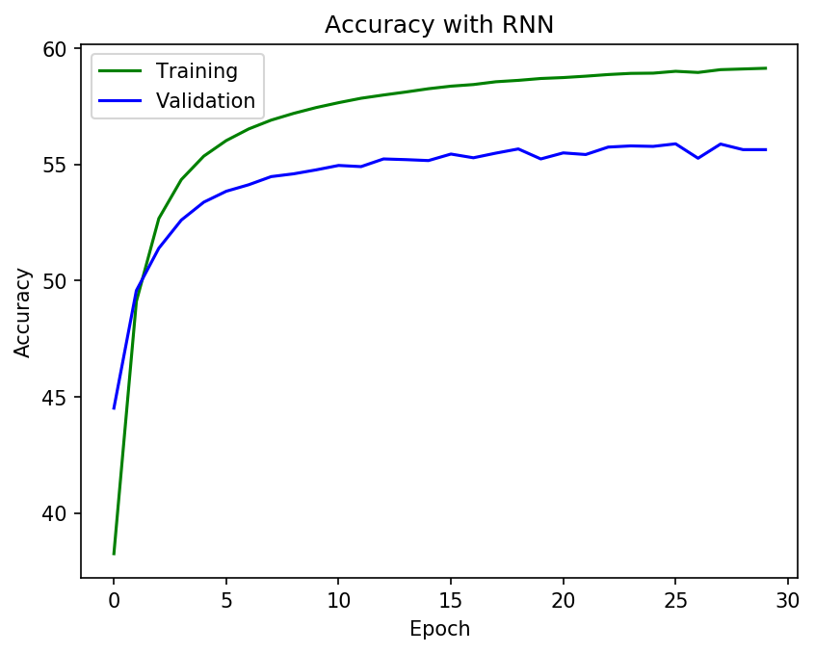

|  |  |  |
| --- | --- | --- |
|  | Train | Validation |
| Loss | **1.3145** | **1.4879** |
| Accuracy | **59.13%** | **55.63%** |

1. **Validation during training**

|  |  |
| --- | --- |
| Eth | Content |
| 0th | Acc Epoch 0: 38.25%  Input: 'tell what answer\nLewis and the Lady Bona send to him.\nNow, for a while farewell, good Duke of York.'  Output: 'tell what answer\nLewis and the Lady Bona send to him.\nNow, for a while farewell, good Duke of York.\n'  Predict: 'thrl tiet t d er Tot l a d the sori aurdtaoet th tes \n\now tor t soice toie rl aood more af tou \n' |
| 1st | Acc Epoch 1: 49.1%  Input: 'ed no more to time\nThan I do now: with thought of such affections, \nStep forth mine advocate; at your'  Output: 'd no more to time\nThan I do now: with thought of such affections, \nStep forth mine advocate; at your '  Predict: 'aetowmore th thme Toet t ho not thlh theu ht tf tuch a fection Toaattor h tene a veukti \nan tou ' |
| 10th | Acc Epoch 10: 57.65%  Input: 'lse he must not only die the death,\nBut thy unkindness shall his death draw out\nTo lingering suffera'  Output: 'se he must not only die the death,\nBut thy unkindness shall his death draw out\nTo lingering sufferan'  Predict: 'oi fe sast bot bney trs.the sevdh \nAut the fncindness ohall bas ceadh.aoowntfr Th heee r ng ohcferan' |
| 20th | Acc Epoch 20 : 58.73%  Input: 'My brother had but justice,\nIn that he did the thing for which he died:\nFor Angelo,\nHis act did not '  Output: 'y brother had but justice,\nIn that he did the thing for which he died:\nFor Angelo,\nHis act did not o'  Predict: 'E teither,tad bet aust ce \nA thet te hid the shing ior thach te widd Tor tntelo, Tos bncioos tot b' |
| 29th | Acc Epoch 29 : 59.13%  Input: 'om his best ward.\n\nLEONTES:\nWell said, Hermione.\n\nHERMIONE:\nTo tell, he longs to see his son, were s'  Output: 'm his best ward.\n\nLEONTES:\nWell said, Hermione.\n\nHERMIONE:\nTo tell, he longs to see his son, were st'  Predict: 'r oes soat ooyr \n\nFOONAES:\nAhll,said maloiane \n\nFOLMIANE:\nTh thll ie ioog to see tim peu ah e ih' |

1. **GRU**
2. **Network architecture**

The setup as the same as the RNN above.

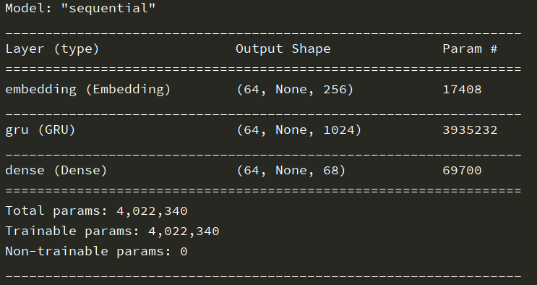

1. **Learning curve & Accuracy curve**

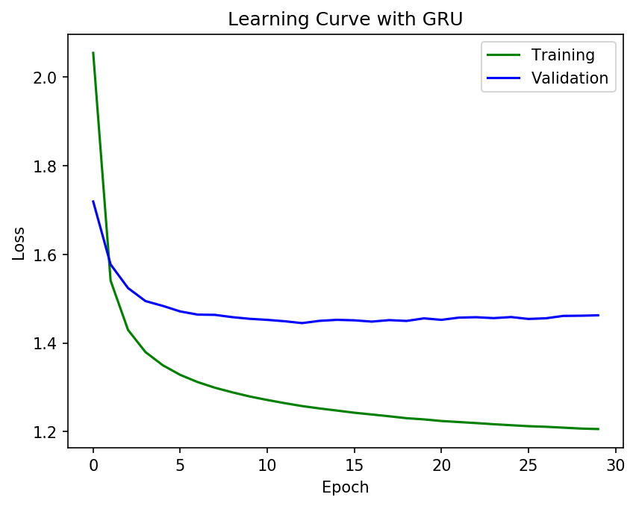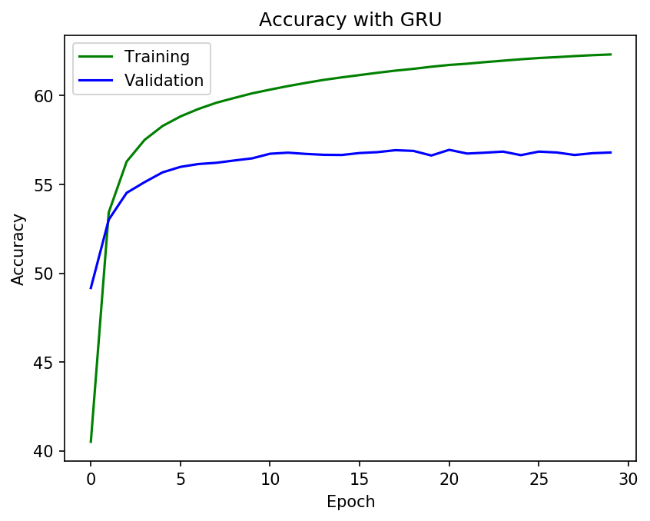

|  |  |  |
| --- | --- | --- |
|  | Train | Validation |
| Loss | **1.2059** | **1.4625** |
| Accuracy | **62.32%** | **56.8%** |

1. **Validation during training**

|  |  |
| --- | --- |
| Eth | Content |
| 0th | Acc Epoch 0 : 40.51 %  Input: "ing: what of that?\nHer eye discourses; I will answer it.\nI am too bold, 'tis not to me she speaks:\nT"  Output: "ng: what of that?\nHer eye discourses; I will answer it.\nI am too bold, 'tis not to me she speaks:\nTw"  Predict: 's e thet tn thet \nereIaesoodcomnte a hill n dwer tn \n\n am nh merd atis tot th ty toa sheak \nAh' |
| 1st | Acc Epoch 1 : 53.43 %  Input: 'th; which I receive much better\nThan to be pitied of thee. Prithee, bring me\nTo the dead bodies of m'  Output: 'h; which I receive much better\nThan to be pitied of thee. Prithee, bring me\nTo the dead bodies of my'  Predict: 'ho\nahach I seaeivedtesh aeater That th te artyes tf the \nTrathee, muing te Th the muar oeryes tf ty' |
| 10th | Acc Epoch 10 : 60.34 %  Input: 'unk that bears this head\nBe round impaled with a glorious crown.\nAnd yet I know not how to get the c'  Output: 'nk that bears this head\nBe round impaled with a glorious crown.\nAnd yet I know not how to get the cr'  Predict: 'sd yhet tears ahes boav Te seund tnpeti tith t soovious soown,\n\nnd tot I wnow not wow th bit theeso' |
| 20th | Acc Epoch 20 : 61.73 %  Input: "To have her match'd: and having now provided\nA gentleman of noble parentage,\nOf fair demesnes, youth"  Output: "o have her match'd: and having now provided\nA gentleman of noble parentage,\nOf fair demesnes, youthf"  Predict: 'h bave air ainch d tnd teveng not arovoded Tnpontleman of table bertntsge.\nAr tair aevar es aou hf' |
| 29th | Acc Epoch 29 : 62.32 %  Input: "es,\nWere thinly scatter'd, to make up a show.\nNoting this penury, to myself I said\n'An if a man did "  Output: "s,\nWere thinly scatter'd, to make up a show.\nNoting this penury, to myself I said\n'An if a man did n"  Predict: " t Ah e nhesey tearter'd ah take ts t stawe\n\now ng thes mrrnry sh ta elf h heyd,TTs in t man ood s" |

1. **LSTM**
2. **Network architecture**

The setup as the same as the RNN above.

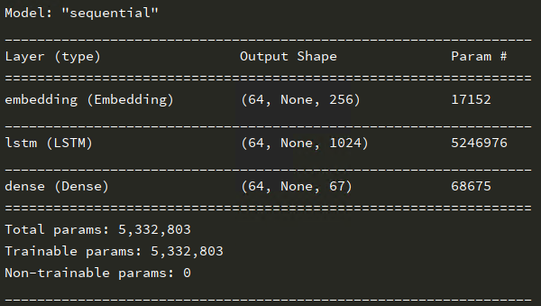

1. **Learning curve & Accuracy curve**

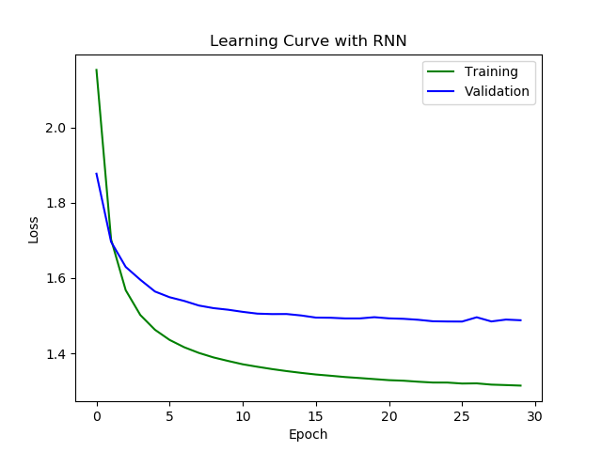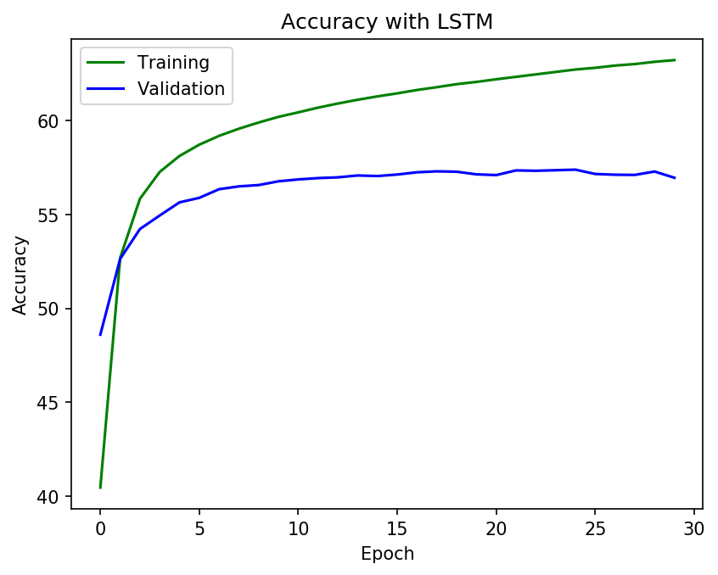

|  |  |  |
| --- | --- | --- |
|  | Train | Validation |
| Loss | **1.1728** | **1.4494** |
| Accuracy | **63.21%** | **56.95%** |

1. **Validation during training**

|  |  |
| --- | --- |
| Eth | Content |
| 0th | Acc Epoch 0: 40.46%  Input: ':\nWhat else? and that succession be determined.\n\nWARWICK:\nAy, therein Clarence shall not want his pa'  Output: '\nWhat else? and that succession be determined.\n\nWARWICK:\nAy, therein Clarence shall not want his par'  Predict: '\nThit svse \nInd thet thchhst on te aeaurvengs \n\nPARTICK:\nWn, she e n taeyy te ohall bot tist tim srr' |
| 1st | Acc Epoch 1 : 52.68 %  Input: 'nks;\nAnd yet we should, for perpetuity,\nGo hence in debt: and therefore, like a cipher,\nYet standing'  Output: 'ks;\nAnd yet we should, for perpetuity,\nGo hence in debt: and therefore, like a cipher,\nYet standing '  Predict: 'ae,\nAnd tot hi ahauld tor trrconirny Tooterce tn tearh tnd the e ore seke t sotiir \nTot hhand ng ' |
| 10th | Acc Epoch 10 : 60.43 %  Input: " pardon me; indeed, I will not forth.\n\nVALERIA:\nIn truth, la, go with me; and I'll tell you\nexcellen"  Output: "pardon me; indeed, I will not forth.\n\nVALERIA:\nIn truth, la, go with me; and I'll tell you\nexcellent"  Predict: 'trrdon te,\nIf eed, a will not bor h \n\nPALENIA:\nI dthuth Ied toowith me tnd t ll tell you tvcellent' |
| 20th | Acc Epoch 20: 62.19 %  Input: 'for the defence of a town, our general is excellent.\n\nFirst Servingman:\nAy, and for an assault too.\n'  Output: 'or the defence of a town, our general is excellent.\n\nFirst Servingman:\nAy, and for an assault too.\n\n'  Predict: ' dwtha wevence of t crnn,\narr srneral ss axcellent.\n\nFirst Senvingman:\nWy, mnd tor t ers.ult ao .\n\n' |
| 29th | Acc Epoch 29 : 63.21 %  Input: " he, our hope, might have retired his power,\nAnd driven into despair an enemy's hope,\nWho strongly h"  Output: "he, our hope, might have retired his power,\nAnd driven into despair an enemy's hope,\nWho strongly ha"  Predict: "aaa 'rr seses aysht have besured tem howers\nAnd toine an o tespiir tsdenemy s teue,\nTho whaikg y sa"  Validation Loss 29 : 1.4494915950999538  Validation Accu 29 : 56.95 % |

1. **Compare RNN/GRU/LSTM with different size of sequence length and hidden state**

|  |  |  |  |  |  |  |  |
| --- | --- | --- | --- | --- | --- | --- | --- |
|  | #hidden state | Sequence  Length | #params | Accuracy  Train | Accuracy  Validation | Loss Train | Loss Validation |
| RNN | 1024 | 100 | 1.397.571 | 59.13% | 55.63% | 1.3145 | 1.4879 |
| RNN | 1024 | 50 | 1.397.571 | 56.49% | 52.54% | 1.3868 | 1.5564 |
| RNN | 512 | 100 | 445.251 | 59.05 | 55.3% | 1.3165 | 1.5015 |
| GRU | 1024 | 100 | 4.022.340 | 62.32% | 56.8% | 1.2059 | 1.4625 |
| GRU | 1024 | 50 | 4.022.340 | 60.08% | 54.53% | 1.2726 | 1.4936 |
| GRU | 512 | 100 | 1.234.243 | 62.2 | 56.85 | 1.2101 | 1.4590 |
| LSTM | 1024 | 100 | 5.332.803 | 63.21% | 56.95% | 1.1728 | 1.4494 |
| LSTM | 1024 | 50 | 5.332.803 | 63.98% | 54.33% | 1.1389 | 1.5330 |
| LSTM | 512 | 100 | 1.628.483 | 63.19% | 57.29% | 1.1728 | 1.4385 |
| LSTM | 2048 | 100 | 21.074.755 | 82.3% | 57.93% | 0.7224 | 1.40861 |

* From the comparison, we can see clearly that LSTM out of performance compare to the other RNN method.
* However, LSTM hit the **overfitting problem** in case that we **increase** the number of hidden layer. Earlier stopping, add L2 norm with respect to the weights, or Drop out technique might help to prevents this problem or just simply reduce the number of hidden state.

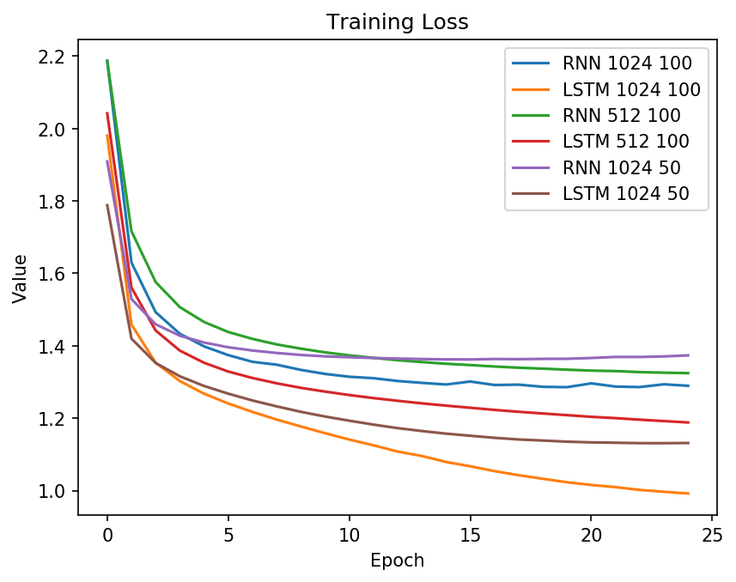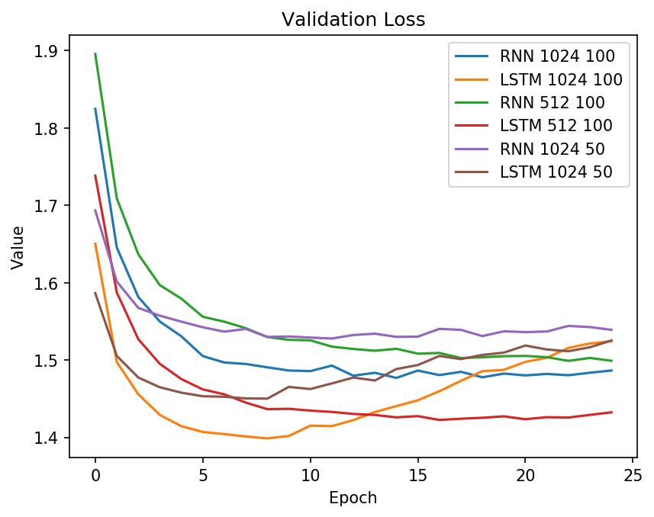

Comparison between RNN & LSTM on loss

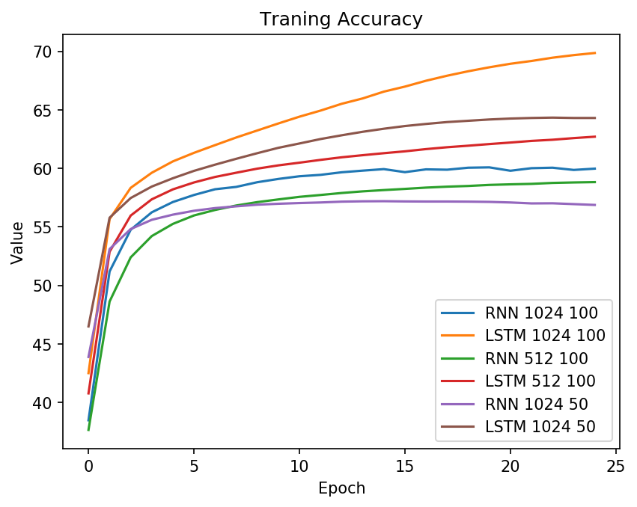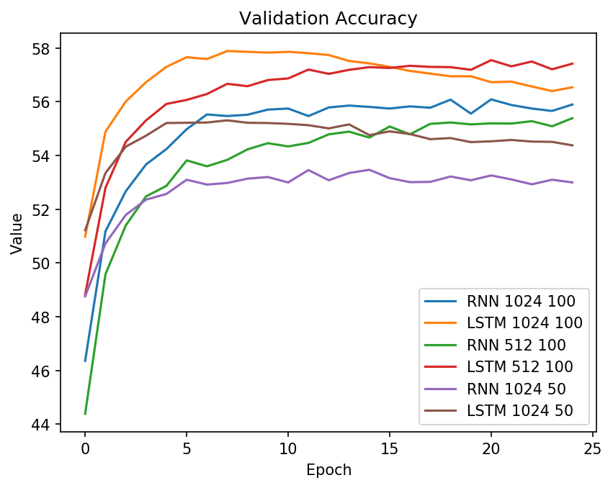

Comparison between RNN & LSTM on accuracy

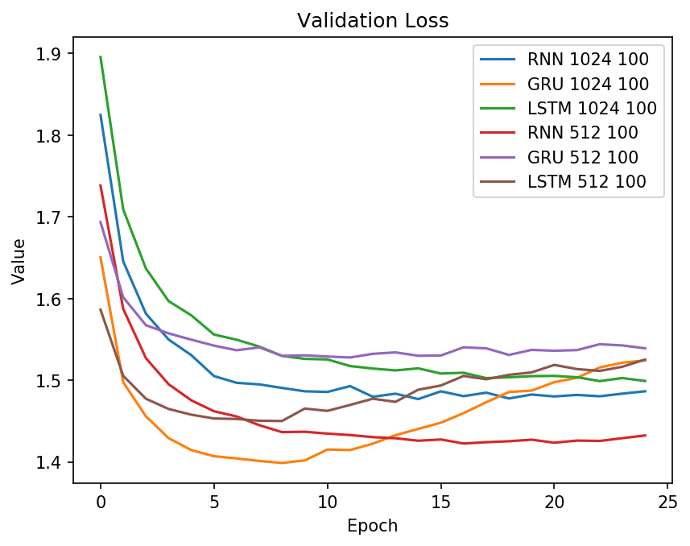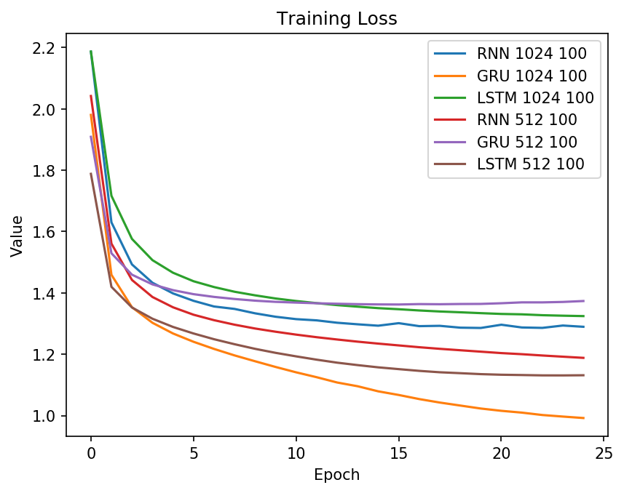

Comparison between RNN & LSTM & GRU on loss

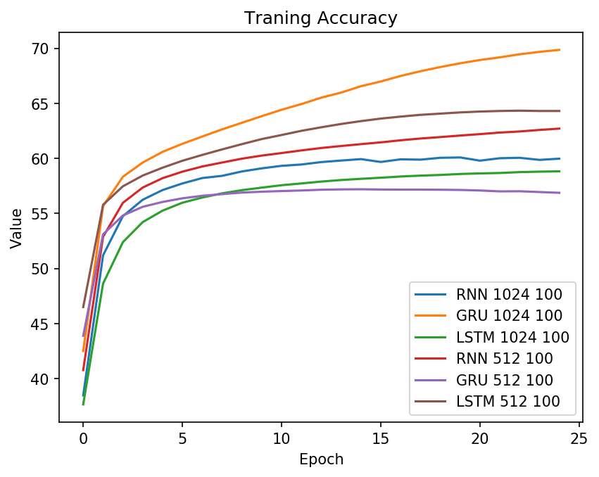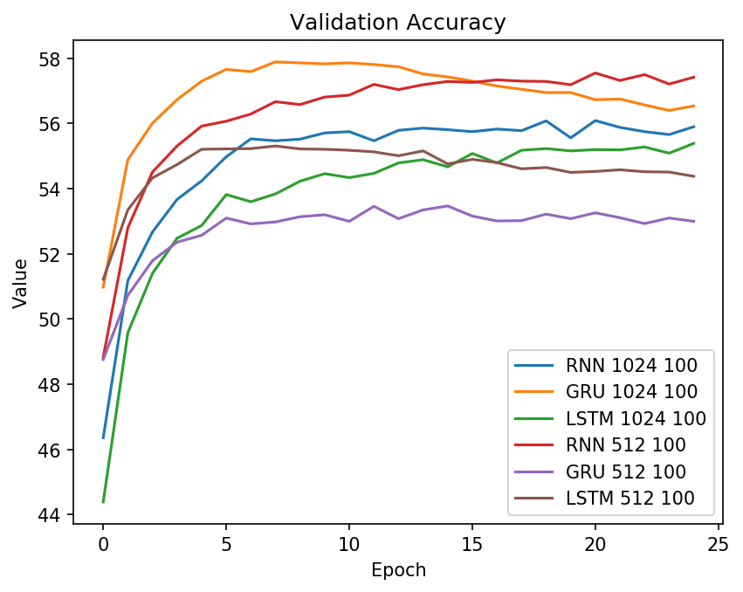

Comparison between RNN & LSTM & GRU on accuracy

1. **Generate text**
2. **RNN**

ROMEO:

I know you fit in the curtair;

And speak in socian, and womaring, villain. Good lanks in

thy terribly: I prithee.

GUIDERIUS:

O, lords, do not be a foul my way;

He comes't shepherd let

their sacred in his now

With doubtful son of our jewel espounter, then and greatest service;

Whiles him threaten thee of any man be curse,

If Hermia's princely back; unto the breats, run

should think hir, wrong'd the lion merit our names grave,

To take a gentleman.

SALARINO:

That I may be rackness thy logging vows, so access thee.

AEGEO:

I shells us by: I will make him dowerly.

BRUTUS:

Is there is note's cause,

Seemy soul of Gloucesta.

YORK:

The qualities

Shall be flattered?

IACHIMO:

Indeed, you make your born on?

Forward you past; for the war

The very sword with bloods as from me well, my lord.

FORD:

Our lection o' my head'wove you bams.

Youth, I'll be so drew;

To the value o'er'd wife, my

master I am made.

GLOUCESTER:

What coulder please, look you, Marlair, went thee?

PRINCESS:

Your pinied in

JULIET:

Good Abe rather have peace;

And on thy heart,

A plate;

As you are undone; the duke, sir,,

'Twere best and disgrace, and tear the crupt: but I have pleased?

ARVIRAGUS:

About a king?

FALSTAFF:

Old Anotheel, he's their promises and we ut.

Now Lepidus I will not do, when your worshipper-to

Form. O, sir, my Lord of York of God's head, as black things of men, I loved in pries the king, one so true;

I'll charge hos; a sister spoke with my a crown? all,

Though he his word their lords and journey.

BIRON:

Very pertury bringled breeding enterprised trdet?

HAMLET:

Now, gade this world.

AEGEON:

Ne'er nature have in silent huge: fetch with a weak and

fault, sir, straight metiness

Of rare prightening:

Come, lordsilerveshou will make a like so happy.

DUMAIN:

Judot Nice ne'er: his noble Pyramus is miall, Oxformwell!

ghome! By his son!

If not remember me to.

BELARIUS:

Here, Petrus ik;

That grace?

HAMLET:

But forbid; I have seen praise

What abused enough.

GUIDERIUS:

Your thoughts,

What say your

1. **GRU**

ROMEO:

Let me keep up my dear folly, bar, a most

man's liquit thickens, meet me confess it;

Whose shows not, you may have informed fools.

GLOUCESTER:

I do? See you in their learning thy weapon.

Clown:

The honour of service on, sir?

OPHELIA:

Make the ass man gone from hence. Our But's form of the fiend?

I prithee, doth we mean your fair love would.

Within the hug loves; and then to your majesty,

That, said, thou filESS QUEEN ELIZABETH:

Indeed, is this sick, not with wearing, but

the rust of this.

MARCELLIUS:

What we set out of noble, better for all.

ROSENCRANTZ:

Go, know I, in apring, a comfort of my first. There is a

my lord in Juno, soon of Percy's east

Forsok and prefer these both that men

I cannot take the Goths; fetch my wit.

DESDEMONA:

What say you; speak, sir: and 'my dame's sake,

Are short against us, as we understand.

IACHIMO:

I was then no more; for meat for the fiends of worse,

As babes and secret and long there?

THERSITES:

Call mine is in a swartheing and diet;

My too must

JULIET:

How now! what's alliancemosto.

APEMANTUS:

To second Luceglingmothee, cadd down by light

Takes all; for't, -not yours;

What shipric, the sue Cod and service were more grieved against

a sovereign, and all our circumasit

And entertain the chamber, for their cold looks their fierce.

NORTHUMBERLAND:

Right Philomel: and wears hers, Norway! Soldiers,

I'll hang on; and am as have I. Both of my cardinal

now le new death;

Not she after-will be stop'till together, as

musical did call you a sovere use not; 'tis eby:

before the air broke the seafance of our horses and

play harmony.

First Lord:

PRINCE HENRY:

What a livinicalar kill top of a dead-sheet,

Is the narry; lord, comnaticulary days and daughter. Of a monster, death,

Mine honest mente do well say so; come, let's heard guess ite of that.

ACHILLES:

Most helm affectation; and yours, as twenty and ope like

and two such noble friends. 'tis much, subve Ialose, I am your

father.

OTHELLO:

Thou art the dupon to me as thy fellow.

LEPIDUS:

You

1. **LSTM**

ROMEO:

Lord John, my husband will I grant ye; and therefore tell me

what's the matter here?

PRINCE HENRY:

I know thee well.

DUKE SOLINUS:

An English lady, e they were

Some other men and means to gain themselves

As frozes in the first; for, in the presence

One, and you shall not say yourself: 'ig' is he not.

Here, Mistress Anne Page.

ANTIPHOLUS OF DAUPHIN:

We horse, Iagree, most stones, most dear;

For, being known three years old Dane;

But, not thy noble, subject'st to expect

These tedious drops.

Lord, prove plain, sola, without fair,

And budge from him that was his valiant love.

SILVIUS:

It would have spoke to-day a smiling untreadbar the likelier; slave, not d

Which you have known when I was borrowed now; but if you would have

the thing in him that will shame't strive: will you go, Marcus Brutus.

ANDROMACHARD IIN:

Yea, in both mile? will they holy arm?

ADRIANA:

Caesar doth not atteed and right through thee.

FPeet,

pray not, lessell shift nor higher than he is.

YORK:

Come, thou mine

JULIET:

No words.

IAGO:

I am sorry to you--

DIOMEDES:

No, my lord,

I'll make a monsteral fearful when I wear

Upon the very nooks to fair regards.

SUFFOLK:

What pleasant yeart there are not ignorant,

And then consort you woore on Hernk,

Would you consume and like ted so post as thou affect!

Unto the French, have never born awitch:

For what others, what does you stand halt been

That footed arm his sword with his own store

Seeming such secrets, but one of them thence

For a for a passing of it.

LUCIANA:

Will it not grapp?

OTHELLO:

Your pardon for more chains and then to glus?

YORK:

In my request deny

Thou couldst have drag ersologence is drunk. But to redemptroours in arms

And his her chamber-band of her poor breast.

Lascivers of Marchiefest the thief. Haven we looked through our

wraths, and to tave all qualifying-blowing with disposing conscience wing

Together from the former world's excell;

Were triving to his rageon, reverence,

Or sense of as a catepiris.

CRESSIDA:

How now, love's that