PHUNG THANH HAI (馮清海)  
Student ID : 0880803

REPORT

DEEP LEARNING HOMEWORK 1

1. Regressiona. Network Architecture

|  |  |
| --- | --- |
| Network Architecture | 16 – 10 – 10 - 1 |
| Selected features | in range (8) |
| Training ERMS | 0.31443078494589627 |
| Testing ERMS | 0.4736531381767725 |
| Epochs | 10000 |
| Learning rate | 0.002 |
| Batch Size | 32 |
| Training / Testing Size | 75% - 25% |

**b. Learning Curve**

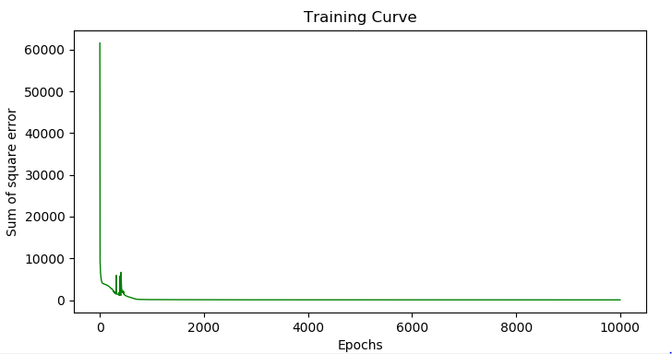

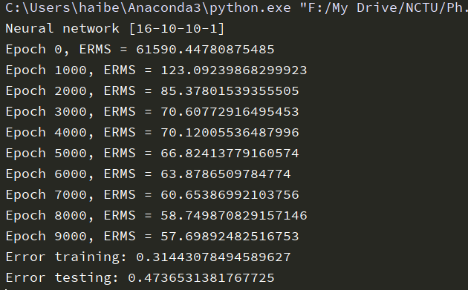

**c. Regression result with training label**

* **Shuffle = TRUE**

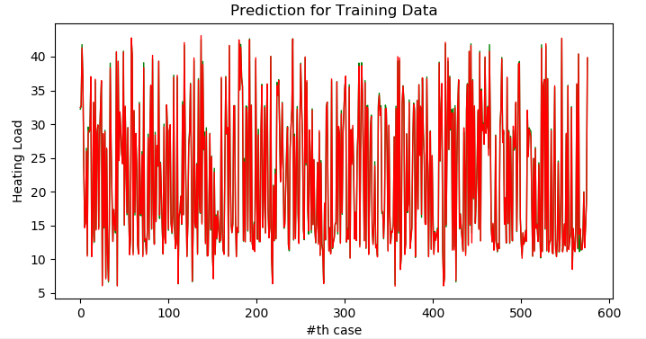

* **Shuffle = FALSE**

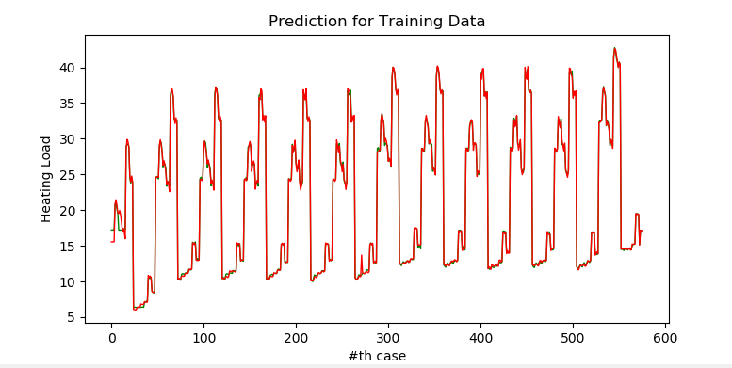

**d. Regression result with testing label.**

* **Shuffle = TRUE**

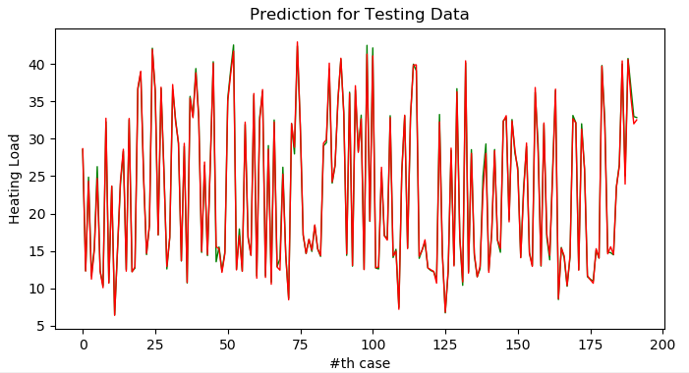

* **Shuffle = FALSE**

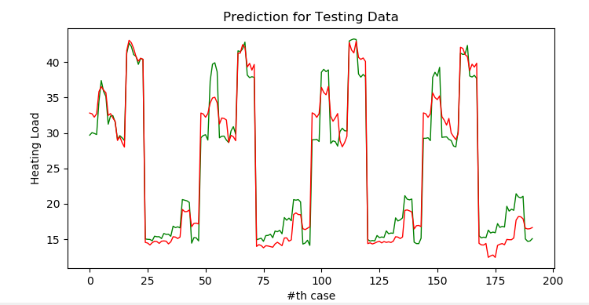

* A method to identify which feature that has the most influent to the result is that adding noise to the feature. Assuming that in practice, the collected data comes from the sensors might be noise, and which feature that we need to reduce the noise as small as possible. The error is generated by Gaussian ((μ, σ), zero mean and be normalize from 0 to 1, saying as how many percent that data was noised.

*ERMS/each data

* By this test, we could say that the 3rd features influent to the result more than the others two feature. We had tried this method to find out which features is more important than the others feature.
* By the way, this is the state – of – art questions on Machine Learning, as well as how we configure the parameter and the structure of the network.
* Another method to select features is by the variance of the features. Removing the features have the variance that is smaller than the threshold. We could expect that the features that have small variance will not effect to result.
* Remove 1 feature (2nd feature) with minimum variance. The result is quite similar to when we use all of the features, shown below:

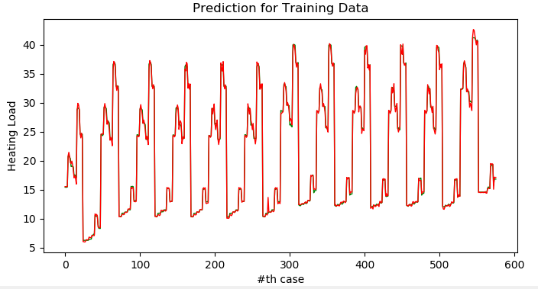

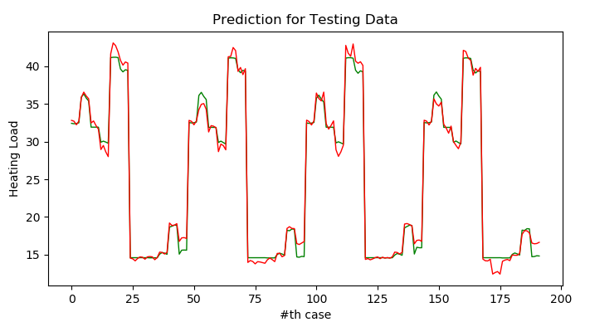

* Remove 2 features (0th and 2nd features) with minimum variance. The result shown below:

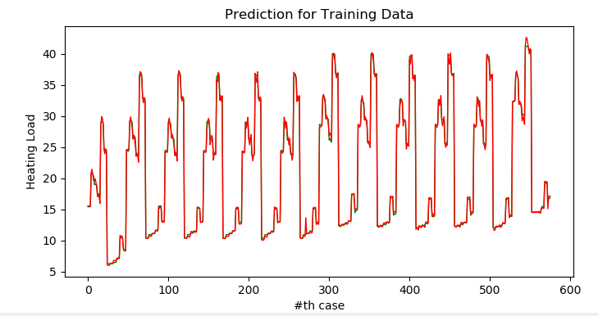

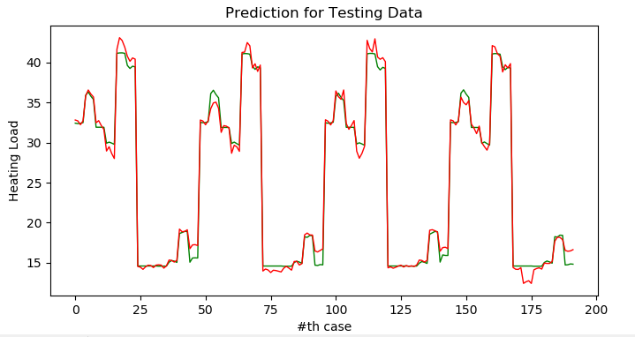

* Remove 1 features (5th features) with maximum variance. Shown below:

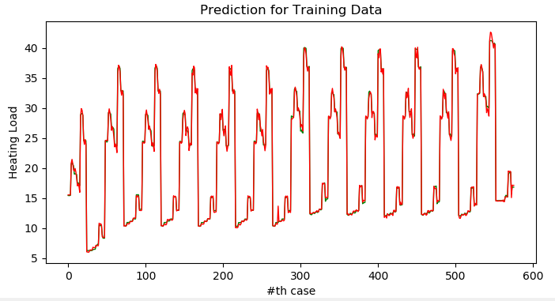

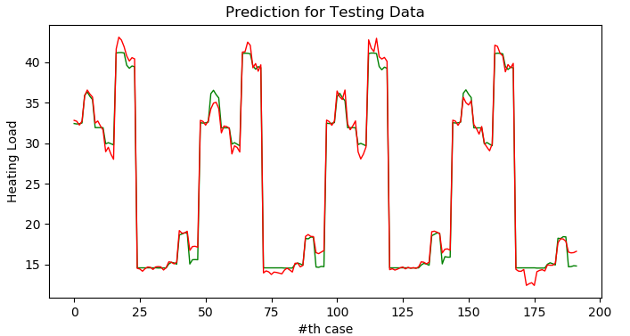

**2. Classification**

**a. Network Architecture**

|  |  |
| --- | --- |
| Network Architecture | 128-64-32-3-2 |
| Selected features | all |
| Error Rate Training | 0.0% |
| Error Rate Testing | 5.63% |
| Epochs | 2000 |
| Learning rate | 0.005 |
| Batch Size | 32 |
| Training / Testing Size | 80% - 20% |

b. Learning Curve

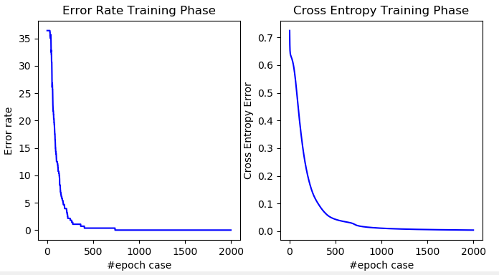

Error & Loss during Training Phase

c. Plotting latent features at different training state

By changing the hidden layer before output layer, using 2 or 3 nodes, we then compare the result by visualize (2D or 3D) the distribution of this hidden layer at different training state.

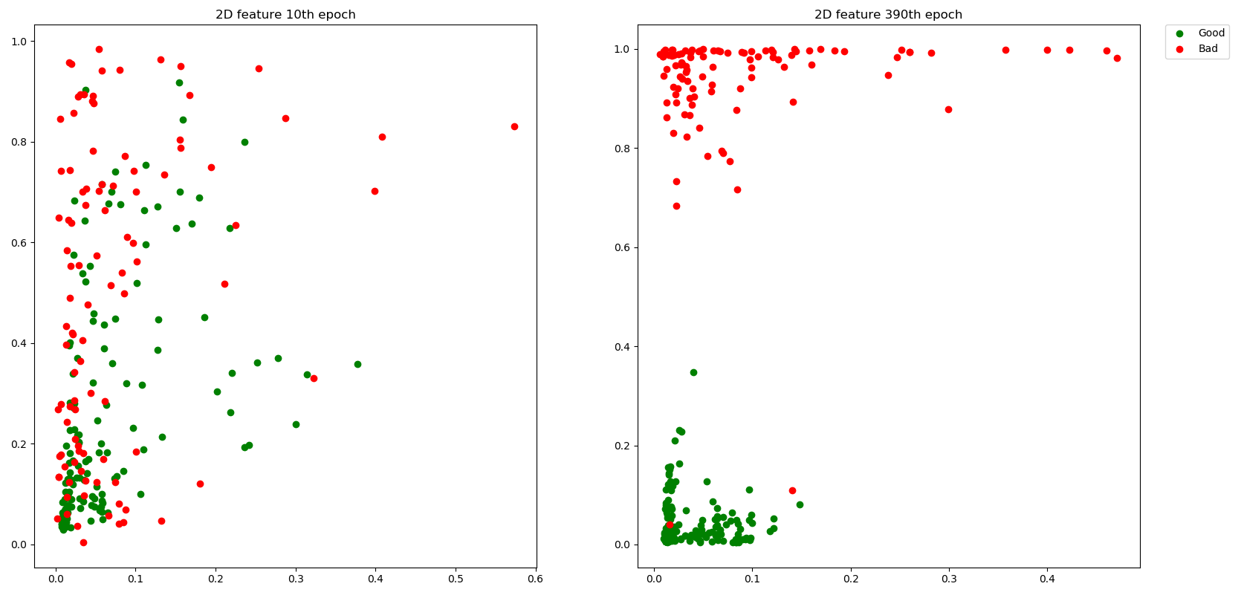

The result by visualize (2D)

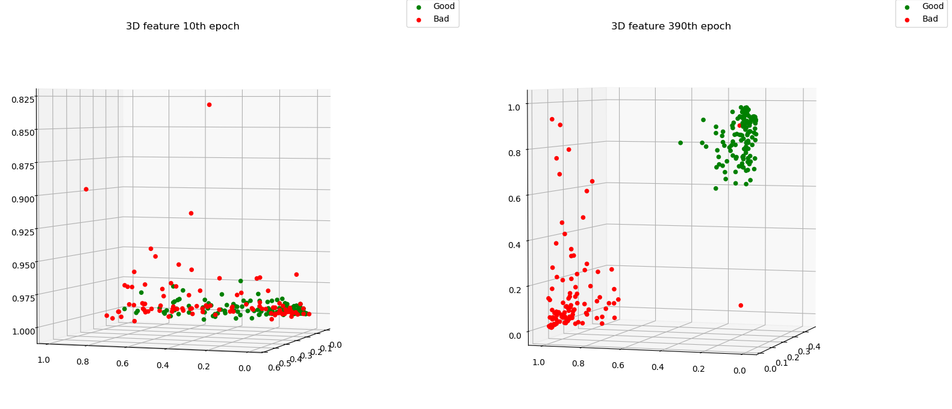

The result by visualize (3D)

*Usage:To run regression program:  
>> python Dregression.py  
To run Classification program:  
>> python Dclassification.py

*If there is anything goes wrong thru my code, please don’t hesitate to contact me to check it out. Thank you very much!*Email: haiphung106@gmail.com