**Nguyễn Hải Quân – ITITWE21104**

**Lab 02 - Exercise 3**

**Website Description:**

This personal website serves as an introduction to Nguyen Hai Quan, a passionate web developer skilled in front-end and back-end technologies. The site is designed to showcase skills, projects, and experience, providing a professional online presence. It includes a homepage, about me section, portfolio, resume, contact form, and a blog.

**Folder Structure Screenshot:**

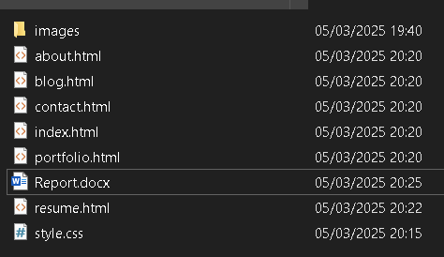

**Website Screenshots:**

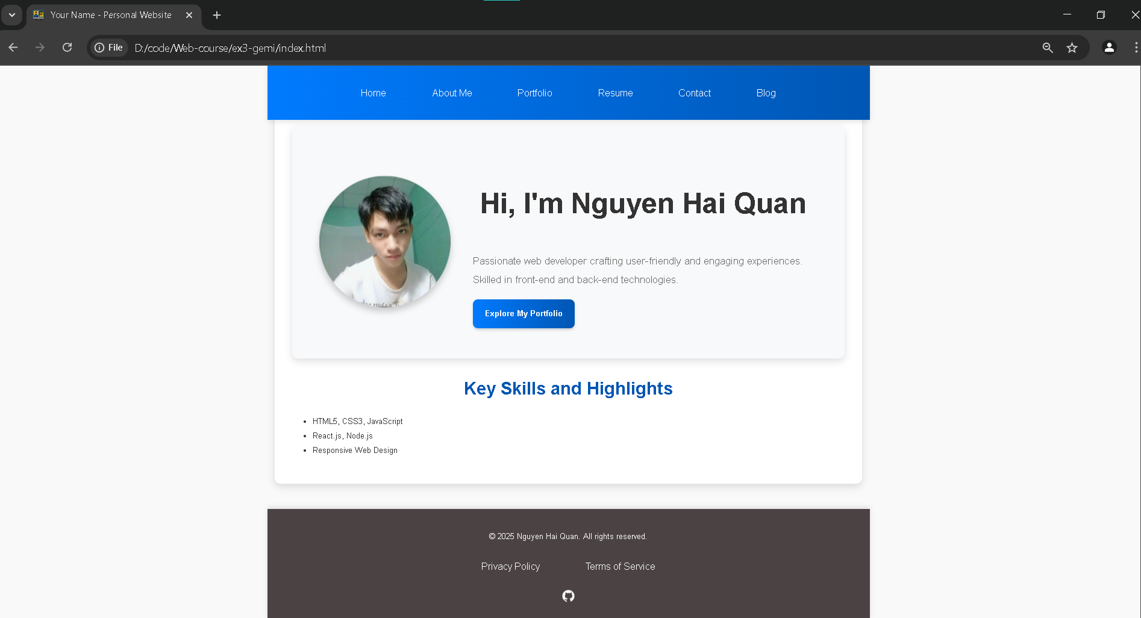

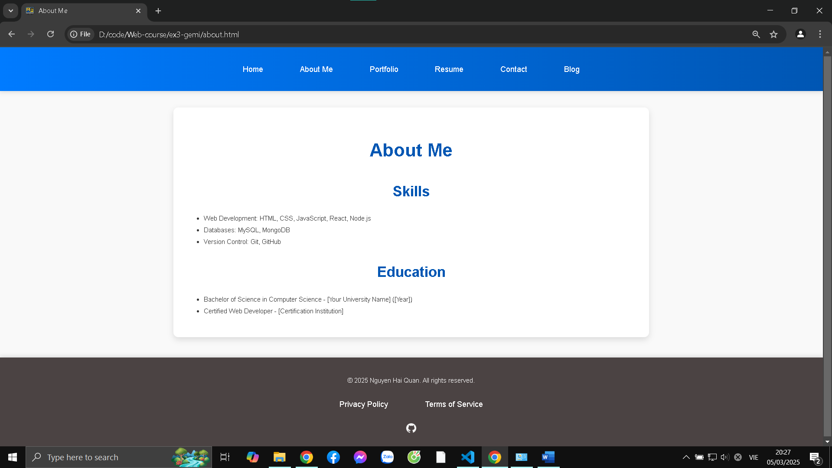

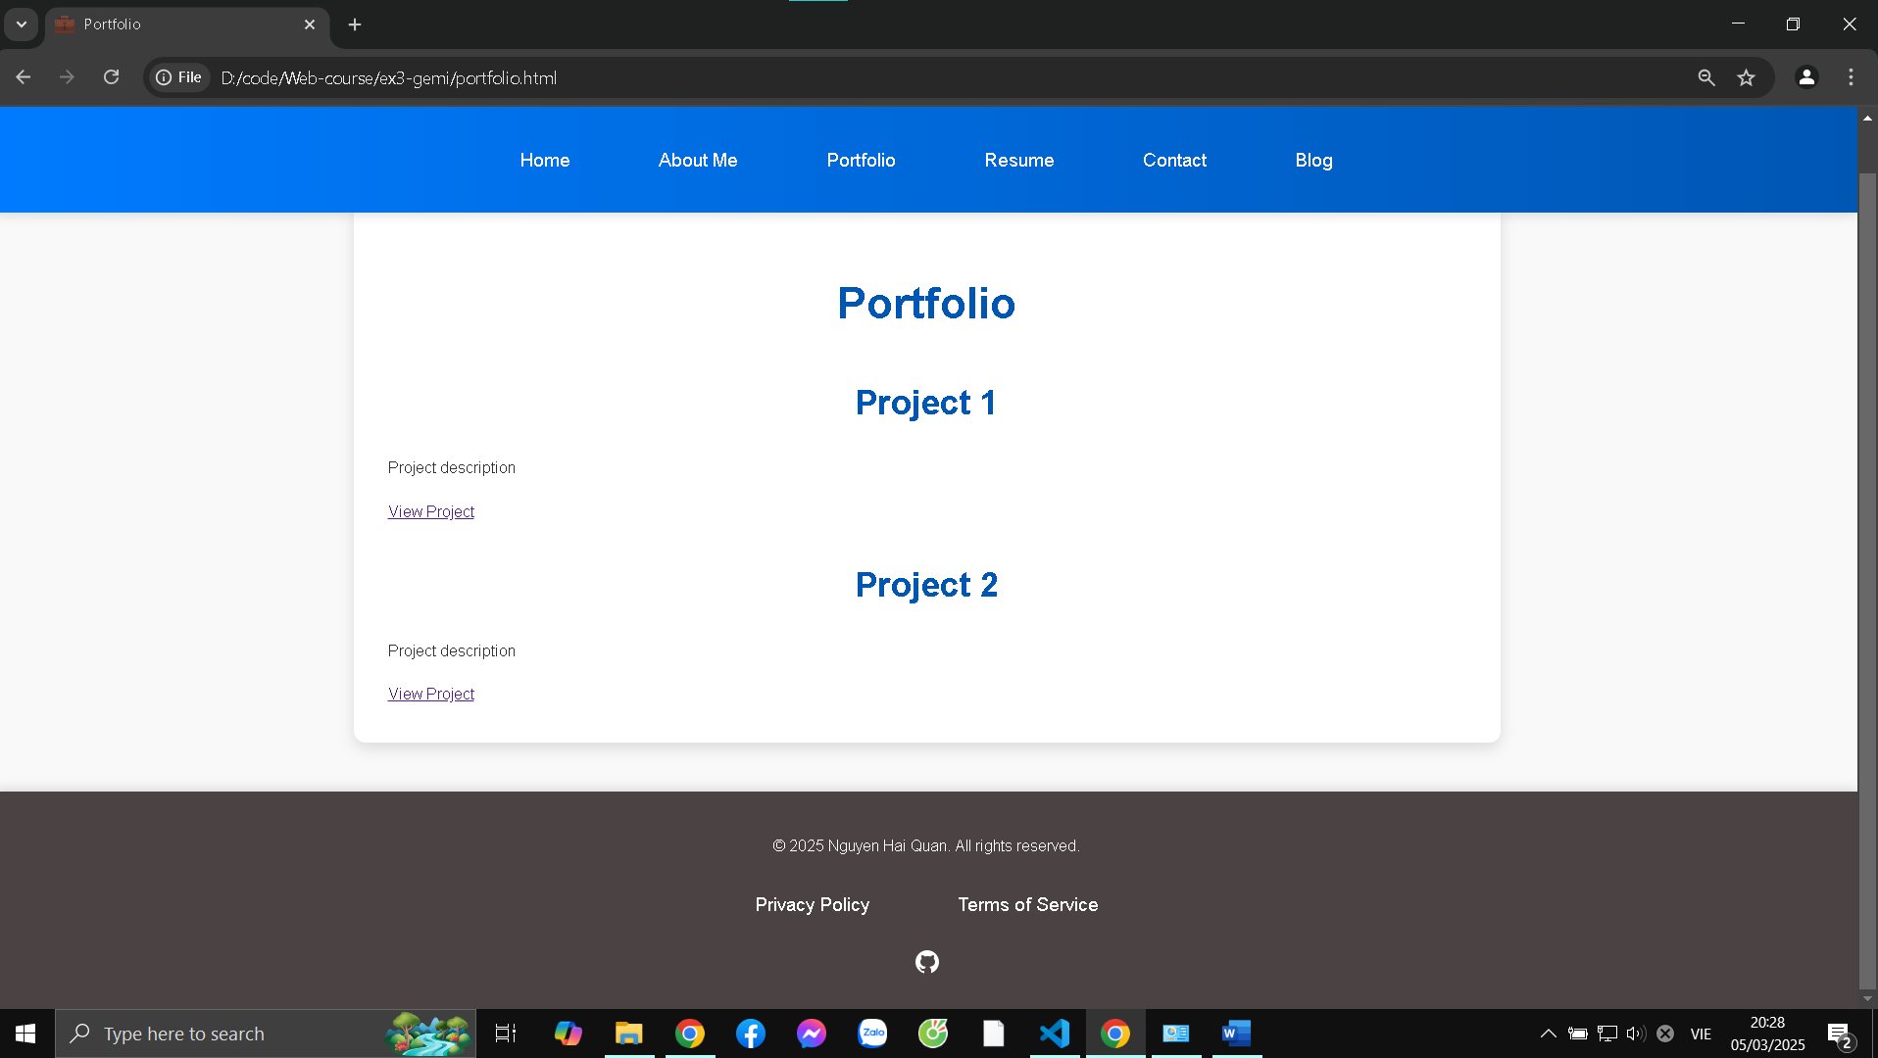

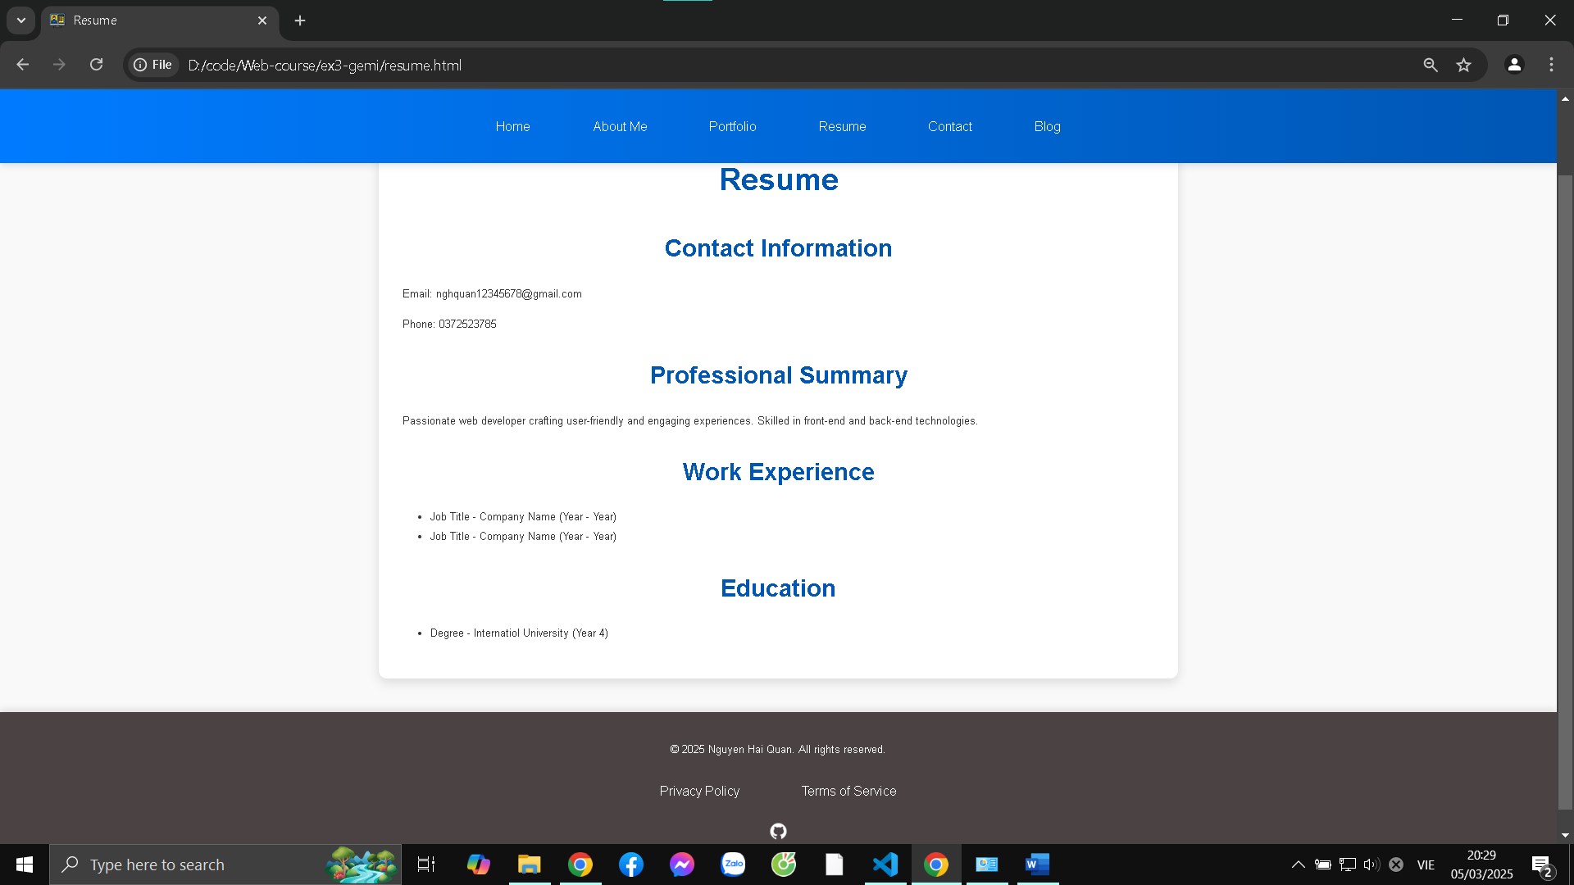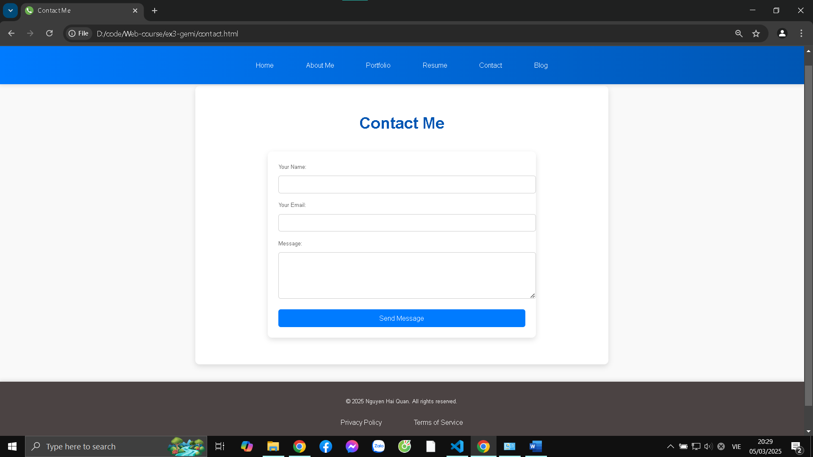

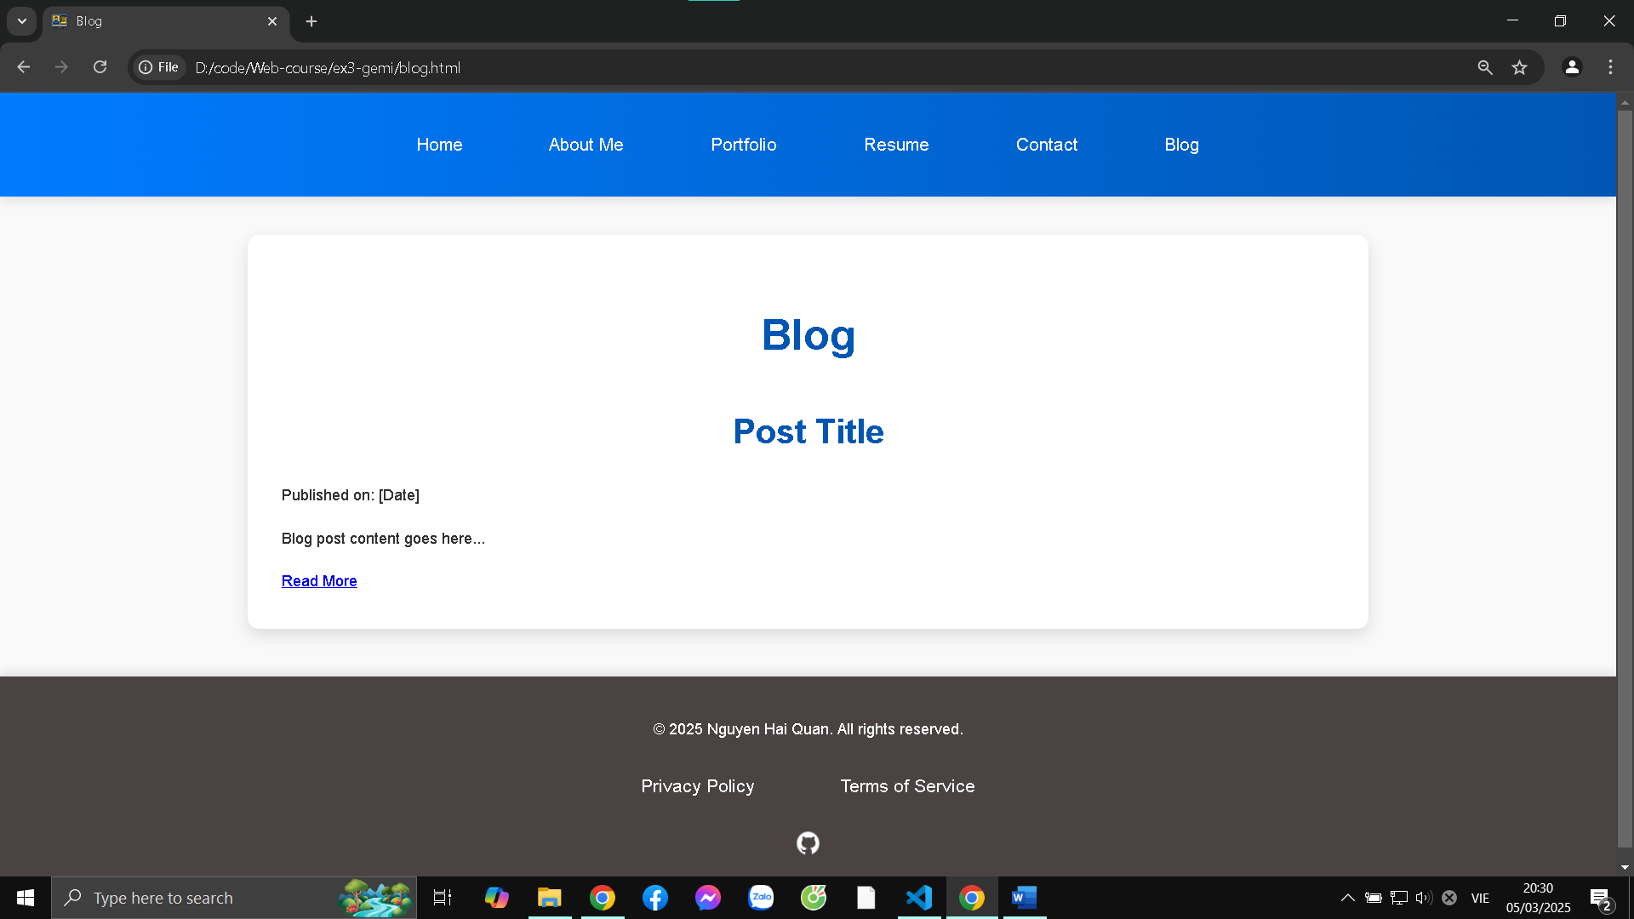

**Explanation of Features:**

* **HTML Structure:** The website utilizes semantic HTML tags (<header>, <nav>, <main>, <footer>, <section>, <article>) to structure the content logically and improve accessibility. The <meta> tags in the <head> provide metadata for SEO and social sharing.
* **CSS Styling:** CSS is used to control the visual presentation of the website. A mobile-first approach is adopted to ensure responsiveness across different devices.
* **Container:** I implemented a .container class to control the layout of the main part of the website. This ensure that the website layout looks well proportioned across different pages, and better user experience.
* **Navigation:** The navigation menu in the header allows users to easily navigate to different sections of the website.
* **Hero Section:** The hero section on the homepage provides a welcoming introduction and highlights the key skills and experiences.
* **Images:** Images are used to enhance the visual appeal of the website (e.g., profile picture, project thumbnails).
* **Links:** Links are used for navigation, both internal (between pages) and external (to social media profiles).
* **Contact Form:** The contact form on the contact page allows visitors to send messages directly.
* **Responsiveness:** The website is responsive and adapts to different screen sizes using media queries.
* **Animations:** Subtle animations are used to enhance the user experience and create a more engaging website.

**CSS Styling Explanation:**

The CSS styling approach focuses on creating a clean and modern design. A consistent color palette is used throughout the website, and typography is carefully chosen for readability. Flexbox is used for layout to create a responsive and flexible design. Animations are added to provide visual interest.  
Specifically, using style tag ensures faster first content rendering.

**Key Improvements Made:**

* **Clearer Structure:** Organized the code into semantic HTML sections (header, navigation, main content, footer).
* **Hero Section:** Created a compelling hero section with a clear introduction.
* **Portfolio Emphasis:** Provided the base structure and guide how projects would be showcased effectively with project descriptions and link to repos.
* **Responsiveness:** Implemented a responsive layout that adapts to different screen sizes with hero and its elements being well arranged on mobile devices.
* **CSS Styling:** Applied a CSS styling to create a modern style.