Sage-HaLow
A Low-Cost Modular Environmental Sensing Platform Using Wi-Fi HaLow and the SAGE Edge Infrastructure
Hairik Honarchian Saki
Ben Owusu-Amo
SAGE Summer Camp 2026
University of Illinois Chicago
Electronic Visualization Laboratory (EVL)
July 2026

1. Project Summary

SageHaLow is a proof-of-concept project that investigates the use of low-cost, modular sensing devices for environmental monitoring using the SAGE edge computing infrastructure. During the Summer Camp, we demonstrated a Heltec HT-HC33 camera communicating through a Heltec HT-H7608 Wi-Fi HaLow gateway to the SAGE platform. The project explores how commercially available hardware can provide a scalable and affordable foundation for distributed environmental sensing while supporting future event-driven monitoring through additional sensors and edge intelligence.

2. System Architecture

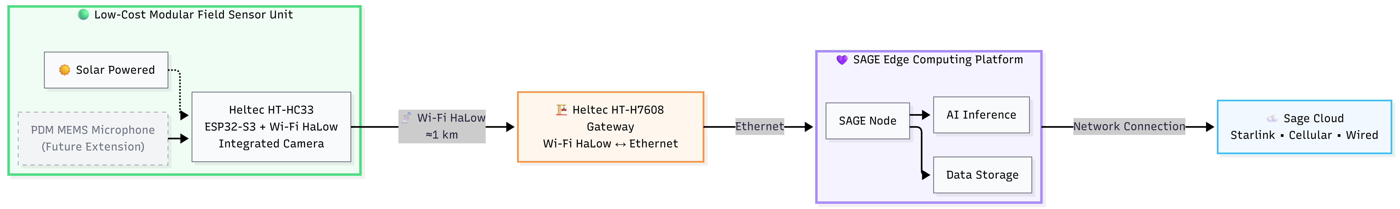

Figure 1. SageHaLow system architecture showing the communication pathway from the low-cost modular field sensor unit through the SAGE edge computing platform and onward to the Sage Cloud.

3. Summer Camp Accomplishments
- Configured and tested the Heltec HT-HC33 camera platform.
- Established Wi-Fi HaLow communication through the Heltec HT-H7608 gateway.
- Successfully accessed camera images through the SAGE infrastructure.
- Demonstrated a low-cost communication architecture for environmental sensing.

4. Looking Ahead
The Summer Camp demonstration established the foundation for a modular environmental sensing platform that can be expanded with additional low-cost sensors. One area of continuing development is the evaluation of a low-cost digital PDM MEMS microphone for event-driven sensing. Rather than transmitting images continuously, future versions of the platform may use acoustic events to trigger or prioritize image collection at the edge, reducing unnecessary data transmission while preserving meaningful environmental observations.
Additional sensors, such as temperature and relative humidity sensors, may provide environmental context that helps explain observed events. For example, these measurements could be used to examine whether bird activity or other environmental phenomena are associated with local weather conditions.
The long-term vision is a scalable, low-cost, modular sensing platform that combines cameras, microphones, and other environmental sensors with intelligent edge processing to deliver meaningful observations to the SAGE infrastructure.

Acknowledgments
This project benefited greatly from the collaborative environment of the SAGE Summer Camp. Special thanks are extended to Ben Owusu-Amo for developing the HT-HC33 firmware used in this project and to Pete Beckman for his leadership, for providing the Heltec hardware used in this work, and for his guidance and valuable feedback throughout the project. We also thank the SAGE Summer Camp organizers, mentors, and participants for creating an exceptional hands-on learning environment. This work was supported in part by the National Science Foundation under Awards No. 2331263 and 2436842.

