**1.**



**HCL Technologies Limited** (Hindustan Computers Limited) is an Indian multinational IT services company, headquartered in [Noida](https://en.wikipedia.org/wiki/Noida), Uttar Pradesh, India. It is a subsidiary of HCL Enterprise. Originally a [research and development](https://en.wikipedia.org/wiki/Research_and_development)division of HCL, it emerged as an independent company in 1991 when HCL ventured into the software services business.[[7]](https://en.wikipedia.org/wiki/HCL_Technologies#cite_note-7) HCL Technologies (the abbreviation of Hindustan Computers Limited)[[8]](https://en.wikipedia.org/wiki/HCL_Technologies#cite_note-8) offers services including [IT consulting](https://en.wikipedia.org/wiki/Information_technology_consulting), [enterprise transformation](https://en.wikipedia.org/wiki/Business_Transformation), [remote infrastructure management](https://en.wikipedia.org/wiki/Remote_infrastructure_management), engineering and [R&D](https://en.wikipedia.org/wiki/Research_and_development), and [business process outsourcing](https://en.wikipedia.org/wiki/Business_process_outsourcing) (BPO).[[9]](https://en.wikipedia.org/wiki/HCL_Technologies#cite_note-9) HCL also provides services such as DRYiCE,[[10]](https://en.wikipedia.org/wiki/HCL_Technologies#cite_note-:0-10) [Cybersecurity](https://en.wikipedia.org/wiki/Cybersecurity) and [Digital](https://en.wikipedia.org/wiki/Digital_transformation) & [Analytics](https://en.wikipedia.org/wiki/Analytics).

The company has offices in 34 countries including the United States, France and Germany, and the United Kingdom. It operates across sectors including aerospace and defense, automotive, consumer electronics, energy and utilities, financial services, government, industrial manufacturing, life sciences and healthcare, media and entertainment, mining and natural resources, public services, retail and consumer, semiconductor, server and storage, telecom, and travel, transportation, logistics, and hospitality.[[11]](https://en.wikipedia.org/wiki/HCL_Technologies#cite_note-11)[[12]](https://en.wikipedia.org/wiki/HCL_Technologies#cite_note-12)

HCL Technologies is on the [Forbes Global 2000](https://en.wikipedia.org/wiki/Forbes_Global_2000) list.[[13]](https://en.wikipedia.org/wiki/HCL_Technologies#cite_note-13) It is among the top 20 largest publicly traded companies in India with a market capitalisation of $18.7 billion as of May 2017.[[14]](https://en.wikipedia.org/wiki/HCL_Technologies#cite_note-14)[[15]](https://en.wikipedia.org/wiki/HCL_Technologies#cite_note-15) As of September 2017, the company, along with its subsidiaries, had a consolidated revenue of $7.4 billion.[[16]](https://en.wikipedia.org/wiki/HCL_Technologies#cite_note-16)[[17]](https://en.wikipedia.org/wiki/HCL_Technologies#cite_note-17)

--- Baskar R – Software Engineer

--- 9486884407

**SAP**

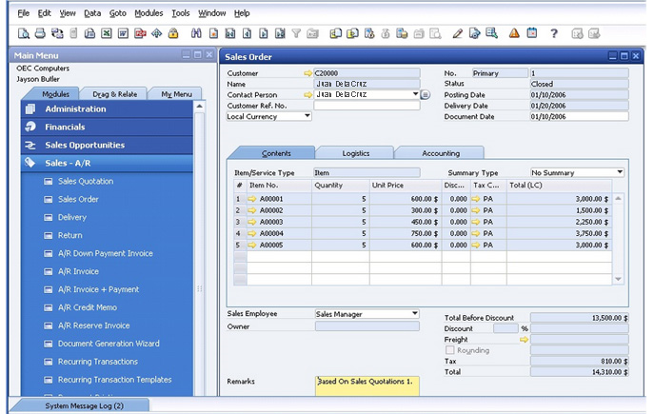

**2.**



**Infosys Limited** (formerly **Infosys Technologies Limited**) is an Indian [multinational corporation](https://en.wikipedia.org/wiki/Multinational_corporation) that provides [business consulting](https://en.wikipedia.org/wiki/Business_consulting), [information technology](https://en.wikipedia.org/wiki/Information_technology) and [outsourcing](https://en.wikipedia.org/wiki/Outsourcing) services. It has its headquarters in [Bengaluru, Karnataka, India](https://en.wikipedia.org/wiki/Bengaluru).[[4]](https://en.wikipedia.org/wiki/Infosys#cite_note-Infosys_Overview-4)

Infosys is the second-largest Indian IT company by 2017 revenues and 596th largest public company in world in terms of revenue.[[5]](https://en.wikipedia.org/wiki/Infosys#cite_note-5) On June 30, 2017, its [market capitalisation](https://en.wikipedia.org/wiki/Market_capitalisation) was $34.33 billion.[[6]](https://en.wikipedia.org/wiki/Infosys#cite_note-6) The [credit rating](https://en.wikipedia.org/wiki/Credit_rating) of the company is A- (rating by [Standard & Poor's](https://en.wikipedia.org/wiki/Standard_%26_Poor%27s)).[[7]](https://en.wikipedia.org/wiki/Infosys#cite_note-7)

--- Vijiyalakshmi – Senior Analyst Consultant

--9790434542

**Oracle ERP**

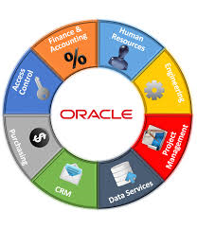

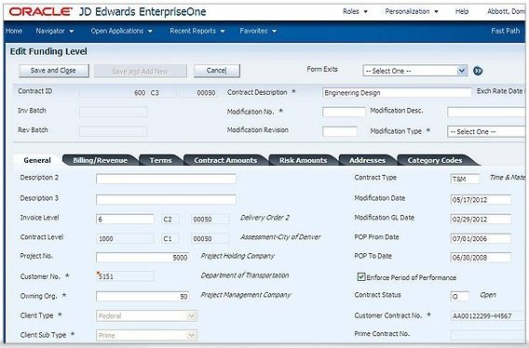

**3.**



**Standard Chartered PLC** is a British [multinational](https://en.wikipedia.org/wiki/Multinational_corporation) banking and [financial services](https://en.wikipedia.org/wiki/Financial_service) company headquartered in [London](https://en.wikipedia.org/wiki/London), [England](https://en.wikipedia.org/wiki/England). It operates a network of more than 1,200 branches and outlets (including subsidiaries, associates and joint ventures) across more than 70 countries and employs around 87,000 people. It is a [universal bank](https://en.wikipedia.org/wiki/Universal_bank) with operations in consumer, corporate and institutional banking, and treasury services. Despite its UK base, it does not conduct [retail banking](https://en.wikipedia.org/wiki/Retail_banking) in the UK, and around 90% of its profits come from [Asia](https://en.wikipedia.org/wiki/Asia), [Africa](https://en.wikipedia.org/wiki/Africa) and the [Middle East](https://en.wikipedia.org/wiki/Middle_East).

Standard Chartered has a primary listing on the [London Stock Exchange](https://en.wikipedia.org/wiki/London_Stock_Exchange) and is a constituent of the [FTSE 100 Index](https://en.wikipedia.org/wiki/FTSE_100_Index). It had a [market capitalisation](https://en.wikipedia.org/wiki/Market_capitalisation) of approximately £24.4 billion as of 4 April 2017, the 28th-largest of any company with a primary listing on the London Stock Exchange.[[2]](https://en.wikipedia.org/wiki/Standard_Chartered#cite_note-2) It has secondary listings on the [Hong Kong Stock Exchange](https://en.wikipedia.org/wiki/Hong_Kong_Stock_Exchange) and the [National Stock Exchange of India](https://en.wikipedia.org/wiki/National_Stock_Exchange_of_India). Its largest shareholder is the [Government of Singapore](https://en.wikipedia.org/wiki/Government_of_Singapore)-owned [Temasek Holdings](https://en.wikipedia.org/wiki/Temasek_Holdings).[[3]](https://en.wikipedia.org/wiki/Standard_Chartered#cite_note-SC-H-19-3)[[4]](https://en.wikipedia.org/wiki/Standard_Chartered#cite_note-SC-H-20-4)[[5]](https://en.wikipedia.org/wiki/Standard_Chartered#cite_note-SC-H-21-5)

**PEOPLESOFT**

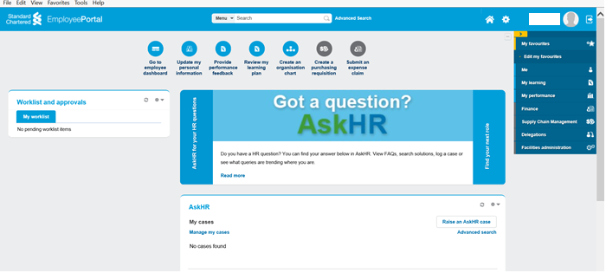

**--Rajkumar Muthiah – Project Manager**

**--+919087857025**

**4.**



**HSBC Holdings plc** is a British[[6]](https://en.wikipedia.org/wiki/HSBC#cite_note-6) [multinational](https://en.wikipedia.org/wiki/Multinational_corporation) banking and financial services [holding company](https://en.wikipedia.org/wiki/Holding_company), tracing its origin to a [hong](https://en.wikipedia.org/wiki/Hong_(business)" \o "Hong (business)) in [Hong Kong](https://en.wikipedia.org/wiki/Hong_Kong). It is the [world's seventh largest bank by total assets](https://en.wikipedia.org/wiki/List_of_largest_banks) and the largest in Europe with total assets of US$2.374 [trillion](https://en.wikipedia.org/wiki/10%5E12) (as of December 2016). It was established in its present form in London in 1991 by [The Hongkong and Shanghai Banking Corporation](https://en.wikipedia.org/wiki/The_Hongkong_and_Shanghai_Banking_Corporation) to act as a new group [holding company](https://en.wikipedia.org/wiki/Holding_company).[[7]](https://en.wikipedia.org/wiki/HSBC#cite_note-HSBC-R-01-7)[[8]](https://en.wikipedia.org/wiki/HSBC#cite_note-HSBC-R-02-8) The origins of the bank lie mainly in [Hong Kong](https://en.wikipedia.org/wiki/Hong_Kong) and to a lesser extent in [Shanghai](https://en.wikipedia.org/wiki/Shanghai), where branches were first opened in 1865.[[1]](https://en.wikipedia.org/wiki/HSBC#cite_note-Grouphistorylast-1) The HSBC name is derived from the initials of the Hongkong and Shanghai Banking Corporation.[[9]](https://en.wikipedia.org/wiki/HSBC#cite_note-Grouphistorytwo-9) The company was first formally incorporated in 1866. The company continues to see both the United Kingdom and Hong Kong as its "home markets".[[10]](https://en.wikipedia.org/wiki/HSBC#cite_note-10)

HSBC has around 3,900 offices in 67 countries and territories across Africa, Asia, Oceania, Europe, North America and South America, and around 38 million customers.[[11]](https://en.wikipedia.org/wiki/HSBC#cite_note-11) As of 2014, it was the world's sixth-largest public company, according to a composite measure by [*Forbes*](https://en.wikipedia.org/wiki/Forbes) magazine.[[12]](https://en.wikipedia.org/wiki/HSBC#cite_note-12)

HSBC is organised within four business groups: Commercial Banking; Global Banking and Markets ([investment banking](https://en.wikipedia.org/wiki/Investment_banking)); Retail Banking and Wealth Management; and Global Private Banking.

-- relative.

--

**SAP**

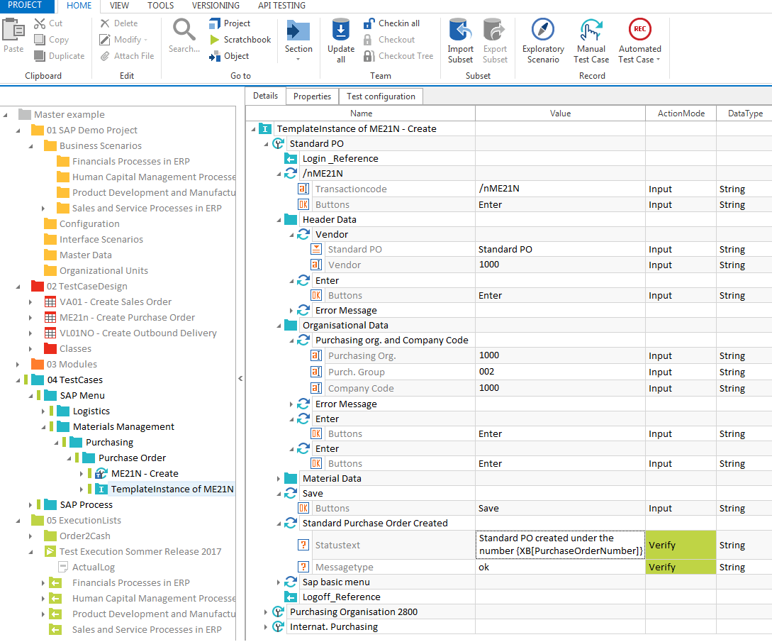

**5.**



**Barclays plc** [/ˈbɑːrkliz, -leɪz/](https://en.wikipedia.org/wiki/Help:IPA/English) is a British [multinational](https://en.wikipedia.org/wiki/Multinational_corporation) [bank](https://en.wikipedia.org/wiki/Banking) and [financial services](https://en.wikipedia.org/wiki/Financial_services) company headquartered in London. It is a universal bank with global reach, offering products and services across personal, corporate and investment banking, credit cards and wealth management. It has operations in over 40 countries and employs approximately 120,000 people.[[3]](https://en.wikipedia.org/wiki/Barclays#cite_note-grouporg-3) Barclays is organised into four core businesses: Personal & Corporate (Personal Banking, Corporate Banking, Wealth & Investment Management), Barclaycard, Investment Banking and Africa.[[4]](https://en.wikipedia.org/wiki/Barclays#cite_note-4)

Barclays traces its origins to a [goldsmith](https://en.wikipedia.org/wiki/Goldsmith) banking business established in the City of London in 1690.[[5]](https://en.wikipedia.org/wiki/Barclays#cite_note-archives-5) James Barclay became a partner in the business in 1736. In 1896 several banks in London and the English provinces, including [Backhouse's Bank](https://en.wikipedia.org/wiki/Backhouse%27s_Bank) and [Gurney's Bank](https://en.wikipedia.org/wiki/Gurney%27s_Bank), united as a [joint-stock](https://en.wikipedia.org/wiki/Joint-stock_company) bank under the name Barclays and Co. Over the following decades Barclays expanded to become a nationwide bank. In 1967, Barclays deployed the world's first [cash dispenser](https://en.wikipedia.org/wiki/Automated_teller_machine). Barclays has made numerous corporate acquisitions, including of London, Provincial and South Western Bank in 1918, [British Linen Bank](https://en.wikipedia.org/wiki/British_Linen_Bank) in 1919, Mercantile Credit in 1975, [the Woolwich](https://en.wikipedia.org/wiki/The_Woolwich) in 2000 and the North American operations of [Lehman Brothers](https://en.wikipedia.org/wiki/Lehman_Brothers) in 2008.

Barclays has a primary listing on the [London Stock Exchange](https://en.wikipedia.org/wiki/London_Stock_Exchange) and is a constituent of the [FTSE 100 Index](https://en.wikipedia.org/wiki/FTSE_100_Index). It has a secondary listing on the [New York Stock Exchange](https://en.wikipedia.org/wiki/New_York_Stock_Exchange). [Qatar Holdings](https://en.wikipedia.org/wiki/Qatar_Holdings), an investment vehicle of the [State of Qatar](https://en.wikipedia.org/wiki/State_of_Qatar), is the largest shareholder of the company.

-- Vani

--

**SAP**

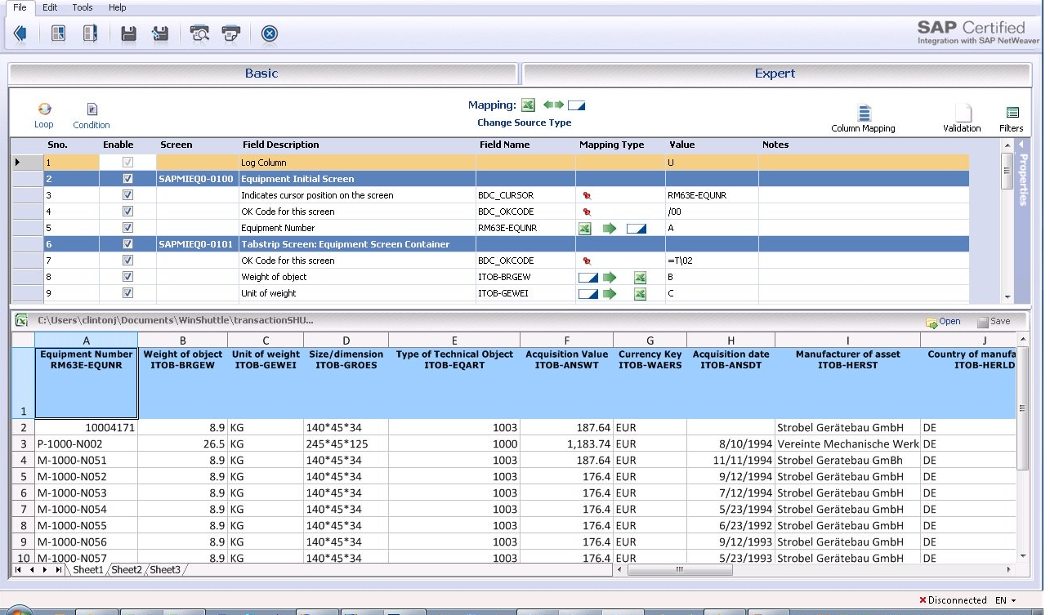

**6.**



**ABN AMRO Bank N.V.** is a [Dutch](https://en.wikipedia.org/wiki/Netherlands) bank with headquarters in [Amsterdam](https://en.wikipedia.org/wiki/Amsterdam). ABN AMRO Bank is the third-largest bank in the Netherlands.[[4]](https://en.wikipedia.org/wiki/ABN_AMRO#cite_note-4) It was re-established in its current form in 2009, following the acquisition and break-up of the original ABN AMRO by a banking consortium consisting of [Royal Bank of Scotland Group](https://en.wikipedia.org/wiki/Royal_Bank_of_Scotland_Group), [Santander Group](https://en.wikipedia.org/wiki/Santander_Group) and [Fortis](https://en.wikipedia.org/wiki/Fortis_(finance)). Following the collapse of Fortis, who acquired the Dutch business, it was nationalized by the [Dutch government](https://en.wikipedia.org/wiki/Dutch_government) along with [Fortis Bank Nederland](https://en.wikipedia.org/wiki/Fortis_Bank_Nederland).[[5]](https://en.wikipedia.org/wiki/ABN_AMRO#cite_note-5) It was relisted as a public company again in 2015.

The bank is a product of a long history of mergers and acquisitions that date to 1765. In 1991, [Algemene Bank Nederland](https://en.wikipedia.org/wiki/Algemene_Bank_Nederland)(ABN) and [AMRO Bank](https://en.wikipedia.org/wiki/AMRO_Bank) (itself the result of a merger of the Amsterdamsche Bank and the Rotterdamsche Bank in the 1960s) agreed to merge to create the original ABN AMRO. By 2007, ABN AMRO was the second-largest bank in the Netherlands and the eighth-largest in [Europe](https://en.wikipedia.org/wiki/Europe) by [assets](https://en.wikipedia.org/wiki/Assets). At that time the magazine [*The Banker*](https://en.wikipedia.org/wiki/The_Banker) and [Fortune Global 500](https://en.wikipedia.org/wiki/Fortune_Global_500)placed it 15th[[6]](https://en.wikipedia.org/wiki/ABN_AMRO#cite_note-cnn-6) in the list of world's biggest banks and it had operations in 63 countries, with over 110,000 employees.

--Gopal Manickam – Technical Lead

--9842448433

**SAGE ERP**

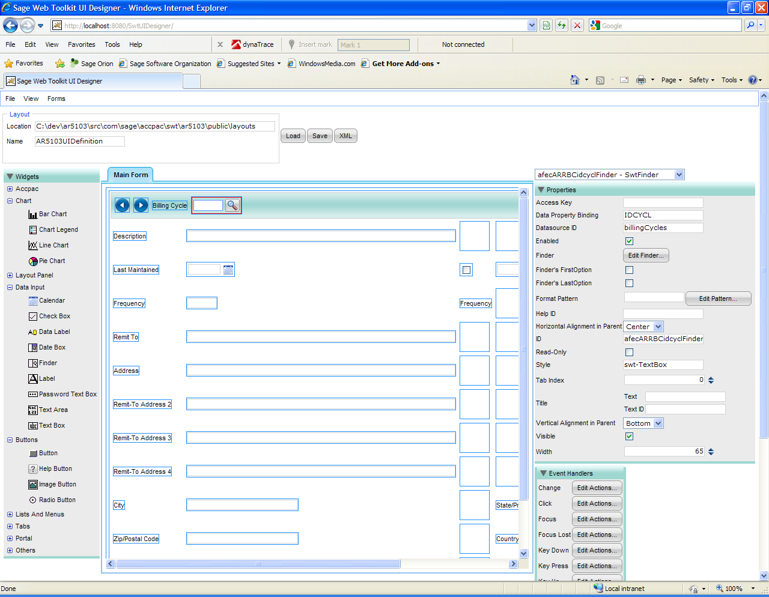

**7.**



**The Royal Bank of Scotland** ([Scottish Gaelic](https://en.wikipedia.org/wiki/Scottish_Gaelic_language): *Banca Rìoghail na h-Alba*, [Scots](https://en.wikipedia.org/wiki/Scots_language): *Ryal Baunk o Scotland*, [Welsh](https://en.wikipedia.org/wiki/Welsh_language): *Banc Brenhinol yr Alban*),[[1]](https://en.wikipedia.org/wiki/Royal_Bank_of_Scotland#cite_note-1) commonly abbreviated as **RBS**, is one of the retail banking subsidiaries of [The Royal Bank of Scotland Group](https://en.wikipedia.org/wiki/The_Royal_Bank_of_Scotland_Group) plc, together with [NatWest](https://en.wikipedia.org/wiki/NatWest) and [Ulster Bank](https://en.wikipedia.org/wiki/Ulster_Bank). The Royal Bank of Scotland has around 700 branches, mainly in Scotland, though there are branches in many larger towns and cities throughout England and Wales. Both the bank and its parent, The Royal Bank of Scotland Group, are completely separate from the fellow Edinburgh-based bank, the [Bank of Scotland](https://en.wikipedia.org/wiki/Bank_of_Scotland), which pre-dates The Royal Bank of Scotland by 32 years. The Bank of Scotland was effective in raising funds for the [Jacobite Rebellion](https://en.wikipedia.org/wiki/Jacobite_Rebellion)[[*clarification needed*](https://en.wikipedia.org/wiki/Wikipedia:Please_clarify)] and as a result, The Royal Bank of Scotland was established in 1724 to provide a bank with strong [Hanoverian](https://en.wikipedia.org/wiki/House_of_Hanover) and [Whig](https://en.wikipedia.org/wiki/Whig_(British_political_faction)) ties.

--Prasanth B – Technology Lead

--9677736171

SALESFORCE

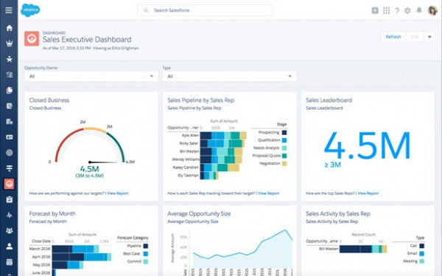

**8.**

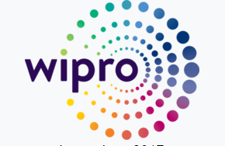

**Wipro Limited** (**Western India Palm Refined Oils Limited**[[4]](https://en.wikipedia.org/wiki/Wipro#cite_note-businesstodayin-4) or more recently, **Western India Products Limited**[[1]](https://en.wikipedia.org/wiki/Wipro#cite_note-NPHistory-1)) is an Indian Information Technology Services corporation headquartered in [Bengaluru, India](https://en.wikipedia.org/wiki/Bengaluru,_India).[[5]](https://en.wikipedia.org/wiki/Wipro#cite_note-Wipro_Ltd._-_Company_Information-5)

In 2013, Wipro demerged its non-IT businesses into separate companies to bring in more focus on independent businesses. Wipro has been ranked 1st in the 2010 Asian Sustainability Rating (ASR) of Indian companies[[74]](https://en.wikipedia.org/wiki/Wipro#cite_note-Wipro_continues_to_lead_in_sustainability_disclosures-74) and is a member of the [NASDAQ](https://en.wikipedia.org/wiki/NASDAQ) Global Sustainability Index[[75]](https://en.wikipedia.org/wiki/Wipro#cite_note-Nasdaq-100_includes_Wipro_in_Global_Sustainability_Index-75) as well as the [Dow Jones Sustainability Index](https://en.wikipedia.org/wiki/Dow_Jones_Sustainability_Index).

--- Gurumoorthy Muthiah – Operation Process Executive

--- Number

**SAP HANA**

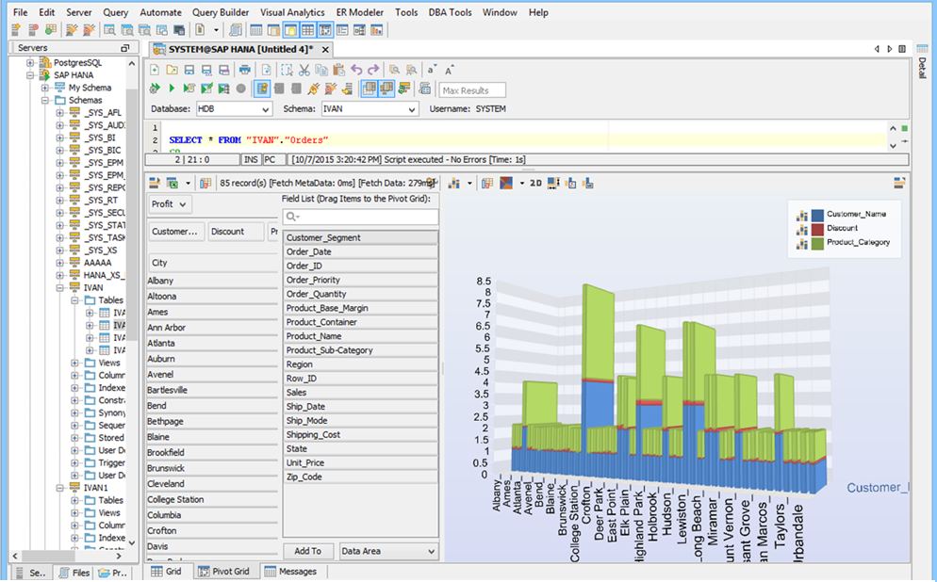

**9.**



**Tata Consultancy Services Limited** (**TCS**) is an Indian [multinational](https://en.wikipedia.org/wiki/Multinational_corporation) [information technology](https://en.wikipedia.org/wiki/Information_technology) (IT) [service](https://en.wikipedia.org/wiki/Service_(economics)), [consulting](https://en.wikipedia.org/wiki/Information_technology_consulting) and business solutions company [Headquartered](https://en.wikipedia.org/wiki/Headquarter) in [Mumbai](https://en.wikipedia.org/wiki/Mumbai), [Maharashtra](https://en.wikipedia.org/wiki/Maharashtra).[[3]](https://en.wikipedia.org/wiki/Tata_Consultancy_Services#cite_note-3)[[4]](https://en.wikipedia.org/wiki/Tata_Consultancy_Services#cite_note-4) It is a subsidiary of the [Tata Group](https://en.wikipedia.org/wiki/Tata_Group) and operates in 46 countries.[[5]](https://en.wikipedia.org/wiki/Tata_Consultancy_Services#cite_note-TCS_Investor_FAQs-5)

TCS is one of the largest Indian companies by [market capitalization](https://en.wikipedia.org/wiki/Market_capitalization) ($80 billion).[[6]](https://en.wikipedia.org/wiki/Tata_Consultancy_Services#cite_note-6)[[7]](https://en.wikipedia.org/wiki/Tata_Consultancy_Services#cite_note-7) TCS is now placed among the most valuable IT services brands worldwide.[[8]](https://en.wikipedia.org/wiki/Tata_Consultancy_Services#cite_note-8) TCS alone generates 70% dividends of its parent company, [Tata Sons](https://en.wikipedia.org/wiki/Tata_Sons).[[9]](https://en.wikipedia.org/wiki/Tata_Consultancy_Services#cite_note-9)[[10]](https://en.wikipedia.org/wiki/Tata_Consultancy_Services#cite_note-10) In 2015, TCS is ranked 64th overall in the [*Forbes*](https://en.wikipedia.org/wiki/Forbes) World's Most Innovative Companies ranking, making it both the highest-ranked IT services company and the top Indian company.[[11]](https://en.wikipedia.org/wiki/Tata_Consultancy_Services#cite_note-11) It is the world's 9th largest IT services provider by revenue.[[12]](https://en.wikipedia.org/wiki/Tata_Consultancy_Services#cite_note-12) As of December 2015, it is ranked 10th on the [Fortune India 500](https://en.wikipedia.org/wiki/Fortune_India_500) list.

Naveen – Consultant

9962866198

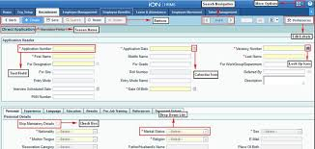

**TCS iON** is a Cloud based ERP solution catering to the changing business needs of Small and medium business. Aas a cloud based solutions offer single-window IT with a pre-integrated suite of hardware, network, software and services. We ensure that your functions are digitized, automated and connected. For example, if you are using a CRM solution along with a core ERP (e.g a Manufacturing ERP) and have a document management system to organize supporting files and an HRMS, we ensure that these solutions are connected and work as one. So for you, it is simply one IT and not multiple applications. Integrated applications thus provide a comprehensive view of business enabling better decisions.

**10.**



**Cognizant** is an American [[3]](https://en.wikipedia.org/wiki/Cognizant#cite_note-3) [multinational corporation](https://en.wikipedia.org/wiki/Multinational_corporation) that provides IT services, including digital, technology, consulting, and operations services. It is headquartered in [Teaneck](https://en.wikipedia.org/wiki/Teaneck,_New_Jersey), [New Jersey](https://en.wikipedia.org/wiki/New_Jersey), United States. Cognizant is included in the [NASDAQ-100](https://en.wikipedia.org/wiki/NASDAQ-100) and the [S&P 500](https://en.wikipedia.org/wiki/S%26P_500) indices. It was founded as an in-house technology unit of [Dun & Bradstreet](https://en.wikipedia.org/wiki/Dun_%26_Bradstreet) in 1994,[[4]](https://en.wikipedia.org/wiki/Cognizant#cite_note-mishra-4)and started serving external clients in 1996.[[4]](https://en.wikipedia.org/wiki/Cognizant#cite_note-mishra-4)

After a series of corporate splits and restructures of its parent companies there was an [initial public offering](https://en.wikipedia.org/wiki/Initial_public_offering) in 1998.[[5]](https://en.wikipedia.org/wiki/Cognizant#cite_note-5)Following the Y2K and dot-com boom of the late 1990s, when companies sharpened their focus on hard business parameters such as revenues and profits, the company grew by delivering critical application development and maintenance services.

Cognizant had a period of fast growth during the 2000s, becoming a [Fortune 500](https://en.wikipedia.org/wiki/Fortune_500) company in 2011.[[6]](https://en.wikipedia.org/wiki/Cognizant#cite_note-6) In 2015, the [Fortune magazine](https://en.wikipedia.org/wiki/Fortune_(magazine)) named it as the world's fourth most admired [IT services](https://en.wikipedia.org/wiki/IT_services) company.[[7]](https://en.wikipedia.org/wiki/Cognizant#cite_note-7) In 2017, Cognizant was named in [Fortune's](https://en.wikipedia.org/wiki/Fortune_(magazine)) Future 50 list.

Perundevi – Software Tester

8754982353

Oracle Cloud ERP

