Task completed:

| Date started | Date completed |
| --- | --- |
| 03/05/2019 |  |

Contents

Task completed: 1

Analysis 1

Design 2

Test design 3

Development 4

Testing 5

Evaluation 6

References/Resources Used: 7

Analysis

Key success criteria for your program.

**Success Criteria:**

1. Login System:

A User can enter user name

B User can enter password

C Script can check if username exists

D1 Script rejects username cause it doesn’t exist

D2 Script Accepts username

E Script checks password connected to username

F1 Script rejects password

F2 Script Accepts password

G Runs next part of script

2. Read songs/artists/accounts from an external file

3. Script is able to use/edit those files

4. Script takes first letter of artist and song and puts then im a question format

5. User Guesses

6. Answer checking:

A Compares user input to external file string

B1 Rejects input due to not being the same

B2 Accepts input runs next script

7. Adds score to that account in external file

8. Repeats asking 10 questions

9. Script reads external scores

10. Script displays your score

11. Script displays top 5 scores

12. Final:

A Gives user options

B1 User quits

B2 User inputs retry and starts code again at step 2

Design

* *You may like to create a flow chart which will show broadly how your program will work. If so include your flow chart in this section.*
* *You must create pseudocode for a part of your program (minimum of 15 lines)*

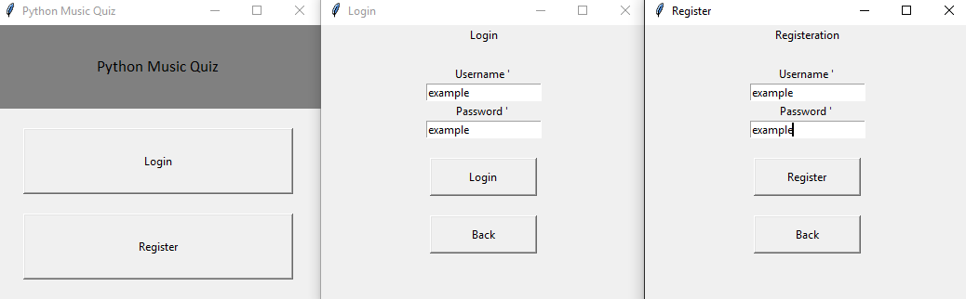Concept/mock-up of login system (made a test)

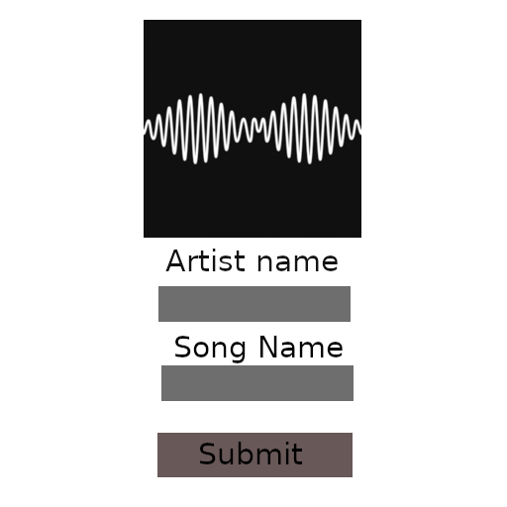

Concept for quiz UI

(Made in gimp)

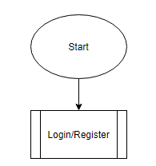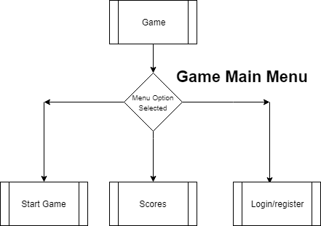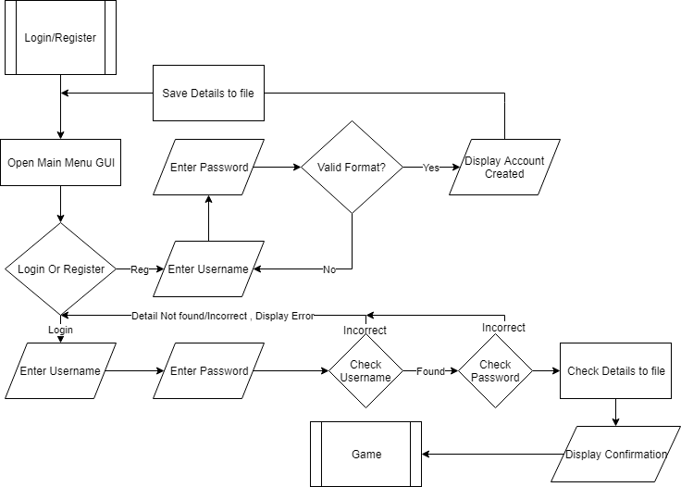

Login System

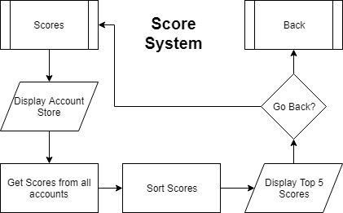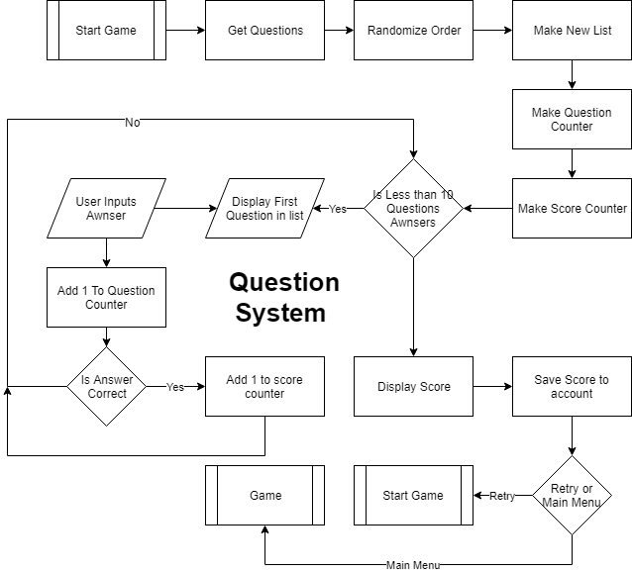

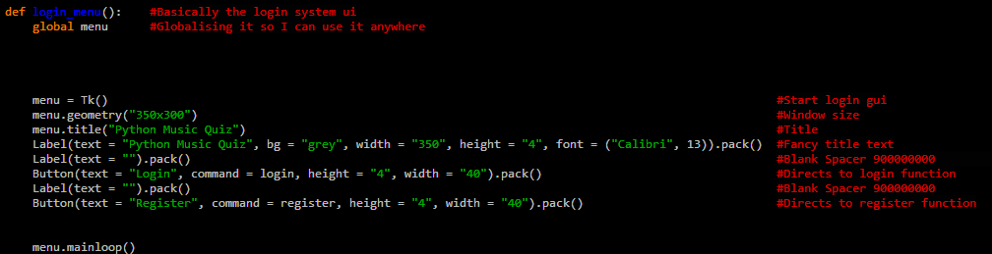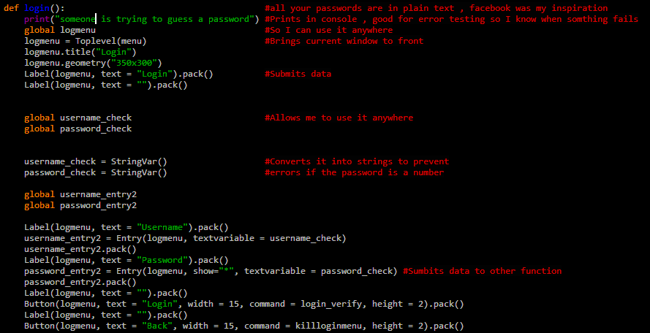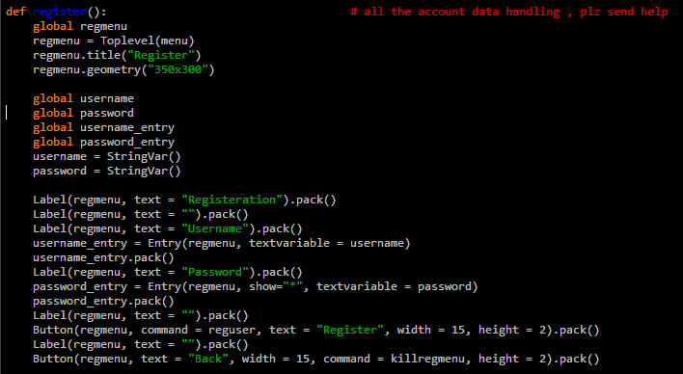

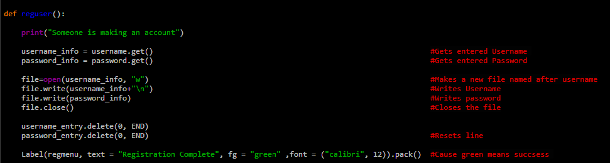

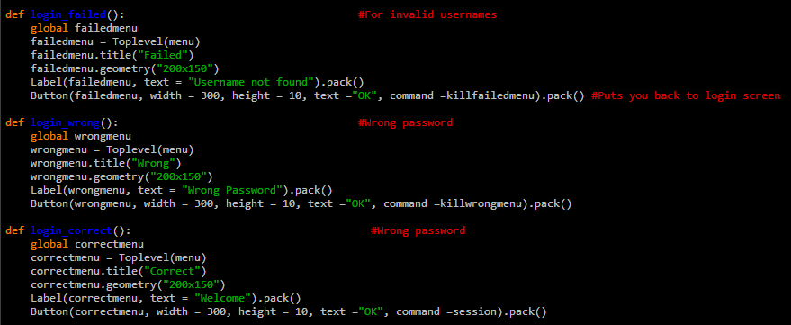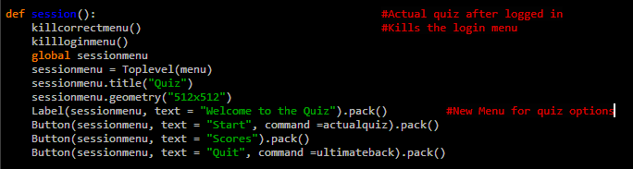

Added password encryption



Test design

* *Think of tests that you can carry out to see if your system works*
* *Remember to try and use normal, boundary and erroneous tests.*
* *If you wish to, you may add more tests to the table.*

**My tests:**

|  |  |  |  |  |
| --- | --- | --- | --- | --- |
| Test | What am I testing? | What data will I use? | Normal/Boundary/Erroneous? | Expected Result |
| 1 | Does the Username  Check work | The username | N – Is input bigger than 0  E – Not found username | Will either reject or accept Username |
| 2 | Does the password check work | The password | N – Is input bigger than 0  E – Incorrect password | Will either reject or accept username |
| 3 | Question List Randomizer | The Question List | Erroneous | The Question list is randomized |
| 4 | Does Question score Counter work | Score count | Normal | Will it count the scores |
| 5 | Does the Question Counter Work | Amount of questions awnsered | Normal | When it hits 10 it ends the loop |

**My test screenshots:**

Development

* *Copy and paste your code into this section*
* *Remember to try and add comments to your code to make it more readable!*

**My program code:**

Testing

* *Show you have completed the tests you thought of*
* *Identify if you needed to make changes to your program*
* *Include the screenshots of the tests*

**My tests:**

|  |  |  |  |  |
| --- | --- | --- | --- | --- |
| Test | What am I testing? | Expected result | Pass/Fail | Do I need to change my program? If so, how? |
| 1 |  |  |  |  |
| 2 |  |  |  |  |
| 3 |  |  |  |  |
| 4 |  |  |  |  |
| 5 |  |  |  |  |

**My test screenshots:**

Evaluation

* Evaluate how successful your program was. You may find it useful to refer back to your tests
* You should reflect on any new skills you have developed

This section should be approximately 200-500 words.

**How successful was my program?**

**What new skills have I developed?**

References/Resources Used:

|  |  |
| --- | --- |
| Resource Used | Reason |
|  |  |
|  |  |
|  |  |
|  |  |
|  |  |
|  |  |
|  |  |
|  |  |
|  |  |
|  |  |
|  |  |
|  |  |