**REPORT**

**LAB 1**

**Student name: Phan Quang Huy**

**Student ID: 21IT618**

**Student email: huypq2.21it@vku.udn.vn**

# **Introduction**

* Briefly describe the purpose of the lab report.

Lab 1

* Provide background information on your mobile app.

Programming the cross-platform application 'I Am Rich' using flutter

# **Objectives**

* State the objectives of the lab.

Understand the basic setup and usage of flutter

# **Methodology**

* Describe the methodology used in the lab.

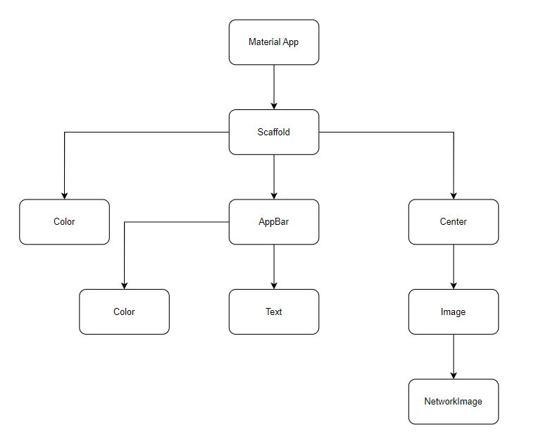

* Explain how your app was developed.

# **Results**

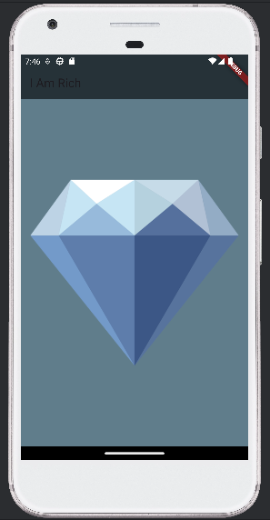

# **Discussion**

* Discuss the results obtained.
* Analyze the strengths and weaknesses of cross-platform mobile app development.

# **Conclusion**

* Summarize the main findings of the lab.
* Provide recommendations for future work.