HiTune
Visual Reporter Utility Manual

Contacts
Jason, Dai (jason.dai@intel.com)
Jie, Huang (jie.huang@intel.com)

Contents
Visual Reporter 2
1. Prepare report folder 3
2. Configure report folder 3
3. Import report folder 5
4. View reports 5
4.1 Details report 5
4.2 Aggregation report 6
4.3 Comparison report 7
Appendix 9
1. Visual Report component list 9
2. Terminology in Visual Report 10

Visual Reporter
Visual reporter is the additional utility for HiTune, which renders the figures and charts using the report sheets under Windows. It provides an insightful and visual view of the analysis results. We offer this utility as a method to use the raw data on the report sheets (generated by the Analysis Engine).
This document contains the information about how to configure and use this visual report utility based on the Analysis Engine’s output. There is no need to install any program other than Microsoft Excel 2007 on your Windows machine.
Currently the visual report engine supports two types of Report Folder, namely, the SINGLE-JOB and MULTI-JOB folders. In the SINGLE-JOB folder, there is only one report folder (belonging to a single job). While in the MUTI-JOB folder, there are multiple report sub-folders. The MUTI-JOB type allows you to load several jobs’ data into the visual report template at the same time, and output the comparison report for these jobs. The raw data of the Report Folder can be retrieved from the Analysis Engine’s output originally.
Below is the “3-step” usage guide, and the further details can be found in the following sections:
MUST do item Click Action
- Copy the Report Folder generated by Analysis Engine from a Linux machine to a Windows machine
- Create and edit a TYPE file (the template is under the HiTune package) as the configuration step and copy the AnalysisReport.xlsm to the Report Folder on that Window machine, more details see 2. Configure report folder .
- Open the AnalysisReport.xlsm (contained in the HiTune package, click 1.configure) file on that Windows machine, and import the data into the template(click 2.load data ), more details see 2. Configure report folder and 3. Import report folder.

There is an example of visual report (i.e., VisualReportExample) with some data results in the HiTune package for your reference, from which you can intuitively obtain the brief information about the major functionalities and usage offered by the visual utility.

Prepare report folder
This section describes how to retrieve and compose your Report Folder.
Under each generated Report Folder, there are several sheets with pre-defined name. Do not change the name of these sheets. You can copy these report sheets from the Report Folder generated by the Analysis Engine into a SINGLE-JOB folder, or as a sub-folder in the MULTI-JOB.

Configure report folder
This section describes how to configure your report folder before you run the visual report utility.
Before importing the data into the visual report template, you need to prepare the configurations for the source report folder. The sample file can be found under HiTune distribution package as well, which is named as “TYPE”.
- For SINGLE-JOB folder, you can just edit the TYPE file under the report folder as follows:
TYPE,NAME,AUTHOR,TIME,DESCRIPTION
SINGLE-JOB, your_test_name, your_name, your_test_time, your_test_description
The TYPE file should be put under the Report Folder along with other raw data files. The first line is the header which should not be changed and you need to prepare from the next line with comma-separated items. The items prefixed with “your_” in the above template needs to be modified based on your environment.
- For MULTI-JOBS folder, you need to put all the SINGLE-JOB Report Folders into one common MULTI-JOB folder. Then, create a new TYPE file under that MULTI-JOB folder as follows:
TYPE,NAME,AUTHOR,TIME,DESCRIPTION
MULTI-JOB, your_test_name, your_name, your_test_time, your_test_description

In addition, you need to copy the AnalysisReport.xlsm file in the HiTune package into your Report Folder (in addition to the TYPE file and the raw data files).
Now open the AnalysisReport.xlsm file and configure the location of the report folder for your visual report template. Please click the 1.Configure button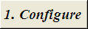, it pops up a dialog box as follows in Figure 1.
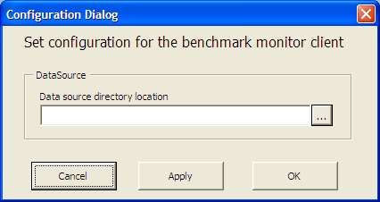
Figure 1. Configuration dialog
- Select the Report Folder (either MULTI-JOB or SINGLE-JOB) folder as the import data folder type
- Click Cancel to quit and without any changes
- Click Apply to import the configuration file without closing the dialog box
- Click OK to import the configuration file and close the dialog box

Import report folder
This section shows the steps to import a job data into the visual report template.
- To import the data, you can select the items from the Benchmark(s) Drop-down list in Figure 2.
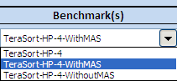
Figure 2. The Drop-down benchmark list
- Then click the 2.Load Data button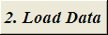 to import the data. It will cleanup all the dirty sheets and import the new data from the source report folder which you selected.
It pops up 2 dialogs waiting for you to input the Hadoop metrics sampling period in seconds, the system statistics’ interval in second (sampling period for sysstat), you can choose the default values by clicking OK. The default values are shown in the input text box.

View reports
This section describes the visual report’s features in 3 perspectives.
- To view the details in each sub-category.
- To view the aggregation content in each sub-category for the whole cluster.
- To view the comparison content among several jobs.

Details report
The details report shows the certain metrics for each sub-category in both a compact way and raw data sheet. To see the details about each report sheet, you can choose the Metric Selection Drop-down list as follows in Figure 3.
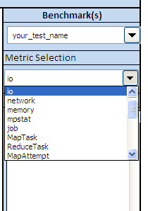
Figure 3. Metric selection Drop-down list
Then click Details button to see the detailed report sheet.
Here is a snapshot for Reduce tasks analysis report in Figure 4.
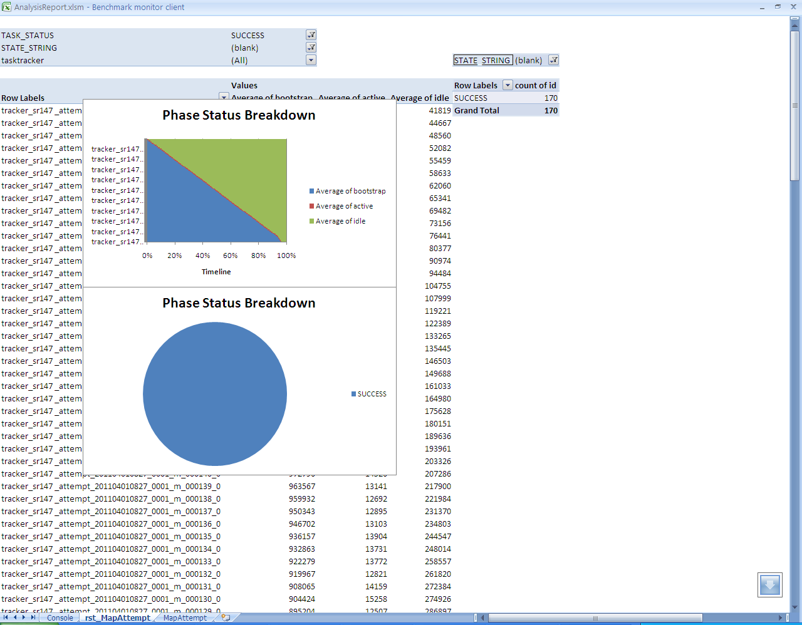
Figure 4. The snapshot for Reduce tasks analysis report

Aggregation report
The aggregation report prints out all the statistics figures for each node in the target cluster in a summary page. To see the aggregation report, you can choose the Metric Selection Drop-down list first. Then click Aggregation button to see the aggregation report.
Generally, the aggregation report will show the visual charts for each node in the print-out style.
Here is a snapshot for network utilization aggregation report for the whole cluster in Figure 5.
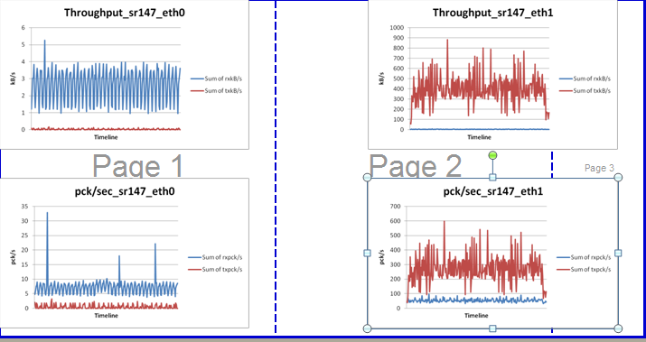
Figure 5. The snapshot of network utilization for the whole cluster

Comparison report
The comparison feature offers a summary figure to compare the running time with further break down among target jobs. You can get comparison report with the normalized running times, and the denominator is decided by the job running time of “Ref benchmark”.
- First, you can choose one or more tests in the multi-selection list in Figure 6.
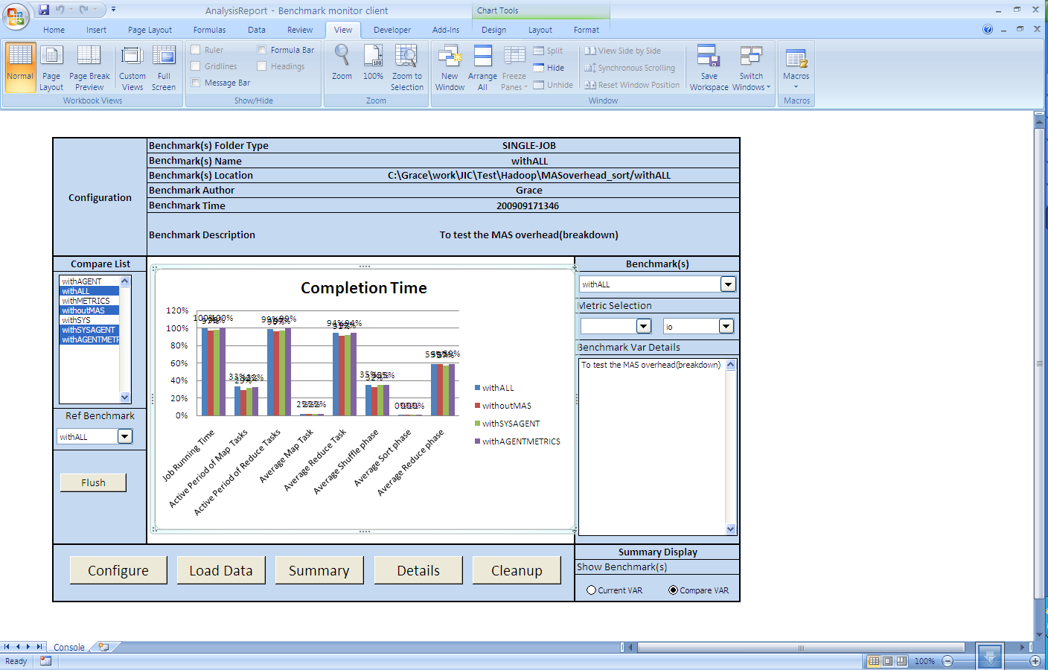
Figure 6．Multi-selection list for comparison benchmarks
- Select the reference test in Figure 7. The job running time of the selected Ref benchmark will be normalized as 100%.
Figure 7. Reference benchmark for the comparison benchmark list
- Select the Radio button “Normalized Data” in Figure 8.
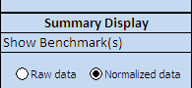
Figure 8. Comparing ratio button
The result will be shown as follows in Figure 9:
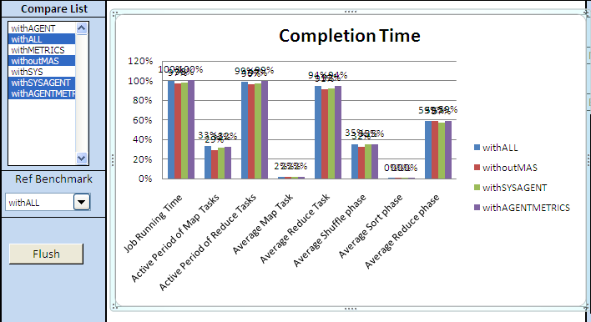
Figure 9. Comparison report among several benchmarks

Appendix

Visual Report component list
In this part, we list the supporting components in this visual report utility currently in the following list (Table 1).
Table 1. HiTune visual reporter’s supporting components list
Category | Sub-category | Metrics
System statistics | CPU | Utilization
System statistics | IO | IO throughput, latency, utilization, request size
System statistics | Network | Throughput
System statistics | Memory | Utilization
System statistics | mpstat | Utilization for each core
History Log | Map Tasks | Active period, bootstrap, idle of Map Stage
History Log | Reduce Tasks | Active period, bootstrap, idle of Reduce Stage
History Log | Map Attempt | Active period, bootstrap, idle of each map task
History Log | Reduce Attempt | Active period(shuffle, sort, reduce), bootstrap, idle for each reduce task
History Log | Job | N/A
Dataflow based statistics | Stage for Map Tasks | Active period, bootstrap, idle for each map task;  Further breakdowns in Map Task Pool;
Dataflow based statistics | Stage for Reduce Tasks | Active period, bootstrap, idle for each reduce task; Shuffle period breakdown for total reduce tasks;  Further breakdowns in Reduce Task Pool;
Hotspot analysis statistics | Stage for Map Tasks | Top N called functions in Map Task Pool
Hotspot analysis statistics | Stage for Reduce Tasks | Top N called functions in  Reduce Task Pool
Hadoop Metrics | JVM | Thread status distribution, Thread heap utilization
Hadoop Metrics | Datanode | N/A
Hadoop Metrics | TaskTracker | Map and Reduce Tasks execution time line
Hadoop Metrics | Namenode | NameNode operations
Hadoop Metrics | JobTracker | Tasks throughput for the cluster
Hadoop Metrics | Map Shuffle out | Busy status percentage for Shuffle out
Hadoop Metrics | Reduce Shuffle in | Busy status percentage for Shuffle in

Terminology in Visual Report
Following table shows the decryption and its detailed formula for all those HiTune’s terms in this visual report.
Table 2. Explanations and detailed formula for all terms in HiTune visual report
Terminology | Description | Formula
Job Running Time | The total elapsed time for a single job | = FINISH_TIME - SUMBMIT_TIME
Active Period of Map Tasks | The period of time when any map task is running | = LAST_MAP_FINISH_TIME -FIRST_MAP_START_TIME
Active Period of Reduce Tasks | The period of time when any reduce task is running | = LAST_REDUCE_FINISH_TIME -FIRST_ REDUCE_START_TIME
Average Map Task | Average completion time for all map tasks | = SUM(FINISH_TIMEmap_i - START_TIMEmap_i) / COUNT(MAP)
Average Reduce Task | Average completion time for all reduce tasks | = SUM(FINISH_TIMEreduce_i - START_TIMEreduce_i) / COUNT(REDUCE)
Average Shuffle phase | Average completion time of the shuffle phase for all reduce tasks | = SUM(SHUFFLE_FINISH_TIMEreduce_i - START_TIMEreduce_i) / COUNT(REDUCE)
Average Sort phase | Average completion time of the sort phase for all reduce tasks | = SUM(SORT_FINISH_TIMEreduce_i – SHUFFLE_FINISH_TIMEreduce_i) / COUNT(REDUCE)
Average Reduce phase | Average completion time of the reduce phase for all reduce tasks. | = SUM(REDUCE_FINISH_TIMEreduce_i – SORT_FINISH_TIMEreduce_i) / COUNT(REDUCE)
BOOTSTRAP | The period of time when a task is in the pending status. | = TASK_START_TIME – JOB_START_TIME
ACTIVE | The period of time when a task is running on certain Tracker | = TASK_FINISH_TIME – TASK_START_TIME
IDLE | The period of time between each task’s finishing time and the whole job finishing time. | = JOB_ FINISH _TIME – TASK_FINISH_TIME
SHUFFLE | The period of time when the reduce task copies those map output data into its local node. | = SHUFFLE_ FINISH _TIME – REDUCE_START_TIME
SORT | The period of time when the reduce task sort all fetched keys | = SORT_FINISH_TIME - SHUFFLE_ FINISH _TIME
REDUCE | The period of time the reduce task does the real user defined reduce(aggregation) function. | = REDUCE_FINISH_TIME - SORT_FINISH_TIME

