**Requirement & Design Specification**

**for**

**Booking System**

Version 1.0

Hanoi, 23 April 2024

Prepared by Ta Duy Hai

FPTU_Hoa Lac

Revision History

|  |  |  |  |
| --- | --- | --- | --- |
| **Name** | **Date** | **Reason For Changes** | **Version** |
| Ta Duy Hai | 23/04/2024 | Create Document, 1. User Requirements, 2. Overall Functionalities | 1.0 |
|  |  |  |  |
|  |  |  |  |
|  |  |  |  |
|  |  |  |  |
|  |  |  |  |
|  |  |  |  |
|  |  |  |  |
|  |  |  |  |
|  |  |  |  |
|  |  |  |  |
|  |  |  |  |
|  |  |  |  |
|  |  |  |  |
|  |  |  |  |
|  |  |  |  |
|  |  |  |  |
|  |  |  |  |
|  |  |  |  |
|  |  |  |  |
|  |  |  |  |
|  |  |  |  |
|  |  |  |  |
|  |  |  |  |
|  |  |  |  |

# I. Overview

## 1. User Requirements

### 1.1 Actor

|  |  |  |
| --- | --- | --- |
| **#** | **Actor** | **Description** |
| 1 | General User | The user who is not log in to the system and use some services that all user can do it |
| 2 | Receptionist | The user who is manage the request booking of customer |
| 3 | Content Manager | The user who is manage the images on system and feedback, of customer and manage event of restaurant |
| 4 | Admin | The user who is manage the menu and the general data of system |
| 5 | Mail system | The external system on the booking system, to confirm the request booking of customer |
| 6 | Banking System | The external system of the booking system is responsible for requiring users to pay a small amount of money via the bank to deposit a table. |
| 7 | Chef | The user who is receive order food for each table |

### 1.2 Use Case

a. Diagram

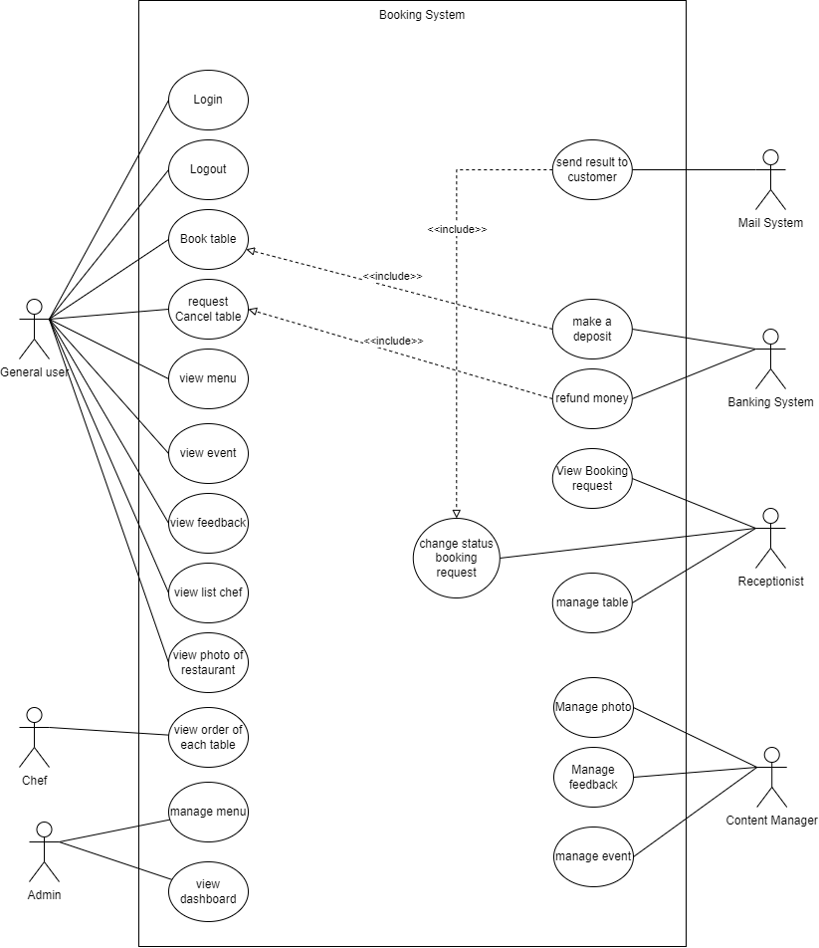

## 2. Overall Functionalitites

### 2.1 Screen Flow

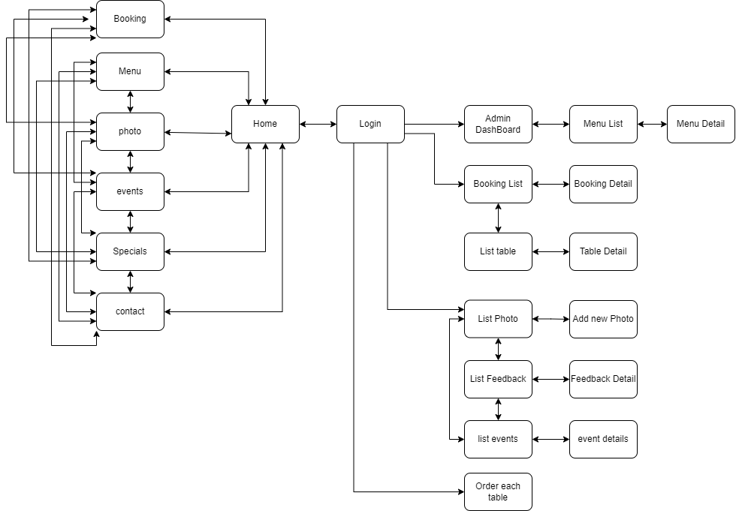

### 2.2 Screen Descriptions