School Garden & Wildlife Habitat Grant 2015–2016

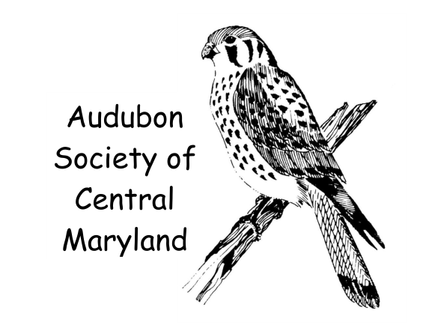

Submission Deadline: December 15, 2015
Award Notification: January 30, 2016

Email completed application to:
Julie Dunlap, Grant Coordinator Audubon Society of Central Maryland
juliejdunlap@earthlink.net
410-381-8710

Name of School: Click here to enter Name of School.
School Principal/Executive Officer | Teacher/Project Leader or Coordinator
Name: | Name:
Enter Officer Name here. | Enter Teacher Name here.
Title: | Title:
Enter Officer Title here. | Enter Teacher Title here.
Address: | Address:
Enter School Address here. | Enter School Address here.
County: | County:
Enter County here. | Enter County here.
Office Phone: | Office Phone:
Enter Office Phone here. | Enter Phone here.
Email Address: | Email Address:
Enter Officer Email Address here. | Enter Teacher Email Address here.

Have you received approval from your grounds department? Select YES or NO.
- Total Grant Request from ASCM ($500 maximum) : $ Enter dollar amount requested here.
- Project Overview

Please provide a brief description (3 or fewer pages) of the project, including details as noted:
Who? List students participating, including grade level of each, volunteers and expert assistants.
What? Describe the goal of the project in terms of the physical result.
Where? Describe the location of the project, including its relationship to existing school facilities and accessibility to students for use.
When? Specify a timeline, including when project will begin, steps to completion, and when it will be completed. Who will be responsible for long-term maintenance?
How? Explain how the project relates to environmental education programs at the school both during and after completion of the project, if appropriate.

Enter Project Overview text here.

- Project Justification

How does the project benefit native wildlife and natural habitat? For example, will you plant native flowers that attract native butterflies? How will it be used in education programs? Will it be used in climate change education efforts? Please be specific.

Enter Project Justification text here.

- Project Support

Will you be asking for matching funds from other organizations or sources? Please list where you are applying and how the project would be affected by receiving more than one grant.

Enter Project Support text here.

- Budget Specifics
(Use form below or create an Excel document to include with your submission)

SAMPLE
Budget Item –item, quantity, price per item | ASCM Request | Donation or Matching $ | Total $
e.g., perennial herbs 5 x $5.00 | $ 0.00 | PTA $25 | $25.00
mulch bags 20 x 3.00 | $0.00 | Garden Ctr. | $60.00
Purple coneflower 4 x 5.00 | $20.00 | 0.00 | $20.00
Total:

- Assessment:
How will you assess what students have learned from the project? How will your students confirm that their work has benefited wildlife and habitat? Will you provide a final report, preferably with photos, to ASCM about your project and what your students learned?

Enter Project Assessment text here.

- Additional remarks:
If you wish, please add any additional thoughts or explanations that will help give a complete picture of your proposed project.

Enter Additional Remarks text here.

Resources

Organizations with Local Expertise

Audubon Society of Central Maryland http://centralmdaudubon.org/

Chesapeake Bay Field Office, U.S. Fish and Wildlife Service (teacher and student support for habitat creation efforts) http://www.fws.gov/chesapeakebay/schoolyd.html

Irvine Nature Center (teacher workshops in Project WILD, Project WET, Project Learning Tree, and Wow! The Wonders of Wetlands) http://www.explorenature.org/experience-irvine/teacher-workshops

Maryland Association for Outdoor and Environmental Education (MAEOE) (Green School and schoolyard habitat resources) http://maeoe.org/related-articles-resources/

Maryland Master Gardeners (gardening advice) http://extension.umd.edu/mg

Maryland Master Naturalists (wildlife and ecology advice) http://extension.umd.edu/masternaturalist

Benefits of Natural Habitats, Outdoor Classrooms, and Nature Play Spaces for Students

“Natural-Terrain Schoolyards Reduce Children’s Stress, Says Colorado University-Boulder Study” http://medicalxpress.com/news/2014-07-natural-terrain-schoolyards-children-stress-colorado.html

“Nature Is a Powerful Teacher: The Educational Value of Going Outside” http://m.theatlantic.com/education/archive/2013/10/nature-is-a-powerful-teacher-the-educational-value-of-going-outside/281027/?utm_content=bufferd8402&utm_source=buffer

“School Gardens Grow Kids’ Physical Activity Levels” http://www.news.cornell.edu/stories/2014/03/school-gardens-grow-kids-physical-activity-levels

Non-Profit Educational Websites

Children & Nature Network Natural Teachers Network (teaching guides, research reports, and success stories) http://www.childrenandnature.org/movement/naturalteachers/

Cornell Lab of Ornithology (K-12 resources, citizen science projects, and professional development) http://www.birds.cornell.edu/page.aspx?pid=1663

Journey North (citizen science projects including Monarch migration, with teaching resources such as sample lessons and standards correlations) http://www.learner.org/jnorth/

Monarch Watch (monarch waystation instructions, milkweed sources, and tagging and other project ideas) http://www.monarchwatch.org/index.html

National Wildlife Federation Schoolyard Habitats (advice, lessons plans, certification application, and maintenance tips) http://www.nwf.org/How-to-Help/Garden-for-Wildlife/Schoolyard-Habitats.aspx

Nature Conservancy (garden design tool, activity guide, lesson plans, maintenance tips, and urban tree information) https://natureworkseverywhere.org/#home

Next Generation Science Standards (information on changing science standards) http://www.nextgenscience.org/

Project Budburst (citizen science projects studying plant growth for climate change understanding, with professional development and student project ideas) http://budburst.org/

Project Junco (film-based curriculum focusing on biology, ecology, evolution, behavior, and conservation of common songbird) http://juncoproject.org/

Schoolyard Habitat Project Guide from U.S. Fish and Wildlife Service http://www.fws.gov/cno/pdf/HabitatGuideColor.pdf

Additional Funding Sources

Annie’s Garden Funder on CrowdRise https://www.crowdrise.com/anniesgardenfunder?utm_source=annies&utm_medium=gardenpage&utm_campaign=g4g

Annie’s Grants for Gardens http://www.cbtrust.org/site/c.miJPKXPCJnH/b.5368633/k.BDEA/Home.htm

Chesapeake Bay Trust Minigrants http://www.cbtrust.org/site/c.miJPKXPCJnH/b.5368633/k.BDEA/Home.htm

Kickstarter https://www.kickstarter.com/

How-To Guide for Planning Your Project from the U.S. Fish and Wildlife Service:
Schoolyard Habitat Project Guide from U.S. Fish and Wildlife Service
http://www.fws.gov/cno/pdf/HabitatGuideColor.pdf

