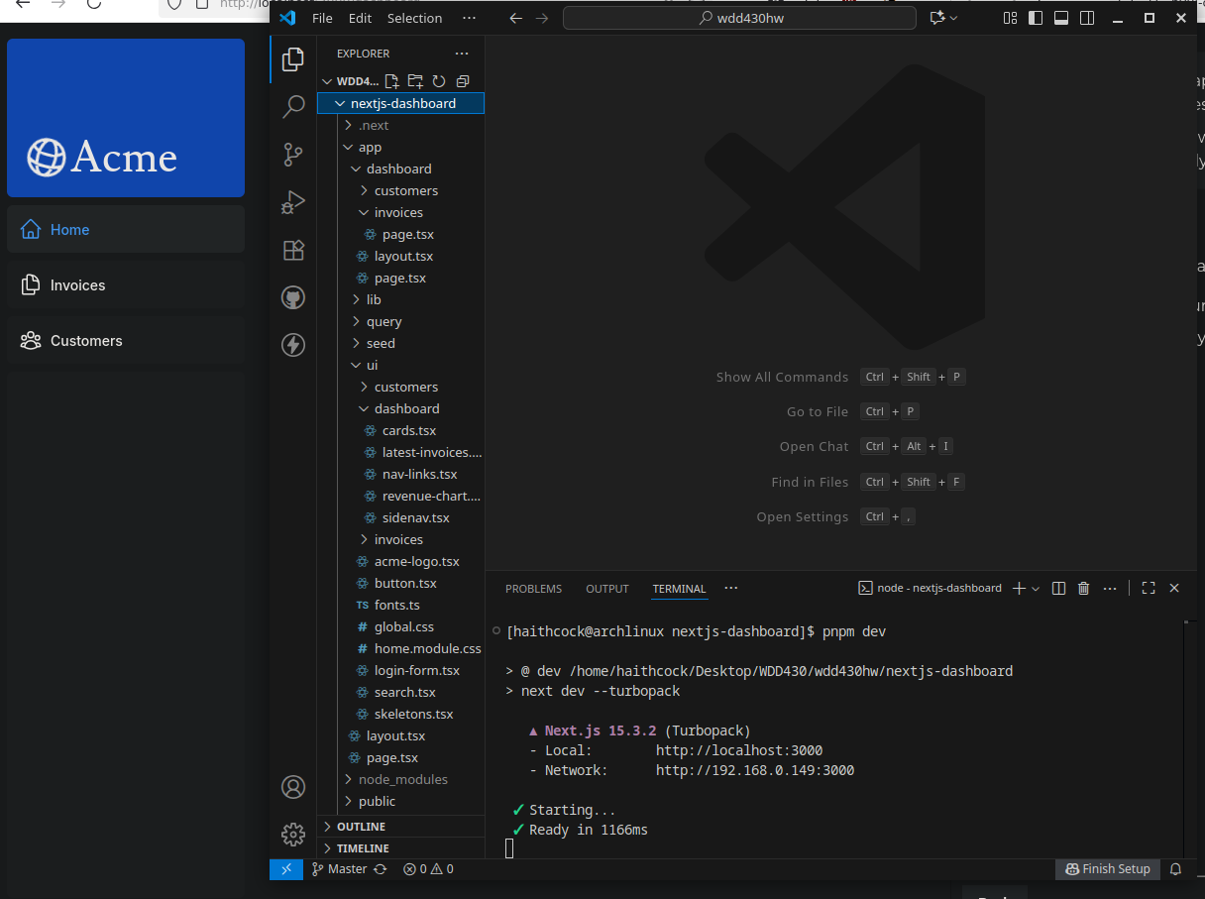
Github Link: https://github.com/haithcock/wdd430hw

