**How the Web Works?**

Web pages are stored on web servers located around the globe. Entering the Uniform Resource Locator or URL of a web page in your web browser or clicking a link sends a request to the server that hosts the page. The server transmits the web page data to your computer and your web browser displays it on your screen.



When you type a web address into your browser:

* The browser goes to the DNS server, and finds the real address of the server that the website lives on.
* The browser sends an HTTP request message to the server, asking it to send a copy of the website to the client. This message, and all other data sent between the client and the server, is sent across your internet connection using TCP/IP.
* If the server approves the client's request, the server sends the client a message, and then starts sending the website's files to the browser as a series of small chunks called data packets.
* The browser assembles the small chunks into a complete web page and displays it to you.

**What do you need to be a web developer?**

While there are no formal or specific qualifications required becoming a web developer, a numerate degree in a subject such as math’s or science will be useful.

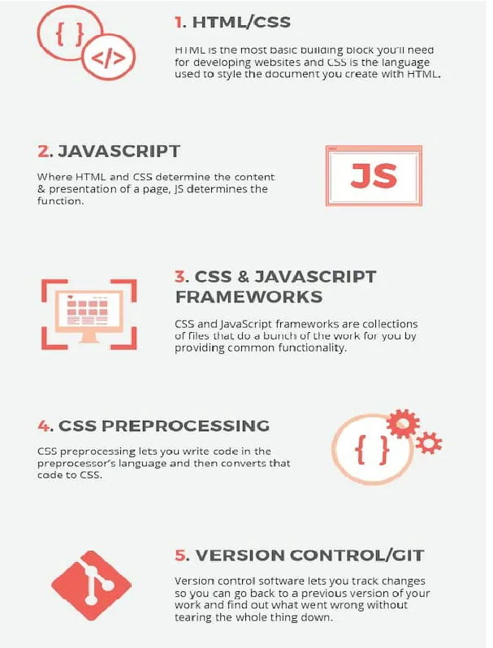

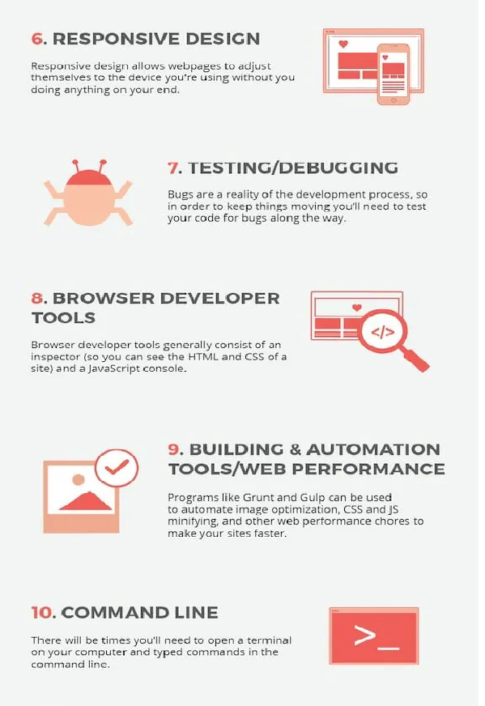

**What is the role of a web developer?**

A web developer is responsible for programming the code that “tells” a website how to

function. A developer builds a website from the bottom up. He is responsible of:

* Website and software application designing, building, or maintaining.
* Using scripting or authoring languages, management tools, content creation tools, applications, and digital media.
* Conferring with teams to resolve conflicts, prioritize needs, develop content criteria, or choose solutions.
* Directing or performing Website updates.
* Developing or validating test routines and schedules to ensure that test cases mimic external interfaces and address all browser and device types.
* Editing, writing, or designing Website content, and directing team members who produce content.
* Maintaining an understanding of the latest Web applications and programming practices through education, study, and participation in conferences, workshops, and groups.
* Back up files from Web sites to local directories for recovery.
* Identifying problems uncovered by customer feedback and testing, and correcting or referring problems to appropriate personnel for correction.
* Evaluating code to ensure it meets industry standards, is valid, is properly structured, and is compatible with browsers, devices, or operating systems.
* Determining user needs by analyzing technical requirements.