Howard University
College of Engineering and Architecture
Department of Electrical Engineering & Computer Science

Large Scale Programming
Fall 2024

Midterm Exam – Part I
October 17, 2024
Haithem Amir

Part I: 50 pts. (essay questions)

Instructions:
- Submit completed exam to your github repository under package org.howard.edu.lsp.midterm

Verify that the commit(s) completed successfully

- OPEN BOOK, OPEN NOTES. THERE IS NO COLLABORATION ON THIS EXAM
- Site any and ALL references for anything obtained off the internet.

Question 1. (10 pts.)

You are reviewing the following class in a Fitness Tracking System. The class is intended to manage various aspects of a user’s fitness activities.

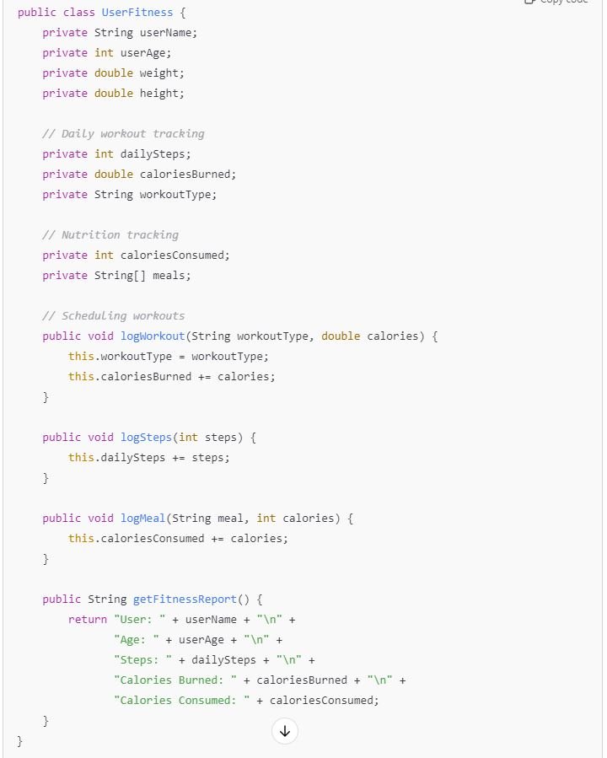

Tasks:
- Analyze the UserFitness class. Explain why this class has low cohesion. (5 pts.)
  - The UserFitness class has low cohesion because it’s trying to manage too many unrelated tasks, like tracking workouts, managing diet, and setting fitness goals, all in one place. It ends up doing too many things that don’t logically belong together. In good Object-Oriented design, a class should have a clear, single responsibility, and this class doesn’t. Having many unrelated tasks reduces maintainability and increases complexity which is why the class feels scattered and not cohesive.

- Describe, in general, how you would split the UserFitness class into more cohesive classes. Your answer should not be a complete design. (5 pts.)
  - To make the class more cohesive, I’d break it down into smaller, focused classes. For example, I’d create a WorkoutTracker class to handle the workout-related tasks, a DietTracker class for managing dietery information, and a UserGoals class to track and manage user goals. This way, each class does one job and does it well, which makes the code cleaner and easier to maintain.

Question 2. (5 pts.)
Given the following, answer the below questions.

A university manages its students using a program that has a class Student with subclasses FirstYear, SecondYear, and ThirdYear for year-specific state and behaviors. The program has a List that contains all Students.

Should Student be a class, an abstract class or an interface? Explain your answer
- Student should be an abstract class because it has common functionality that all subclasses can inherit, but on its own, it doesn't need to be instantiated. FirstYear, SecondYear, and ThirdYear will extend Student, allowing each subclass to implement its own year-specific behavior while sharing the common features of a student. This approach avoids duplicating code and keeps things structured.

- At the end of each year, the third-year students graduate and must be removed. This is done by passing the list to the following method:

void removeThirdYears(List<Students> students) {
for (Student student : students) {
try {
ThirdYear = (ThirdYear) student;
students.remove(thirdyear);
}
}
}

Why is the above method flawed? Hint: Another Arthur Riel heuristic (5 pts.)
- The method is flawed because it uses exceptions to control program flow, which is not good practice. Casting each Student to ThirdYear and catching a ClassCastException when it fails is inefficient and violates the heuristic that exceptions should not be used for regular control flow. Additionally, removing elements from the list while iterating over it can cause a ConcurrentModificationException. Instead, we should use instanceof to check if a student is a ThirdYear and use an iterator to safely remove them during iteration.

Question 3. (5 pts.)
Given the following, answer the below questions.

public class BankAccount {
public String accountHolderName;
public String accountNumber;
public double balance;
public double interestRate;

public BankAccount(
String accountHolderName,
String accountNumber,
double initialDeposit,
double interestRate) {
this.accountHolderName = accountHolderName;
this.accountNumber = accountNumber;
this.balance = initialDeposit;
this.interestRate = interestRate;
}

// Exposed implementation for adding interest
public void addInterest() {
double interest = balance * (interestRate / 100);
balance += interest;
}

// Exposed implementation for deposits
public void deposit(double amount) {
balance += amount;
}

// Exposed implementation for withdrawals
public void withdraw(double amount) {
balance -= amount;
}
}

- Is BankAccount well-encapsulated? Why or why not? If so, describe what changes you would make to the class. Otherwise, state nothing. (5 pts.)
  - The BankAccount class is not well-encapsulated because its fields, such as AccountHolderName, AccountNumber, Balance, InterestRate are publicly accessible. To improve encapsulation, these fields should be private and accessed through getter and setter methods. This protects the internal state of the object and allows for validation or control over how fields are accessed or modified.

Question 4. (10 pts.)
Given the following, answer the below questions.

Given:
A car manufacturer uses Java software to track current vehicles being built. The UML diagram below shows an excerpt of the current software structure. You should assume the presence of other appropriate fields and methods

Car
getTrimLevel()
Engine
accelerate()
getFuelLevel()
Base
Sports
Luxury
Electric
Petrol

Each car can be built to one of three trim levels: Base, Luxury or Sport. They can also be configured with an electric or petrol engine. At various points in the manufacturing process the customer can choose to change the trim level.

Task:
- Explain in detail why the current structure does not support this. (5 pts.)
  - The current structure ties the trim level directly to the car's type (Base, Luxury, Sport) through inheritance. This makes it difficult to change the trim level once the car is instantiated because the class hierarchy is static and doesn't allow for changes after object creation.

- Describe how to refactor the structure to allow trim-level change for a car to dynamically change. Hint: How would you modify Car to use composition to solve the problem? (5 pts.)
  - A better approach would be to use composition instead of inheritance. You could create a TrimLevel class and a Car class that contains a TrimLevel object. This way, the Car can dynamically switch its TrimLevel object to a different instance (e.g., from Base to Luxury) at runtime, allowing more flexibility in changing configurations.

Question 5. (5 pts.)
Suppose you are about to code a particular class and find that you have written another class with nearly the functionality that you now are developing. This means that the two classes in large parts contain the same code, but in smaller parts have different code. Explain in detail why this may be a problem and how to solve it. Give your answer in terms of Arthur Riel’s design heuristics.
- Having two classes that largely contain the same code but differ in smaller parts presents a problem because it leads to code duplication, which can make maintenance more difficult and error-prone. According to Arthur Riel's design heuristics, specifically the heuristic that "redundant code should be eliminated through inheritance," this situation violates good object-oriented design principles. The duplication increases the risk of inconsistencies, as any change in the shared code must be replicated across all classes containing it. To solve this problem, the common functionality should be extracted into an abstract base class that both classes inherit from. This approach adheres to Riel's heuristic by promoting code reuse and reducing redundancy. It allows the shared code to reside in one place, making maintenance easier and ensuring that any updates automatically apply to all subclasses. By leveraging inheritance and abstraction, we improve the design's modularity and maintainability.

Question 6. (5 pts.)
Suppose we need to store instances of the classes Car and BankAccount in a database. To obtain low coupling it may seem as if the functionality to save an instance should be in precisely those classes, since they have the information that shall be saved. Why is it unwise to place the database calls there?
- Placing database calls directly in classes like Car or BankAccount leads to high coupling between the business logic and the database. This makes the code harder to maintain and test because changes in the database structure or technology would directly impact these classes. A better approach is to use a Data Access Object or a service layer to handle database operations. This way, the Car and BankAccount classes remain focused on their core responsibilities and are not tied to how data is stored or retrieved.

Question 7. (5 pts.)
Given a set of requirements, what conditions must be met to make it appropriate to create a new class hierarchy using inheritance? Neither superclass nor subclass exist before, the question is about designing a new class hierarchy.
- When designing a new class hierarchy using inheritance, you should only do so if there is a clear “is-a” relations between the superclass and subclass. The subclass should inherit behavior from the superclass and possibly extend or modify it. In addition, both the superclass and subclass should follow the Liskov Substitution Principle, meaning instances of the subclass should be usable wherever the superclass is expected. If these conditions aren’t met, it’s better to consider alternatives like composition.

Question 8. (2.5 pts.)
Describe the difference between inheritance and composition why would you choose one over the other.
- Inheritance establishes an “is-a” relationship where one class inherits the properties and behaviors of another class. Composition, on the other hand, establishes a “has-a” relationship, where a class contains references to other objects, allowing for more flexible design. I’d choose composition over inheritance when I want more flexibility and to avoid the tight coupling that inheritance can create. Composition allows you to change behavior at runtime by swapping out components, whereas inheritance locks you into a fixed hierarchy.

Question 9. (2.5 pts.)
Explain the meaning of cohesion and describe whether low or high cohesion is better.
- Cohesion refers to how closely related and focused the responsibilities of a class or module are. High cohesion means that a class or module is focused on a single responsibility, making it easier to maintain and understand. Low cohesion, on the other hand, means that the class or module is trying to do too many unrelated tasks, leading to confusion and harder maintenance. In general, high cohesion is always better because it promotes a cleaner, more maintainable codebase.

