Kathmandu University
Department of Artificial Intelligence
Dhulikhel, Kavre



Lab Report-IV
Testing and Reading Unsecured Data Sent Through HTTP Connection using Wireshark

Subject Code: AICL 318
Cloud Computing and AI
BTech in Artificial Intelligence

Submitted by,
Ashish Gupta
Batch 2023

Submitted to,
Rupak Gyawali
Department of Artificial Intelligence

Testing and Reading Unsecured Data Sent Through HTTP Connection using Wireshark

Step 1:

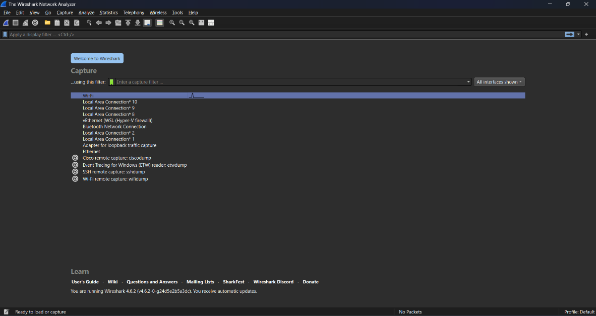

Step 2:

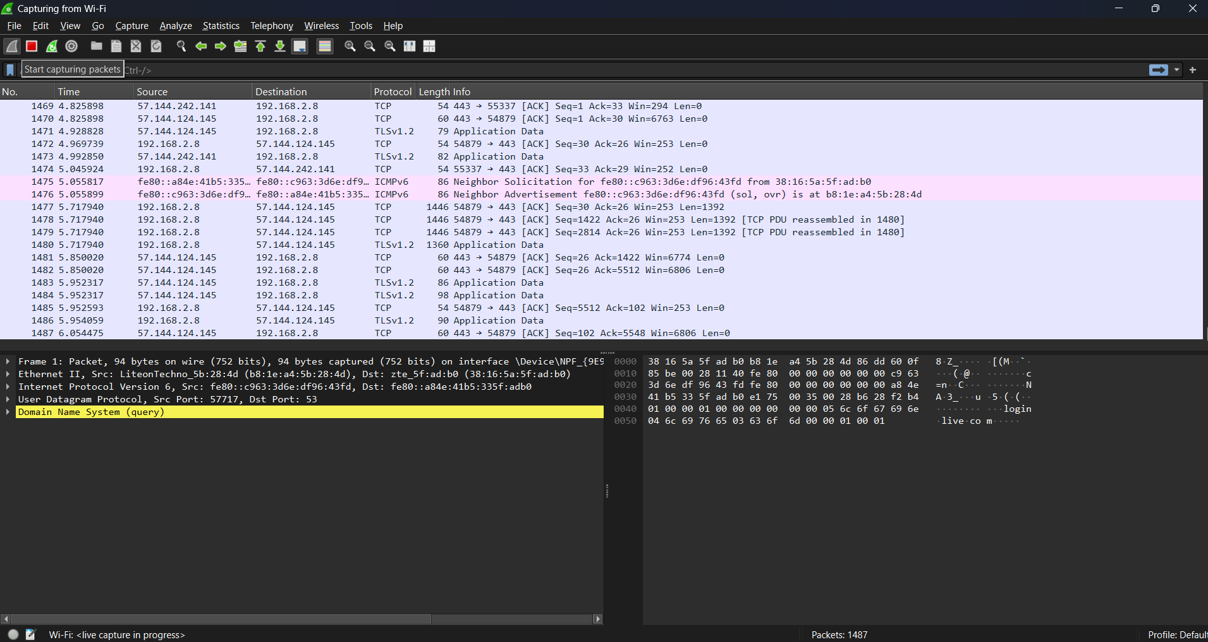

Step 3:

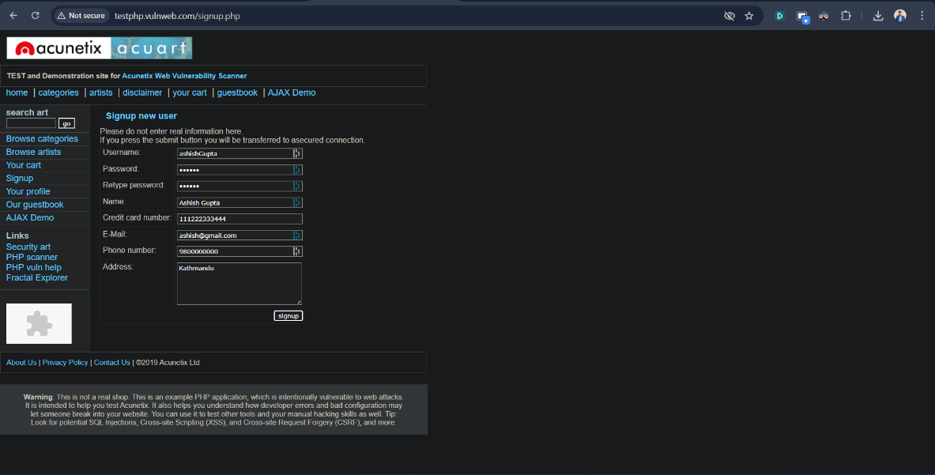

Step 4:

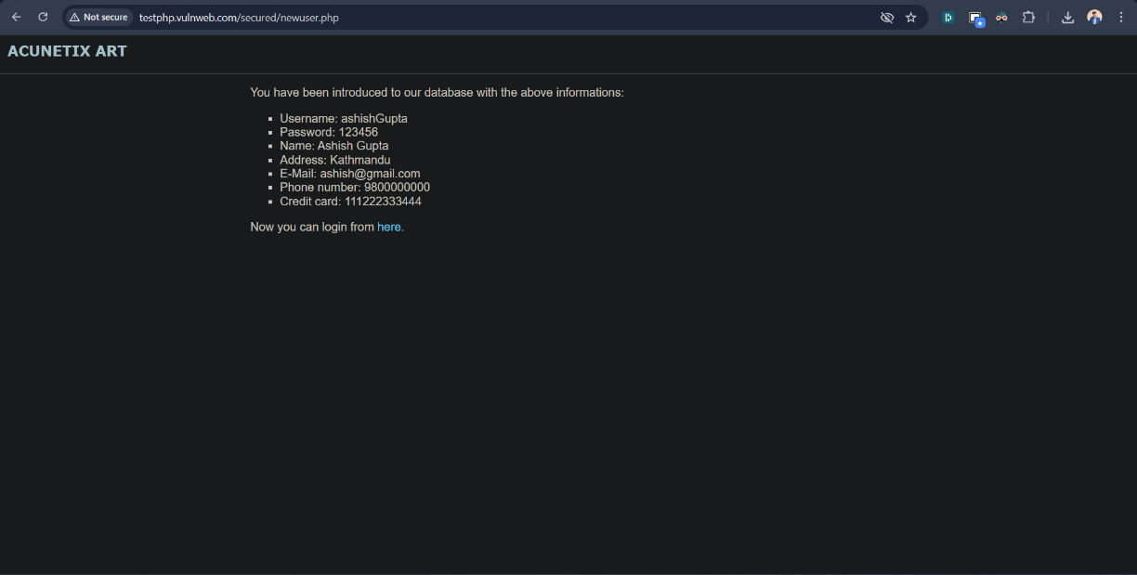

Step 5:

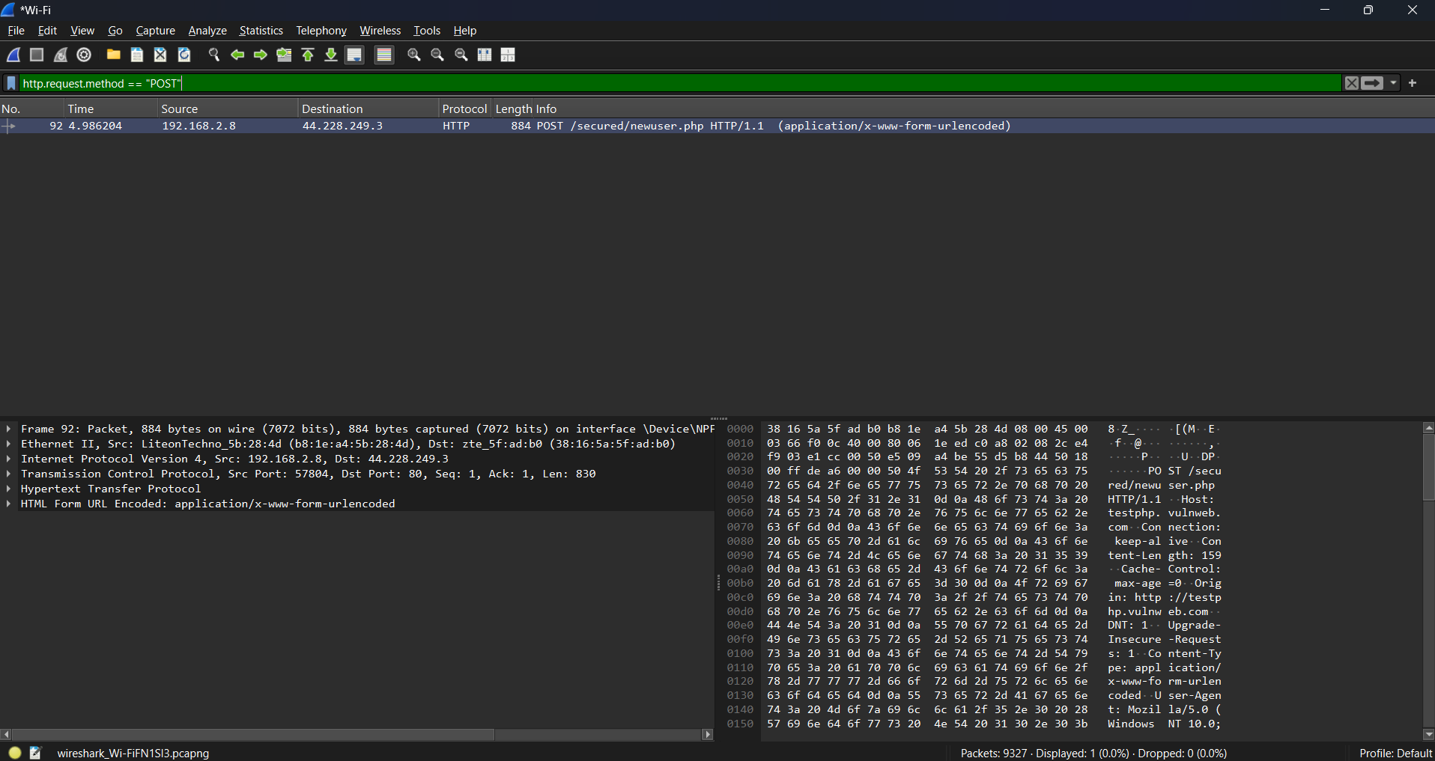

Step 6:

