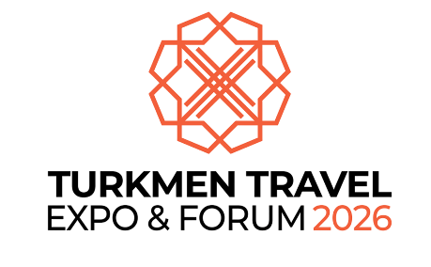
Dear Ladies and Gentlemen,
We are honored to invite you to take part in the International Exhibition and Forum “TurkmenTravel 2026”, which will be held in Ashgabat on April 14–16, 2026.
TurkmenTravel 2026 is set to become a key industry event, bringing together representatives of the international and national tourism communities to exchange experience, establish new partnerships, and promote the tourism potential of Turkmenistan and Central Asia.
The exhibition and forum will showcase the main directions of tourism development in the country, including cultural, ecological, business, and health tourism, as well as modern technologies in the fields of hospitality, digitalization of tourism services, and sustainable tourism development.
Special attention will be given to international projects aimed at promoting Turkmenistan’s historical and natural heritage, developing transport and hotel infrastructure, improving the quality of tourism services, and advancing national tourism brands.
The event will bring together representatives of leading travel companies, airlines, hotel chains, international organizations, and relevant ministries. TurkmenTravel 2026 will serve as a unique platform for sharing ideas, signing business agreements, and promoting joint initiatives.
Within the framework of the forum, meetings with representatives of government institutions, sectoral agencies, and the private sector will be organized to foster promising cooperation and implement joint projects in the field of tourism.
We will be delighted to welcome you as an esteemed delegate and partner at the upcoming TurkmenTravel 2026 Exhibition and Forum.
Sincerely,
Organizing Committee of TurkmenTravel 2026

  Minister of Culture of Turkmenistan  A. Shamyradov |   Chairman of The Union Of Industrialists And Entrepreneurs Of Turkmenistan  N. Atagulyyev |   Chairman of the Chamber of Commerce and Industry of Turkmenistan    M. Gurdov |     General Director of JSC  Talwas Yoly  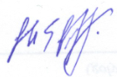  G. Gochmyradow

Ministry of Culture of Turkmenistan  medeniyet.gov.tm  +99312 440 033 | The Union of Industrialists and Entrepreneurs of Turkmenistan  tstb.gov  +99312 212 344 | Chamber of Commerce and Industry of Turkmenistan  cci.gov.tm  +99312 398 981 | Oguz Forum and Expo  oguzforum.com  +99361 480 080

