Overview
Provide a brief description of the DU test Firmware (FW) for the running scan limit test code. NOTICE: This version does not include the scan limit checks just the base to start this work.

DU Scan Limit Test FW:
This FW is targeted to the ZCU104 evaluation module. This evaluation module uses the same Xilinx Zynq MSPOC that will be used on the DU Control board. This will allow testing and evaluation of the scan limit check without completed custom hardware but provide accurate results in the final design.
The design consists of the required block design with the Zynq IP configured for the ZCU104. The block design wrapper is part of the top level VHD file.
In addition, there is a 32-bit bus interface between the ARM and FPGA to allow data transfer between the two sides. This is a fixed address register-based interface with ARM as the master.
An interrupt from the FPGA to the ARM was added to allow indication to the ARM of events.
This base test bed will allow running the scan limit check in both Software (SW) and FW and the assessment of which is more efficient.
This FW also served as a test run for Vitis/Vivdo 2024.2. This is the latest Xilinx software version and has not been used by the SW/FW team before (the team is familiar with older versions).

Block Design
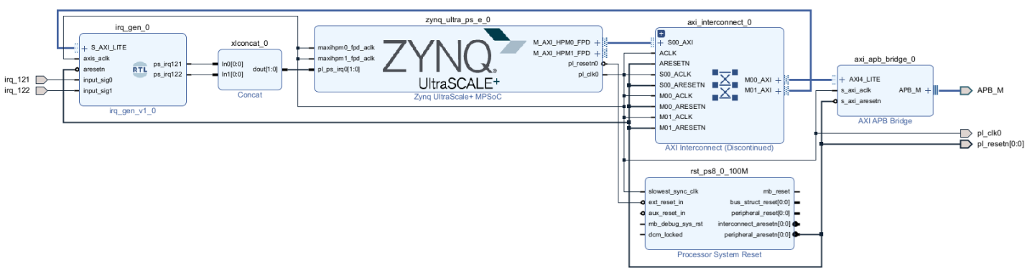

Design Hierarchy
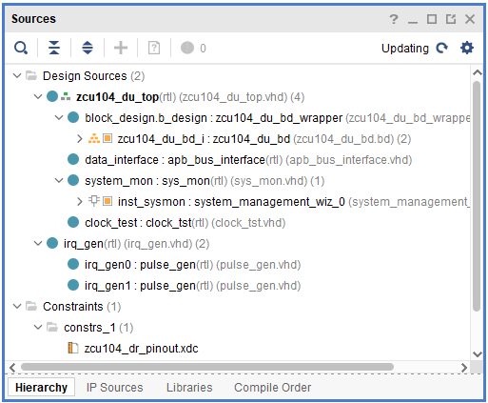

Register Map

Test FW Bare Metal SW Check:
A simple bare metal version of SW was created to test the base scan limit check FW. Below is the output of a serial terminal connected to the ZCU104 showing information shared between the ARM and FPGA.
