Database Relationship Guide for the AI Security Monitoring Project

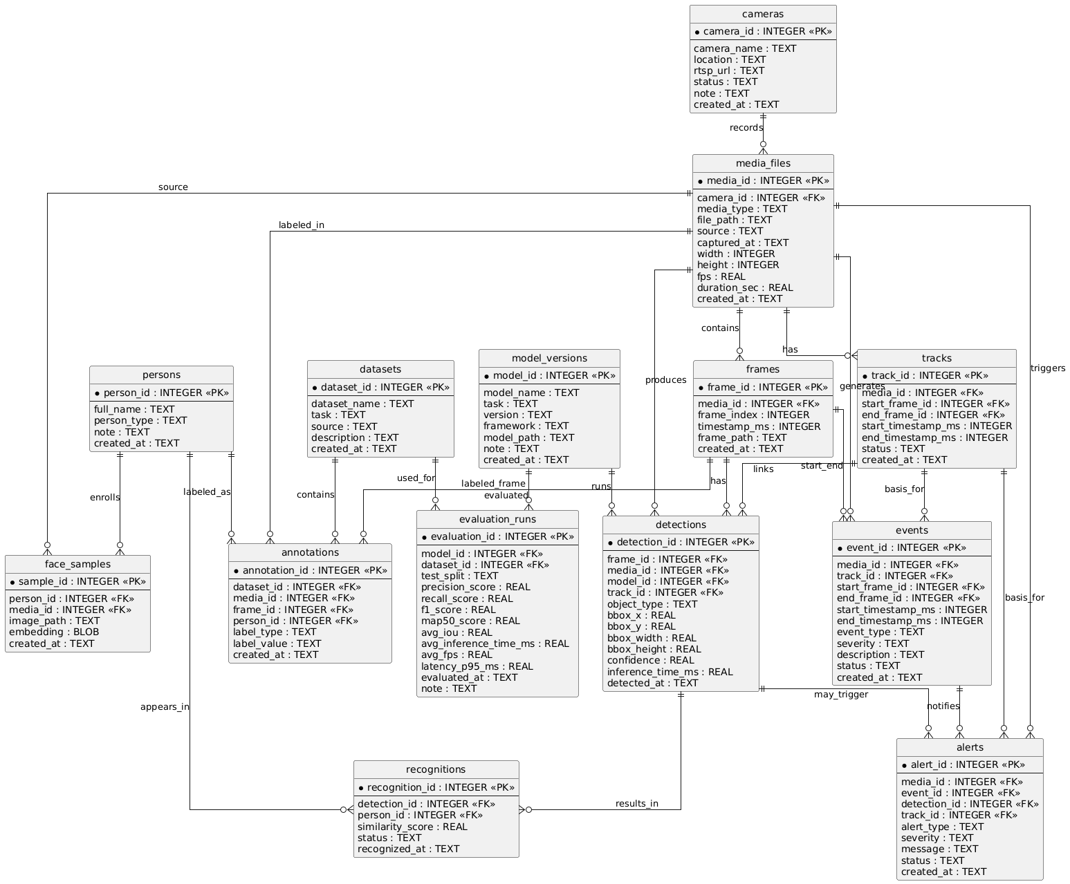

1) Big Picture Flow
The database follows this pipeline:
cameras -> media_files -> frames -> detections -> recognitions / tracks -> events -> alerts
Supporting tables:
persons, face_samples, model_versions, datasets, annotations, evaluation_runs

2) Relationship Chart

From table | To table | Relationship | Why it exists
cameras | media_files | 1-to-many | One camera can produce many videos/images/streams.
media_files | frames | 1-to-many | One video or stream contains many frames.
media_files | tracks | 1-to-many | One media source can contain many tracked objects.
media_files | detections | 1-to-many | Detection results belong to a specific media source.
media_files | events | 1-to-many | A media source can contain many anomaly/security events.
media_files | alerts | 1-to-many | A media source can generate many alerts.
persons | face_samples | 1-to-many | One person can have many face samples for enrollment.
persons | recognitions | 1-to-many | One person can appear in many recognition results.
persons | annotations | 1-to-many | A person can be linked to many labeled samples.
frames | detections | 1-to-many | Each frame can have zero or many detections.
frames | tracks | indirect | Tracks are built using multiple frames over time.
frames | events | optional 1-to-many | Events may start or end at specific frames.
detections | recognitions | 1-to-many | A face/person detection can be recognized or rejected.
detections | alerts | optional 1-to-many | Some alerts are triggered from a specific detection.
detections | tracks | many-to-1 | Multiple detections across frames can belong to one track.
tracks | events | 1-to-many or optional 1-to-1 | Many behavior events are based on the same tracked person.
tracks | alerts | optional 1-to-many | Alert logic such as loitering or anomaly often depends on track history.
model_versions | detections | 1-to-many | A model version produces many detections.
model_versions | evaluation_runs | 1-to-many | The same model can be evaluated many times.
datasets | annotations | 1-to-many | One dataset contains many annotations.
datasets | evaluation_runs | 1-to-many | One dataset can be used for many evaluation runs.
annotations | frames | optional many-to-1 | A labeled annotation may point to a specific frame.
annotations | media_files | optional many-to-1 | Some annotations apply to the whole media file.

3) Why These Relations Matter

cameras -> media_files
This relation tells you where the data came from. It is useful when the project has multiple cameras at different locations.

media_files -> frames
A video or stream must be split into frames before detection can run. This relation stores the original frame order and timestamp.

frames -> detections
Object detection and face detection are usually performed on each frame. This is the core connection between video and AI results.

detections -> recognitions
Detection answers the question “where is the face/person?”. Recognition answers “who is this person?”. They are separate tasks, so they should be stored separately.

detections -> tracks
Tracking links detections across multiple frames so the system can follow the same person over time.

tracks -> events
Many security events are not based on one frame only. For example, loitering, fall detection, or unusual behavior usually need a time sequence. That is why events connect well to tracks.

events -> alerts
An event is the actual analytic result. An alert is the notification generated from that event. This separation makes the design cleaner.

model_versions -> detections / evaluation_runs
This lets you compare which AI model version produced the result and how well it performed.

datasets -> annotations -> evaluation_runs
These tables support data preparation and model testing. They are useful when the project includes dataset collection, labeling, and benchmarking.

4) Recommended Dependency Direction
The safest dependency order is:
- cameras
- persons
- media_files
- frames
- tracks
- model_versions
- detections
- recognitions
- events
- alerts
- datasets
- annotations
- evaluation_runs
This order helps because child tables depend on parent tables.

5) Simple Example Flow
Example:
- A camera records a video.
- The video is stored in media_files.
- The video is split into frames in frames.
- The model detects a person in a frame and stores it in detections.
- The same person is followed across frames in tracks.
- The system recognizes the person in recognitions.
- If the person loiters too long, the system creates an event.
- The event becomes an alert.

6) Short Design Summary
This schema is good because it separates:
- source data (cameras, media_files, frames)
- AI outputs (detections, recognitions, tracks)
- security logic (events, alerts)
- training and evaluation (datasets, annotations, evaluation_runs)
That makes the database easier to understand, debug, and expand later.

